**IMPACT OF SOCIAL MEDIA ON BUYING BEHAVIOUR OF CONSUMER WITH SPECIAL REFERENCE TO MUMBAI YOUTH**

CONTENTS

|  |  |  |
| --- | --- | --- |
| Sr. No | Topics | Page No |
| 1 | Introduction | 3-5 |
| 2 | Objectives of the research | 6 |
| 3 | Scope and limitation of the research | 7 |
| 4 | Research Structure | 8-9 |
|  | Chapter one Consumer Behaviour | 9 |
| 5 | CONSUMER | 10 |
| 6 | The Consumers Decision Process | 11 |
| 7 | Problem recognition | 11 |
| 8 | Search of Information | 11 |
| 9 | Evaluation of Alternatives | 12 |
| 10 | Final Decision | 13 |
| 11 | Post Purchase Decision | 14 |
| 12 | Attitude | 14 |
| 13 | SOCIAL MEDIA | 15 |
| 14 | What is social media | 15 |
| 15 | Types of Social Media | 17 |
| 16 | Social Networking Sites | 17 |
| 17 | Social News and Bookmarking Sites | 17 |
| 18 | Media-Sharing Sites | 18 |
| 19 | Blogs | 18 |
| 20 | Nature of Consumer Behaviour | 18 |
| 21 | Factors influencing consumer behaviour | 20 |
| 22 | Marketing factors | 21-22 |
| 23 | Personal factors | 22-23 |
| 24 | Psychological factors | 24-25 |
| 25 | Situational factors | 26-27 |
| 26 | Social factors | 27-29 |
| 27 | Cultural factors | 30-33 |
| 28 | Social Media and Marketing | 34-35 |
| 29 | Social Media and Consumer | 36-38 |
| 30 | Questionnaire | 39 |
| 31 | DATA ANALYSIS | 40-49 |
| 32 | CONCLUSION | 49-51 |
| 33 | Limitation | 53 |
| 34 | APPENDICES | 52 |
| 35 | Bibliography | 53-55 |

**Introduction**

Social media is the online communications medium dedicated to community-based input, interaction, and content-sharing. Websites and applications dedicated to [forums,](http://whatis.techtarget.com/definition/discussion-board-discussion-group-message-board-online-forum) [social networking](http://whatis.techtarget.com/definition/social-networking), [social bookmarking](http://whatis.techtarget.com/definition/social-bookmarking) etc. are among the different types of social media. Facebook, Google plus, Twitter, Linkedin, Wikipedia, Pinterest etc. are some of the examples of social media. Social media is becoming an integral part of life online as social websites and applications proliferate. Most traditional online media include social components, such as comment fields for users. In business, social media is used to market products, promote brands, and connect to current customers and foster new business. Social media marketing takes advantage of social networking to help a company increase brand exposure and broaden customer reach. The goal is to find out the impact of social media on consumer behaviour in urban areas. Consumers and businesses around the globe have been more connected than ever before with the presence of Internet. While Internet penetration in urban India is at 64.84 per cent in December 2017 compared to 60.6 per cent in December 2016, the rural Internet penetration has grown only a little -- from 18 per cent in 2016 to 20.26 per cent in December 2017.   
An estimated 182.9 million urban users access Internet daily as compared to 98 million users in rural India. Data from the Internet and Mobile Association of India (IAMAI) has shown that Mumbai has the highest number of Internet users in India. Mumbai has close to over 12 million Internet users. Number two on the list is national capital Delhi with 8.1 million users, followed by Hyderabad with 4.7 million users. Chennai and Kolkata are on the number four and five spots with 4.5 and 4.4 million users respectively. In terms of growth Mumbai has seen a 45 per cent year-on-year growth as the city had. In 2012, Mumbai had 8.3 million Internet users, while Delhi had 6 million users. There were 3.6 million Internet users in Hyderabad in 2012, while Chennai had 3.4 million Internet users and Kolkata had 3 million Internet users. Where Mumbai's growth rate is concerned, the key drivers behind this are college students, the impact of mobile usage and the smartphone boom in India. According to Nilotpal Chakravarti, the associate Vice-President at IAMAI, the reasons for Mumbai's growing Internet population are many. He says, "The primary reason for the growth is the increasing use of Internet by college going students. There are various factors which have been instrumental in bringing about this change with the major ones being the increase in mass media exposure and also the rising number of social networking apps targeting the youth." In terms of year-on-year growth, Kolkata leads with a 47 per cent growth as far as Internet users are concerned. Bangalore saw a growth 43 per cent and is third on the list. Pune with a growth rate of 37 per cent is fourth while Delhi with a growth of 35 per cent is fifth. Ahmedabad with 26 per cent year-on-year growth rate has the lowest growth rate among the top eight cities.

The report also says that the top four metros in India have 37 per cent penetration where active Internet users go. Among the other four metros, Hyderabad leads with a penetration of 37 per cent active Internet users. In the small metros, Coimbatore with a 40 per cent penetration is on top.

Origin of the research problem:

Now a day most of the youth are available on social media. They spend most of their time on social networking so it’s struck to me to find out the impact of social media on their buying behaviour as most of the students and youth purchase their needs online.

KEYWORDS: Social media, consumer behaviour, marketing, decision making process

**Objectives of the research**

The objective of the research is to explain why, when, and how social media has impacted on consumer decision process. The theoretical framework rests on literature of consumer decision making process, social media, as well as previous studies relating to social media marketing. Quantitative research method is adapted for the purpose of this research. The empirical data was gathered by sending out questionnaire to individuals in Mumbai, July-August 2018.

**Significance of the Study**

This study is of significance and interest to various stakeholders. The study mainly affect the below;

**Scholars and Academicians**

Researchers can use this study to facilitate further research on other sectors especially those that are related to social media platforms. The study provides baseline data that assists people to carry out similar studies among other organizations where the business environment is similar.

**Companies and Organizations**

The study assists online retailers to increase their profits by utilizing their sales opportunities. The study also helps online retailers through social media to adapt to the changing consumer tastes and preference to avoid heavy losses when stocks pile up. The research also aims to serve as an indicator to potential companies of how they can tap into the market niche of the youth via social media sites.

**Youth**

Since most youth interact with social media in making decision relating to purchases of their choice, the findings of this study can be used to help the youth population establish the factors that impact on their choices based on the different stages of buyer decisions.

**Online Consumers**

Often, online shoppers are not aware of the factors that impact their decisions. The research provides measures required to ensure that consumers purchase quality products that suit their needs.

**Research Questions**:

1. How do consumers attend, process, and select the information before a purchase?

2. What are the differences between marketing on social media and through mass media?

3. What are the changes social media has brought to consumers in different stages of their decision making?

**1.2 Scope and limitation of the research**

With regard to the objectives, conducting the research from the perspective of consumers would be a considerably suitable approach. The researcher realizes that there are many available reports and studies which rather aims to help businesses to gain a better understanding in social media marketing but not to help consumers to identify reasons that social media has changed their decision making process. Since the purpose of marketing is, in sum, about consumer; therefore, by having the starting point from the perception of consumer, and by collecting data from consumers’ point of view, fresh insights can be gathered. The research also aims to serve as an indicator to potential readers (companies) of how they can tap into the decision making process via social media sites. Factors, such as technology, infrastructure, cultural values, norms, and so forth, across continentals are different, the implication of this research may vary in countries accordingly; therefore, the research targets at a geographical area, Mumbai, where individuals share a similar background within a standardized infrastructure. The research focuses on the behaviour of end consumers (individuals) and particularly within the retailing industry, for instance clothing, food and beverage, consumer electronics, and so on. Moreover, in order to provide a more comprehensive perspective concerning the decision making process, the researcher has discussed the five-stages buying model and the information processing theory, because the former theory explains the stages in decision making process clearly whereas the latter one denotes the psychological factors during the process- they are closely linked with one another based on their objectives. Social media marketing is no longer a new aspect, and yet it is still considerably a developing and evolving topic in the field. With a quick literature scan on the related topic, indeed there are vast amount of journals and articles, but with few scientific/academic research and classical literatures about social media marketing associating with changes of consumer behaviour. Thus, this would be another limitation of the research that the discussion on the topic is rather in a general manner.

**1.3 Research Structure**

The first chapter introduces and highlights the research background, the motivation of the researcher, as well as the research questions. In order to answer all three questions, literature review is covered by three chapters – consumers, social media, as well as consumers and social media. Decision making process is discussed elaborately so as to provide the components involved in the process before an actual purchase taken place, and how consumers can be affected during the course of the information processing before a purchase. With the purpose of identifying what are the core values that social media has offered to both marketers and consumers, as well as how marketers are utilizing social media in marketing, clarifications in terms of social media, types of social media sites, as well as discussions in relating to social media marketing are covered in Chapter 3. In the last chapter of the theoretical framework, the relation between social media and consumer decision making process is discussed. As for the empirical part, reasons of selected approach and the data collection process are explained in details in order to provide the reliability and validity of the research. Findings form the collected data are analysed in associating with the discussed theories in the theoretical framework in Chapter 5. Last but not least, conclusions are drawn for the research questions, and suggestions are made for any further research in future.

**Chapter one**

**Introduction**

**Meaning of consumer behaviour**

Consumer behaviour is the study of how individual customers, groups or organizations select, buy, use, and dispose ideas, goods, and services to satisfy their needs and wants. It refers to the actions of the consumers in the marketplace and the underlying motives for those actions.

Marketers expect that by understanding what causes the consumers to buy particular goods and services, they will be able to determine—which products are needed in the marketplace, which are obsolete, and how best to present the goods to the consumers.

According to Engel, Blackwell, and Mansard, ‘consumer behaviour is the actions and decision processes of people who purchase goods and services for personal consumption’.

According to Louden and Bitta, ‘consumer behaviour is the decision process and physical activity, which individuals engage in when evaluating, acquiring, using or disposing of goods and services’.

Consumer behaviour has been defined as “the acquisition, consumption and disposition of products, services, time and ideas by decision-making units.”(Institute of chartered analysis of India)

In other words, it is the body of knowledge which studies various aspects of purchase and consumption of products and services by individuals with various social and psychological variables at play.

According to Satish K Batra & S.H.H.Kazmi, “Consumer behaviour refers to the mental and emotional process and the observable behaviour of consumers during searching, purchasing and post consumption of a product or service.”

Consumer behaviour is not static. It undergoes a change over a period of time depending on the nature of products. For example, kids prefer colourful and fancy footwear, but as they grow up as teenagers and young adults, they prefer trendy footwear, and as middle-aged and senior citizens they prefer more sober footwear. The change in buying behaviour may take place due to several other factors such as increase in income level, education level and marketing factors.

All consumers do not behave in the same manner. Differ­ent consumers behave differently. The differences in consumer behaviour are due to individual factors such as the nature of the consumers, lifestyle and culture. For example, some consumers are techno holics. They go on a shopping and spend beyond their means.

They borrow money from friends, relatives, banks, and at times even adopt unethical means to spend on shopping of advance technologies. But there are other consumers who, despite having surplus money, do not go even for the regular purchases and avoid use and purchase of advance technologies.

The consumer behaviour varies across states, regions and countries. For example, the behaviour of the urban consumers is different from that of the rural consumers. A good number of rural consumers are conservative in their buying behaviours.

The rich rural consumers may think twice to spend on luxuries despite hav­ing sufficient funds, whereas the urban consumers may even take bank loans to buy luxury items such as cars and household appliances. The consumer behaviour may also vary across the states, regions and countries. It may differ depending on the upbringing, lifestyles and level of development.

Buyer behaviour is an important tool in the hands of marketers to forecast the future buying pattern of customers and devise appropriate marketing strategies to create long-term customer relationships. A vital part of the marketing process is to understand why a customer or buyer makes a purchase.

Without such an understanding, businesses find it hard to respond to customer needs and wants. Consumer behaviour is the study of how individuals make decisions to spend their available resources (time, money and effort) on consumption-related items.

It includes the study of what? Why? When? How often do they buy and how often do they use the product. For example, consumer researchers want to know what types of toothpaste consumers buy (gel, regular, etc.); what brand (national, international and generic); why do they buy it (to prevent cavities, to remove stains and to brighten or whiten teeth); where do they buy it (supermarket, drugstore and convenience store); how often do they use it (when they wake up, after each meal, when they go to bed, or any combination thereof); and how often do they buy it (weekly, biweekly or monthly).

An insight into psyche of the consumer helps us understand the processes that go behind their preference of certain goods and services over other. Consumer behaviour not only helps companies plan market strategies, but also facilitates the process of new product development to cater to the needs of customers. This research gives explanation on how individuals are attending, processing, and selecting the information on social media before a purchase. The findings indicated that individuals pursue an active role in information serach on social media comparing to mass media, yet information exposure is selective and subjective during the course of information search. Moreover, the empirical part of the research strives to provide insights to any companies that are trying to shift to or are currently participating in the new marketing trend. Findings and conclusions presented in the research are only valid within the population selection and cannot not to be generalized elsewhere due to the differences in environmental factors.

**2 CONSUMERS**

A Consumers is a person who purchases goods and services for personal use. The consumer is the one who pays something to consume products. Consumers, in general, can be referred as individuals who purchase or consume products and services; however, in terms of buyer and consumer, there is a little difference. Buyers are the people who are acting either as ultimate, industrial, or institutional purchasers. And the consumer refers to individuals who are ultimate user of the product. Following are the steps in consumer buying process

**Consumer buying process**

Inevitably, businesses face problems where the message is not reaching their consumers, with the fact that, at times, consumers are facing significant blocks in their decision process. If not, each of them should be fully committed, loyal, enthusiastic, repeated consumers; however, this is not the case. Today the accessibility and transparency of information has profoundly influenced the decision making process; therefore, it is important to examine what are the hurdles and fiction points that hold prospects becoming consumers, or keeps consumers hesitating from repurchasing. (Silverman 2001.)

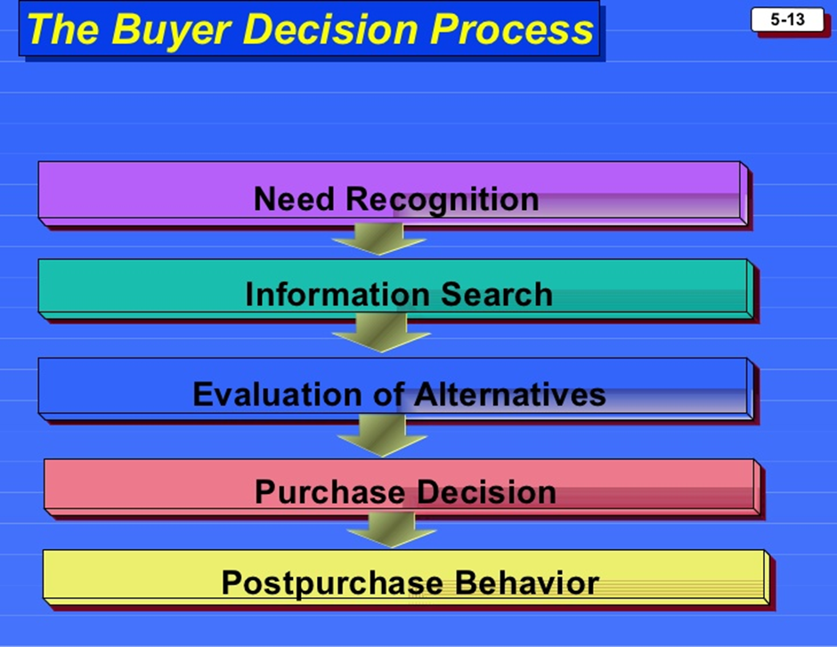

1. **Need recognition**

The buying process starts with need recognition - the buyer identify need or problem. A need can be triggered by internal or external stimuli such as hunger, thirst, sex etc. Problem recognition takes place whenever a consumer recognizes a significant difference between the desired and the actual state of affairs, which is in sufficient magnitude to arouse and activate the decision process , or need triggered by internal or external stimuli. After the realization of a problem, it initiates the search for information before any typical buying decisions. Nowadays, the mass media is no longer the only source of information, which may promote ideas goods and services. As a result, consumers are exposed to vast amount of information to identify a claim or promise about their services or products, which are strongly penetrative.

1. **Information search**

If the consumer’s drive is strong and a satisfying product is near at hand, the consumer is likely to purchase the product to satisfy his need. If not, the consumer may simply store the need in memory or undertake an information search. The final purchase decision will not be made at once, even when individuals acknowledge, recognize their problems, and pay attention to the available products; likewise, when prospects have a certain interest in a product or service, they tend to go through the following steps before carrying out any action – identifying available options, studying information of selected options, and eventually judging which of these options can most likely deliver the best outcome. The information sources can be divided into two types: internal and external. Internal search indicates earlier information and experience of an individual which result in future behaviour that the consumers will be likely to take. Even when a consumer is attentive towards a marketing offer, it does not imply that the offer will be comprehended as intended; therefore, aside from the accumulated information, any information or message that is generally analysed and stored in the consumers’ memory in forms of certain meaning will be used to evaluate alternatives. Essentially, competitive brands provide alternatives for consumers who are willing to find the best solution to their problems or needs; even they may offer same products or services. As more information is obtained, the consumer’s awareness and knowledge of the available brands and features increases. The marketer should identify consumers’ sources of information and the importance of each source.

1. **Evaluation of Alternatives**

How does the consumer choose among the alternative brands? The Marketer needs to know about alternative evaluation. Once an option is identified as the best solution to fulfil the individual’s needs after accumulating sufficient information, they undertake alternative evaluation. Depending on their motives or goals, consumers establish criteria for evaluating choice alternatives, for instance which alternative is the simplest to use or to arrange, or what are other users’ experiences, because there is a need to confirm whether or not the information is reliable and to verify that the product will work out as anticipated. In order to ensure the outcome within the expectation, individuals require relevance of experience. Direct and indirect experiences, which individuals, serve as indicators during the buying process. Direct experience is not always preferred since individuals are inexperienced towards specific products, which may result using it in an unskilled manner and have negative experience with it. Most often, if negative experiences take place, they are most likely to be costly (both financially and time), risky, or even damaging to reputation. After the assessment of the choice alternatives, consumers formulate beliefs regarding the alternatives, which guide their attitudes, intentions, and ultimately their choice among alternatives. Besides, several studies have provided evident findings that the decision maker will increasingly seek ways to simplify the evaluation process when a decision becomes more complex. “How consumers go about evaluating purchase alternatives depends on the individual consumer and the specific buying situation. In some cases, consumers use careful calculations and logical thinking. At other times, the same consumers do little or no evaluating: instead they buy on impulse and rely on intuition.”(Philip kotler, Gary Armstrong)

1. **Buying Decision**

During the course of evaluation, consumer eventually forms preferences among the brands in the choice desk, however, there are two factors, which can interfere between the purchase intension and purchase decision – attitude of the others and unanticipated situational factors. Attitudes of others is the extent to which another person’s negative attitude towards the preferred alternatives or reluctance to meet the terms of supporting the purchase intention, this may result in a readjustment of the consumer’s purchase intention. Likewise, consumers are influenced by the info-me-diaries who publish their evaluations (e.g. customer reviews on Amazon.com, blogs, bulletin boards, and so on). Unanticipated situational factors refer to those may erupt to alter the purchase intention, for instance, there might come an unexpected purchase that is more urgent compared to the purchase the consumer was firstly stimulated to buy; in other words, preferences and purchase intentions cannot be served as completely reliable predictors of purchase behaviour. The stages in the decision process are not followed sequentially, but rather in a cyclically order; that is, in reality there are loops, for instance between information search and evaluation, consumer learns about new criteria not previously considered. A consumer’s decision to change, postpone or avoid a purchase decision is influenced heavily by perceived risk. The amount of perceived risk varies with the amount of money at stake. A consumer takes certain actions to reduce risk, such as avoiding purchase decision, gathering more information and looking for various brands and therefore there is need to understand the factors that provoke feelings of risk in consumers and try to reduce those risks with strategic marketing offers.

1. **Post Purchase Evaluation**

After purchasing the product, the consumer will experiences certain levels of satisfaction or dissatisfaction, and evaluates the wisdom of the choice made in selecting the alternative. Two potential outcomes are derived from this phase – satisfaction or dissatisfaction. When consumer experiences dissatisfaction towards the purchase, the choice is ‘devaluated’ and the consumer begins the process of searching, obtaining information and evaluating other options for future buying decision, in which triggers new behaviour. It is a phase when the consumer decides whether or not to move from merely implementing the product to a full adaption; that is, whether to use the product repeatedly or repurchase or not. Since consumer always has a choice regarding the products priority, frequency of usage, and new circumstances of new uses. When individuals are comfortable in using a specific product regularly, they will recommend it to others from using the product as well.

**3 Attitudes**

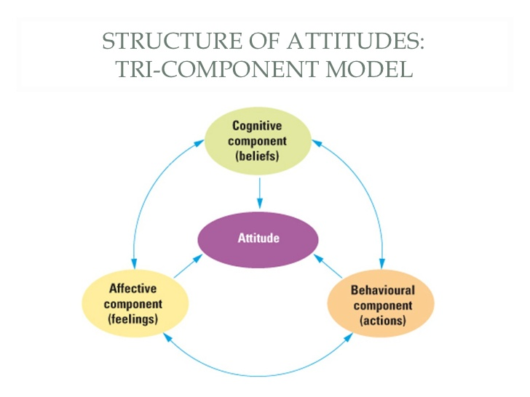

Attitude is the tendency of person to behave in particular manner in a particular situation for particular products. Personal attitude towards products and brands has been underlined in the buying model, due to the fact that attitudes are closely related to consumers’ information process in which judgments are presumably based. Attitudes regarding the product and brand are powerful predictors of the process and the patterns of exposure to information. Attitudes are learned through past associations and experience, through trails, as well as through information processing. It is composed of three elements –

1. Cognitive,
2. Affective, and
3. Conative.

Cognitive refers to the awareness or knowledge, such as, a brand; affective are the positive and negative feelings associated with a certain brand; and conative is the intention to purchase). In general, individuals, for whom marketers most likely want to persuade, are the most challenging to reach. In response to the findings, individuals’ initial opinions (attitudes) are important determinants of the information they will seek out; as people are prompt to seek information that is consistent to their initial thought, and keenly avoid those that encounters with it. An attitude may be positive or negative experience, which the individual has with a certain product.

## What is 'Social Media'?

Social media is a computer-based technology that facilitates the sharing of ideas and information and the building of virtual networks and communities. By design, social media is internet based and offers users easy electronic communication of personal information and other content, such as videos and photos. Users engage with social media via computer, tablet or smartphone via web-based software or web application, often utilizing it for messaging.

Social media originated as a tool that people used to interact with friends and family but was later adopted by businesses that wanted to take advantage of a popular new communication method to reach out to customers. The power of social media is the ability to connect and share information with anyone on Earth (or multitudes of people) as long as they also use social media.

Social media can take the form of a variety of tech-enabled activities, such as photo sharing, blogging, social gaming, social networks, video sharing, business networks, virtual worlds, reviews and more.

For individuals, social media is used to keep in touch with friends and extended family, [network](https://www.investopedia.com/terms/n/networking.asp) for career opportunities, find people from all over the globe who share a common interest, share content and more. Those who engage in these activities are part of a virtual [social network](https://www.investopedia.com/terms/s/social-networking.asp). For businesses, social media is an indispensable tool for finding and engaging with customers, sales, advertising and promotion, gauging trends and offering customer service. Governments and politicians utilize social media to engage with constituents and voters.

Social media's role in helping businesses is significant. It facilitates communication with customers, enabling the melding of social interactions on [e-commerce](https://www.investopedia.com/terms/e/ecommerce.asp) sites. Its ability to collect information helps focus marketing efforts and market research. It helps in promoting products and services, as it enables the distribution of focused timely and exclusive sales and coupons to would-be customers. And it can assist in relationship building, such as through [loyalty programs](https://www.investopedia.com/terms/l/loyalty-program.asp) linked to social media.

Social media is a series of websites and applications designed to allow people to share content quickly, efficiently and in real-time. Most people today define social media as apps on their smartphone or tablet, but the truth is, this communication tool started with computers. This misconception stems from the fact that most social media users access their tools via apps. In fact, 50% of online users never engage social media.

The ability to share photos, opinions, events, etc in real-time has transformed the way we do life and it is also transforming the way we do business. Retailers who [engage social media](https://www.thebalance.com/understanding-the-role-of-social-media-in-marketing-2296140) as part of their marketing strategy have seen great results. But the key to success with social media is to treat it with the same care, respect and attention you do all of your marketing.

Some social media sites have greater potential for content that is posted there to spread [*virally*](https://en.wikipedia.org/wiki/Viral_phenomenon) over social networks.

The idea that social media are defined by their ability to bring people together has been seen as too broad a definition, as this would suggest that the [telegraph](https://en.wikipedia.org/wiki/Telegraph) and [telephone](https://en.wikipedia.org/wiki/Telephone) were also social media. Social media technologies take many different forms including [blogs](https://en.wikipedia.org/wiki/Blog), [business networks](https://en.wikipedia.org/wiki/Professional_network_service), [enterprise social networks](https://en.wikipedia.org/wiki/Enterprise_social_networking), [forums](https://en.wikipedia.org/wiki/Internet_forum), [micro blogs](https://en.wikipedia.org/wiki/Microblogging), [photo sharing](https://en.wikipedia.org/wiki/Photo_sharing), [products/services review](https://en.wikipedia.org/wiki/Review_site), [social bookmarking](https://en.wikipedia.org/wiki/Social_bookmarking), [social gaming](https://en.wikipedia.org/wiki/Social_network_game), [social networks](https://en.wikipedia.org/wiki/Social_network), [video sharing](https://en.wikipedia.org/wiki/Video_hosting_service), and [virtual worlds](https://en.wikipedia.org/wiki/Virtual_world).

Social media is the collective of online communications channels dedicated to community-based input, interaction, content-sharing and collaboration.

Websites and applications dedicated to forums, micro, [social networking](https://whatis.techtarget.com/definition/social-networking), [social bookmarking](https://whatis.techtarget.com/definition/social-bookmarking), and [wiki](https://searchmicroservices.techtarget.com/definition/wiki)s are among the different types of social media.

Forms of electronic communication (such as websites for social networking and micro blogging) through which users create online communities to share information, ideas, personal messages, and other content (such as videos)

Here are some prominent examples of social media:

[Facebook](https://whatis.techtarget.com/definition/Facebook) is a popular free social networking website that allows registered users to create profiles, upload photos and video, send messages and keep in touch with friends, family and colleagues.

[Twitter](https://whatis.techtarget.com/definition/Twitter) is a free micro blogging service that allows registered members to broadcast short posts called tweets. Twitter members can broadcast tweets and follow other users' tweets by using multiple platforms and devices.

[Google+](https://whatis.techtarget.com/definition/Google-plus) (pronounced *Google plus*) is [Google's](https://searchcio.techtarget.com/definition/Google-The-Company) social networking project, designed to replicate the way people interact offline more closely than is the case in other social networking services. The project’s slogan is “Real-life sharing rethought for the web.”

[Wikipedia](https://whatis.techtarget.com/definition/Wikipedia) is a free, open content online encyclopaedia created through the collaborative effort of a community of users known as Wikipedians. Anyone registered on the site can create an article for publication; registration is not required to edit articles. Wikipedia was founded in January of 2001.

[LinkedIn](https://whatis.techtarget.com/definition/LinkedIn) is a social networking site designed specifically for the business community. The goal of the site is to allow registered members to establish and document networks of people they know and trust professionally.

[Pinterest](https://whatis.techtarget.com/definition/Pinterest) is a social curation website for sharing and categorizing images found online. Pinterest requires brief descriptions but the main focus of the site is visual. Clicking on an image will take you to the original source, so, for example, if you click on a picture of a pair of shoes, you might be taken to a site where you can purchase them. An image of blueberry pancakes might take you to the recipe; a picture of a whimsical birdhouse might take you to the instructions.

Social media is becoming an integral part of life online as social websites and applications proliferate. Most traditional online media include social components, such as comment fields for users. In business, social media is used to market products, promote brands, and connect to current customers and foster new business.

Social media allows a company to connect individuals who share similar business interests or activities. Internally, social tools can help employees’ access information and resources they need to work together effectively and solve business problems. Externally, public social media platforms help an organization stay close to their customers and make it easier to conduct research that they can use to improve business processes and operations.

Social media is also often used for [crowdsourcing](https://searchcio.techtarget.com/definition/crowdsourcing). Customers can use social networking sites to offer ideas for future products or tweaks to current ones. In IT projects, crowdsourcing usually involves engaging and blending business and IT services from a mix of internal and external providers, sometimes with input from customers and/or the general public.

### Nature of Consumer Behaviour:

It is important to learn about consumer behaviour the c**onsumer behaviour** is the study of how an individual decides to purchase a particular product over the other and what the underlying factors that mould such behaviour are. Most of our time is spent directly in the marketplace, shopping or engaging on social media, we spend large time about thinking about products and services while talking to family and friends and watching advertisement and now a days most of the people (consumers) spend their valuable time on social media, which affect their buying behaviour The nature of consumer behaviour is briefly stated as follows

**1. Influenced by various factors:**

**The various factors that influence the consumer behaviour are as follows:**

a. Marketing factors such as product design, price, promotion, packaging, positioning and dis­tribution.

b. Personal factors such as age, gender, education and income level.

c. Psychological factors such as buying motives, perception of the product and attitudes towards the product.

d. Situational factors such as physical surroundings at the time of purchase, social surroundings and time factor.

e. Social factors such as social status, reference groups and family.

f. Cultural factors, such as religion, social class—caste and sub-castes.

Consumer behaviour model includes various motivational factors such as marketing and environmental forces, consumer buying process, buyer’s characteristics buying decision process and buyer’s response.

The knowledge of consumer behaviour enables marketers to take appropriate marketing decisions in respect of the following factors**:**

a. Product design/model

b. Pricing of the product

c. Promotion of the product

d. Packaging

e. Positioning

f. Place of distribution

Positive consumer behaviour leads to a purchase decision. A consumer may take the decision of buying a product on the basis of different buying motives. The purchase decision leads to higher demand, and the sales of the marketers increase. Therefore, marketers need to influence consumer behaviour to increase their purchases.

Consumer behaviour is different for different products. There are some consumers who may buy more quantity of certain items and very low or no quantity of other items. For example, teenagers may spend heavily on products such as cell phones and branded wears for snob appeal, but may not spend on general and academic reading. A middle- aged person may spend less on clothing, but may invest money in savings, insurance schemes, pension schemes, and so on.

The consumer behaviour is not only influenced by the status of a consumer, but it also reflects it. The consumers who own luxury cars, watches and other items are considered belonging to a higher status. The luxury items also give a sense of pride to the owners.

Some of the most important factors influencing consumer behaviour are as follows: A. Marketing Mix Factors B. Personal Factors C. Psychological Factors D. Social Factors E. Cultural Factors.

The study of consumer behaviour indicates how individuals, groups and organizations select, buy, use and dispose goods, services, ideas, or experiences to satisfy their needs and desires. Consumer behaviour is affected by several factors. Marketers need to have a good knowledge of the factors affecting the consumer behaviour.

**In general, the factors that affect consumer behaviour are discussed in the following sections:**

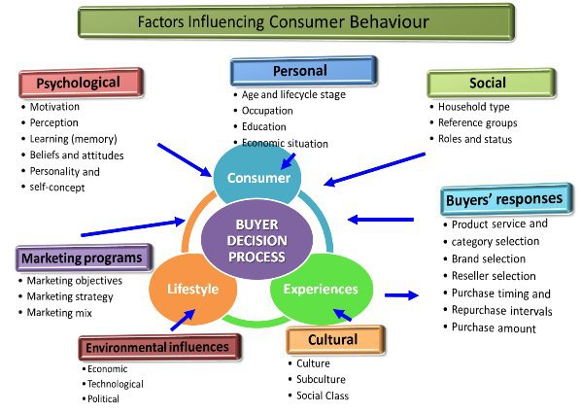

The study of consumer behaviour not only helps to understand the past but even predict the future. The below underlined factors pertaining to the tendencies, attitude and priorities of people must be given due importance to have a fairly good understanding of the purchasing patterns of consumers which helps in taking marketing decisions and framing effective marketing strategies

### A. Marketing Mix Factors:

Each component of the market mix—product, pricing, promotion and place of distribution has a direct or indirect impact on the buying process of the consumers. Marketing manager need to consider these factors while framing marketing strategies and plans. It includes

**Product**

Product is anything that is offered to market for sale. It is tangible and intangible attribute and it also affects the buying behaviour of the consumers

**Price**

Price is the exchange value of the product t which buyer is ready to buy and seller is ready to sell the product. It is the first thing that customer ask for while purchasing the product. An effective pricing strategy can influence the buying behaviour of customer. Premium pricing strategy may appeal to higher income group customer whereas everyday low pricing strategy may appeal to price sensitive people.

**Place**

Place includes distribution network and dealers network. It must be convenient for the customer. It also affects the buying behaviour of the customer.

**Promotion**

Promotion includes all those activities which are undertaken to create awareness about the product and stimulates demand. It includes advertising, Publicity, Personal selling and various sales promotion activities etc. It influences the buying behaviour of customer.

**B. Personal factors:**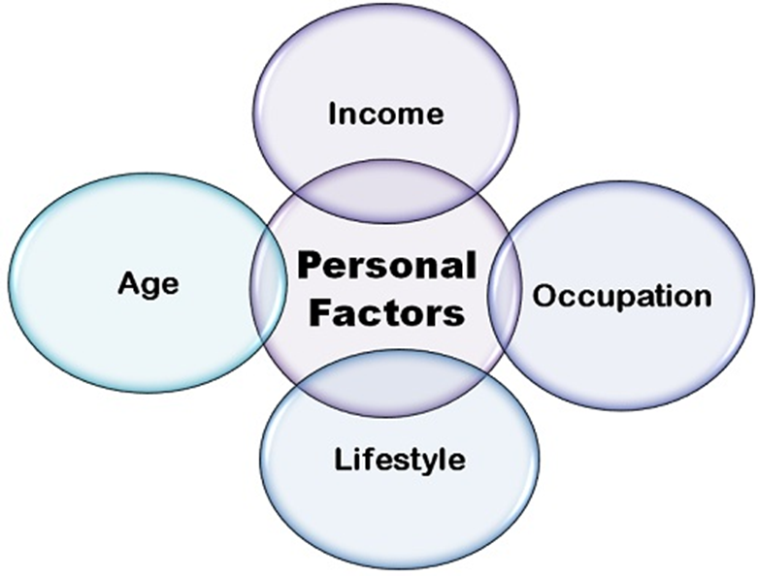

Personal factors include age, gender, educational qualification, income etc. of the consumer. The Personal Factors are the individual factors to the consumers that strongly influence their buying behaviours. These factors vary from person to person that result in a different set of perceptions, attitudes and behaviour towards certain goods and services. Followings are various personal factors that affect consumer behaviour.

**Age:**

Age decides the buying behaviour and needs and preferences of the customers. Such as children will definitely demand toys and chocolates whereas grownups will demand fashion products as well as clothing. Age affects the buying behaviour of the customers. Teenagers would be more interested in buying bright and loud colours as compared to a middle aged or elderly individual who would prefer decent and subtle designs. A bachelor would prefer spending lavishly on items like beer, bikes, music, clothes, parties, and clubs and so on. A young single would hardly be interested in buying a house, property, insurance policies, gold etc. An individual who has a family, on the other hand would be more interested in buying something which would benefit his family and make their future secure.

**Gender:**

Gender also affects buying behaviour of customers. The consumer buying behaviour varies from gender to gender. Male

**Income:**

The income of the person influences his buying patterns. The income decides the purchasing power of an individual and thus, the more the personal income, the more will be the expenditure on other items and vice-versa.

**Educational Qualification:**

Education level of the consumer also affects their buying behaviour. Highly educated customer will spend on books and luxuries whereas less educated people will spend more on basic necessities.

**PERSONALITY AND SELF-CONCEPT-**

Each person has a distinct personality that influences his or her buying behaviour. By personality, we mean a person’s distinguishing psychological characteristics that lead to relatively consistent and enduring responses to his or her environment. Personality can be a useful variable in analysing consumer behaviour, provided that personality type can be classified accurately and that strong correlations exist between certain personality types and product or brand choices.

**Life style**

Life style is person’s pattern or way of living as expressed in his activity, interests and opinions that portrays the “whole person” interacting with the environment. Marketing managers have to design different marketing strategies to suit the life styles of the consumers.

**C. Psychological factors**

A person’s buying choices are influenced by four major psychological factors – motivations, perception, learning, beliefs and attitudes.

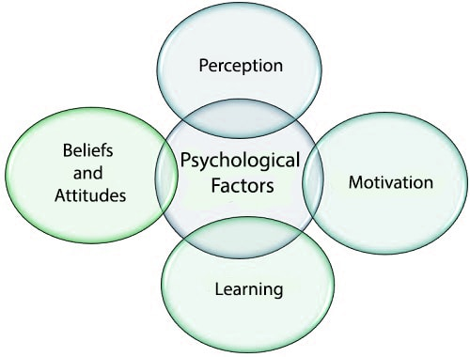

[**MOTIVATION**](https://www.mbaknol.com/management-concepts/motivation/)

A person has many needs at any given time. A need becomes motive when it is aroused to a sufficient level of intensity. Motivational researchers hold that each product is capable of arousing a unique set of motive in consumers.

**LEARNING-**

When people act they learn. Learning  involves changes in an individual’s behaviour arising from experience. Learning theory teaches marketers that they can build up demand for a product by associating it with strong drives, using motivating cues and providing positive reinforcement.

**PERCEPTION-**

Perception is the process by which an individual selects, organizes, & interprets information inputs to create a meaningful picture of the world. A motivated person is ready to act. How the motivated person actually acts is influenced by his or her perception of the situation.

**BELIEFS & ATTITUDES**

A belief is a descriptive thought that a person holds about something. Through doing & learning, people acquire beliefs & attitudes. These in turn influence their buying behaviour. Particularly important to global marketers is the fact that buyers often hold distinct disbelief’s about brands or products based on their country of origin. An attitude is person’s enduring favourable or unfavourable evaluations, emotional feelings, and action tendencies towards some object or idea. People have attitude toward almost everything: religion, politics, clothes, music, food, and so on. Attitude put them into a frame of mind of liking or disliking an object, moving toward or away from it.

**D. Situational Factors**

Situational influences are temporary conditions that affect how buyers behave. They include physical factors such as a store's buying locations, layout, music, lighting, and even smells. ... The consumer's social situation, time situation, the reason for their purchases, and their moods also affect their buying behaviour

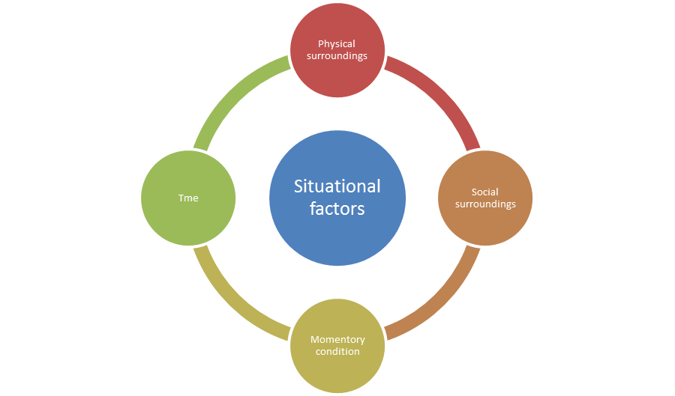

## Physical Surroundings:

This category of situational factors include marketer's geographical and institutional location, furnishings, sounds, lighting, aromas, weather, signs and observable contours as well as products, exhibits or other materials circumventing the stimulus thing (Pride, Hughes & Kapoor, 2008). Significant physical factors also include store design and layout that if considered by markers at the time of designing their facilities can benefit them in increasing consumers' purchase. It could also be understood with an example of a grocery store (Kotler, 2002). it can be said that physical factors is related to the management of the physical environment that involves all the nonhuman, physical facets of the market in which consumer behaviour takes place (Kotler, 2002).

## Social Surroundings:

Social surroundings related to a purchase involve features and fundamental interactions of other people who are present throughout a purchase decision or who may be there when the product is utilized or consumed coffee (Quester, Neal, Pettigrew, Grimmer, Davis & Hawkins, 2007). In addition to this social surroundings also include the shopping environment conditions. In other words, it can be said that social surroundings that influence consumers purchasing decisions are other persons, their compatibilities, roles, interactions and crowding. When a student is in collage he will not spend much amount on fast-food but when he is in a restaurant with his special friend or close friend he will definitely spend much more on his food or drink. In this way, consumers purchasing decisions are highly affected by their social situation or surroundings that if understood by marketers can assist them with effective selling strategies (Docrat, 2007). Social surroundings have significant influence on the consumers throughout their purchase and consumption process.

## Time:

The next substantial situational factor that influences consumer purchasing decision is time. Time affects consumers buying decision process in a number of ways like the amount of time necessitated to become well-informed about a product, to look for it, and to pay money for and make use of it

**Momentary conditions**

It includes the mood and condition of buyer at time of purchase for example if customer is in hurry he may spend less time in thinking and decision process and may buy goods immediately without having second thought. During evening time when people are in relax mood they tend to purchase more goods as compare to morning time when they are busy with their daily routines.

**E. Social factors**

Social factors play an essential role in influencing the buying decisions of consumers. Human beings are social animals. We need people around to talk to and discuss various issues to reach to better solutions and ideas. We all live in a society and it is really important for individuals to adhere to the laws and regulations of society.

Social Factors influencing consumer buying decision can be classified as under:

* Reference Groups
* Immediate Family Members
* Relatives
* Role in the Society
* Status in the society

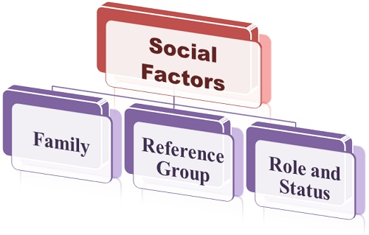

### Reference Groups

Every individual has some people around who influence him/her in any way. Reference groups comprise of people that individuals compare themselves with. Every individual knows some people in the society who become their idols in due course of time. Co-workers, family members, relatives, neighbours, friends, seniors at workplace often form reference groups.

Reference groups are generally of two types:

**Primary Group –**

It is consists of group of individuals, one interacts with on a regular basis.

Primary groups include:

* + - Friends
    - Family Members
    - Relatives
    - Co Workers

All the above influence the buying decisions of consumers due to following reasons:

They have used the product or brand earlier.

They know what the product is all about. They have complete knowledge about the features and specifications of the product.

Tim wanted to purchase a laptop for himself. He went to the nearby store and purchased a Dell Laptop. The reason why he purchased a Dell Laptop was because all his friends were using the same model and were quite satisfied with the product. We tend to pick up products our friends recommend.

A married individual would show strong inclination towards buying products which would benefit not only him but also his family members as compared to a bachelor. Family plays an important role in influencing the buying decisions of individuals.

A consumer who has a wife and child at home would buy for them rather than spending on himself. An individual entering into marriage would be more interested in buying a house, car, household items, and furniture and so on. When an individual gets married and starts a family, most of his buying decisions are taken by the entire family.

Every individual goes through the following stages and shows a different buying need in each stage:

**Bachelorhood:** Purchases Alcohol, Beer, Bike, Mobile Handsets (Spends Lavishly)

**Newly Married:** they are tend to purchase a new house, car, household furnishings. (Spends sensibly)

**Family with Children:** Purchases products to secure his as well as his family’s future.

**Empty nest (Children getting married)/Retirement/Old Age:** Medicines, Health Products, and Necessary Items.

A Ford Car in the neighbourhood would prompt three more families to buy the same model.

**Secondary Groups -** Secondary groups share indirect relationship with the consumer. These groups are more formal and individuals do not interact with them on a regular basis, Example - Religious Associations, Political Parties, and Clubs etc.

### Role in the Society

Each individual plays a dual role in the society depending on the group he belongs to. An individual working as Chief Executive Officer with a reputed firm is also someone’s husband and father at home. The buying tendency of individuals depends on the role he plays in the society.

### Social Status

An individual from an upper middle class would spend on luxurious items whereas an individual from middle to lower income group would buy items required for his/her survival.

**F. Cultural factors;** The **Cultural Factors** are the factors that an individual learns at a very early stage of life due to socialization within the family and other key institutions, such as the set of values, preferences, behaviour patterns, and perceptions are learned as the individual grows.it includes culture, subculture and social class.

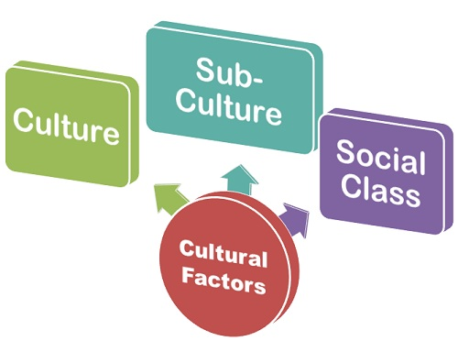

**Culture:**The culture refers to the beliefs, customs, rituals and practice that a particular group of people follows. As a child grows, he inculcates the buying and decision-making patterns through his family and the key institutions. The culture varies from region to region and even from country to country. Such as the sale of “sarees” and “Lungis” is more in South than the North India. Therefore, the marketer should carefully study all the different cultures and frame the marketing strategies accordingly. Cultural Factors are some of the strongest influences of consumer buyer behaviour.  Cultural Factors are the set of basic values, perceptions, wants and behaviours that are "learned" by a consumer from their families and other important social institutions.  "Culture" is the most basic source of a consumer's wants and behaviour.  It lives at the foundation of a consumer's world view.  Culture is mostly a learned behaviour, being constructed by the society a consumer grows up in. That society "teaches" the consumer basic values, perceptions, wants and behaviours.  What a consumer is "taught" can vary greatly in different parts of the world.    
Marketers need to remember that *every* group or society has a culture.  Cultural influences can and will vary greatly from country to country, social group to social group.  If you do not account for these values in your marketing plans, your campaigns could be ineffective, and at worst embarrassing.

**Subculture**:

The culture can be further divided into subculture wherein the people are classified more specifically on the basis of their shared customs and beliefs, including religions, geographic regions, nationalities, etc. The different sub-cultures forms several market segments whose needs can be carefully studied by the marketer and the strategic marketing decisions can be taken accordingly. Such as the needs of the people living in metro cities and the ones living in B-grade cities must be identified before the launch of the marketing campaign. Cultural Factors are some of the strongest influences of consumer buyer behaviour.  Cultural Factors are the set of basic values, perceptions, wants and behaviours that are "learned" by a consumer from their families and other important social institutions.  "Culture" is the most basic source of a consumer's wants and behaviour.  It lives at the foundation of a consumer's world view.  Culture is mostly a learned behaviour, being constructed by the society a consumer grows up in. That society "teaches" the consumer basic values, perceptions, wants andbehaviours.  
Marketers need to remember that *every* group or society has a culture.  Cultural influences can and will vary greatly from country to country, social group to social group.  If you do not account for these values in your marketing plans, your campaigns could be ineffective, and at worst embarrassing

**Social Class**:

The social class to which an individual belongs influences the buying decision. Generally, the people belonging to the same class are said to be sharing the similar interest, value and the behaviour. Our society is classified into three social classes’ upper class, middle class, and the lower class. The consumers belonging to these classes possess different buying behaviours. Such as an individual belonging to the upper class buy those products or services that advocate his status while the lower class people buy those products which satisfy their basic needs.

These are some of the cultural factors that influence the individual buying behaviour due to his membership in the group where different customs, practices, beliefs, and rituals are followed.

India is home to over 1.17 billion people who represent a broad spectrum of cultures, traditions and ideologies. Indians thus belong to different market segments based on characteristics such as demographics, social status and income levels. Traditionally, Indian consumers have a high degree of family orientation. As a result values like nurture and care have been preferred to ambition and achievement.

So brands with identities that support family values are more likely to be popular with Indian consumers. Many FMCG products have aimed at connecting with the cultural values of people. For instance, Cadbury India launched its Celebrations range as an expression of love and festivity for occasions like Diwali. Nestle s Nescafe Coffee emphasizes building relationships over coffee. We now look at popular models of consumer behaviour applied to the Indian context.

Traditionally, Indian consumers have a high degree of family orientation. As a result, values like nurturing and care have been preferred to ambition and achievement. So, brands with identities that support family values and exhibit strong emotions are more likely to be popular with Indian consumers.

1. Inputs, which stimulate the buying process. These include product-related factors (price, quality and distinctiveness), symbolic factors (images that stem from the mass media and sales people), and social factors (family, reference groups and social class influences).

2. Perceptual constructs, which explain the consumer’s cognitive activity in terms of information processing.

3. Learning constructs, which represent the results of information processing.

4. Outputs, which include not just the purchases but also the implications for perception and learning.

People today have become far more empowered due to the widespread availability of information. This is causing a transformation in consumer preferences, much of which is powered by the evolving middle class.

For instance, a vast majority of middle class women were housewives, so they preferred self-cooked meals that catered to the family’s taste. With time, more women have begun to work, thus increasing the demand for packaged food.

**India’s dramatic pace of urbanization is influencing lifestyle patterns and buying behaviour of consumers:**

1. Bulk purchases from supermarkets and hyper stores instead of frequent trips to the nearby shops this is due to convenience, hygiene and an attractive ambience associated with the former. Consumers today are also more experimental and ready to take risks.

2. A changing work culture leads to an increasing focus on ready to eat food instead of traditional cooking. ITC offers a range of such products under the ‘Kitchens of India’ label. Other packaged food products include Knorr and Maggi soups and MTR idli and upma mixes. Despite the presence of Indian brands, the ready to eat food segment is underdeveloped and has become the focus of foreign companies who are eyeing the growth opportunities presented by this market.

3. There is a growing influence of Western culture on Indians, who have become more modernized and willing to experiment. A number of foreign brands have been successful in the FMCG sector in India due to this Westernization. For instance, many Indian women use L’Oreal and Maybelline products.

4. Consumers today are also health conscious. They want to eat healthy and stay fit. Hence, a greater number of FMCG products position themselves as being healthy options. Maggi Atta Noodles, Sunfeast’s Sachin Fit Kit Multigrain Biscuits, and Tropicana fruit juices are a few products that address this need.

5. In India, celebrities, especially movie stars and cricketers, are frequently asked to endorse products and play a role in marketing communication. As the print and electronic media become all pervasive, the influence of celebrities has increased.

They are closely followed and even their most mundane activities create headlines. They are watched and imitated. Consequently roping in celebrities for advertising attracts a lot of consumer attention.

6. Consumers like advertisements more if they feature their favourite celebrity. What the star says has a positive impact on the consumer’s mind leading to positive vibes about the product. Also, these advertisements have a higher recall value amidst the advertisement clutter.

For example, Lux soaps created headlines when they aired the advertisement featuring Bollywood heartthrob Shah Rukh Khan along with four Bollywood beauties.

From the viewpoint of marketing strategy the mix of cultural, social, personal and psychological factors which influence behaviour are largely non-controllable. Because of the influence they exert on patterns of buying, it is essential that we understand how they interact and influence purchase behaviour. In doing this, we should not lose sight of the differences that exist between customers and consumers, and the implications of these differences for strategy.

**Social Media and Marketing**

Social Media Marketing is an umbrella term that can be described as the utilization of social media platforms as marketing tools. According to Weinberg (2009), he refers social media marketing as leveraging the ‘social’ through the ‘media’ to ‘market’ businesses’ constituents; in other words, it is a process in empowering individuals to promote their websites, products, and/or services through online social channels, to interact with and to tap into a much larger community that may not have been available via traditional advertising channels. It is no longer a striking fact that most of the advertisements via mass media are not as efficient as in the past, because by advertising through the mass, the message is generally reaching far more people than the potential customer intended to reach (Weber 2009; Weinberg 2009) Social web is where people with a common interest can gather to share thoughts, comments, and ideas; hence, instead of continuing as broadcasters, marketers should become aggregators of customer communities; that is, the Web should not be considered as a mere advertising channel, it is a place where marketers can listen and respond to communities, review contents, as well as promote a particular piece of content within the vast social sphere (community building)(Weber2009).

What makes social media marketing special? Upon the insufficient advertising budget that companies oftentimes encounter via the traditional channels, social media marketing might be, particularly, easier and more effective for small and medium size companies to take maximum advantage of it. While social media marketing is an evolving technology with much potential, yet marketing’s role still reminds the same–defining the target market, communicating with prospects, building loyalty, and customer engagement and so on. (Weber 2009)

**Social Media:**

The New Mind-set In order to gain a better position in the transition from traditional marketing approach to social media marketing, marketers will have to, firstly, change their

marketing mind-set. Social media platforms has radically changed the approach of segmentation in implanting marketing strategy, instead of easily identified demographics, such as age, gender, or income are relatively less important, it groups people by what they do, think, like, and dislike, and more importantly by their behaviours, also known as behavioural targeting. (Weber 2009.)

Many marketing experts (Drury 2008; Mayfield 2008; Weber 2009; Weinberg 2009) have always emphasized that since marketing via social media is rather about receiving and exchanging perceptions and ideas, which makes social media marketing no longer one dimensional but a two-way process engaging a brand and an audience (Drury 2008) as well as a creation of increasingly visualize contents (Weber 2009). Oftentimes, content is a critical factor in achieving an effective marketing via social media; however, according to Curata’s “B2B Marketing Trends Survey 2012 Report” (Marketing Profs 2012), companies seem to encounter challenges in creating original content, having time to create it, and finding high-quality content (see Jacobs 2013).

In the foregoing chapter about the course of information search and evaluation in decision making process, it has been discussed that individuals are likely to seek information that is consistent to their initial thought, and keenly avoid those that encounters with it; as a result, social media in today’s marketing provides linkages to connect individuals who share similar interests and backgrounds, in which, to consumers, these communities serve as an vital "tuning" mechanism in the selection of needed information among the overwhelming information understanding of media content, explain and diffuse the content to others Listeners, in turns, subsequently feed back to the opinion leaders. (Smith and Zook 2011.)

**SOCIAL MEDIA AND CONSUMER**

Social media as a mean of giving consumers a voice Having explained the possible components involved in the consumer decision process, the nature and the essence of social media, as well as having a brief discussion of the prominent features in different social media outlets, the researcher believes that social media is an essential touch point in today’s

Consumer decision process, from stage one of need identification to the stage of post purchase; likewise, companies are engaging with the purpose of creating brand awareness, engaging their existing customers, driving traffic to other marketing properties and growing channel number. The following section discusses on how consumers are affected by social media, and identify which would be the considerate phase of the purchase process that marketers should tap into. Regarding the information processing theory of consumer choice, it is mentioned that there are vast amount of advertisements competing with each other in order to grasp individuals’ attention and the fact that human beings have an obvious limited brain capacity in processing information; therefore, it is a challenge for each discrete message to get heard above the din (extraneous factors that distract or distort the message), even if marketers have the right message. Each of the social media platforms plays a role in giving out, receiving, and exchanging information without any boundary limitations, and as mentioned previously that social media enables two-way flow of information. Since the flow of communication does not merely impact how companies can access their targeted groups, but also it influences throughout the entire decision process, from interpreting the message, searching for available alternatives, as well as actions carried out in the after the purchase; thus, It is important to denote that message rejection, misinterpretation, and misunderstanding are the possible pitfalls in the flow of communication. In relating to social media marketing, the biggest fear of companies and brands is to give up the control over the content, and the frequency of information; however, it is essential for marketers to realize that reviews and discussions, as user-generated contents, serve to demonstrate a company’s transparency.

When Zagat and Amazon started inviting individuals (such as consumers and users) to give their opinions, there was no stopping the trend that is, the communication in present-day has drastically altered into a medium that is composed of millions of people who can actually contribute or detract from a marketing message. Consequently, comparing to offline traditional marketing channels (such as television, newspaper, magazines, and so on), word-of-mouth solely relies on social media outlets in this digital age, due to the fact that websites allow users to create their own virtual spaces in which fosters and ignite the word-of-mouth. Conversation in traditional media is one-way: the company spoke, an audience listened. Mass messages are filtered through opinion leaders to the mass audience, in which opinion leader is very hard to be identified since they are not formal experts and do not necessarily provide advice but have a certain degree of influence on consumers. In the notion of communication models theories, the findings have provided that opinion leaders are those initially exposed to certain media content who interpret the message based on their own opinion, and are more active than others both in seeking information and in conveying it to others. According to Lazarsfeld and Katz’s hypothesis (1955) , the information is channelled to the masses through opinion leaders, who have a more literate During the phase of mass communications, marketing guru Philip Kotler says, ‘Bad news travel faster than good news’ (see Smith and Zook 2011), therefore, it is not hard to picture the speed of bad news travel in present-day is in a formidable fast speed, as social media offers everyone an opportunity to their own message delivery systems, in which enables individuals to share and link stories to one another. If the negative press is highly visible, consumers may likely to look to a competing brand that is not facing a bad press while marking the purchase decision. As a result, social media platforms have added more dimensions to the communication, rather than having most of the messages flowing from the organization. As a matter of fact, the proliferation of social media is a double-edge sword. While social media has empowered the consumers due to they have access to information which previously was not available for them, has accelerated information flow, as well as has allowed discussions happened globally, yet social media has also offered marketers with the tools to better target their consumers more efficiently, to cultivate relationship a mong groups of consumers, as well as to exploit new opportunities. Indeed, the accessibility and availability to information has resulted changes in individuals’ attitudes changes, which eventually leads to new needs and buying behaviour; it will be further discussed. The Influences on Decision Making Process As the business world re-centres around serving and delighting customers, CMOs are confident that social media impacts sales, brand awareness, and loyalty as a result; social media data impacts their decisions while making predictions or forecasts. According to social media marketing industry report, the social media realm is not a mere fads in which marketers are increasingly attracted and 83% of them place high value high value on social media of their businesses.

Social media, as a new component, has further complicated the time-honoured buying behaviour process theory wherein the buying attitudes are not impacted merely by the traditional channels but extend to the online platforms. Preferences and decision marking are prompted depend upon the inputs provided by parties beyond the control of online marketers, such as peer reviews, referrals, blogs, social networks, and other forms of user-generated content.

Since the contents on social media are rather democratic and neutral, according to Vollmer and Precourt (2008), consumers are turning more frequently to various types of social media to conduct their information searches and to make their purchasing decisions

Reviews and user-generated contents such as rate movies, books, music, and other things on social media are involved a high degree of personal taste and subjectivity to users , in which these reviews have one overriding attribute that gives their influence on consumers’ purchasing decision–trust. “More than a quarter of social media users say they are more likely to pay attention to an ad shared by one of their social connections,” Bannon noted. “Additionally, more than a quarter of consumers are OK with seeing ads on social networking sites tailored to them based on their profile information ” (Miller 2012);that is, individuals tend to trust these contents so as to filter, and objectively evaluate the mound of information(Silverman 2001).

Google (2012) conducted a research in U.K, U.S, France, Germany, Japan, Canada, and Brazil associating with the customer journey to online purchase, the research has shown different marketing channels influence the customer at different points in the path to purchase. In all the targeted countries, social media serves as an assisting channel in which to build awareness, consideration, and intent earlier in the purchase funnel. Sliverman (2009) has also stated that there are many brands competing for attention, therefore an interesting blog post or a compelling video on YouTube can be the stage quo in which a prospect pays attentions and gains awareness of a product or a service. During the stages of consumer decision process, social media is applicable as both a prompt (awareness) and as a validation (support the purchase decision takes place). (Evans 2008.) As indicated previously, one of the most valuable aspects of social media is in building and maintaining a feedback loop, as the conversations are more dynamic and flow in two-way. The difference that social media has impacted on the purchase funnel is the accessibility and transparency of experiential data generated by current customers for the benefit of the next wave of shoppers and prospects. Although there is an obvious decline in the usage of traditional channels both from marketing and consumer perspectives, traditional media still takes a part of the picture in terms of triggering awareness. Furthermore, Evans (2008) has explicated the importance to denote the role of the social feedback cycle as a purchase validation tool (Figure 10); that is consumer may find out a particular product or service or either television, radio, or magazine, and then consumer can verify it on Internet. As it is depicted in figure 10, social media extends the purchase funnel with the addition of post-purchase word of mouth and user-

**Data Analysis**

**Q,1 Do you use social Media**

**Yes No**

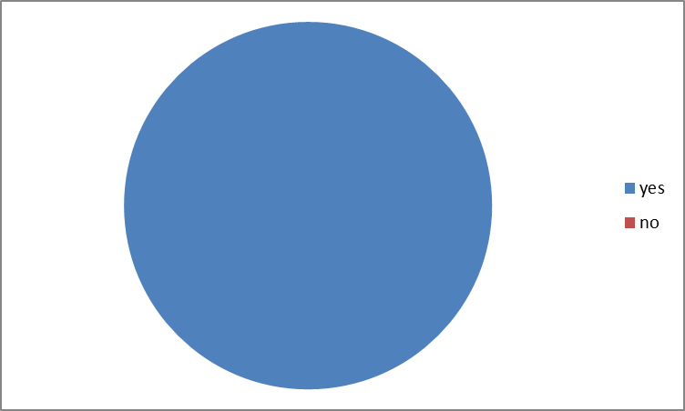

Out of 233 responses 100 per cent respondents say they are using social media, so it is concluded that most of youth in Mumbai region used social media either on their mobile phones or computers. So social media is very much popular among young generation in Mumbai region and almost everyone used it for various purposes such as making friends, chatting, for information and for shopping etc.

**Q.2. You use social Media for:**

**Shopping chatting information make friends**

|  |  |  |  |  |
| --- | --- | --- | --- | --- |
| shopping | Chatting | Information | Make friends | |
| 127 | 233 | 210 | 200 |  |

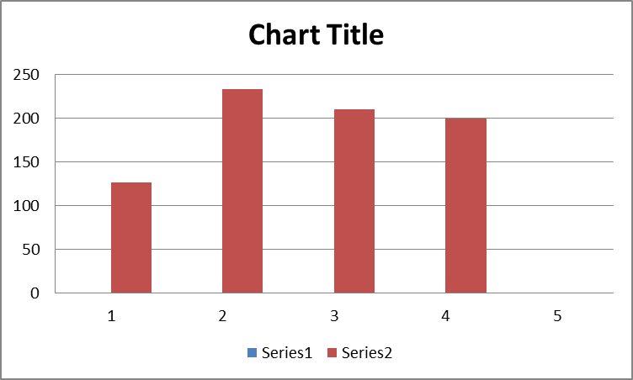

Out of 233 respondents 127 youths are using social media for shopping as well as for other purpose such as most of the people are using social media for chatting purpose i.e. 100% youth are using it for chatting purpose as well as for other purpose more than 90% youth are using it for information and other purposes and more than 85% are using it for making friends as well as for other three purpose.

**Q.3. Type of social media you use :**

**Facebook Instagram Whatsapp Snapchat**

**Other specify_________________.**

|  |  |  |  |
| --- | --- | --- | --- |
| facebook | instagram | whatsapp | snapchat |
| 233 | 200 | 233 | 150 |

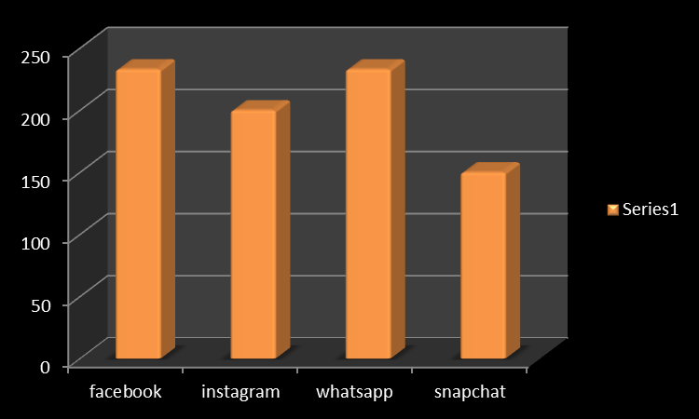

Most of the youth in Mumbai are using facebook and whatsapp as a social media for socialising; these two media are most popular among youth in Mumbai region. Even respondents also use Instagram and Snapchat for socialising. But whatsapp and facebook are the widely used social media among Mumbai youth.

**Q.4. Do you pay attention to advertisement on social Media websites?**

**Yes No**

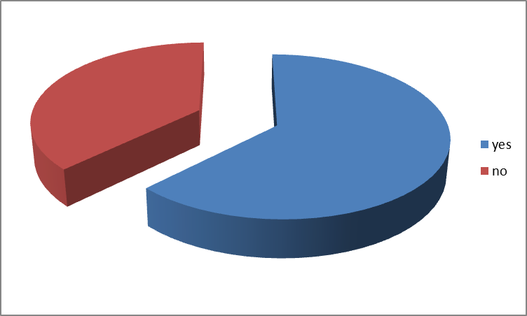

Out of 233 responses 146 respondents are paying attention to advertisement on social media whereas 87 respondents are not paying attention to advertisement on social media. Therefore it can be concluded that still advertisement on social media are not very attractive and failed to attract the attention of audience. It attracts only 62 percentages whereas more than 38 percentage of audience do not pay attention to advertisement on social media websites. So it can be concluded that still social media is not powerful media of advertising though some extent it influence the buying decision of the consumer.

**Q.5. Do you trust Social Media?**

**Yes No**

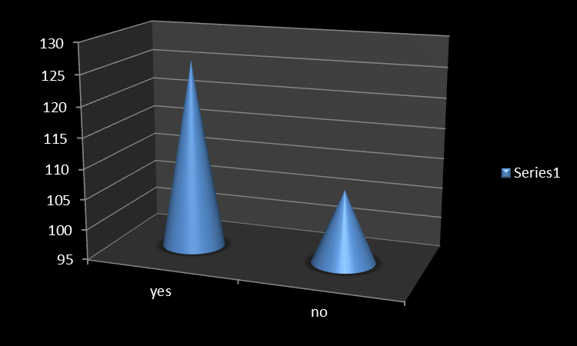

Out of 233 responses 126 respondents are having trust on social media advertising, whereas 107 respondents do not having trust on social media promotion, as they believe social media platform is only meant for socialising and not for commercial purpose.

**Q.6.Social Media influence your buying decisions:**

**Strongly agree Agree Neither Agree nor Disagree**

**Disagree Strongly Disagree**

|  |  |  |  |  |
| --- | --- | --- | --- | --- |
| **Strongly Agree** | **Agree** | **Neutral** | **Disagree** | **Strongly Disagree** |
| 11 | 111 | 97 | 11 | 3 |

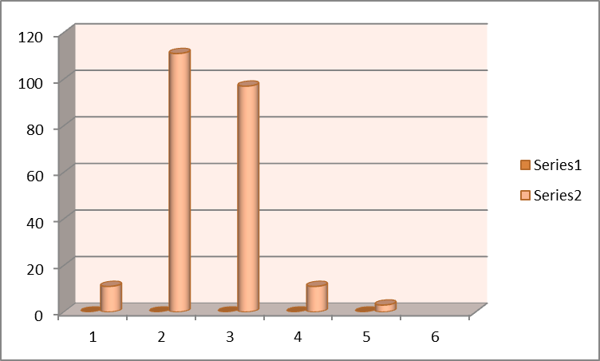

From above diagram it is clear that out of 233 responses 11 plus 111 that is 122 respondents are agree that social media influence their buying decisions, 97 respondents are neither agree or disagree with the statement that is they are neutral, and 11 plus 3 that is only 14 respondents out of 233 feels that social media does not influence their buying behaviour. From this we can conclude that social media does affect and influence the buying behaviour of customer

**Q.7.What is your preferred source of information for your buying decision**

**Company’s website Social Media Friends & Relatives**

**Advertisements**

|  |  |  |  |
| --- | --- | --- | --- |
| **Company’s website** | **Social Media** | **Friends & Relatives** | **Advertisements** |
| 38 | 93 | 74 | 28 |

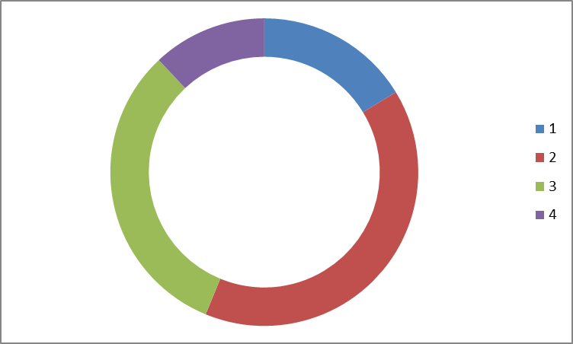

Out of 233 respondents 93 respondents preferred social media as a source of information for their buying decision, 38 respondents prefer company’s website, 28 prefer advertisement and 74 respondents relied on their friends and relatives for information, therefore it can be conclude that nearly 40% of respondents preferred social media whereas 32% respondents preferred friends and relatives for information, so social media play crucial role in providing information to customer before buying decision

**Q.1.How many products have you purchased currently influenced by advertisement on social media?**

**1 to 5 5 to 10 More than 10 Almost everything**

|  |  |  |  |  |
| --- | --- | --- | --- | --- |
| **1 to 5** | **5 to 10** | **More than 10** | **Almost everything** | **nothing** |
| 171 | **29** | 21 | 6 | 6 |

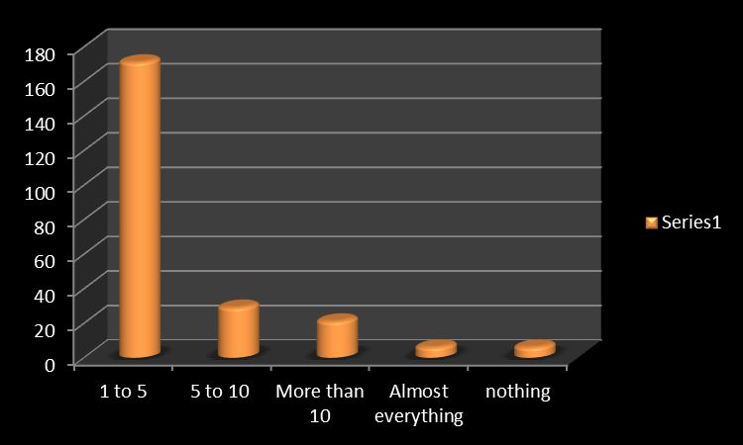

Out of 233 responses 171 respondents purchase 1 to 5 products recently, 9 respondents purchase 5 to 10 products, and 6 respondents purchase almost everything and remaining 6 respondents purchase nothing, so it can be concluded that almost 97% of respondents purchased currently influenced by advertisement on social media, social media influences the buying behaviour of customer.

**Q.9. Do you feel social media helps in your buying decision?**

Most of the responses for the above mention question is that while purchasing durable, shopping, luxuries and electronic products social media helps them to find out various facts and details of the product and it help them in taking their right buying decision.

**Q.10. According to you what is the role of social media in promoting products?**

And for question no 10 most of the respondents feels that social media plays an important role in creating interest related to the products in their minds, promoting product on social media helps the product to reach maximum number of customers as most of them use social media. Respondents feel that it create awareness about products. It also influence and create demand for the products. People think that social media gives marketers a voice and a way to communicate with peers, customers and potential customers. It personalise the brand and help them to spread their message quickly. Many feel that it advise them to purchase the right product through awareness and feedback system. It makes message more authentic and believable as most of the people believe social media more as compare to mass media.

**CONCLUSION**

The motive of the research was triggered by personal interest in how consumer behaviour has changed in the Digital Age, in particular with social media. The amount of information available to us increases in each and every day; as a result, we are overwhelmingly exposed and attained to different aspects of information via the Social Media available to us in Internet. The accessibility and transparency that social media offers has led changes in how consumers position themselves in today’s market, in which it is inevitable and necessary for companies to equip with a new marketing mind-set. The central gravity of the research was to explain why, when, and how social media has impacted on consumer decision making process both in theory and in practice. There is a generous amount of reports relating to social media marketing which are primarily aimed to help businesses benefit from this marketing trend. Oftentimes, businesses assume that they are on the right track in the new marketing era, for instance engaging customers by creating a Facebook page; in fact, customers may not share the same picture as businesses may have. Therefore, the research was carried out in the perception of consumers (in Mumbai), which was aimed to explain the impacts of social media on different stages in their decision making process, by finding out how consumers perceive social media in the entire process. Additionally, the research, perhaps, could help company to gain new insights from this perspective and to identify potential pitfalls and opportunities via social media, for instance to develop appropriate ways to tab into the decision making process at the right time or to have a better understanding of why their social media marketing campaigns may not be executing as they would have anticipated essentially, the theoretical framework of this research was built upon consumer buying model and the changes social media has predominately brought to marketing. The five stages in the buying model served as a basis of the logical order of how the survey was carried out and the theories in social media provided guidelines on which set of questions would grasp the research questions. The following chapter presents the conclusions drawn from the research findings. Nonetheless, further discussions and limitations are outline and deliberated. The objective of the research was to explain why, when, and how social media has impacted on consumer decision making process. Research questions were designed to narrow down the subject and to help the researcher to identify the explanations of the issue. The three research questions for this thesis were as follow:

1. How do consumers attend, process, and select the information before a purchase?

2. What are the differences between marketing on social media and through mass media?

3. What are the changes social media has brought to consumers in different stages of their decision making?

To begin with, social media has brought profound changes to both consumers and businesses. In terms of the first research question, the five-stage decision making model has provided a systematic approach in outlining the general stages that consumers engage in all purchase, while the information process theory addresses an in-depth perspective of how information is in used of throughout the course of decision making. The data analysis of the research have both proven that, no matter it is in association with social media or mass media, consumers are highly selective in attending, process, and selecting the information before a purchase takes place. Information exposure is highly selective in the initial stage of information, because consumers have the selections of information source, in which determinates the type of information that consumer will be exposed to. To be noted, personal attitude is a crucial factor which underlines during the course of information acquisition and evaluation. As a result, not only judgments regarding products or services are presumably based, but also it is a vital determinant of the information consumers will seek out, in which it eventually affects the extent of the information reception. At the essence, all platforms available on social media have offered a two-way communication flow, which is help consumer to find out various facts about product and company and helps them in buying decision process. Consequently, this principle feature of social media has created a new landscape in supporting the socialization of information, and has forced marketers to give up what they old mind-set in dealing with mass media marketing. As the collected feedbacks from the individuals, it has emphasized that, in particular with social media, consumers are able to access to customer experiences and word of mouth. In other words, marketing via social media is more about creating high-quality contents that are consumer relevant. Moreover, marketing through social media focuses on building relationships between consumers and companies. The research findings have shown that the position of the consumer in the new marketing approach is the centralized gravity, because consumers are empowered. As many respondents have reflected that social media has provided a more effective platforms to communicate with one another and with the company. Finally the core objective of the entire research was to find out the changes that social media has brought to consumers in each stage of their decision making process. According to the finding, social media still cannot be considered as a powerful tool to trigger a purchase in Mumbai, whereas individuals have reflected that mass media still remains a certain influence in gaining awareness, for instance discounts available in stores, or a good deal. Social media has considered as a powerful tool in getting relevant information, while mass media creates awareness of certain discounts or promotions. In theory, information exposure through mass media is considered as a passive process as individuals are exposed and receiving information unconsciously. However, when consumers seek out information initiatively, it is perceived as an active process. In the research findings, consumers play an active role in the course of information acquisition because of the accessibility and availability of information on social media platforms. The accessibility and transparency of information that social media has offered to consumers have been indicated throughout the entire research. Consumers are able to access to relevant information not only in a great range but also in a faster speed. In contrary, contents are not in control and monitored, thus the chance of getting false and nonfactual information which the consumers have shown concern of. In terms of a business context, marketers have to be aware of the bad mouth on social media, because it can be spread virally and led to damage to company’s reputation. The research finding has revealed the current situation concerning consumers’ post purchase behaviour in Mumbai. Many individuals have noticed and agreed that with social media, they are able to voice out their opinions and to communicate with other consumers and with the company more effectively. However, again, many of them have felt not encouraged to voice out their feedbacks and to pass along their comments to peers, friends, or family members via social media. In responding to the purchase validation tool, the reason why social media has added value to today’s marketing is by bridging up the post-purchase word of mouth with the consideration stage of the consumer decision process, which has extended purchase funnel. Specifically, due to the word of mouth and user-generated contents on social media, the ”talks” are able to generate an experiential data for prospects; however, the findings have shown that the word of mouth would be insufficient for the influence because of unwillingness to share the information via social media. In the perspective of marketers, this pitfall may serve as a bottleneck in association with marketing via social media; thus, marketers should identify the reason of these particular negative feelings among consumers and initiate consumers to participate in the conversations. Social media has altered the communication model which it used to be in mass media instead of having companies deliver messages to the public all times, social media has fostered a web communications between customers and opinion leaders in which spins around the brand; consequently, this particular new communication flow has built interactivity and communities among all users, which the effects of it has penetrated in every stage of the decision making process. This influence has been reflected from the collected opinions. To conclude, from the findings of this research, it can be observed that consumers in Mumbai are actively utilizing social media platforms as a tool in-validating of the purchase decisions; however, consumers are deemed to be inactive in sharing their word of mouth to others with the available social media platforms. The consistency in the gathered data and time-honoured theories relating to consumer behaviour and contemporary frameworks regarding social media marketing, it has suggested that the essence of consumer behaviour still remains the same even after the advent of social media, in which individuals have to go through the all the stages before a purchase, instead of straight to the purchase decision once a thought of purchase being triggered. Future Research considering the limited time and scope of this research, many theories related to the subject were covered but in a rather general perspective so as to provide a big picture for the readers. Therefore, if further research could be conducted, then an in-depth survey should be carried out in tackling the research objective.

It would be undoubtedly useful and interesting to have a case company as a reference of the research. By studying the case company, it may offer a comparison between what company thinks it is working out, and what does their consumer actually perceive. Would the result reflect a diverse perception from two different parties in regards of social media and decision making process? The results could help company to gain an evident insight and to identify actual tactics to tackle the situation. Since research has revealed that consumers do not feel encouraged to generate the word of mouth through social media, and this indications may imply that marketers would have to carry out certain actions in order to provoke these conversations. Therefore, a future research can be conducted based on this perspective in investigating the reasons associating with this particular feeling and how it could be altered in order to utilize social media as an effective purchase validation tool. Nonetheless, if further research could be conducted for companies, then theories could be implied more accurately, because some of the theories are proposed and developed in aiming to help companies to gain a better position in the transition from the traditional marketing approach to the new marketing mind-set.

**Limitation**

Despite the fact that theories were approved by findings from survey and the research is able to provide a certain degree of new insights in relating to the current situation, limitations may still exist. In the foregoing chapter the above findings cannot represent all individuals across Mumbai as a whole; due to the decision making process involves psychological factors which may result in different behavioural actions. And due to constraint of time it is not possible to cover entire population and finding may differ from time to time and circumstances which may change in future.

**Appendix 1.**

**A survey on the Impact of Social Media on Buying behaviour of consumer with special reference to Mumbai Youth**

**Name: ___________________________________________________________________________**

**Age: _____________Gender:___________ Qualification:___________________________________**

**Address:___________________________________________________________________________**

1. **Do you use social Media**

**Yes No**

1. **You use social Media for:**

**Shopping chatting information make friends**

1. **Type of social media you use :**

**Facebook Instagram Whatsapp Snapchat**

**Other specify_________________.**

1. **Do you pay attention to advertisement on social Media websites?**

**Yes No**

1. **Do you trust Social Media?**

**Yes No**

1. **Social Media influence your buying decisions:**

**Strongly agree Agree Neither Agree nor Disagree**

**Disagree Strongly Disagree**

1. **What is your preferred source of information for your buying decision**

**Company’s website Social Media Friends & Relatives**

**Advertisements**

1. **How many products have you purchased currently influenced by advertisement on social media .**

**1 to 5 5 to 10 More than 10 Almost everything**

1. **Do you feel social media helps in your buying decision? Comments__________________**

**_____________________________________________________________________________**

**_____________________________________________________________________________**

**10.According to you what is the role of social media in promoting Products? Comments_____**

**______________________________________________________________________________**

**______________________________________________________________________________**

**Signature**

**Bibliography**

1. S.Ramesh Kumar, Consumer behaviour and branding concepts, reading and cases-Pearson Power publication 2009 first edition ISBN 978-81-317-2236-7
2. Anil Kumar and Dinesh Chawla, Consumer Behaviour by KBD Publication New Delhi edition 2010, ISBN 978-81-908967-6-4
3. Consumer Behaviour by ICFAI University Hydrabad edition May 2005.
4. Satish K Batra & S H H Kazmi, Consumer Behaviour Text and Cases published by Excel Books New Delhi, first edition, ISBN 814-7446-361-5.
5. Kotler, Philip. Armstrong, Gary. Wong, Veronica and Saunders, John. Principles of Marketing 2008, , Fifth European Edition, Pearson Education Limited.
6. M. C. Cant, J. W. Strydom, C. J. Jooste and P. J. du Plessis 2009 Marketing Management, Fifth Edition. Juta and Company Ltd.
7. Charles W. Lamb, Joseph F. Hair, Jr., Carl D. MacDaniel, Marketing, 2008 Tenth edition, Cengage Learning.
8. Charles W. Lamb, Joseph F. Hair, Jr., Carl D. McDaniel Essentials of Marketing 2010 seventh edition, Cengage Learning.
9. The article is Written By “Prachi Juneja” on factors affecting consumer behaviour in management study guide.com
10. Bargh, JohnA.; Pietromonaco, Paula.1982. Automatic information processing and social perception: The influence of trait information presented outside of conscious awareness on impression formation.Journal of Personality and Social Psychology
11. Bettman, J. R. 1979. An Information Processing Theory of Consumer Choice. USA and Canada: Addison-Wesley Publishing Company, Inc..
12. Boyd, D. M, Ellison, N. B. (2007). Social network sites: Definition, history, and scholarship. Journal of Computer-Mediated Communication, 13(1), article
13. Constantinides, Efthymios and Fountain, Stefan J. 2008. Web 2.0: Conceptual foundation and marketing issues. Journal of Direct, Data and Digital Marketing Practice, 9 (3). 231-244. USA: Pal grave Macmillan.
14. Dann, S. & Dann. S. 2011. E-Marketing: Theory and Application. London, U.K: Palgrave Macmillan.
15. Drury, G.n. 2008. Social Media: Should marketers engage and how can it be done effectively”.Journal of Direct, Data and Digital Marketing Practice 9 (3): 274-277. USA: Palgrave Macmillan.
16. Evans, D. 2008. Social Media Marketing: An Hour a Day. N.J, USA: John Wiley and Sons.
17. Fazio, R. H., & Zanna, M. P. 1981. Direct experience and attitude-behaviour consistency. In L. Berkowitz (Ed.), Advances in experimental social psychology (Vol. 14, pp. 161-202). New York: Academic Press.
18. Fennin, B. M., & Stroebe. 2010. The Psychology of Advertising. Philippines: Psychology Press.
19. Foxall, G.; Goldsmith, R. E. & Brown, S. 1998. Consumer Psychology for Marketing. Second Edition. London; Boston: International Thomson Business Press.
20. Ghauri, P. & Gronhaug, K. 2002. Research Methods in Business Studies, a Practical Guide. Harlow: Financial Times. Prentice Hall.
21. Kaheman, D. 1973. Attention and Effort. Englewood Cliffs, N.J: Prentice Hall, Inc.
22. Kaplan, Andeas M. and Haenlein, Michael 2010. Users of the World, Unite! The Challenges and Opportunities of Social Media. Business Horizons 53,59-68.
23. Ethel Lee Katz, E. & Lazarsfeld, P.F. 2009. Personal Influence, the Part Played by People in the Flow of Mass Communications. Second Edition. N.J, USA: Transaction Publishers.
24. Kotler, P., & Keller, K. L. 2009. Marketing management. Upper Saddle River, N.J: Pearson Prentice Hall.
25. Mangold, W. G. and Faulds, David.J. 2009. Social media: the new hybrid element of the promotion mix. Business Horizons, 52 (4). 357-365.
26. Reichheld, F.F. &Schefter, P. 2000. Loyalty: Your Secret Weapon on the Web. USA: Harvard Business Review.
27. Ratneshwar, S.; Mick, D.G & Reitinger, G. 1990. Selective Attention in Consumer Information
28. Processing: the Role of Chronically Accessible Attributes. Advances in Consumer Research 17, 547-553. Provo, UT : Association for Consumer Research.
29. Safko, L. & Brake, D. K. 2009. The Social Media Bible. Tactics, Tools and Strategies for Business Success. N.J, USA: John Wiley and Sons.
30. Saunders, M., Lewis, P. & Thornhill, A. 2009. Research Methods for Business Students. Fifth Edition. England: Pearson Education Limited.
31. Shapiro, C. & Varian, H. R. 1998. Information Rules; A Strategic Guide to the Network Economy. USA: Harvard Business Review Press. Silverman, G. 2001.
32. The Secrets of Word-of-Mouth Marketing. USA: AMACOM.
33. Smith, PR & Zook, Z. 2011. Marketing Communications: Integrating Offline and Online with Social Media. Fifth Edition. London, U.K: Kogan Page Ltd.
34. Smith, PR. 1993. Marketing Communications: An Integrated Approach. London: Kogan Page Ltd.
35. Weinberg, T. 2009. The New Community Rules: Marketing on the Social Web. Sebastopol, CA: O’Reilly Media Inc.
36. Wuyts, S.; Dekimpe, M. G.; Gijsbrechts, E. & Pieters, R. 2010. The Connected Customers. New York: Taylor & Francis Group.
37. Zarrella, D. 2010. The Social Media Marketing Book.Sebastopol, CA: O’Reilly Media Inc.
38. Zynman, S. 1999. The End of Marketing As We Know It. New York: Harper Business.
39. <https://www.mbaknol.com/marketing-management/consumer-behaviour-and-factors-influencing-buyer-behavior/>
40. [https://www.ukessays.com/essays/marketing/situational-influences-affecting-consumer-purchasing-decision-marketing-essay.](https://www.ukessays.com/essays/marketing/situational-influences-affecting-consumer-purchasing-decision-marketing-essay.php?vref=1)
41. https://www.managementstudyguide.com/social-factors-affecting-consumer-behaviour.htm
42. <http://marketmedialife.blogspot.com/2012/09/marketing-101-cultural-factors.html>