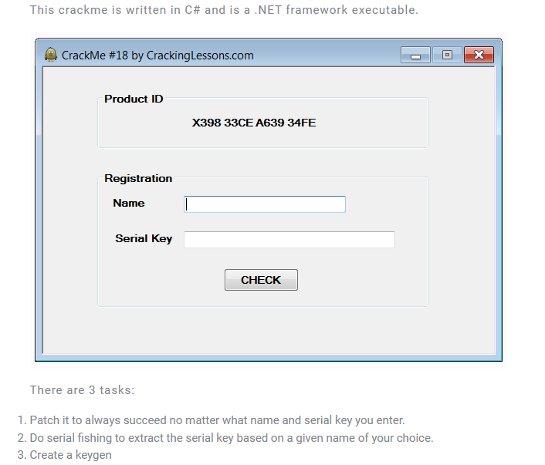

Task1

Decompile crackme using dnSpy

We see the following code

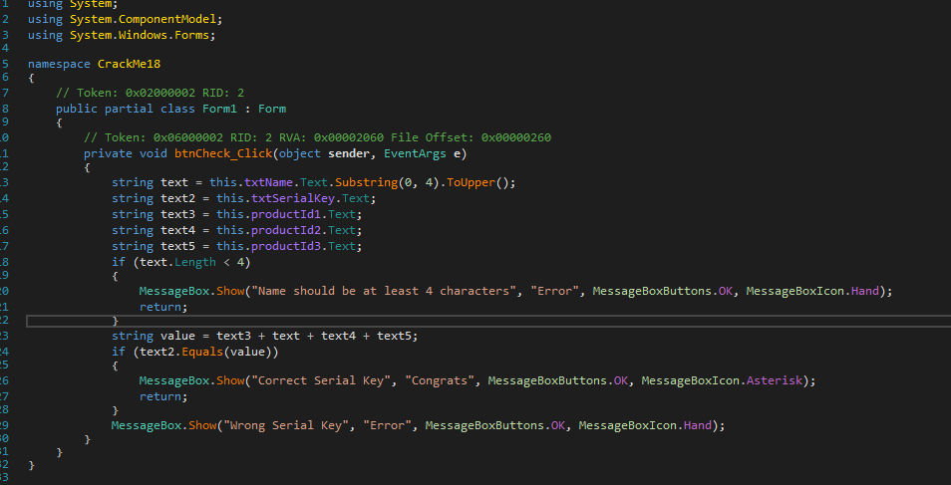

To auto Register program we can modify the btnCheck_Click() function as follow:

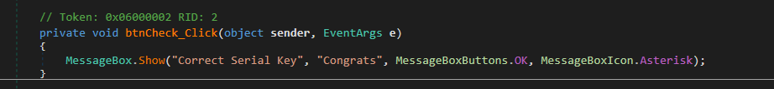

Save it, and Test

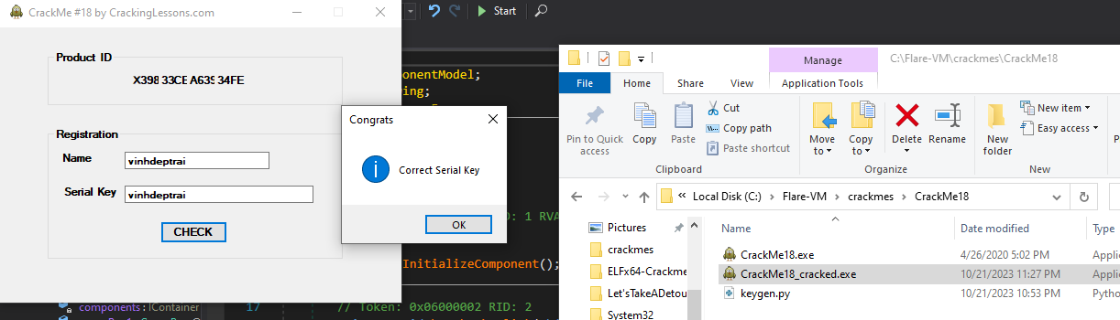

Task 2 and 3

Because this crackme is written in C# so we use dnSpy to decompile this crackme

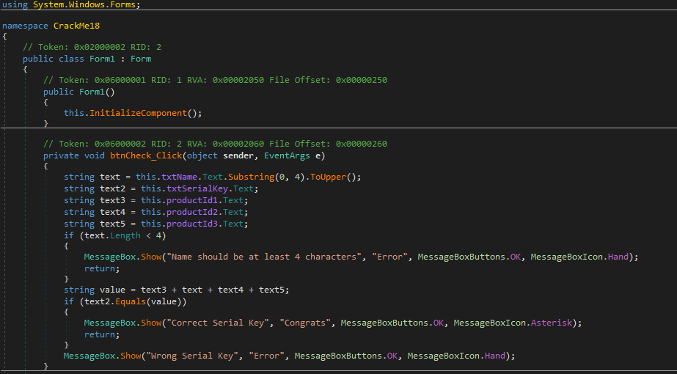

Follow the code

This crackme check length of name, if it less than 4, it show a nag “Name should be at least 4 characters”

Then, text2 which is our SerialKey must be equal to value which is first 4 character in uppercase concat with 3 productId which are: in order ID1 + name[:4] + ID2 + ID3

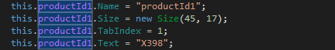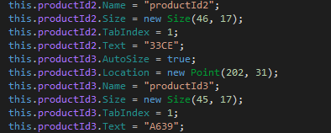

**So Serial Key = “X398” + name[:4].upper() + “33CE” + “A639”**

So the keygen for this is

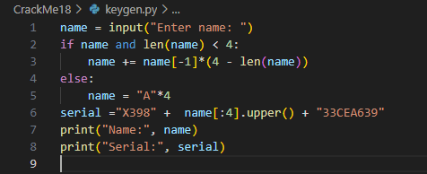

Check