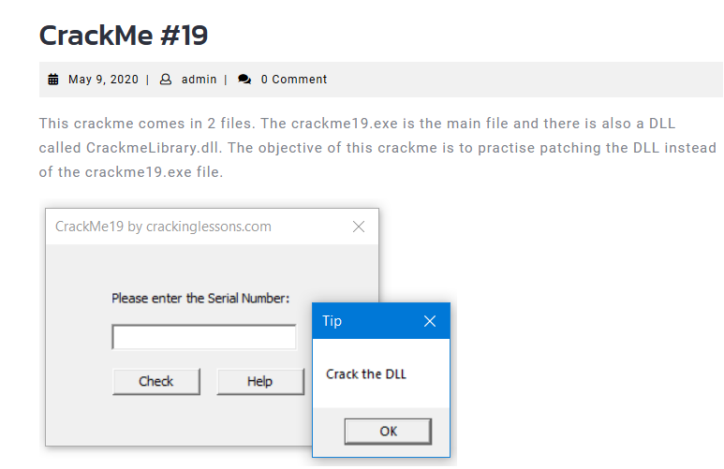

Search for all reference strings in crackme

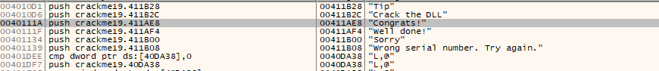

We jump to where have some important strings

We see that, it call a checkSerialNumber which a function in crackmelibrary.dll

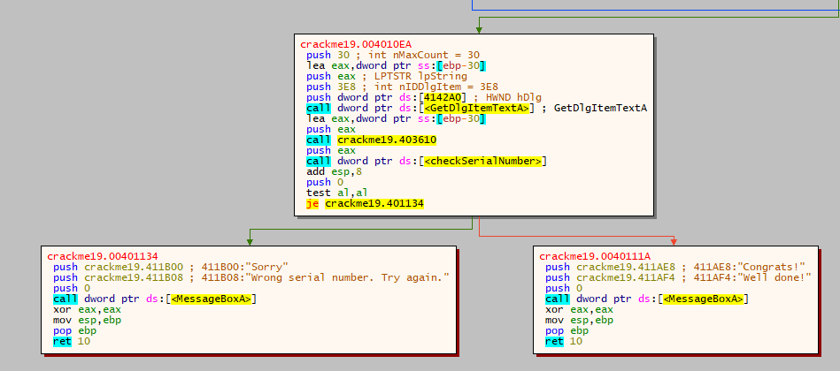

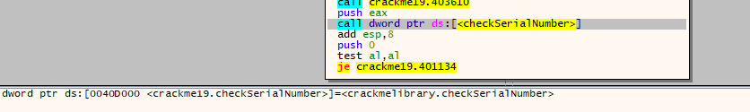

Open dll with IDA, we see the function checkSerialNumber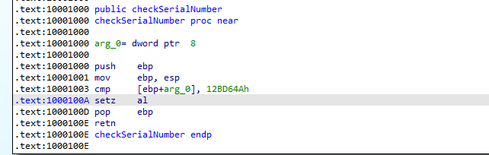

What we want is al is set to 1 so that the jump to badboy will not be taken.

so we can patch setz al into mov al, 1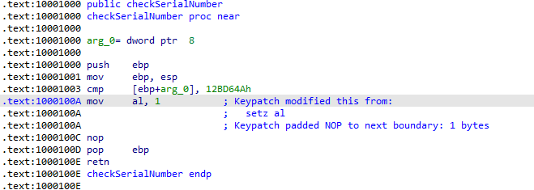Save it an run crackme to see what happen

