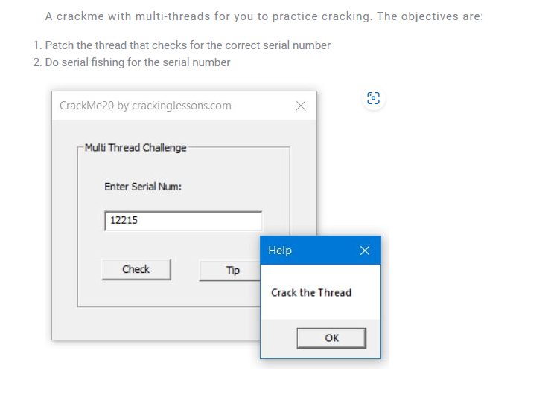

Throw it into x32dbg, find reference strings



jump there

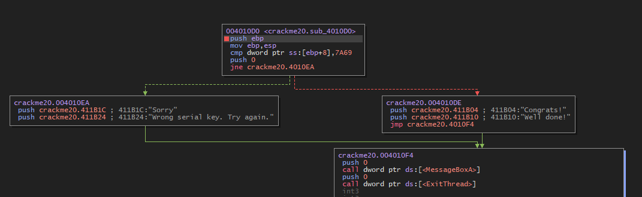

We see just a comparison [ebp+8] , 7A69 == 31337 if not equal jump to badboy.

At the end of function has an ExitThreads call, so this function is called by a CreateThread, find reference for this, we found that

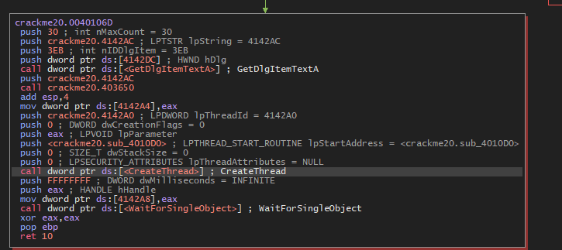

After getting our input through GetDlgItemText API function, it called crackme20. 403650 and the result was stored at dword [4142A4] then it pushed the address 4142A0 into the stack.

After that, the CreateThread API was called with StartAddress is exactly the function I analyzed above.

To see what does the function 403650 do, throw crackme into IDA, IDA analyzes that this is 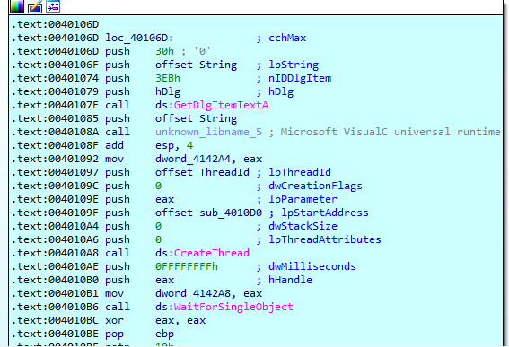

unknown_libname_5, jump into this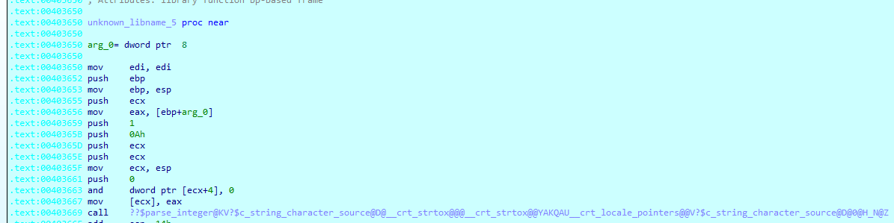

This is parse_integer function

So This function is used to parse int from our input, then compare it with 0x7A69.

So the serial for this crackme is 31337.

We also can do fishing, enter any number and also see that, that number we enter is compared with this number 0x7A69.

