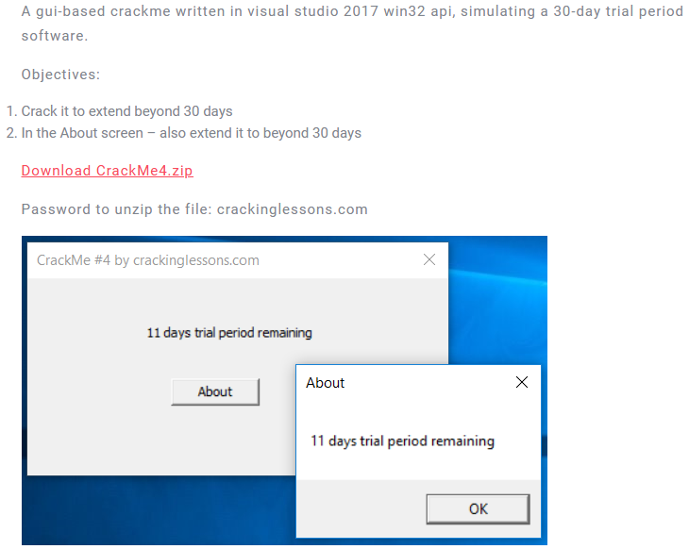

Add description of this challenge, this is a 32 bit crackme

Some notable string is:

* About
* 11 days trial period remaining

Throw to x32dbg and find all reference strings



jump to where the %d trial period remaining

we know that, %d in this string is reference to the number of days remaining, so that could be where we wanna try

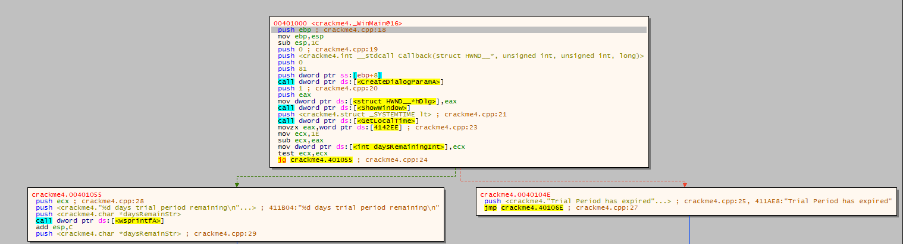

A simple logic was there. program read dword at 0x4142EE to eax then load 0x1E(30) into ecx, then subtract ecx from eax the result ecx - eax is the period left.

As object of this challenge is extending period beyond 30 day, so there is two ways to do this:

* the dword at 0x4142EE must be a negative number
* change 0x1E into another number that bigger than it

The second solution might be easier to patch

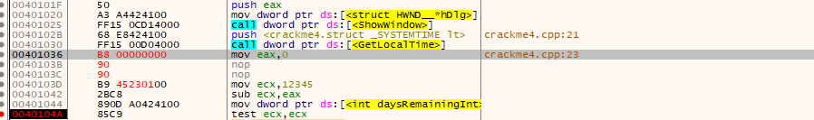

make eax always zero, and make ecx is a positive integer number

that make the daysRemainingInt always is ecx

Check the result:

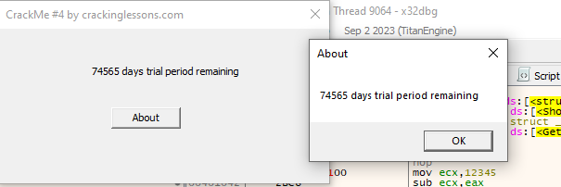

74565 is equal to 0x12345

Hehe, this works, right?