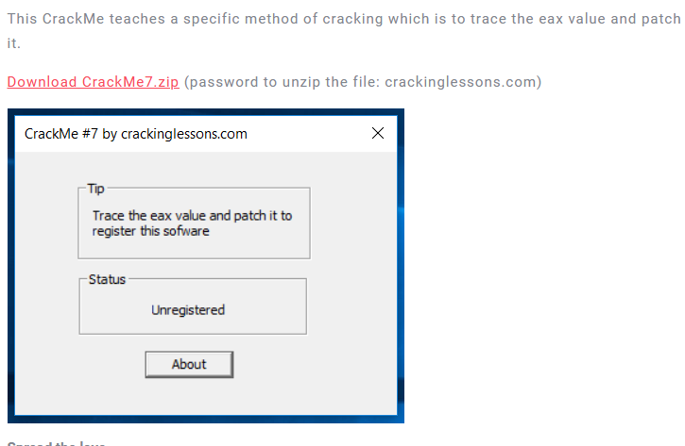

Object is Register the program

Some notable strings:

* Status
* Unregistered
* Tip
* Trace ..

Find strings references:



Go to where Registered is referenced

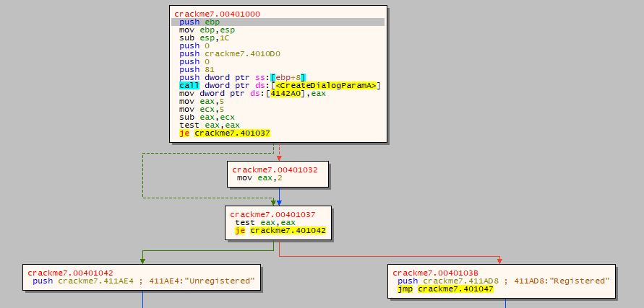

We can see that the value stored at EAX decides whether the crackme registered or not

Read the code, the value EAX must be different from 0 to register the crackme. But it was set to eax because three following instructions:

So to patch this, we just path value that is moved to eax and ecx differ from each other.



Check the patched version

