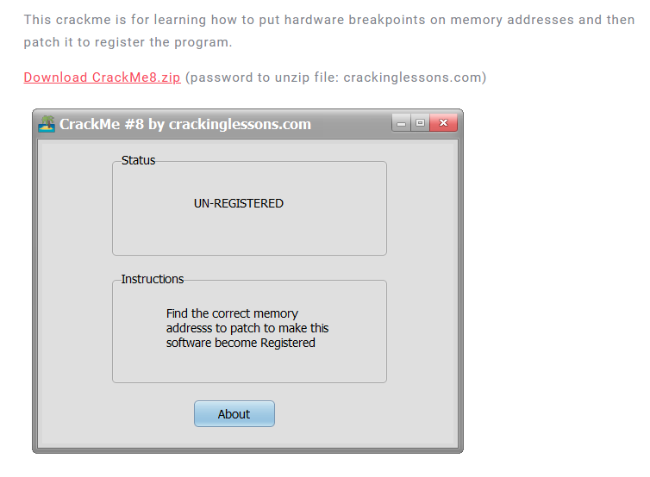

Object: Register the crackme

Some notable strings:

* Status
* UN-REGISTERED

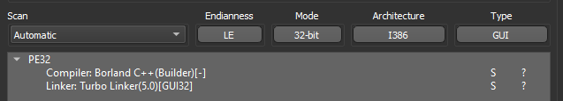

DiE says that it is a PE 32 bit

Throw crackme to x32dbg, and find all reference strings



Go There

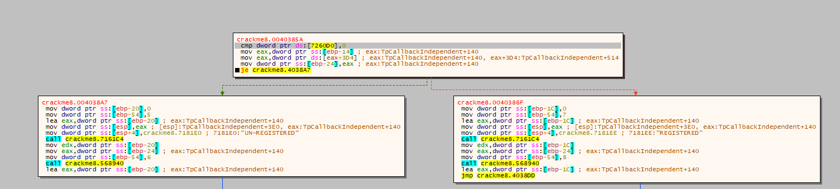

Logic is compare dword ptr ds:[crackme8.007260D0] with 0, if it equal 0, program is UnRegistered so, patch memory at that address differ from 0 is the solution

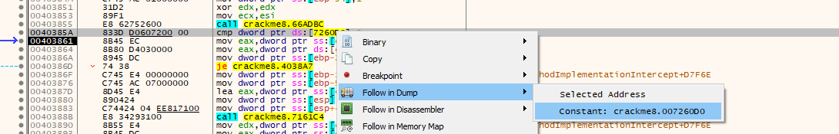 : the patched was changed into Red

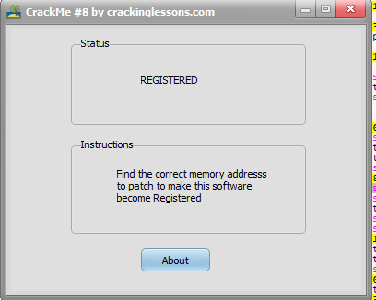

This works