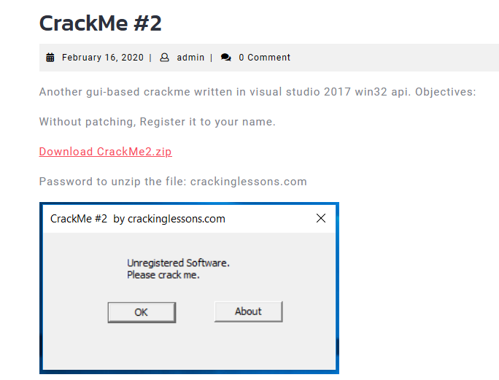

Objective is without patching, register it to your name

According to description, it is a win32 exe

Run it first, it show exactly same in the above picture

We get some strings:

* Unregistered Software
* Please crack me

Throw it into x32dbg, and find all strings references:

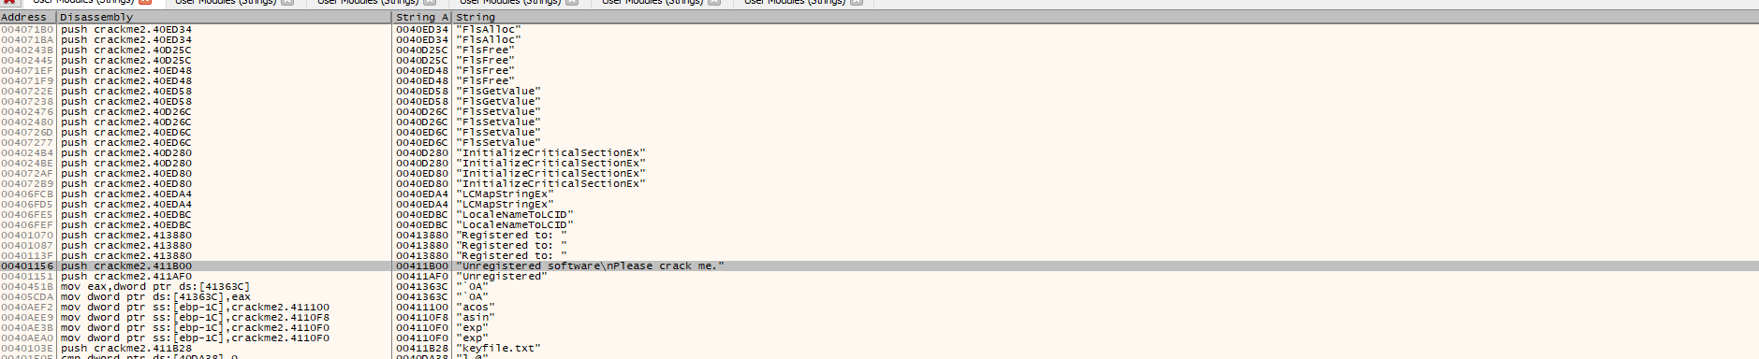

jump to some string we know

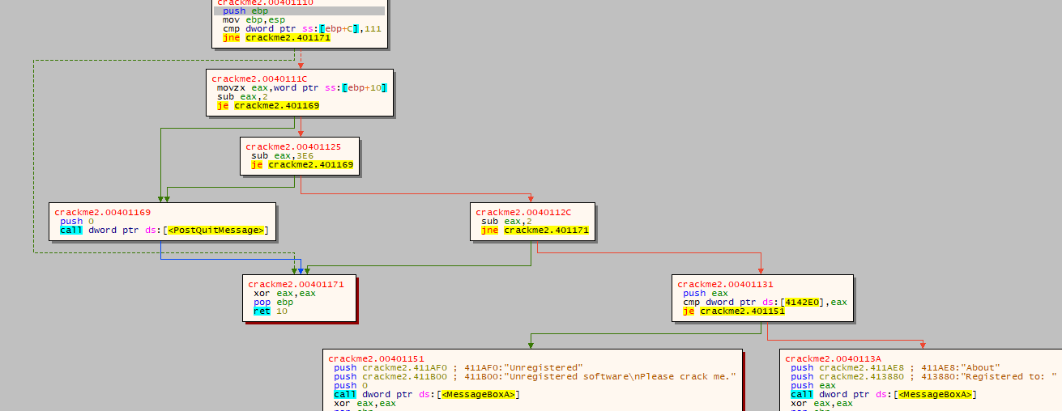

Found that it belong to block crackme2.00401110 and dword ptr ds:[0x004142E0] decides go to bad boy or good boy

We first found reference to dword ptr ds:[0x004142E0]



Go to there

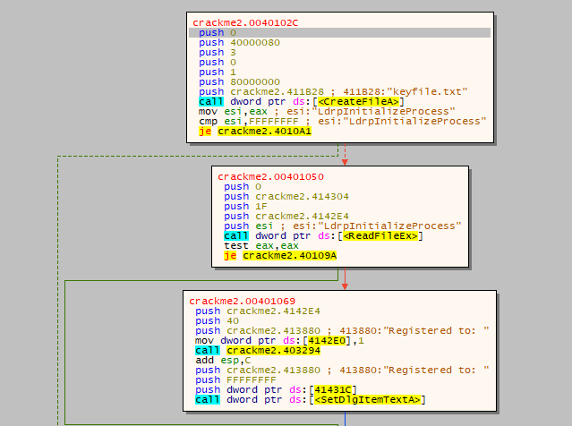

We found that it has: “mov dword ptr ds:[0x004142E0], 0x1”

===> we can conclude that this is the key point, which program run to goodboy if only if this line of code is run through

Read the code above it. Simple to see that, it check whether the file is exist by the CreateFileA API and read it content by ReadFileEx API, the content is read into crackme2.4142E4

And it is show on screen by SetDlgItemTextA API

===> to solve this challenge, we simply create a keyfile.txt and put our name to this file

It will show us what we want

Check:

