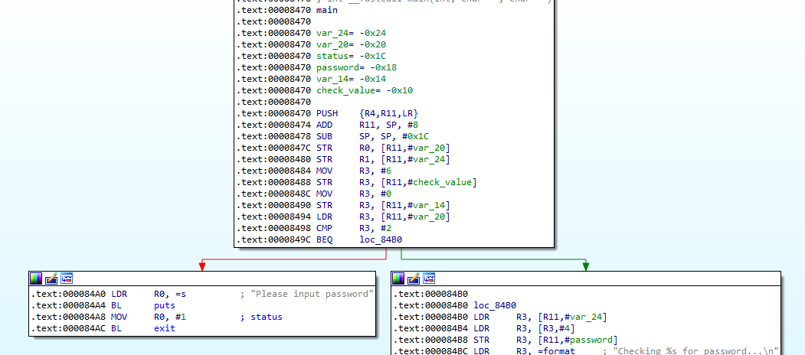

→ password was passed through command line

and check_value = 6

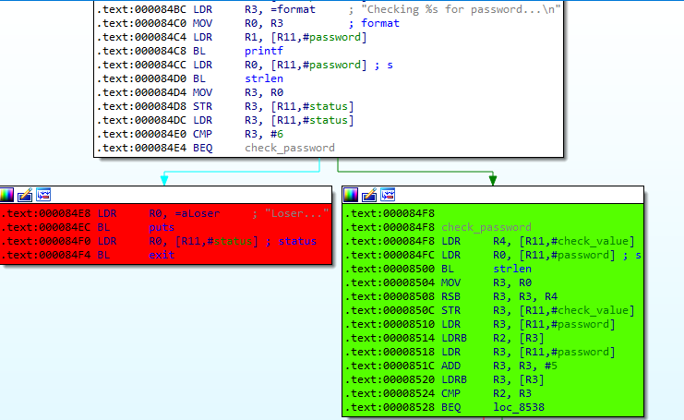

-> password length = 6

and check_value = check_value - len(password) = 0

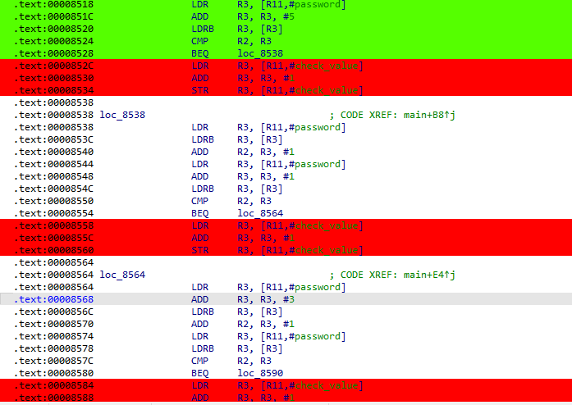

-> password[0] = password[5]

password[0] + 1 = password[1]

password[3] + 1 = password[0]

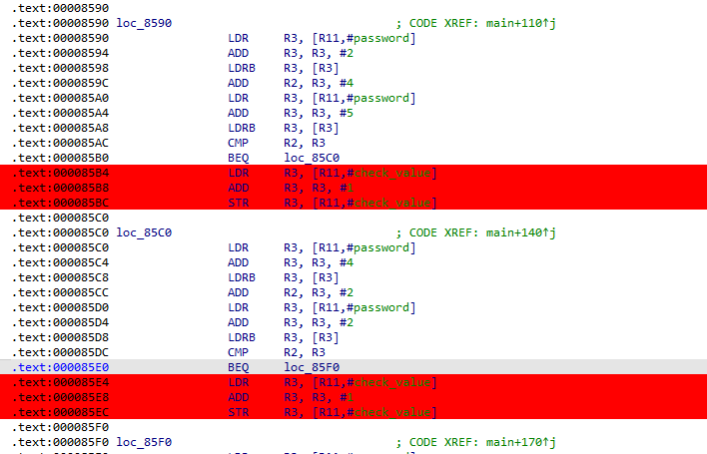

-> password[2] + 4 = password[0]

password[4] + 2 = password[2]

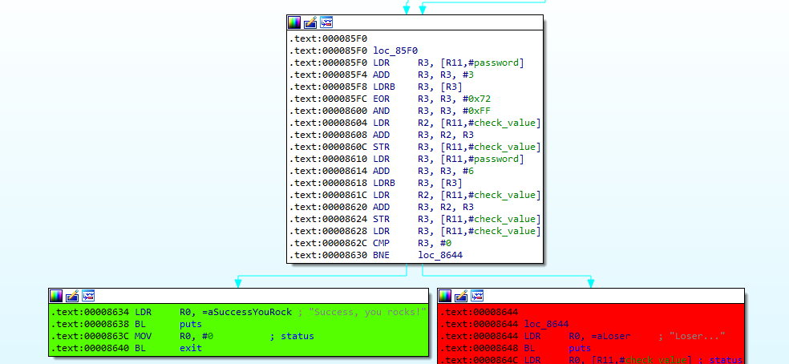

→

check_value = 0 -> Success….

according to the above codes

-> check_value = password[3] ^ 0x72 & 0xFF + check_value + input[6] = 0

We know len(password) = 6 -> input[6] = 0

and check_value was 0 before

-> password[3] ^ 0x72 & 0xFF = 0 -> password[3] = 0 ^ 0x72 = 0x72 = ‘r’

-> password = storms