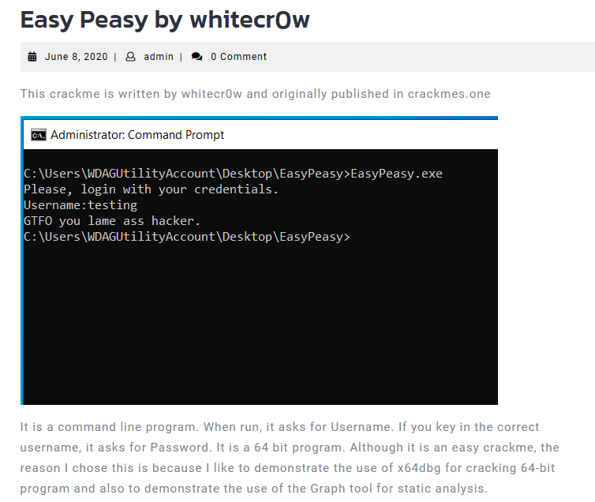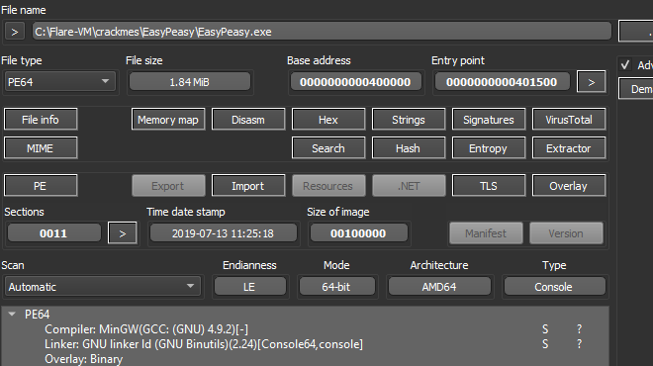

It is a 64-bit crackme.

So we use x64dbg

Search for reference strings

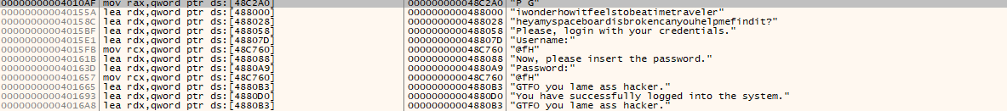

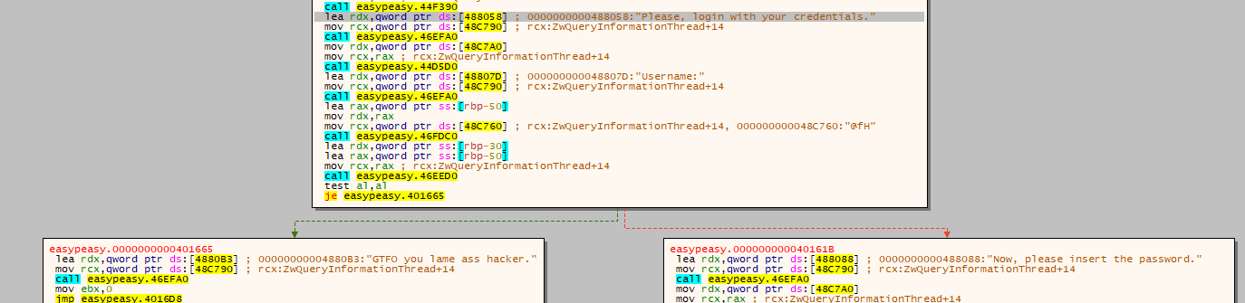First it requires username, and check our username using function 46EED0

If result is 0, we jump into badboy

Let’s check this function.

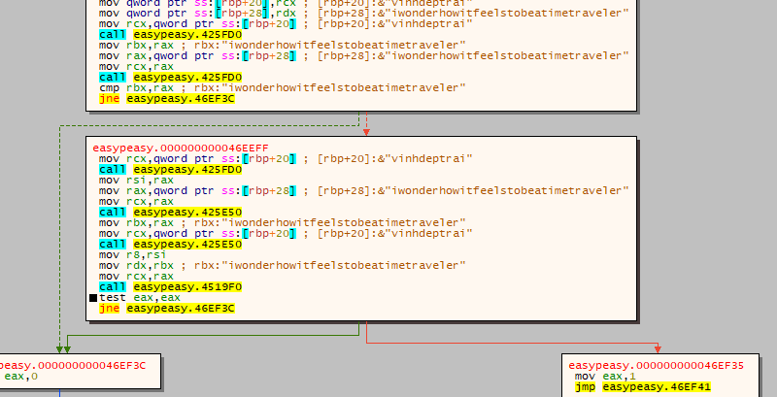



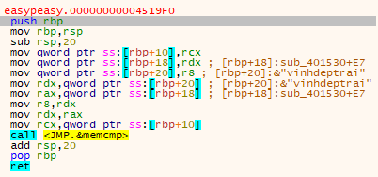

So the function is used to compare two strings

So we conclude that, they our credential is: iwonderhowitfeelstobeatimetraveler

Next is password

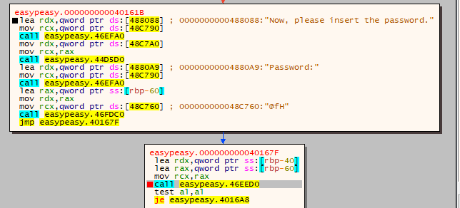

Same as above, it still use function 46EED0 to compare our input password with other which is already hardcoded



So we can conclude that the password is "heyamyspaceboardisbrokencanyouhelpmefindit?"

Test it

