We got a file, not an executable file, but a zipped file

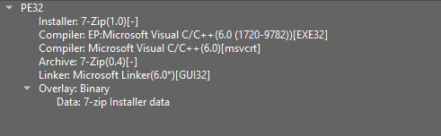

unzip it with 7-zip we got

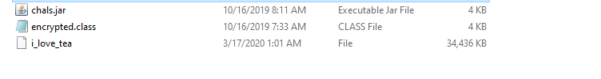

Decompile chals.jar we got some interesting stub

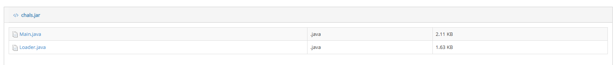

Let’s take a look at Main

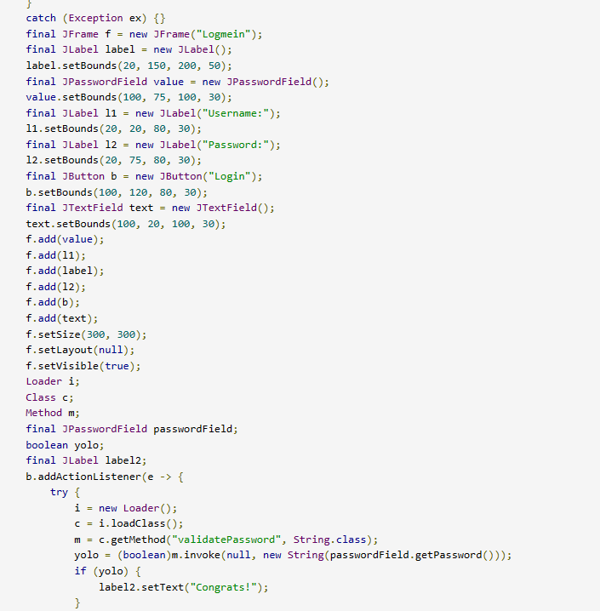

* It requires Username and Password
* you validatePassword method to check only the password, so username can be whatever you want

But we don’t see the validatePassword method there.

So, Loader may have ??

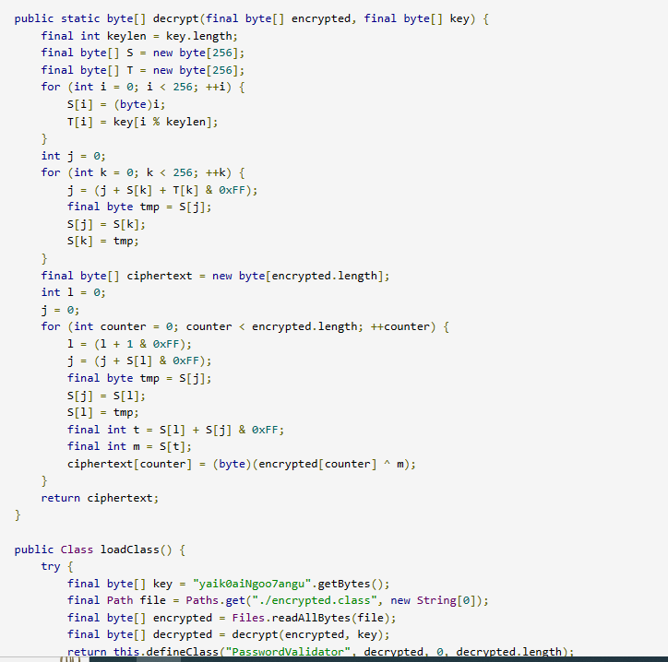

it decrypt the encrypted.class file with given algorithm, so copy it into a file to get the decrypt class (Files.write(Paths.get("ValidPassword.class"), decrypted);

)

Decompile the this file, we got

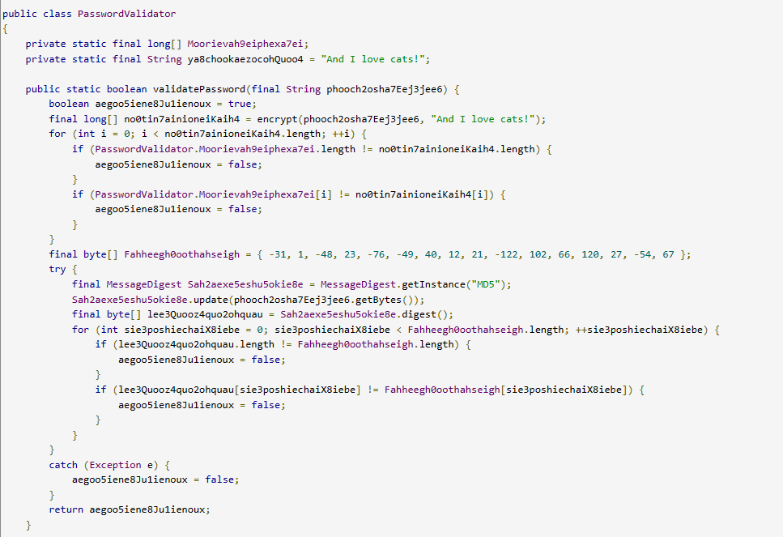

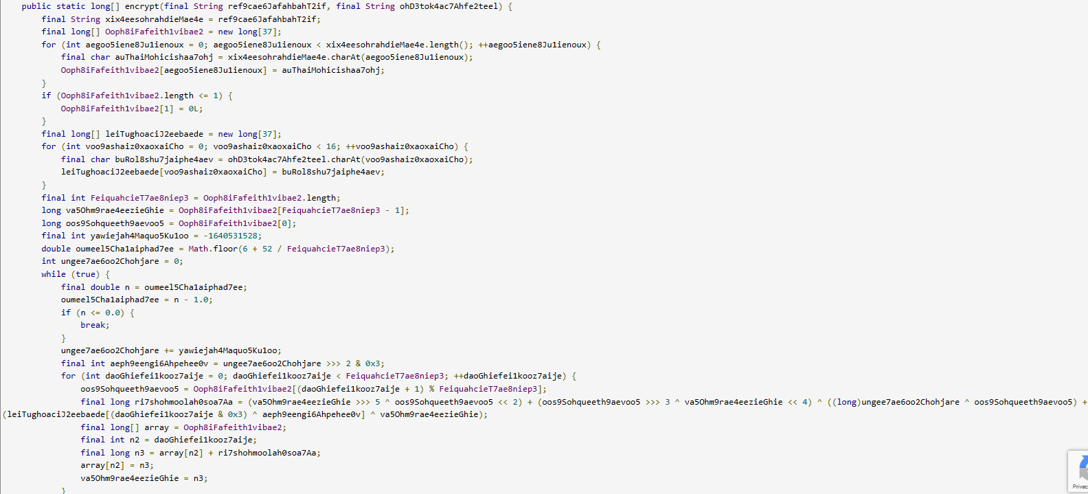

For me, this kind of naming convention is a bit obfuscated :))

So let make it more easy to read

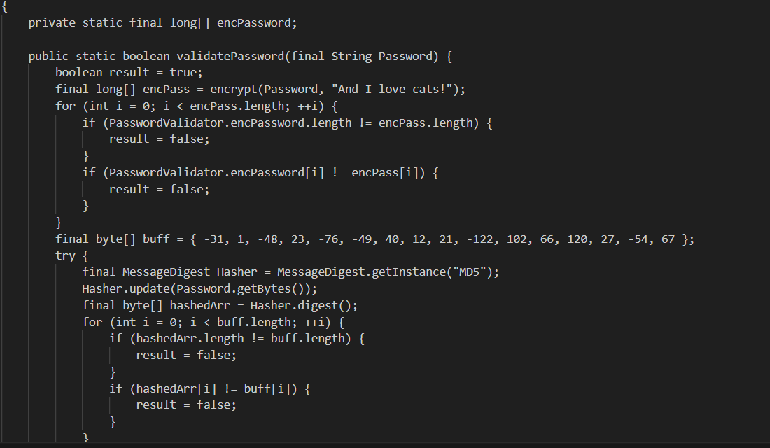

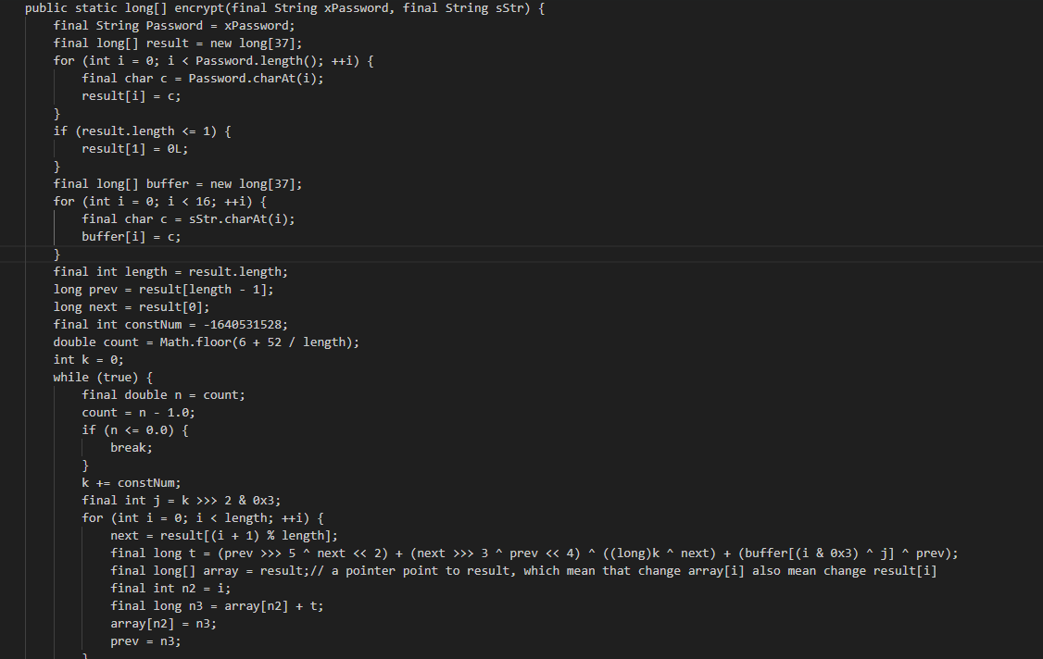



Kind of simple flow. Encrypt the password then compare it with a hard-coded long array.

Let take a look on encrypt function

It requires 2 parameters, one is password, the other is a default String (“And I love cats!

”)

-At first time I try this challenge, I'm stuck there. The encryption algorithm for me is too complicated.

-And an aka in discord give me some hint, the name of that challenge is so suggestive “ilovetea’, TEA algorithm. Finally i get the decrypt 🙂

The encrypt algorithm here is: flag[i] += (flag[i-1] >>> 5 ^ flag[i +1] << 2) + (flag[i+1] >>> 3 ^ flag[i-1] << 4) ^ ((long)k ^ flag[i+1]) + key[(i & 0x3) ^ j] ^ flag[i-1]

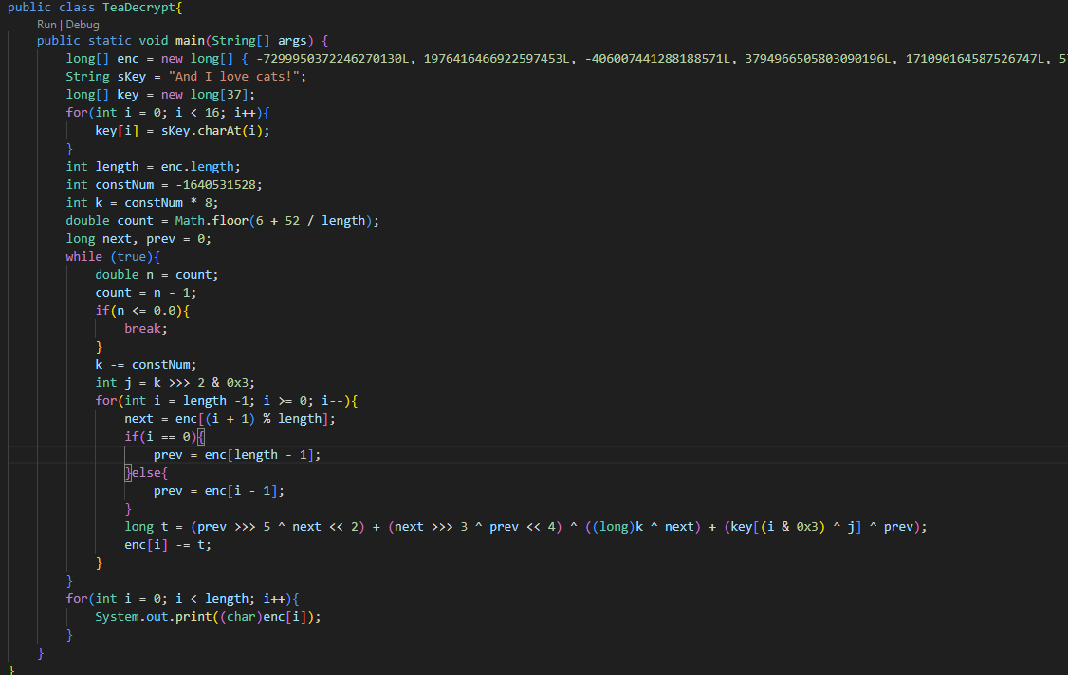

FLAG-cad7a56a5dc20bb43a8c5c3f38726d03

My conclusion for this challenge is that I need to learn cryptography :)