We got a 32 bit-ARM ELF file

Throw it into IDA

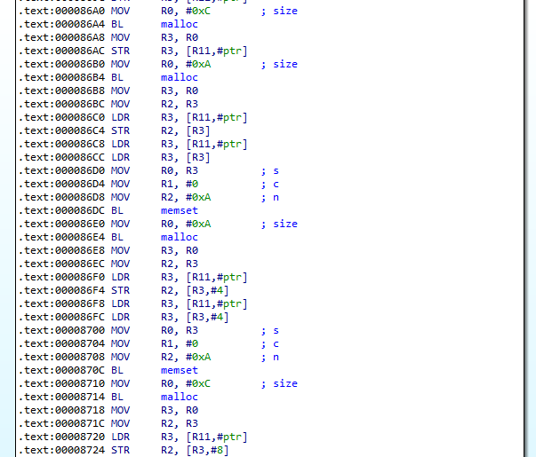

First, it creates a buffer call ptr and clears all bytes of this by memset() with 0 for this buffer.

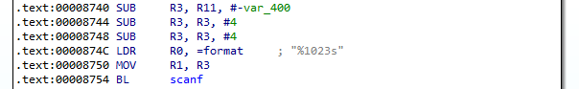

Second, it uses scanf() to get password store it into var_400

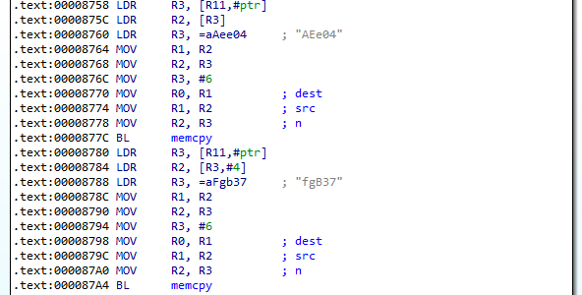

After that, it write into buffer which create at first a string ‘AEe04fgB37’ by memcpy()

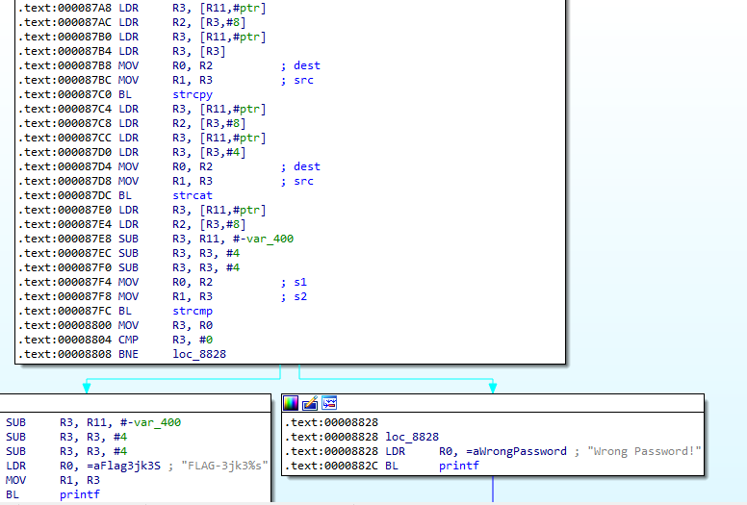

And then, it use strcpy() and strcat() to write from ptr[8] the string above

Finally, it compares the password stored in var_400 with ptr[8] Equal -> get the flag otherwise, Wrong Password!

So, the password is AEe04fgB37

the flag is concatenation from FLAG-3jk3 with the password

FLAG-3jk3AEe04fgB37