Adding sportYcal schedules to Android

Due to some Android limitation, adding calendars to your Android device is only possible via you google account:

Subscribe the calendars you like to your Google Calendar

Step 1: Connect to www.sportYcal.com (You may use any Computer or Device to do so) and find the desired calendar.

Step 2: Add this calendar to your Google Calendar, as seen in figure 1
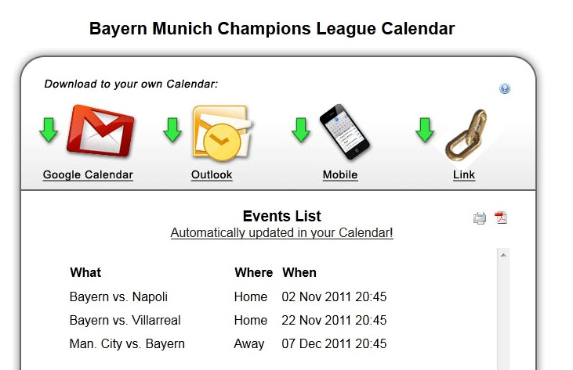
Figure 1

Step 3: Complete the subscription to the calendar
(google requests confirmation, click yes).

Repeat the first 3 Steps for each calendar you wish to add.

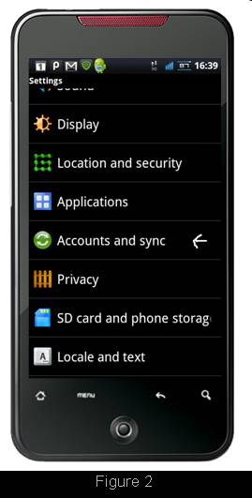
Subscribe with Your Android

Step 4: On your Android device – Choose "Settings"

Step 5: Choose "Accounts and sync" as seen in figure 2

Step 6: In the "Accounts and sync" tab look for an icon showing the letter "g", this is the place to enter your Google account name as seen in figure 3.
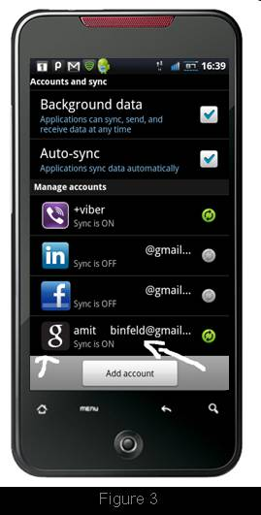

Make sure that the address is the correct.

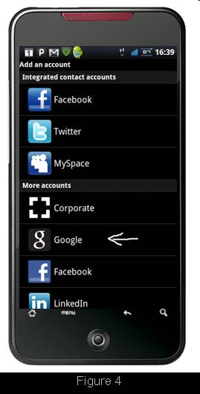
If you can't find the icon with the "g" please press "Add account" and choose "Google" and fill in the right address, as seen in figure 4.

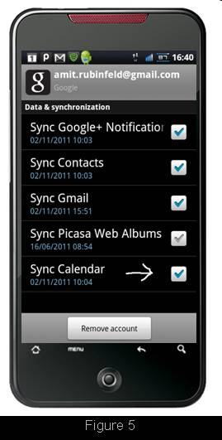
Step 7: Press on the Google account (the icon with the "g") and enable the "Sync Calendar" option as seen in figure 5.

Now your Android calendars will be in synch with the calendars in your Google account you have specified.

For any questions / comments please contact us at info@sportYcal.com.

We hope you will enjoy our service.

