# Add a SportYcal schedule to Yahoo Calendar in 3 steps

## In your desired calendar page, Click the “[Link](javascript:showCalUrl())” option:

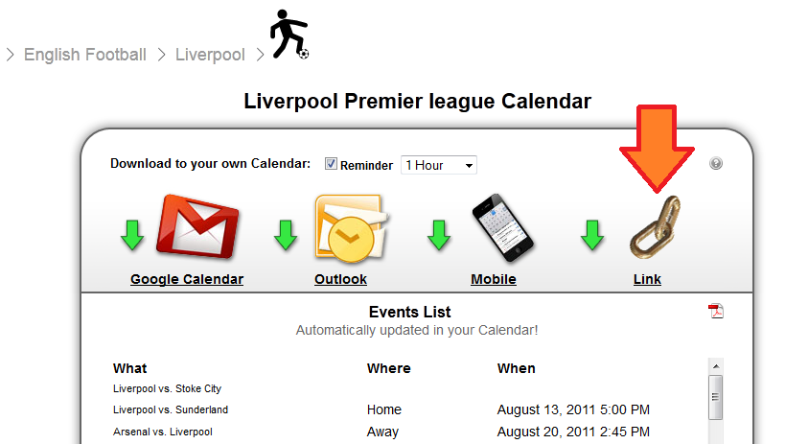

## A popup appears, copy the link:

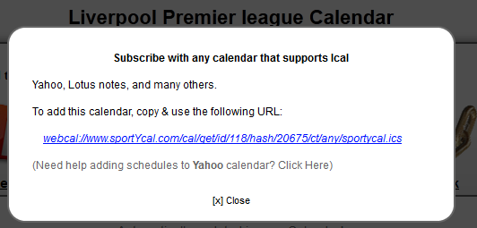

Open your Yahoo calendar, and click the Subscribed icon:

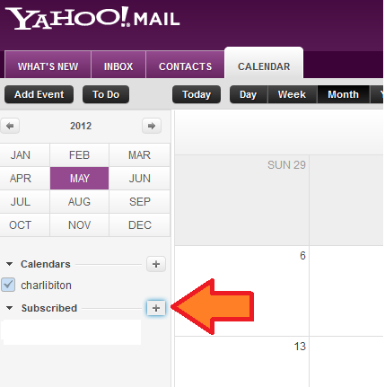

a popup appears, click the "Subscribe to other Calendars":

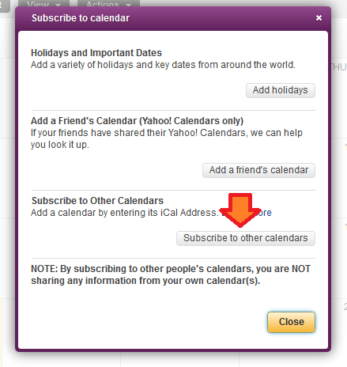

Paste the URL you got from sportYcal:

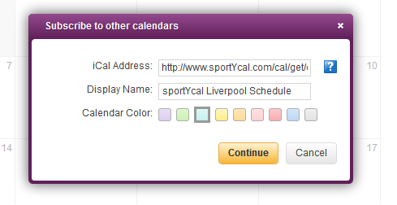

and you are done:

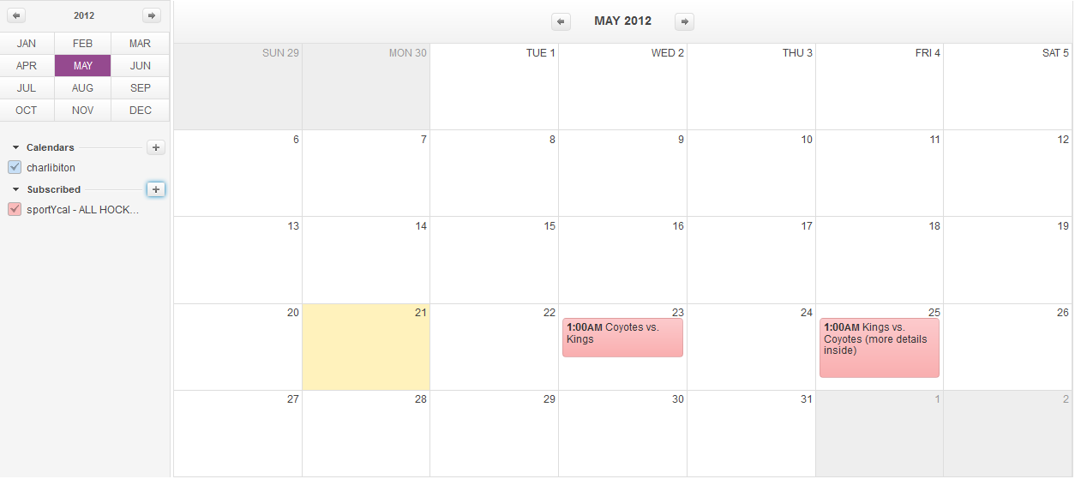

If you have any feedback, please feel free to contact us via the “Contact Us” link on [www.SportYcal.com](http://www.SportYcal.com).

We hope you will enjoy our service.

The sportYcal.com team.