ASSIGNMENT 03

Timers are very good peripherals to generate clock pulses of varying frequency.

Duty Cycle describes the “On Time” for a pulsed signal. We can report duty cycle in units of time, but usually as a percentage. Like Pulse Width and Repetition Frequency, a signal’s duty cycle is a calculated value; not directly measured. To calculate a signal’s duty cycle, we need to know the signal’s pulse width and repetition frequency. Use this equation for calculating a signal’s duty cycle as a percentage of the repetition frequency:

Duty Cycle = Pulse Width (sec) * Repetition Frequency (Hz) * 100

Challenge: Generate a duty cycle of 40% on Timer 1 (TIM1) and verify it with logic analyzer.

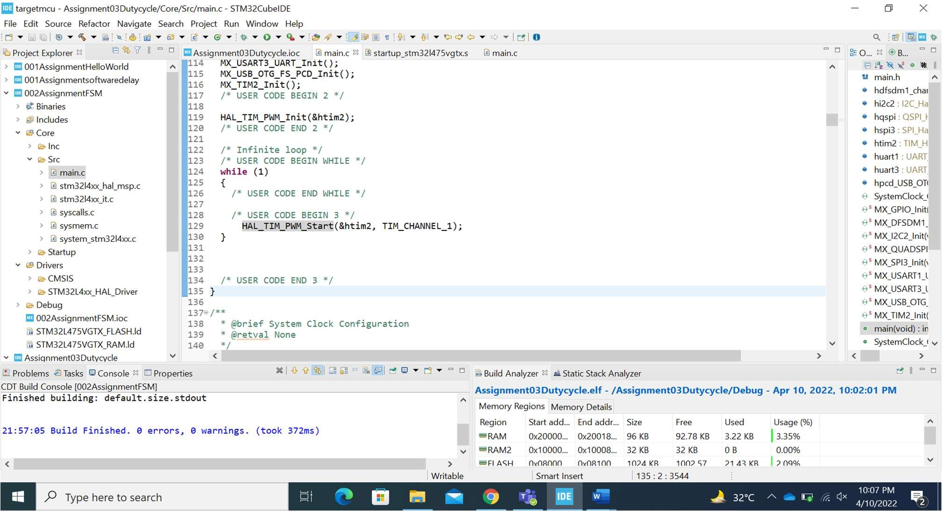

CODE:

HAL_TIM_PWM_Init(&htim2);

/* USER CODE END 2 */

/* Infinite loop */ /* USER CODE BEGIN WHILE */ while (1)

{

/* USER CODE END WHILE */

/* USER CODE BEGIN 3 */

HAL_TIM_PWM_Start(&htim2, TIM_CHANNEL_1);

}

/* USER CODE END 3 */

}

