Correct DICOM Metadata Protocol

Author: Vyas Gupta

Email: [vyas100gupta@gmail.com](mailto:vyas100gupta@gmail.com) or [vgupta13@terpmail.umd.edu](mailto:vgupta13@terpmail.umd.edu)

Date: August 13, 2019

## Purpose/Explanation

This corrective function is meant to iterate through a folder of DICOM images that are problematic when importing into MIM. Iterates through the given folder and modifies each file's metadata such that there are consistent Series Instance UIDs and Study Instance UIDs and sequential and unique Instance Numbers. This enables the user to then provide this folder of DICOM images as an import folder to MIM, which will recognize the files as part of one series.

## Setup Instructions

This code is well documented and requires minimal set up. Refer to the code at ‘//imph9026/b/George/Vyas_Gupta/misc/correct_DICOM_metadata.m’ and read through the contents. Below I will repeat the same information that can be found in the file.

This code assumes that your files are ordered alphabetically. Otherwise, if your instance numbers are correct, you would have to hand correct each image. In case they are correct, comment out the line that modifies instance number in the correction section.

The structure of the folder is as follows:

(+) data_set_dir

----- (+) subfolder_to_correct

-------------- (-) IM001

-------------- (-) IM002

-------------- (-) IM003

-------------- (-) ... (alphabetically ordered slices in DICOM format)

The value for dicom_files_names provides the generic naming convention for the DICOM files in the folder. If all the DICOM files begin with IM, then ‘IM*’ should be this variable’s value. Depending on the data set, you may need to change this value accordingly.

Modify the various values in the configuration section and you should be set!

## Additional Modifications

If you would like to adjust more information in the DICOM files, some small modifications can allow that.

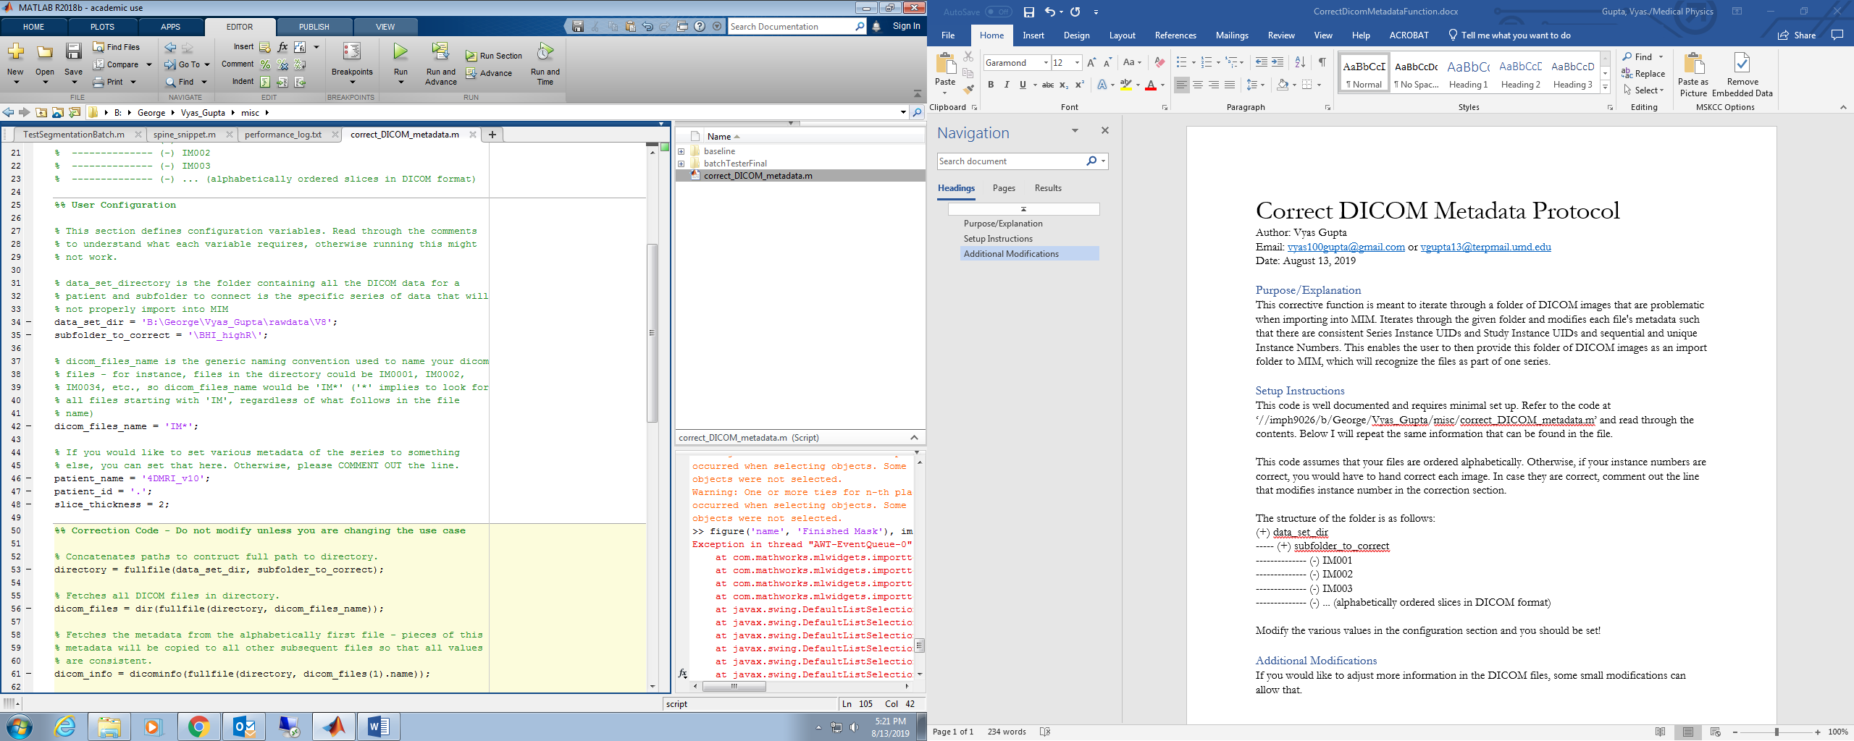In this image, refer to line 46 through 48. These are various attributes that I would also like to modify in addition to the Serial Instance UID, Study Instance UID and the Instance Numbers. You can add more metadata values here if you need to change something across your DICOM dataset.

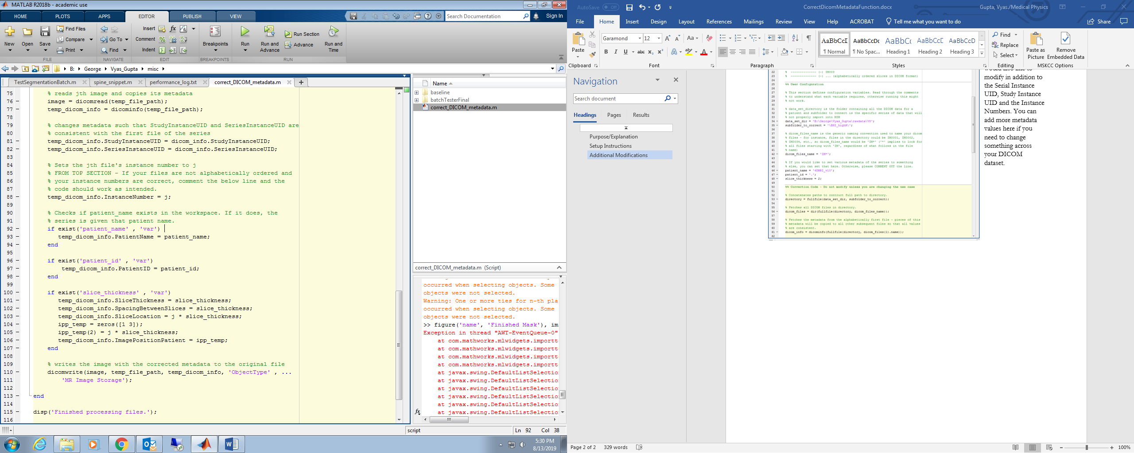From there, one must add a line before writing (at line 110) where the value of that metadata key that you would like changed is set. For instance, if I would like the change the color type in the metadata, I would write ‘temp_dicom_info .ColorType = color_type’ where color_type was a variable I defined in the last step.