NAME : Rajat Vyas

COURSE : Diploma In Softwere Testing and Automation

ASSIGNMENT : Module 1 (Introduction and fundamental)

***Modul – 1 ( Introduction and Fundamental )***

1.what is SDLC ?

SDLC is step by step approach to develop any softwere with high quality, within the time and within the cost.

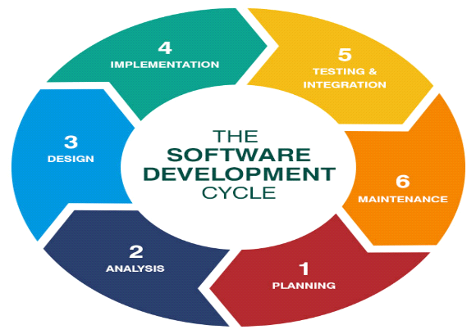

2. What is softwere testing?

Testing is the process of evaluation a system or its component with the intent to find that whether it satisfies the specified requirements or not.

Softwere testing is a process used to identify the correctness, completeness, and quality of developed product**.**

3. What is SRS ?

Software Requirements Specification (SRS) is document that describes what a software product will do and how it will perform.It includes a set of use cases that describe all of the intrections that the users will have with the softwere.

4. What is testing objectives?

Finding defects and preventing defects.

Gaining confident in and providing information about the level quality.

Both dynamic testing and static testing can be used for testing objective.

To prevent defect to be entered into project lifecycle.

Review of documents throughout the lifecycle.

5. Write SDLC phases with basic introduction –

* Planning / Requirement gathering (What)

problems can be raised while gathering the requirement

- Lack of clarity

- Requirement confusion (functional and non-functional)

- Requirmant amalgamation (group)

* Analysis phase (How) -

The analysis phases defines the requirmants of the system, independent of how these requirmants will be accomplished.

Idealy, this document states in a clear and precise fashion

* Design phase -

The design team can now expand upon the information established inn the requirement documant.

The architecture team also converts the typical scenarious io to a test plan.

* Implementation / Coding phase -

In the impementation phase, the builds the componets either from scratch or by composition.

Softwere can be implementation by the technology (java, python, PHP). the implementation phase deals with issuse quality, parformance, baselines and debugging.

* Testing phase -

The testing phese is a separate phase which is performed by a defferent team after the implementation is completed.

Tsting is a procces to verify that the requirement are fullfilled or not.

Testing is a procces which is used to identify the quality of the product , product comletness and correctness to the developed softwere or product.

* Maintenance -

Softwere maintenance is one of the activities in softwere engineering and is the procces of enhancing and optimizing deployed (spftwere release) , as well as fixing defects.

Updating all analysis, design and and user documantation.

There are three types if maintenance :-

- Corrective maintenance : Idantifying and repairing defects.

- Adaptive maintenance : Adapting the existing solution to the new platform

- Perfective maintenance : Implementing the new requirments

6. Draw usecase on Online shopping product using COD.

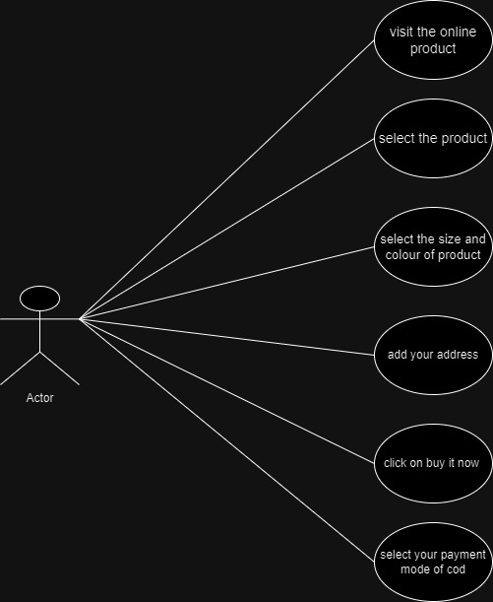

7.Draw usecase on Online shopping product using payment gateway.

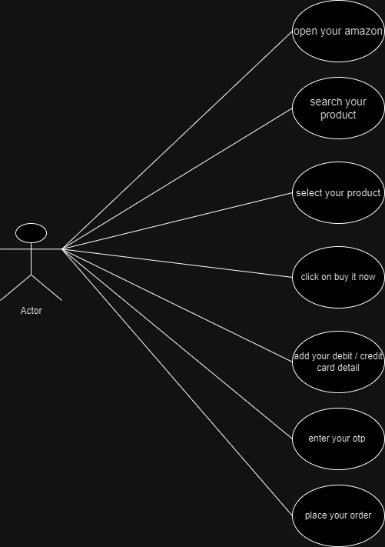

8. Draw Usecase on Online book shopping.

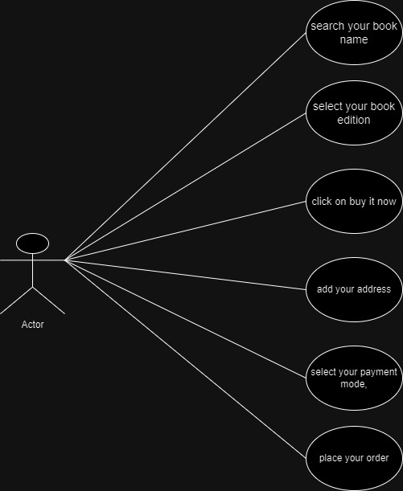

9. Draw Usecase on online bill payment system (paytm).

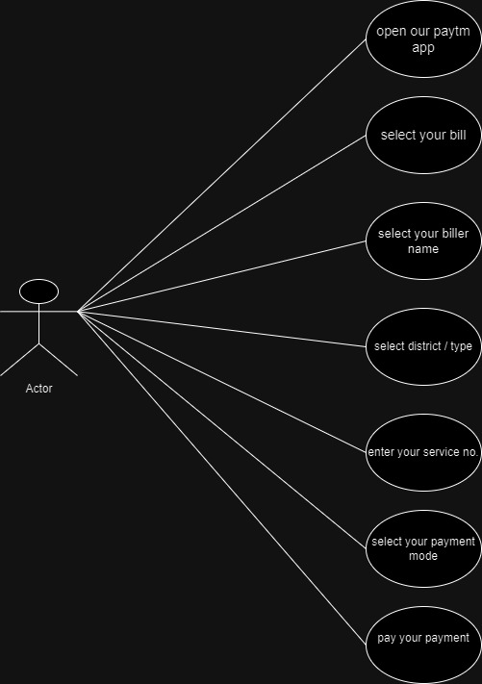

10. What is oops?

Object-oriented programming (OOP) is programming paradigm that uses objects to design computer programs and applications. OOP is a core concept in Java programming and can be characterized as data controlling for accessing code.

11. Write basic concept of opps.

basic concept of oops-

Class

Object

Encapsulation

Polymorphism

Abstraction

12. What is object ?

basic unit for OOP. object will give the memory to the class. object will represant the relevant class.

13. What is class ?

Class is a collection of a data member (variables) and member function with its behaviour.

Class is a blueprint or a template to describe the properties and behaviour of the objects.

14. What is encapsulation?

In object-oriented programming (OOP), encapsulation is the practice of bundling data and methods that work with that data into a single unit. This can be thought of as similar to a medicine capsule that can't be seen from the outside, where the inner workings are hidden and only what's necessary is exposed.

15. What is inheritance?

One class (Super, Base) inherits the properties of another class (Sub, Derived).

Types of Inheritance:

Single Inheritance

Multilevel Inheritance

Hierarchical Inheritance

Hybrid Inheritance

Multiple Inheritance

16. What is polymorphism?

An ability to take one name having many different forms.

Compile time Polymorphism: (Operator Overloading)

Method name should be same in single class, but its behaviour (Arguments & Data type) is

different.

Run time Polymorphism (Operator Overriding)

Method should be same in super class and sub class but its behaviour is different.

17. What is agile methodology?

“Agile SDLC model is a combination of iterative and incremental process models with focus on

process adaptability and customer satisfaction by rapid delivery of working software product.”

18. Explain Phases of the waterfall model.

“The waterfall model is a classical software lifecycle that models the software development as a

step-by-step “waterfall” between the various development phases.”

1. Requirements Collection/Gathering

Three types of problems can arise

Lack of clarity, Requirement confusion, Requirement Amalgamation

2. Analysis

3. Design (Low Level Design & High Level Design)

4. Implementation / Coding

5. Testing

6. Maintenance

Corrective Maintenance, Adaptive Maintenance, Perfective Maintenance

19. Write phases of spiral model.

Phases of spiral modal –

* Planning – determination of objectives, alternative and constraint.
* Risk Analysis/Design - analysis of alternative and identification/resolution of risk.
* Engineering/codding – development of the next level product.
* Customer evaluation/Testing – assessment of the results of engineering.

20. Write agile manifesto principles.

1.Individuals and interactions over processes and tools.

2.Working software over comprehensive documentation.

3.Customer collaboration over contract negotiation.

4.Responding to change over following a plan.

21. Explain working methodology of agile model and write pros and cons.

Agile SDLC model is a combination of iterative and incremental process models with focus on process adaptability and customer satisfaction by rapid delivery of working software product.”

Pros:

1. Very realistic approach

2. Rapid delivery.

3. Functionality can be developed rapidly

4. Resource requirements are minimum.

5. Little or no planning required

6. Promotes teamwork and cross training.

7. Suitable for fixed or changing requirements

8. Gives flexibility to developers

Cons:

1. More risk of sustainability, maintainability and extensibility.

2. Depends heavily on customer interactions.

3. Very high individual dependency.

4. Minimum documentation generated.

5. Not useful for small projects.

6. Not suitable for handling complex dependencies.