Technical Documentation

Contents
1. What the harness does 2
2. Data, models and reproducibility 3
3. Stage 1: From research question to groups 3
4. Stage 2: From papers to codebook 5
5. Stage 3: Coding rounds and the growing codebook 7
6. Stage 4: Analyzing the anomalies 9
7. Using the harness on another question 10
8. References 10

1. What the harness does

This document explains how our harness works. Large language models have enabled researchers to work with far more text than ever before. This volume of textual data can help us answer long-standing questions in organizational science that were previously out of reach. Qualitative researchers have traditionally collected data and coded it by hand to arrive at insights. That process was limited by how much data was available and how much of it a researcher could read and code. Our harness helps researchers code large collections of text, such as interviews, using ideas from published research. It consists of a set of steps and a program that runs them. The workflow is shown below:
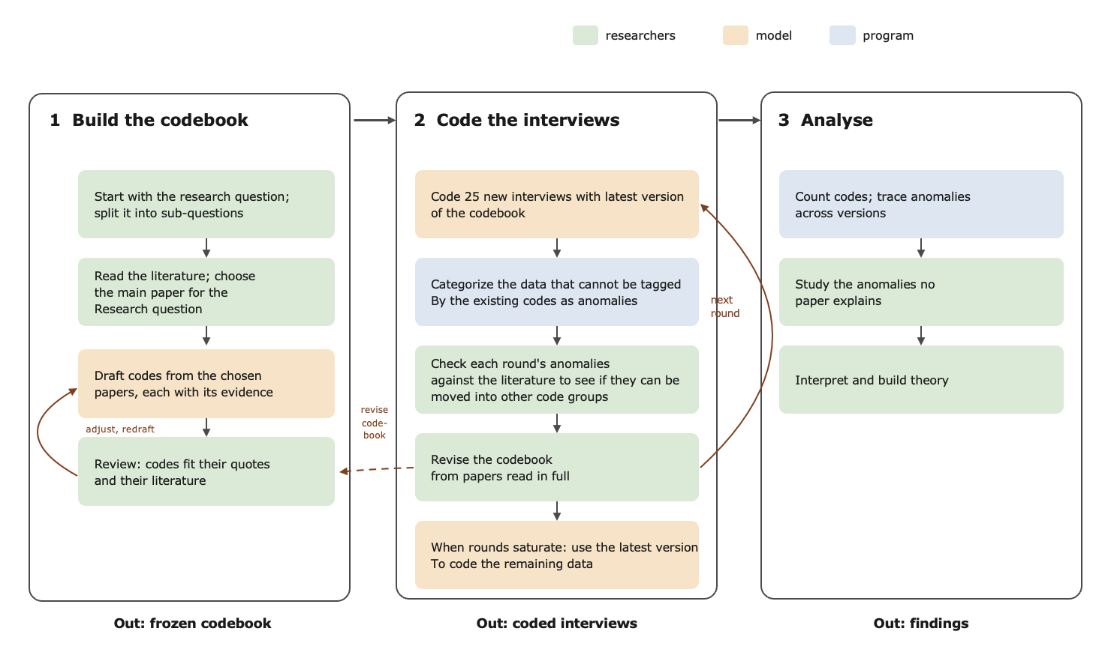
Figure 1. The workflow
How the work is divided: The tool consists of two parts, a language model and a conventional program. The researchers make the research decisions at every stage. The researchers start by choosing the research question, selecting relevant papers, deciding on every code in the codebook, checking anomalies against the literature, and interpreting the results. The large language model does the reading at scale. It reads papers and interviews for meaning, far faster than a person can, and suggests codes and matches. The decision to accept or reject the suggestions still remains with the researchers. The program splits and numbers text, copies passages, runs checks, counts, and applies rules.
The rest of this document explains the harness from start to finish. Section 2 describes the data, the context, and the model we use. Sections 3 to 6 then explain each stage in detail. Stage 1 starts with the research question and breaks it into sub-questions and groups. This helps the researcher look for papers and analyze the data. Stage 2 generates the codebook from the data. Stage 3 codes the interviews in rounds of 25. Data that cannot be tagged by the codebook are classified as anomalies, and the codebook is expanded based on papers that explain them. Stage 4 looks at the anomalies that no paper explains, which is where new theory can come from. Each stage is described first as a general method and then with our example, serendipity in founder interviews. Section 7 shows how to use the harness on another research question.

2. Data, models and reproducibility
Data. We use interviews from Starter Story, a website that publishes long interviews with entrepreneurs about how they started and grew their businesses. Our collection holds 1,972 interviews. Most interviews consist of the following questions:
- who the founder is
- where the idea came from
- how they built and launched the product
- and how the business grew.
Founders answer in their own words, often in detail, so the interviews record the unplanned turns of a venture’s early life: a chance meeting, a passing remark, an article read by accident, a customer who asked for something new. That makes these interviews well suited to studying serendipity in the entrepreneurial journey, our research question. The interviews were collected by Starter Story for its readers, not by us for this study, so they were not shaped by our research question. Starter Story owns the text. For the purpose of building the harness we use 75 interviews from the corpus. We share the 75 coded interviews with reviewers only, in a separate confidential file, with names and personal details replaced by labels such as [FOUNDER] and [COMPANY].
Models. We used Claude (Opus 5.5) for this prototype. The harness saves every instruction it gives the model and every answer it gets back. Researchers can also choose which model the harness uses. Eventually, we want to try other models, including free ones that anyone can download, to see whether the results hold and whether researchers without paid access can use the harness for the full version.

3. Stage 1: From research question to groups
The researcher breaks the research question into sub-questions, and each sub-question becomes a group. The researcher picks papers that cover each group, and the model sorts the ideas from those papers into the groups, where they become codes. Anything in an interview that fits no group goes into the anomaly group. Figure 2 shows this in two parts: (a) the general process, for any research question, and (b) the same process for our question on serendipity, with its six sub-questions and eleven groups.
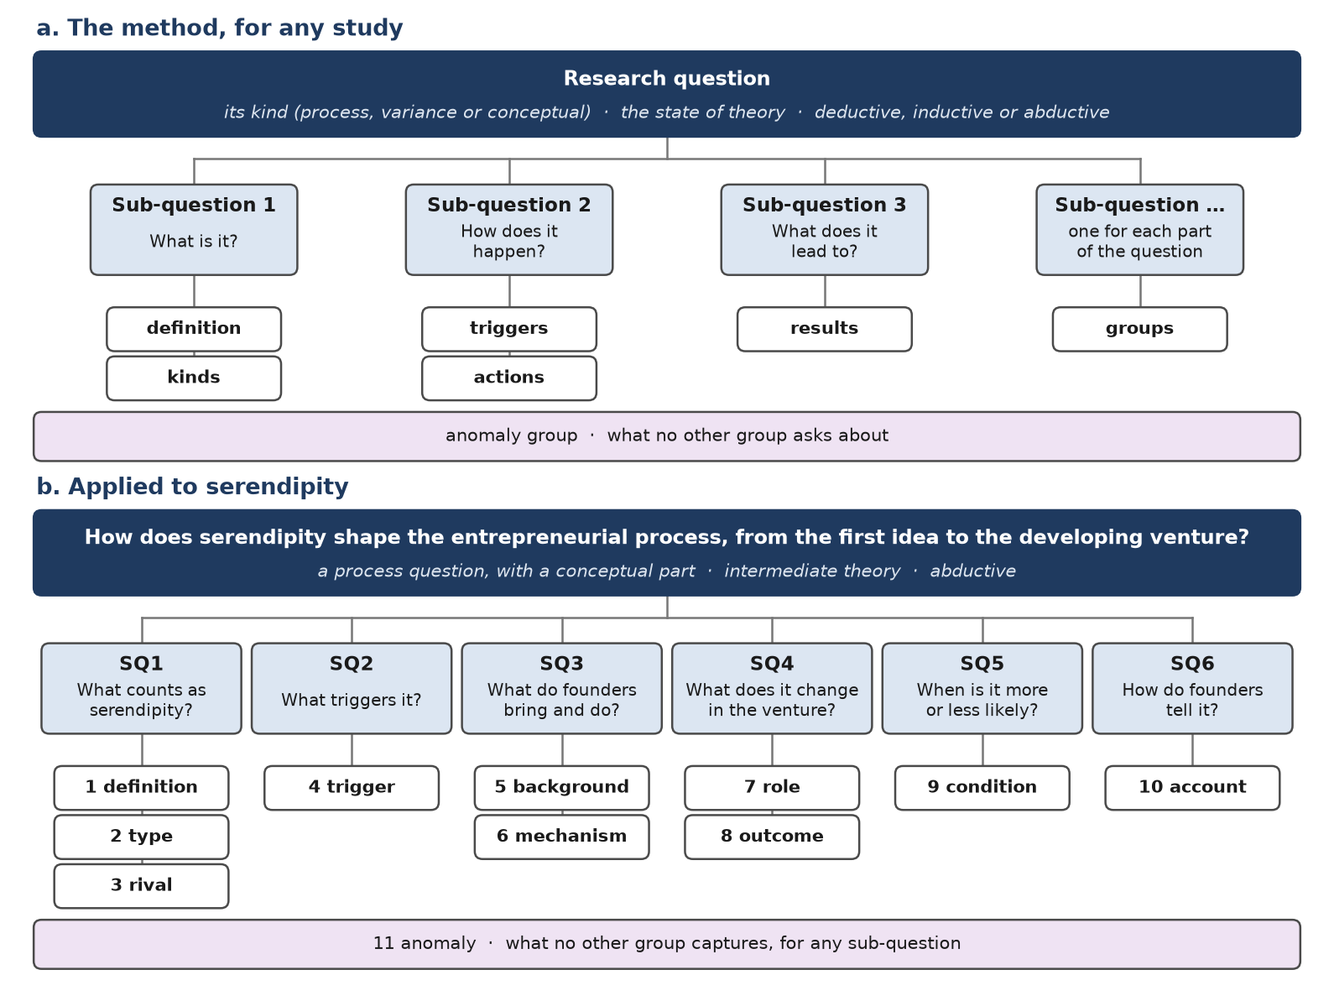
Figure 2. Stage 1. (a) The method for any study. (b) Applied to serendipity: one research question, six sub-questions and eleven analysis groups.

Table 1 below breaks Stage 1 into seven steps. The researcher first reads the literature and decides what kind of question they are asking. They then split the question into its parts, write a sub-question for each part, and keep only the sub-questions the data can answer. Each sub-question becomes one or more groups. Last, they choose the data. These steps work for any study; they follow established advice on building research questions and concepts (Sandberg and Alvesson 2011; Maxwell 2009; Podsakoff et al. 2016; Staller 2022)

Step | What we do
1 Choose the literature | Read the literature closely; choose the seminal works whose views differ and are worth integrating, and the assumptions worth questioning
2 Name the kind of question | Decide whether it asks how something happens, what explains differences, or what something is
3 Split it into parts | List the topic, the action, the time span, the people, the place and the data
4 Write sub-questions | Write the standard sub-questions for that kind of question, in the study's own terms
5 Trace and test each one | Keep a sub-question only if it comes from the main question, the data can answer it and it repeats no other
6 Write the analysis groups | Turn each sub-question into the questions asked of every part of the data, and add an anomaly group
7 Choose the data | Choose an archival source whose texts can answer the sub-questions
Table 1. The steps of Stage 1.
Table 2 lists our six sub-questions for serendipity, which gave ten groups and an anomaly group (Figure 2b). In the codebook, we merged definition and type into one group, so coders work with eight. Whether a story counts as serendipity, and which kind, is worked out afterward from their codes.
SQ | Sub-question | Codebook groups
1 | What counts as serendipity: are its parts (surprise, agency, value) present, what was the search state, which type is it, and is it more than luck or targeted search? | Parts of serendipity; the definitions, types and rival explanations are worked out from it at level 2
2 | What triggers it: an anomaly, an error, a chance meeting, a passing remark, an unsought offer, or a market signal? | Trigger
3 | What background (prior knowledge, a problem in mind, contacts) and which mechanisms (noticing, connecting, acting, changing plans) turn the trigger into an opportunity? | Background; Mechanism
4 | What role does it play in the venture (founding, redirecting, advancing it), and what outcomes follow: a product, a market, growth, or nothing? | Role; Outcome
5 | Which conditions make it more or less likely to occur and be acted on: seeking out chance, cheap trials, loose plans, or scarce resources? | Condition
6 | How do founders account for it afterwards: as luck, as luck plus effort, as clear only in hindsight, or retold as planned? | Account

Table 2. The six sub-questions for serendipity, and the codebook groups that answer each. Each group also has an anomaly code

4. Stage 2: From papers to codebook
In this stage, the papers fill the groups with codes: the possible answers to each group’s question (Figure 3).

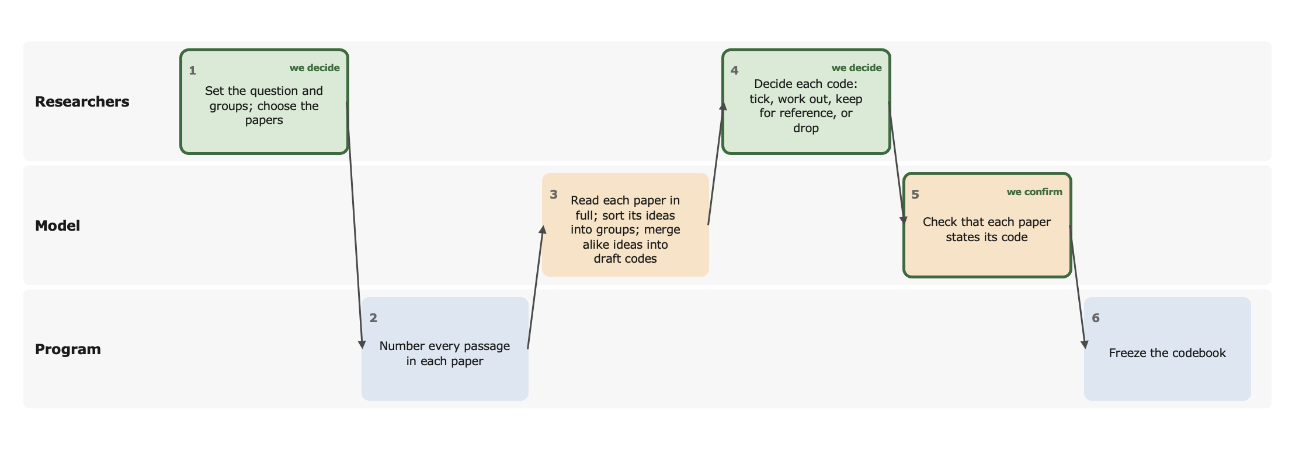
Figure 3. Stage 2, from papers to codebook. Each box is one step, in the row of whoever does it: green for the researchers, orange for the model, blue for the program.
- We set the question and groups, and choose the papers, with a reason for each.
- A program numbers every passage in each paper, so the model can point to a passage instead of quoting it and cannot invent a quote.
- The model reads each paper in full: the whole text, taken from the PDF, not an abstract or a summary. It sorts the paper’s ideas into the groups and merges ideas that mean the same thing into draft codes. Ideas that fit no group are set aside, with a reason.
- We decide each code: coders tick it, it is worked out from other codes, it is kept for reference, or it is dropped. Every decision has a reason.
- We check that each paper really states its code. The model judges the closest sentences in the paper, and we confirm. Every quote is checked word for word against a full-text copy of the paper (a Markdown file made from the PDF).
- A program freezes the codebook and records which files it was built from.
A program checks the model’s work after each model step.
Two levels of codes. Coders tick only what they can see in the text, such as a surprise or an action (level 1). Larger ideas, such as whether a story counts as serendipity, are worked out afterward by rules that combine those codes (level 2). For example, a story counts as luck if it has surprise and value, but the founder did nothing to act on it. Such rules are known as code equations (Vila-Henninger et al. 2024).
For serendipity. The model read 100 works and found 1,893 ideas, which it merged into 369 draft codes. We chose 36 for coders to tick, in eight groups, plus an anomaly code for each group. Eleven more were worked out from those codes: three definitions of serendipity, two rival explanations, four types, and two judgments we make ourselves. Of 473 links between a code and a paper, 427 were confirmed by a sentence that states the code; the other 46 are recorded as checked but not confirmed.

5. Stage 3: Coding rounds and the growing codebook
The model codes the interviews in rounds of 25. It reads each interview in full and splits it into the stories the founder tells, such as how they got the idea or found their first customer. For each story it ticks the codes that fit and points to the passages that show them. Afterwards, rules work out from these codes whether each story counts as serendipity, pure luck or a plan. Anything that matters but fits no code becomes an anomaly, with a reason. Anomalies are the evidence that challenges or extends the theory (Fife and Gossner 2024).
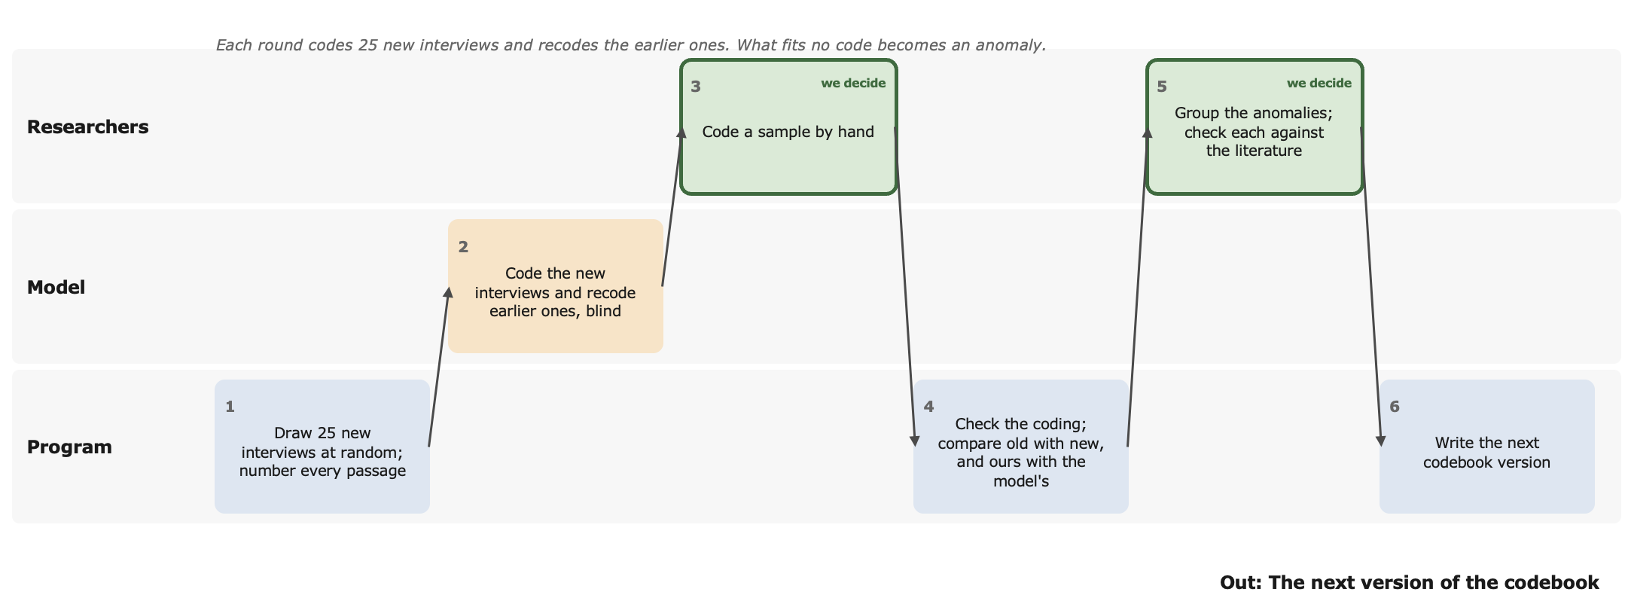
Figure 4. Stage 3, for one round. Outlined boxes are where we decide. The last step writes the next codebook version, and the next round begins.
- A program draws 25 new interviews at random and numbers every passage. The draw is recorded, so it can be repeated.
- The model codes the new interviews, and codes all earlier ones again with the new codebook, without seeing how they were coded before. It gives a reason before each code and points to passages instead of quoting them.
- We code a sample by hand, without seeing the model’s coding. Comparing our coding with the model’s shows whether the model applies the codebook as researchers would. This is the main check before we let the model code all the interviews.
- A program checks the coding and compares it: each earlier interview as coded with the old and the new codebook, and our coding against the model’s.
- We group the anomalies into themes and check each against the literature, reading the likely papers in full. Every search and its result go in the anomaly log.
- A program writes the next version of the codebook from a list of the changes, and the next round begins.
Why rounds of 25. In earlier studies, most codes appeared within 9 to 12 interviews, and their meaning settled within 16 to 24 (Guest et al. 2006; Hennink et al. 2017). A round of 25 covers that range. A varied archive keeps adding codes for longer, so we run several rounds.
How the codebook grows. The codebook starts small, with only the codes chosen from the papers. After each round, we look at the anomalies and ask whether the literature explains them (Hsieh and Shannon 2005). Table 3 shows what we do in each case.
What we find | What we do
A paper states the idea | Add a new code, with a definition, an example and when not to use it (MacQueen et al. 1998; Roberts et al. 2019)
Papers come close but do not state it | Widen an existing code, along the lines the papers draw (DeCuir-Gunby et al. 2011)
An existing code was meant to cover it, but the coder missed it | Make that code’s wording clearer, without changing its meaning
No paper explains it | Keep it as an anomaly, for Stage 4

Table 3. What happens to an anomaly.
A new code must also bear on the research question and must not repeat an existing code (Roberts et al. 2019). There is no minimum number of cases: one case can matter if it challenges the theory (Fife and Gossner 2024). A model may suggest where to search, but we read every paper we keep.
When to stop. We stop adding rounds when the codebook settles: a new round brings no anomaly that a paper explains, and the coding stays steady from one version to the next. This is a form of saturation. We then freeze the codebook, and the model codes all the interviews, with our spot checks.
For serendipity. The model coded three rounds, 27 to 31 October 2026 (Table 4).
 | Round 1 | Round 2 | Round 3
Codebook version | 1.0 | 2.0 | 3.0
Level-1 codes | 36 | 46 | 51
Papers that state its codes | 71 | 83 | 85
Interviews coded (new + again) | 25 | 50 (25 + 25) | 75 (25 + 50)
Stories | 111 | 191 | 297
Anomalies | 35 | 42 | 69
Moved into codes in the next version | 22 | 12 | 40
Agreement with the earlier coding | — | 88% | 90-91%

Table 4. The three coding rounds. “Agreement” shows how often the new codebook coded an earlier interview the same way as the old one. Some difference is expected, because the codebook itself changed.
In these three rounds, only the model coded; agreement compared each codebook version with the one before. Our own hand coding of a sample is the next step. The coding page for it is built, and the program already compares researchers’ coding with the model’s.

6. Stage 4: Analyzing the anomalies
During the coding rounds, new codes come only from papers. Anomalies that no paper explains are kept aside and studied at the end, as directed content analysis does with text that fits no category (Hsieh and Shannon 2005). In the prototype we tried this on the 29 anomalies left after version 4.0.
- We group the anomalies into patterns. The model suggests groupings from the passages and the coder’s reasons; we check and decide them.
- We check each pattern against the literature. We read the closest papers in full and judge whether each one states the pattern, comes close, or does not. A second model reader checks each judgment, and a program checks every quote against the paper.
- A pattern no paper states is a lead for new theory. We write it as a proposition to test on all the interviews.
What changes as the codebook improves. In early rounds, most anomalies are ideas the literature already has, which the codebook had missed. As those become codes, more and more of what is left is something no paper says (Table 5).
 | Round 1 | Round 2 | Round 3 | After version 4.0
Anomalies | 35 | 42 | 69 | 29 left
In patterns no paper states | 3 (9%) | 7 (17%) | 15 (22%) | 17 (59%)

Table 5. How many anomalies no paper explains, round by round. As the codebook improves, these make up a larger share of what is left.
For serendipity. The largest pattern, in 10 of the 29 anomalies, is that serendipity builds on itself. Research usually studies one chance event at a time: something unexpected happens, the founder notices it and acts (Busch and Grimes 2023). In our interviews, a chance event often leaves something behind: goodwill, an audience or people willing to help. That makes the next chance event more likely or more valuable. For example, one founder shared his setbacks online and gained supporters; another founder’s visible results led peers to ask for help, which became a new part of his business. The closest papers describe success building on success (Denrell et al. 2015; Liu and de Rond 2016) or a firm becoming more open to chance (Cunha et al. 2010), but none describes chance building on chance. Three smaller patterns rest on one or two cases each: founders limit their exposure to chance as the venture grows; some credit success to neither luck nor effort; and a lucky break can overwhelm a venture.
These patterns showed up in the same interviews in all three rounds, each coded with a different codebook. Still, they rest on 75 interviews, from founders who chose to tell their story in public. So we treat them as propositions to test on all the interviews. Because each code is tied to a story, we can test the main one directly: does what one chance event leaves behind help bring about a later one?

7. Using the harness on another question
We chose serendipity to demonstrate building the harness. The harness can also be used for other research questions. To use it on another question, a researcher will need to change four things and keep everything else:
- The study’s settings: the research question, the topic being studied, the groups, and which AI model to use. These sit in one settings file.
- The papers: the PDFs of the papers that bear on the question.
- The texts to code: one text file for each interview or document.
- A few lines of instructions to the model: the opening lines that describe the study, rewritten for the new one.
The harness then runs the same four stages: it builds a codebook from the papers, codes the texts in rounds, grows the codebook from the anomalies, and keeps what no paper explains for study at the end. The repository’s README gives the exact commands for each step.

8. References

Busch, C., and Grimes, M. (2023). Serendipity in entrepreneurship, strategy, and innovation: A review and conceptualisation. In S. Copeland et al. (Eds.), Serendipity Science (pp. 69 ff.). Springer. doi:10.1007/978-3-031-33529-7_5.
Cunha, M. P., Clegg, S. R., and Mendonça, S. (2010). On serendipity and organizing. European Management Journal, 28, 319–330. doi:10.1016/j.emj.2010.07.001.
DeCuir-Gunby, J. T., Marshall, P. L., and McCulloch, A. W. (2011). Developing and using a codebook for the analysis of interview data: An example from a professional development research project. Field Methods, 23(2), 136–155. doi:10.1177/1525822X10388468.
Denrell, J., Fang, C., and Liu, C. (2015). Chance explanations in the management sciences. Organization Science, 26(3), 923–940. doi:10.1287/orsc.2014.0946.
Fife, S. T., and Gossner, J. D. (2024). Deductive qualitative analysis: Evaluating, expanding, and refining theory. International Journal of Qualitative Methods, 23, 1–12. doi:10.1177/16094069241244856.
Guest, G., Bunce, A., and Johnson, L. (2006). How many interviews are enough? An experiment with data saturation and variability. Field Methods, 18(1), 59–82.
Hennink, M. M., Kaiser, B. N., and Marconi, V. C. (2017). Code saturation versus meaning saturation: How many interviews are enough? Qualitative Health Research, 27(4), 591–608.
Hsieh, H.-F., and Shannon, S. E. (2005). Three approaches to qualitative content analysis. Qualitative Health Research, 15(9), 1277–1288. doi:10.1177/1049732305276687.
Liu, C., and de Rond, M. (2016). Good night, and good luck: Perspectives on luck in management scholarship. Academy of Management Annals, 10(1), 409–451. doi:10.1080/19416520.2016.1120971.
MacQueen, K. M., McLellan, E., Kay, K., and Milstein, B. (1998). Codebook development for team-based qualitative analysis. Cultural Anthropology Methods, 10(2), 31–36.
Maxwell, J. A. (2009). Designing a qualitative study. In L. Bickman and D. J. Rog (Eds.), The SAGE Handbook of Applied Social Research Methods (2nd ed., pp. 214–253). Sage.
Podsakoff, P. M., MacKenzie, S. B., and Podsakoff, N. P. (2016). Recommendations for creating better concept definitions in the organizational, behavioral, and social sciences. Organizational Research Methods, 19(2), 159–203.
Roberts, K., Dowell, A., and Nie, J.-B. (2019). Attempting rigour and replicability in thematic analysis of qualitative research data; a case study of codebook development. BMC Medical Research Methodology, 19, 66. doi:10.1186/s12874-019-0707-y.
Sandberg, J., and Alvesson, M. (2011). Ways of constructing research questions: Gap-spotting or problematization? Organization, 18(1), 23–44.
Vila-Henninger, L., Dupuy, C., Van Ingelgom, V., Caprioli, M., Teuber, F., Pennetreau, D., Bussi, M., and Le Gall, C. (2024). Abductive coding: Theory building and qualitative (re)analysis. Sociological Methods & Research, 53(2), 968–1001. doi:10.1177/00491241211067508.

