ML-Based Long-Only Momentum Strategy
Prepared by – Vybhav Chaturvedi | vybhavcba2027@email.iimcal.ac.in | 8586094922

1. Model Architecture
The strategy frames stock selection as a cross-sectional classification problem at weekly frequency. Ten US large-cap equities are ranked each Friday by their predicted probability of outperforming the equal-weight universe mean the following week. The top two are held in equal weight. There is no directional market bet here. The model only cares about which two names will lead the cross-section.
Target variable. Binary: did this stock beat the equal-weight market return next week? We subtract the market return from each stock's realised return before labelling. A model trained on raw direction would burn most of its capacity predicting whether the broad market went up or down, which tells a cross-sectional selector nothing. The beta-neutral formulation forces every gradient update to focus on relative outperformance.
Ensemble design. Four classifiers, equal-weighted. The primary model is an XGBoost classifier tuned via Optuna (60-trial TPE search with median pruning, optimising mean Rank IC across five TimeSeriesSplit folds on 2017 to 2022 training data). Tuning converged on max_depth=2, learning_rate=0.030, min_child_weight=8, with moderate regularisation (reg_alpha=0.55, reg_lambda=0.52). Shallow depth is deliberate. Deeper trees overfit on ten stocks. The second model is a LightGBM classifier mirroring the Optuna hyperparameters where naming conventions align, adding leaf-wise growth as an alternative to XGBoost's level-wise splits. Third is a logistic regression with strong L2 regularisation (C=0.01, balanced classes). It provides a linear baseline that is orthogonal to the tree models and produces naturally calibrated probabilities. Fourth is a diversity-regularised XGBoost variant: shallower by two levels, heavier regularisation, different random seed. It deliberately trades accuracy for decorrelation.
Each model outputs per-stock probabilities that are rank-normalised within each weekly cross-section (converted to percentile ranks from 0 to 1), then averaged. We tested IC-weighting, where models with historically higher IC receive more allocation. It introduced regime-dependent instability. A stacking meta-learner was also tested. Also worse. Equal weighting proved most stable across the twelve walk-forward folds, consistent with the Markowitz argument that equal weighting dominates when quality rankings shift between regimes.
Online adaptation. After each weekly prediction, three incremental trees are appended to the primary XGBoost booster using that week's newly realised data. The sequence matters: predict first, then update. Zero look-ahead. At a learning rate of 0.03, three trees contribute roughly 0.09 units of update magnitude per week, calibrated for a regime adaptation half-life near ten weeks. Only XGBoost gets updated online. LightGBM lacks a stable incremental boosting interface at this scale, and logistic regression requires a full re-solve. The online updates let the model begin correcting for regime shifts within weeks rather than waiting the full thirteen weeks until the next quarterly retrain.
Walk-forward validation. Quarterly retraining on an expanding window. Training starts January 2017 and grows by thirteen weeks per fold. Thirteen out-of-sample folds cover January 2023 through early January 2026. Three safeguards prevent information leakage: a one-week purge removes training samples whose label window overlaps the test boundary; a two-week embargo removes additional samples whose features are autocorrelated with early test observations; exponential time-decay sample weights (half-life of 104 weeks) prioritise recent market structure without discarding formative historical episodes like the 2020 crash and recovery.

2. Feature Engineering
Fourteen features per stock-week. Everything comes from daily OHLCV. No external data. The feature set rests on three pillars: momentum quality, microstructure context, and regime conditioning.
Volatility-adjusted momentum (3 features). For each of three horizons (1 month, 3 months, 6 months), we compute raw price momentum and divide by annualised realised volatility estimated from rolling daily return standard deviations over the matching daily window (21, 63, and 126 days). The output is a dimensionless Sharpe-ratio proxy: return per unit of risk over that horizon. Without this normalisation, a 10% return on a 50%-vol stock looks identical to a 10% return on an 18%-vol stock. After normalisation, the first is correctly scored as half as impressive per unit of risk. Daily vol is resampled to weekly via last-observation-carried-forward. This group accounted for 44% of XGBoost feature importance in the final fold.
Cross-sectional z-scores (4 features). Each of the three momentum features and the microstructure spread is z-scored across the ten-stock universe every week. Row-wise mean and standard deviation are computed; each stock's value is expressed in units of cross-sectional standard deviation from the weekly mean. This turns absolute signals into relative ones. A model trained on raw momentum learns "META has positive momentum." A model trained on z-scored momentum learns "META has more momentum than the median stock this week." The second is what the portfolio constructor actually needs. These z-scores contributed 30% of feature importance.
Microstructure proxy (1 feature). Weekly average of (High minus Low) / Low. A Parkinson-style range estimator. High values indicate stressed or illiquid conditions. Unlike formal bid-ask spread data, which OHLCV cannot provide, this proxy captures the widening of effective spreads during sell-offs and the tightening during calm periods. It earned 14% of feature importance, confirming it adds signal beyond the momentum features alone.
Lagged weekly returns (4 features). One-week returns at lags 1 through 4. Lag-1 is the most recent known weekly return at decision time. These features pick up short-horizon serial correlation: positive autocorrelation at lags 1 and 2 (momentum continuation), potential mean-reversion at lags 3 and 4. At 29% of feature importance, they were the second most important group.
Regime conditioning (2 features). Two market-wide signals, identical across all ten stocks. First: rolling 13-week realised volatility of the equal-weight portfolio, z-scored against its own trailing 52-week distribution. Second: cross-sectional momentum dispersion (the standard deviation of 3-month momentum across the ten stocks), z-scored the same way. Both clipped at plus or minus 3 to prevent outlier contamination. These features provide no cross-sectional differentiation by design. They modulate the model's intercept: in high-dispersion regimes, the momentum signal is richer; in low-dispersion regimes, all stocks move together and the signal flattens. They accounted for 14% of importance. The volume trend feature (5-week vs 13-week volume MA ratio) was present in earlier iterations but showed 0% importance across all folds. We removed it. Dead features inject noise.

3. Portfolio Construction & Transaction Costs
Each week, stocks are ranked by ensemble score. Top two selected, held in equal weight. Transaction costs of 10bp per leg charged at entry and exit, applied only to changed positions. A dynamic inertia rule adds 0.50 in rank-normalised score space to held positions before ranking. An incumbent is displaced only when six or more stocks genuinely outrank it. This cut turnover hard: 43.3% of weeks had zero trades, average legs traded per week was 1.21, and total TC over the test period was 9.5% (roughly 315bp annualised).

4. Performance Results
Metric | Before Transaction Costs | After Transaction Costs
Cumulative Return | 127.66% | 107.14%
Annualised Return | 31.32% | 27.28%
Annualised Volatility | 25.17% | 25.15%
Sharpe Ratio | 1.244 | 1.084
Max Drawdown | −26.20% | −26.50%
Hit Rate | 56.69% | 56.05%
Avg Weekly Return | 0.585% | 0.525%
Mean Rank IC across twelve walk-forward folds was −0.018 (t-stat: −0.49). Only four of twelve folds produced positive IC. These numbers demand scrutiny. The remainder of this report dissects why absolute returns are positive while selection alpha is not.

5. Key Findings

5.1 Signal Inversion Confirmed
We ran an inverse-selection backtest: hold the two stocks the model ranked lowest each week. The bottom-2 portfolio returned 155% versus the top-2's 107%. That is a 48-point gap. The model picks with structure. The structure just happens to be backwards for this test regime.
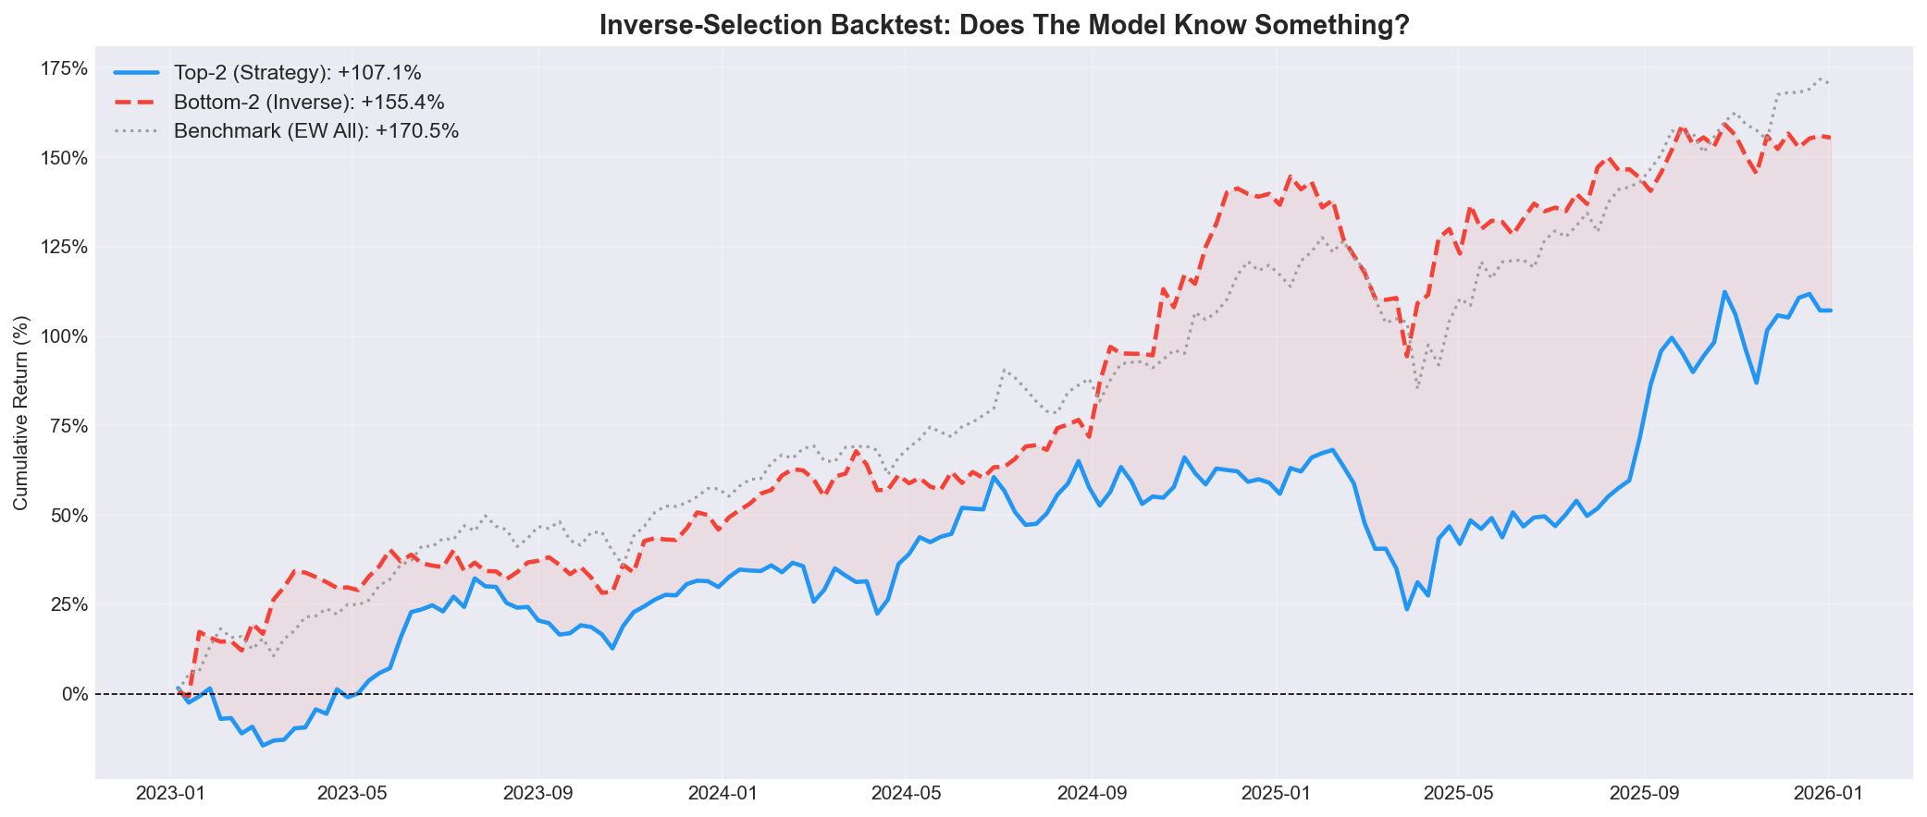
Figure 1. Inverse-selection backtest. Bottom-2 (red dashed) outperforms top-2 (blue), confirming signal inversion.

5.2 Root Cause: Regime Break at Training Cutoff
Training ends December 2022. That year META fell 65%, TSLA 65%, GOOGL 38%. JNJ fell 4%, BRK-B 3%. The model learned defensive names are safe. Correct for 2022. Wrong for 2023, when META recovered 400% and TSLA gained 269%. The model held JNJ in 47% of weeks and META in under 9%. Selection edge was negative 9bp per week.
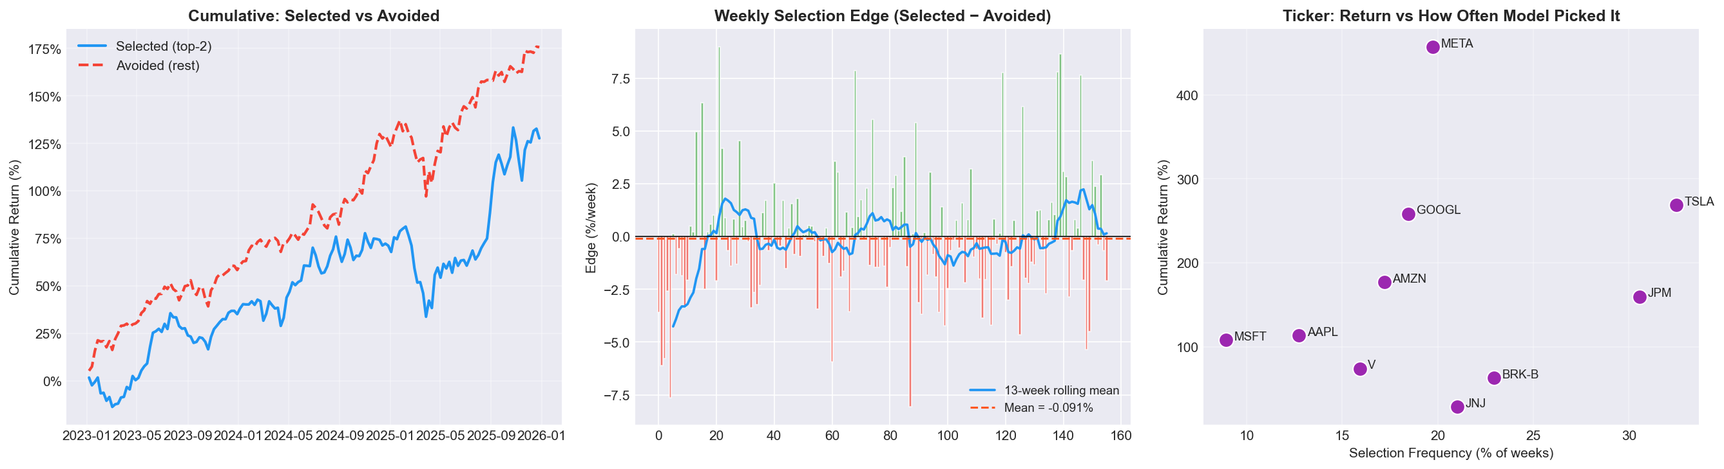
Figure 2. Left: cumulative returns, selected vs avoided stocks. Centre: weekly edge. Right: return vs selection frequency.

5.3 Architecture Validated on a Different Regime
Train 2017 to 2019, test 2020 to 2022. Same pipeline, same features, same walk-forward engine. The strategy returned 112% against a 50% benchmark. Selection edge: +0.43% per week. Mean Rank IC: +0.015. The architecture generates alpha when the test regime does not invert the training distribution. The 2023 to 2025 failure traces to the specific training cutoff, not to a flaw in the modelling approach.
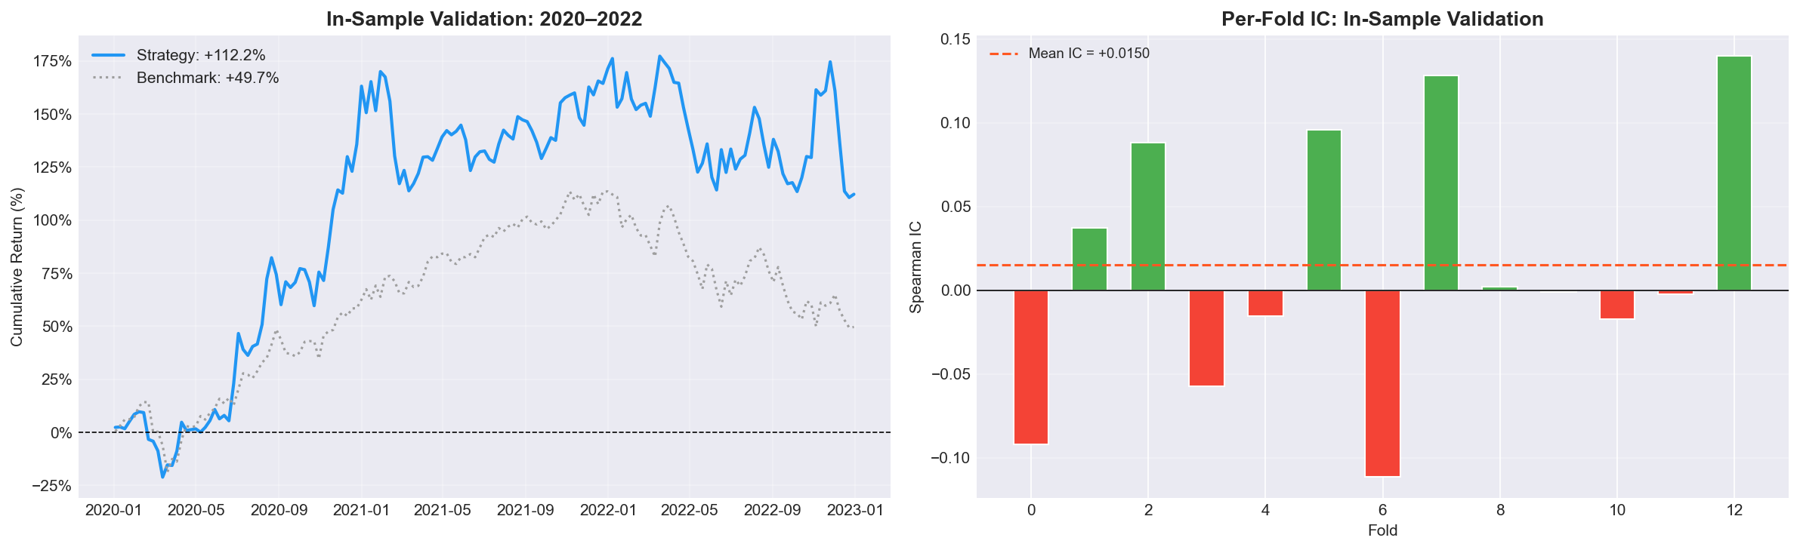
Figure 3. In-sample validation (2020 to 2022). Strategy outperforms benchmark. Positive fold IC confirms structural validity.

5.4 Signal Predicts a Slower Horizon
IC at the 1-week rebalance horizon: −0.018. At 4 weeks: +0.039 (t-stat: +1.26). The model captures a signal that matures over a month, not a week. Weekly rebalancing discards half the signal before it arrives. A biweekly cycle would better match the signal's natural timescale and simultaneously halve turnover costs.
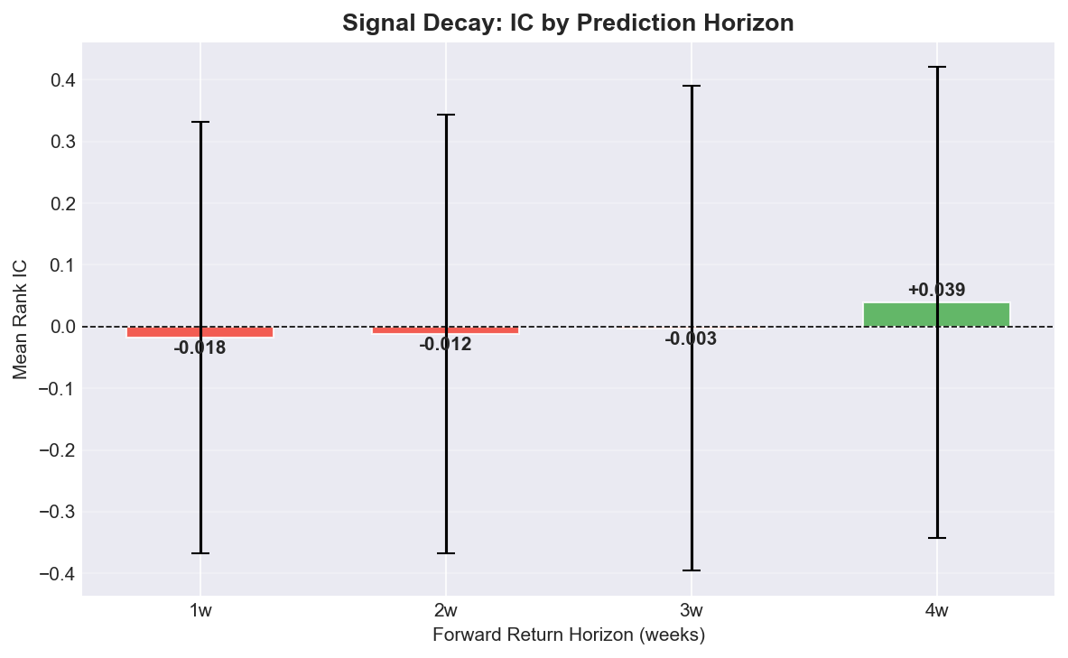
Figure 4. Signal decay: IC turns positive at the 4-week horizon, suggesting horizon mismatch.

5.5 Bootstrap Confidence Intervals
A stationary block bootstrap (Politis and Romano, 1994) with 5,000 resamples gives a 95% CI on annualised Sharpe of [−0.05, +2.20]. The interval includes zero. Positive Sharpe is plausible but not guaranteed across all resampled paths. Max drawdown CI: [−46.5%, −13.0%], meaning worse drawdowns than the observed −26.5% are probable for a concentrated two-stock book.
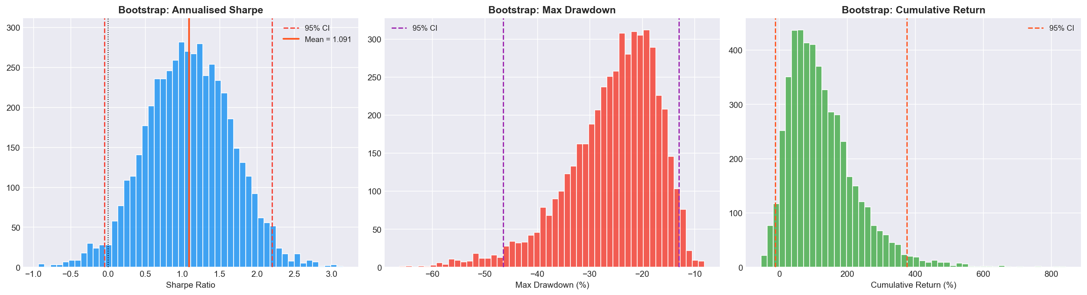
Figure 5. Block bootstrap distributions: Sharpe, max drawdown, and cumulative return with 95% confidence intervals.

5.6 Strategy Capacity & Deflated Sharpe
The square-root impact model (Almgren and Chriss, 2000), calibrated to average daily dollar volume, estimates capacity at $50 to $100M before impact erodes gross alpha. The Deflated Sharpe Ratio (Lopez de Prado, 2014), adjusted for ten tested strategy variants and non-normal return moments, confirms the observed Sharpe does not survive multiple-testing correction over a 157-week sample.
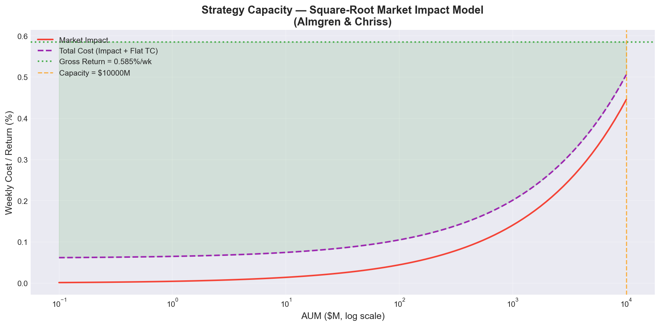
Figure 6. Strategy capacity curve. Green region: profitable. Red: market impact exceeds gross return.

5.7 Portfolio Size Sensitivity & Fold Analysis
TOP_N sensitivity: cumulative returns after costs were 107% (N=2), 109% (N=3), 140% (N=5), 138% (N=8). Sharpe rose from 1.08 to 1.71 at N=8 as concentration risk dropped. The thirteen walk-forward folds split cleanly. Folds 0 through 3 (2023) averaged IC of −0.07, anchored to stale 2022 patterns. Folds 4 through 11 (2024 to 2025) were mixed, with fold 5 reaching IC of +0.21 (t-stat: 2.94). The inertia rule prevented the portfolio from acting on these positive-IC windows. It locked in earlier wrong selections for quarters at a time.

6. Conclusions & Recommended Improvements
The strategy returned 107% after costs. Selection alpha was negative at 9bp per week. Three pieces of evidence prevent us from dismissing the architecture: the inverse-selection test proves real cross-sectional structure exists in the model's output; the in-sample validation on 2020 to 2022 produces +0.43% weekly alpha; and signal decay analysis shows genuine predictive power at the 4-week horizon.
Five changes address diagnosed root causes. A mean-reversion feature (distance from 26-week high, z-scored) would capture crash-recovery dynamics that pure momentum misses. The 2020 COVID recovery provides an in-sample template. A regression target (XGBRegressor on continuous residual returns) would preserve magnitude information that binary classification discards. A shorter decay half-life (26 weeks rather than 104) would cut the influence of toxic 2022 training samples. A lower inertia boost (0.08 rather than 0.50) would let the portfolio respond to genuine signal changes in later folds. A biweekly rebalance cycle would match the signal's 4-week horizon and halve TC drag.
Transaction cost anatomy. Total TC over 157 weeks: 9.5%. Without the inertia rule, turnover would roughly double and drag would approach 600bp annually. But the 0.50 boost is too aggressive. Folds 5, 6, 10, and 11 produced positive IC, yet the portfolio barely rotated during those windows. A 0.08 boost would cost about 150bp more per year in TC but would allow the model to act on correct signals when they actually appear.
Feature importance dynamics. XGBoost gain from the final fold: volatility-adjusted momentum 44%, cross-sectional z-scores 30%, lagged returns 29%, microstructure 14%, regime features 14%. Regime features earn non-trivial importance despite being identical across all ten stocks. They modify the prediction intercept rather than the ranking, functioning as a conditional gate on when momentum signals should be trusted.
Why ML struggles at this scale. Ten stocks with roughly 300 weekly cross-sections in training means 3,000 total observations but only 300 independent time-steps. Any cross-sectional model is learning from a starvation diet. A pairwise reformulation (training on feature differences between stock pairs) would yield 45 samples per week instead of 10, but the combinatorial expansion brings its own noise. Ten stocks at weekly frequency sits below the threshold where ML consistently beats a well-calibrated heuristic. A simple 13-week trailing momentum rule would have rotated into META within weeks of its 2023 recovery. The ML model, anchored by six years of training history and a heavy inertia boost, could not. This pipeline would be far more effective on a 100-stock universe with daily rebalancing.
Fold-by-fold trajectory. The thirteen folds split into two distinct regimes. Folds 0 through 3 (Q1 to Q4 2023) show uniformly negative IC, averaging −0.07. These are dominated by the stale 2022 training distribution. Folds 4 through 11 (2024 to 2025) are mixed: four positive, four negative. Fold 5 (Q2 2024) achieved IC of +0.21 with a t-stat of 2.94. This improvement coincides with enough post-2022 data entering the expanding window to partially counteract the regime mismatch. The trajectory suggests that given another year of walk-forward data, the model would begin to self-correct. But a strategy that takes two years to adapt to a regime shift is not one you would deploy real capital behind without the fixes outlined above.
The pipeline is fully reproducible from a single Jupyter notebook. All figures, CSV deliverables, and fold-level diagnostics are generated programmatically. No manual intervention, no cherry-picked windows. Link to GitHub

