
Department of Electronics and Communication Engineering

CROP HEAT-STRESS WARNING SYSTEM

INNOVATIVE / APPLICATION ORIENTED PROJECT REPORT

Submitted by

VYBHAVI R (25EC248)
SATVEKA A (25EC206) THANMAYAA M (25EC233)
YUTHIKA M (25EC252)

In partial fulfilment for the completion of

U19EC306 & Analog and Digital Electronics Laboratory

During the academic year

2026 - 2027 (Odd Semester)

TABLE OF CONTENTS

S.No. | TITLE | PAGE No.
1. | Abstract | 3
2. | Introduction | 4
3. | Design | 5
4. | Implementation | 8
5. | Result and Discussion | 10

ASSESSMENT

PERFORMANCE INDICATOR | MARKS
Creative Thinking / Novelty | / 10
Execution | / 10
Result | / 20
TOTAL | / 40

LAB IN-CHARGE

1.ABSTRACT
Heat stress is one of the most common causes of yield loss in crops, yet most farmers have no low-cost way of knowing when the temperature around the plants is becoming dangerous. This project presents the Crop Heat-Stress Warning System, a purely analog early-warning circuit that senses the ambient temperature and reports it through a three-level indication: a green LED for normal conditions, a yellow LED for the warning zone and a red LED with a buzzer for the overheating (danger) zone.
A 10 kΩ NTC thermistor connected in a voltage divider converts temperature into a voltage. Two comparators of a single LM358 operational amplifier compare this voltage with two fixed reference voltages that correspond to approximately 36 °C and 39 °C. The reference voltages are produced by fixed resistor dividers, so the circuit needs no calibration and no microcontroller or programming. A BC547 transistor drives the red LED and the buzzer. The complete circuit runs from a 5 V supply and uses only a few low-cost components, which makes it suitable for greenhouses, nurseries and small farms.

2.INTRODUCTION
Crop growth depends strongly on temperature. When the temperature around the plants rises above a critical level, especially during flowering and grain filling, the plants close their pores, lose water faster and suffer reduced pollination and grain formation. For many crops this critical level is in the region of 35 °C. Prolonged exposure leads to wilting, poor yield and, in severe cases, crop failure. With rising average temperatures and frequent heat waves, early detection of heat stress has become an important need in agriculture.
Commercial monitoring systems are usually based on microcontrollers, wireless modules and mobile applications. They are expensive, need programming knowledge and a continuous power source, and are therefore difficult for small farmers to adopt. A purely analog solution built from common components is cheaper, easy to repair and works immediately when it is powered. It also gives students a good opportunity to apply the analog concepts learnt in the laboratory: voltage dividers, thermistor characteristics, comparators and transistor switching.
Objectives. The objectives of this mini project are (i) to sense temperature using an NTC thermistor, (ii) to compare the sensed voltage with two fixed thresholds using the two comparators of an LM358, (iii) to indicate the normal, warning and danger conditions with green, yellow and red LEDs, (iv) to sound a buzzer in the danger condition, and (v) to achieve all this without a microcontroller and without any calibration step.
Scope. The prototype measures air temperature at the sensor location and is intended as a demonstration of the principle. The two threshold values are chosen as 36 °C (warning) and 39 °C (danger); they can be changed by changing the values of the reference-divider resistors.

3.DESIGN

3.1 Block diagram
The system has four functional blocks, shown in Fig. 3.1. The NTC sensor block produces a voltage V_{temp} that rises with temperature. Comparator A and Comparator
B (the two halves of the LM358) compare V_{temp} with the reference voltages V_{ref1} and
V_{ref2}. The outputs of the comparators drive the status LEDs directly, and the output of Comparator B also drives a BC547 transistor that switches the red LED and the buzzer.
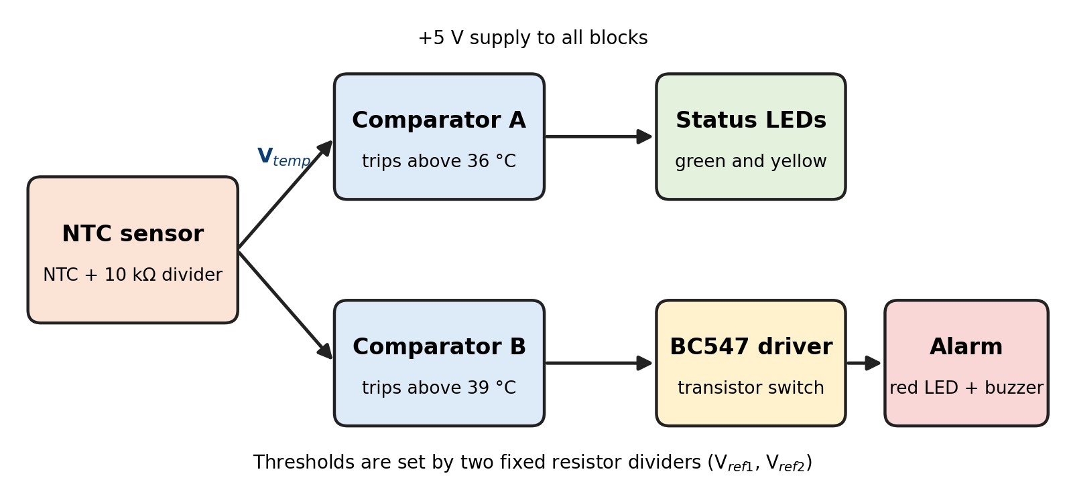
Fig. 3.1 Block diagram of the Crop Heat-Stress Warning System

3.2 Components used
S.No. | Component | Value / Type | Function
1 | NTC thermistor | 10 kΩ at 25 °C, β = 3950 | Temperature sensing
2 | Operational amplifier | LM358 (dual) | Two voltage comparators
3 | Transistor | BC547 (NPN) | Switch for red LED and buzzer
4 | LEDs | Green, yellow, red (5 mm) | Status indication
5 | Buzzer | 5 V active buzzer | Audible alarm
6 | Resistors | 10 kΩ (3), 6.2 kΩ, 5.6 kΩ,  470 Ω (2), 330 Ω, 1 kΩ | Dividers, current limiting, base resistor
7 | Power supply | 5 V DC | Supply for the circuit
8 | Breadboard and wires | — | Assembly of the prototype

Table 3.1 List of components

3.3 Design calculations
Temperature sensor. The resistance of an NTC thermistor at an absolute temperature T is given by the β equation:
R_{NTC} = R₀ · exp [ β ( 1/T − 1/T₀ ) ]
where R₀ = 10 kΩ at T₀ = 298.15 K (25 °C) and β = 3950 K. The thermistor is connected between +5 V and the sensing node, with the 10 kΩ resistor R1 from the node to ground. The sensed voltage therefore increases as the temperature rises:
V_{temp} = V_{CC} · R1 / ( R_{NTC} + R1 )
Reference voltages. The thresholds are produced by two fixed dividers connected across the 5 V supply:
Vref = VCC · Rbottom / ( Rtop + Rbottom )
For the warning threshold, R2 = 6.2 kΩ and R3 = 10 kΩ give V_{ref1} = 5 × 10 / 16.2 = 3.09
V. For the danger threshold, R4 = 5.6 kΩ and R5 = 10 kΩ give V_{ref2} = 5 × 10 / 15.6 =
3.21 V. Using the β equation, these voltages correspond to a thermistor resistance of 6.2 kΩ and 5.6 kΩ, that is, temperatures of about 36.2 °C and 38.6 °C. These are rounded to 36 °C and 39 °C in this report.
Output stage. The LM358 output can swing up to about V_{CC} − 1.5 V = 3.5 V when high. For the green LED (forward drop about 2 V) the current through R6 = 470 Ω is about (5 − 2 − 0.1) / 470 ≈ 6 mA. For the red LED, R9 = 330 Ω limits the current to about (5 − 2 − 0.2) / 330 ≈ 8.5 mA. The transistor base current is (3.5 − 0.7) / 1 kΩ ≈ 2.8 mA, which is far more than the 0.3 mA needed to saturate the BC547 for a buzzer that draws about 30 mA, so the transistor works as a proper switch.

3.4 Circuit diagram
The complete circuit is shown in Fig. 3.2. The NTC and R1 form the sensing divider. Resistors R2–R3 and R4–R5 form the two reference dividers. V_{temp} is applied to the non-inverting input (pin 3) of Comparator A and to the non-inverting input (pin 5) of Comparator B, while V_{ref1} is applied to the inverting input (pin 2) of A and V_{ref2} to the inverting input (pin 6) of B. Pin 8 of the LM358 is connected to +5 V and pin 4 to ground.
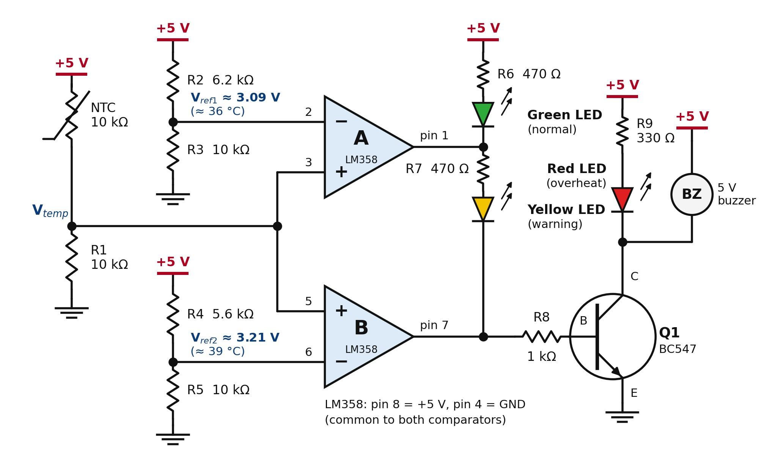
Fig. 3.2 Circuit diagram of the Crop Heat-Stress Warning System

3.5 Working principle
The green LED is connected between +5 V and the output of Comparator A, so it lights when this output is low. The yellow LED is connected between the outputs of Comparator A and Comparator B, so it lights only when A is high and B is low. The red LED and the buzzer are connected between +5 V and the collector of Q1, which conducts when the output of Comparator B is high. The three operating conditions are summarised in Table 3.2.
Condition | Output A (pin 1) | Output B (pin 7) | Q1 | Indication
Vtemp < Vref1 (below 36 °C) | Low | Low | OFF | Green LED ON (normal)
Vref1 < Vtemp < Vref2 (36–39 °C) | High | Low | OFF | Yellow LED ON (warning)
Vtemp > Vref2 (above 39 °C) | High | High | ON | Red LED and buzzer ON (danger)

Table 3.2 Operating conditions of the circuit

4.IMPLEMENTATION

4.1 Hardware assembly
The circuit was assembled on a breadboard in the following order. Step 1: the LM358 was placed in the centre of the breadboard and pin 8 and pin 4 were connected to the +5 V and ground rails. Step 2: the sensing divider was built by connecting the 10 kΩ NTC between +5 V and the sensing node and R1 (10 kΩ) from that node to ground; the node was connected to pins 3 and 5. Step 3: the two reference dividers (6.2 kΩ / 10 kΩ and 5.6 kΩ / 10 kΩ) were built and their mid-points were connected to pin 2 and pin 6 respectively. Step 4: the green LED with R6, and the yellow LED with R7 between pin 1 and pin 7, were connected as shown in Fig. 3.2. Step 5: the base of the BC547 was connected to pin 7 through the 1 kΩ resistor, its emitter to ground, and the red LED with R9 and the buzzer were connected to +5 V and the collector.
The NTC thermistor was mounted on about 15 cm of flexible wire so that it can be placed away from the circuit and near the plants, and its leads were insulated with heat-shrink tubing.

4.2 LM358 pin connections
Pin | Name | Connection
1 | Output A | Green LED (through R6) and yellow LED (through R7)
2 | Inverting input A | V_{ref1} (mid-point of R2 and R3)
3 | Non-inverting input A | V_{temp} (mid-point of NTC and R1)
4 | GND | Ground
5 | Non-inverting input B | Vtemp
6 | Inverting input B | V_{ref2} (mid-point of R4 and R5)
7 | Output B | Yellow LED cathode and base of Q1 (through R8)
8 | VCC | +5 V

Table 4.1 Pin connections of the LM358

4.3 Testing procedure
After checking all connections with a multimeter, the 5 V supply is switched on. At room temperature the green LED should glow. The thermistor is then heated gradually, using the warm air of a hair dryer on a low setting kept 10–15 cm away from the sensor, or by dipping the insulated sensor in a cup of warm water. A thermometer placed beside the sensor is used for reference. The voltage at the sensing node is measured with the multimeter, and the temperature at which the yellow LED and then the red LED with the buzzer switch on is noted. The sensor is then cooled with a fan or a wet cloth to check that the indication returns to yellow and then to green.
Precautions. A naked flame such as a lighter must not be used, because it can overheat and damage the thermistor and melt the breadboard and wires. The insulation of the thermistor leads must be intact before dipping it in water, and the heater or dryer must be kept away from the breadboard.

5.RESULT AND DISCUSSION

5.1 Response of the circuit
The calculated thermistor resistance and sensing voltage for different temperatures, together with the expected indication, are given in Table 5.1. The last column is provided for recording the voltage measured with the multimeter during testing.
Temperatu re (°C) | R_{NTC} (kΩ) calculated | Vtemp (V) calculated | Expected indication | Vtemp (V)  measured
25 | 10.00 | 2.500 | Green | 2.4
30 | 8.04 | 2.772 | Green | 2.3
33 | 7.07 | 2.928 | Green | 2.5
36 | 6.24 | 3.079 | Green / Yellow edge | 3.3
39 | 5.52 | 3.222 | Red + buzzer | 3.6
42 | 4.89 | 3.357 | Red + buzzer | 3.2
45 | 4.35 | 3.485 | Red + buzzer | 3.1

Table 5.1 Calculated response of the NTC divider
Fig. 5.1 plots the calculated sensing voltage against temperature together with the two reference voltages. The green region lies below 36.2 °C, the yellow region between 36.2 °C and 38.6 °C and the red region above 38.6 °C.
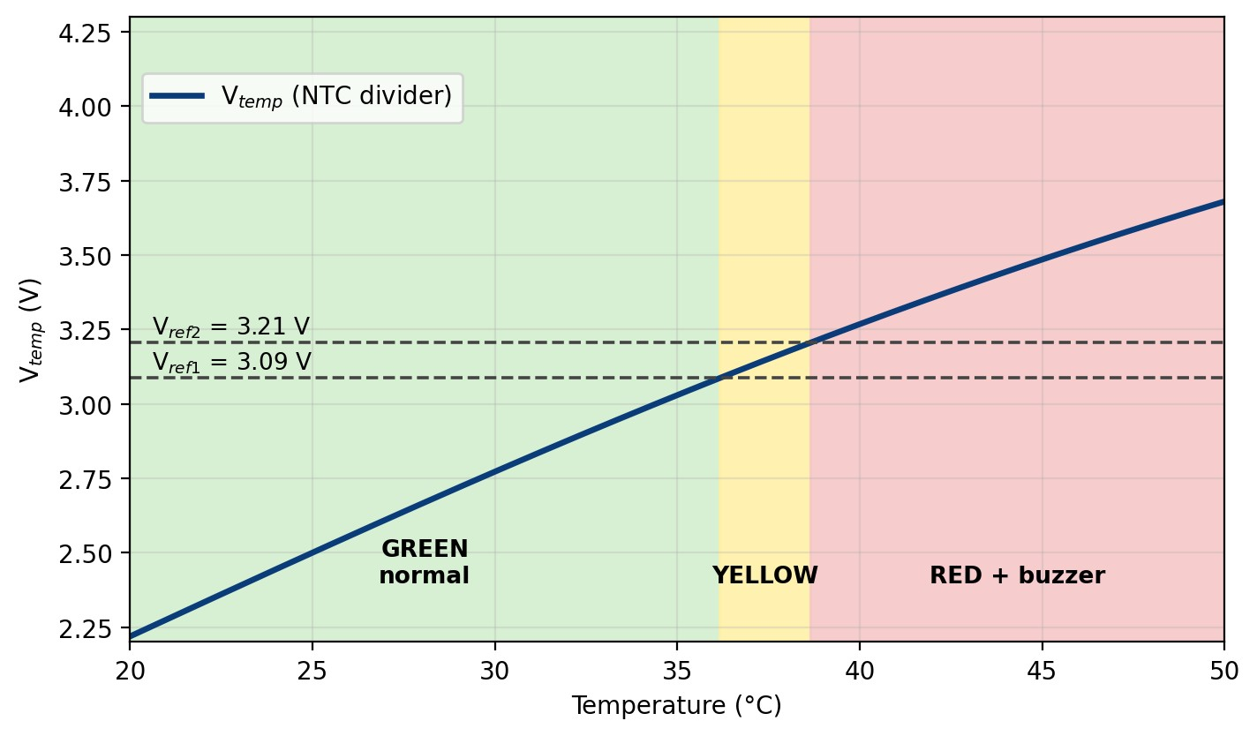
Fig. 5.1 Sensing voltage V_{temp} versus temperature with the two thresholds

5.2 Discussion
The circuit follows the three-level behaviour of Table 3.2. Because the reference voltages are produced by fixed resistor dividers, no potentiometer adjustment or calibration is required: the circuit works as soon as it is assembled with the specified component values. The use of both halves of one LM358 and a single BC547 keeps the component count and the cost low, and the absence of a microcontroller makes the system easy to build, repair and understand.
Some limitations were identified. (i) The comparators have no hysteresis, so the indication may flicker if the temperature stays exactly at a threshold. (ii) The exact switching temperatures depend on the tolerance of the thermistor and the resistors, and may differ by about 1–3 °C from the calculated values. (iii) The LM358 output does not rise to the full supply voltage, so the yellow LED, which is driven from the output of A at about 3.5 V, glows less brightly than the green LED. (iv) The prototype measures air temperature only and does not account for soil temperature, humidity or the type of crop.

5.3 Future scope
The circuit can be improved by adding positive feedback (for example a 1 MΩ resistor from output to the non-inverting input) to introduce hysteresis, by using a waterproof thermistor probe for field use, by powering the circuit from a small solar panel and battery, by replacing the fixed dividers with preset potentiometers for crop-specific thresholds, and by adding a GSM or wireless module to send an alert to the farmer.

5.4 Conclusion
A low-cost, microcontroller-free Crop Heat-Stress Warning System was designed using an NTC thermistor, an LM358 dual comparator and a BC547 transistor. The system gives a clear green, yellow and red indication, with an audible alarm in the danger zone, using fixed thresholds of about 36 °C and 39 °C, and requires no calibration. The project demonstrates the practical use of thermistor characteristics, voltage dividers, comparators and transistor switching, and can serve as a base for a more complete crop-monitoring system.

BELOW 36 DEGREE CELCIUS:

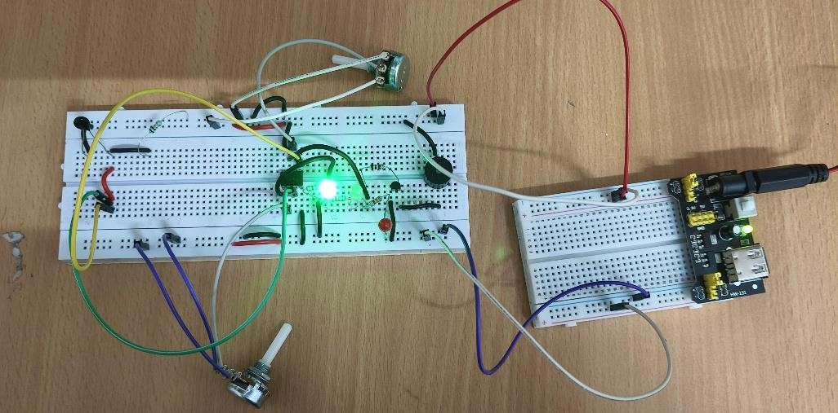

BETWEEN 36 TO 39 DEGREE CELCIUS

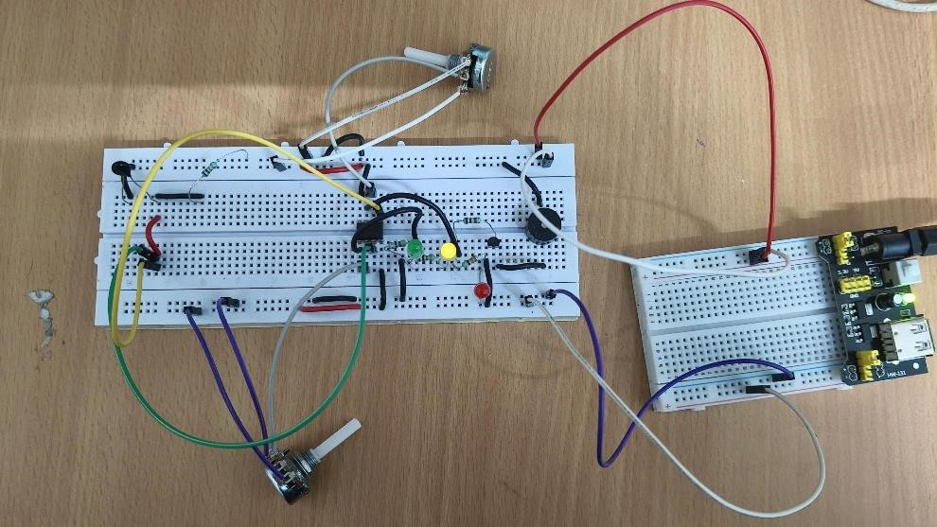

ABOVE 39 DEGREE CELCIUS


