Software Requirements Specification

for

Spa Salon Management System

Version 1.0 approved

Prepared by VyCNN, TuNHM

October 26, 2020

**Table of Contents**

1. Introduction 1

1.1 Purpose 1

1.2 Document Conventions 1

1.3 Project Scope 1

1.4 References 1

2. Overall Description 1

2.1 Product Perspective 1

2.2 User Classes and Characteristics 2

2.3 Operating Environment 3

2.4 Design and Implementation Constraints 3

2.5 Assumptions and Dependencies 3

3. System Features 3

3.1 Remind customer 3

3.2 Make an appointment 4

3.3 Manage Products: 6

4. Data Requirements 8

4.1 Logical Data Model 8

4.2 Data Dictionary 8

5. External Interface Requirements 13

5.1 User Interfaces 13

5.2 Software Interfaces 13

5.3 Hardware Interfaces 13

5.4 Communications Interfaces 14

6. Quality Attributes 14

6.1 Usability 14

6.2 Performance 14

6.3 Security 14

6.4 Safety 14

6.5 Availability Requirements 14

6.6 Robustness Requirements 15

7. Internationalization and Localization Requirements 15

8. Other Requirements 15

Revision History

|  |  |  |  |
| --- | --- | --- | --- |
| **Name** | **Date** | **Reason For Changes** | **Version** |
| VyCNN and TuNHM | 10/05/2020 | Initial draft | 1.0 draft 1 |
| VyCNN and TuNHM | 10/26/2020 | baseline following changes after inspection | 1.0 approved |

# Introduction

## Purpose

This SRS describes the functional and nonfunctional requirements for software release 1.0 of the Spa Salon Management System (SSMS). This document is intended to be used by the members of the project team who will implement and verify the correct functioning of the system. Unless otherwise noted, all requirements specified here are committed for release 1.0.

## Document Conventions

No special typographical conventions are used in this SSMS.

## Project Scope

The SSMS will permit Process Impact customers to book appointment and assist manage operation effectively. A detailed description is available in the *Spa Salon Management System Vision and Scope Document* [1], along with the features that are scheduled for full or partial implementation in this release.

## References

1. Wiegers, Karl. *Cafeteria Ordering System Vision and Scope Document*, www.processimpact.com/projects/COS/COS Vision and Scope.docx

# Overall Description

## Product Perspective

The Spa Salon Management System is a new software system that replaces the current manual and telephone processes for booking appointment or the process of long waiting at spa salons. The feature tree in Figure 1 illustrates major features for release 1.0. The system is expected to connect different spa salons.

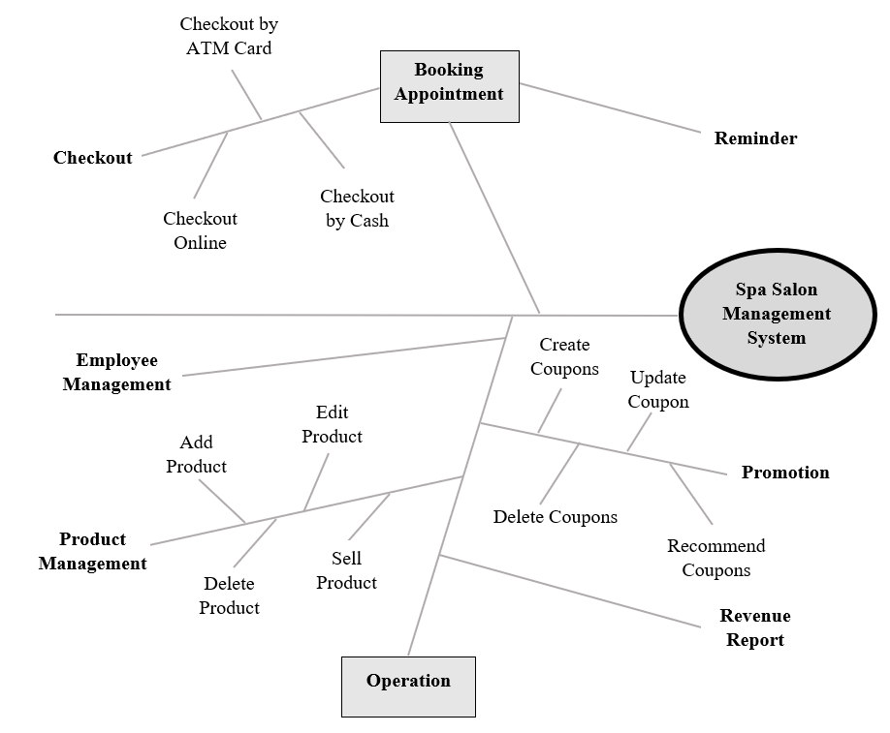

Figure 1. Partial feature tree for the Spa Salon Management System.

## User Classes and Characteristics

|  |  |
| --- | --- |
| Customer | A customer who will book appointments remotely and can receive notification with the purpose of reminding about his or her booking before 1 day. Moreover, the customer can choose the suitable payment when checking out. |
|  |  |
| Spa Staff | The spa staff can choose their own schedule and help the customer to book appointments if they come to spa and booking directly. Moreover, they can manage the product in stock to import and sale products in stock. |
| Spa Manager | The Spa Manager establishes and maintains promotions and coupons. As well as, the Spa Manager can manage the products in stock. The Spa Manager will be the one who manages the schedule of employees when booking schedule has conflict and see the report of revenue. |
| System Handler | The System Handler automatically reports the activities of products and employees daily and revenue monthly. Every day, the System Handler checks appointment and notify to customers. Based on the information and the activities of customers, the System Handler recommends products and promotion for customers. |
|  |  |

## Operating Environment

OE-1: The spa management system shall operate correctly with the following web browsers: Google Chrome (all versions), Microsoft Edge (all versions), Fire Fox version 12 to lasted version, Apple Safari version 4.0 to lasted version.

OE-2: The spa management system shall permit user access from the internet connection and by the Android, iOS smartphones and tablet.

OE-3: The spa management system shall operate on the server running by Amazon Web Services.

## Design and Implementation Constraints

CO-1: All HTML code shall conform to the HTML 5.0 standard.

CO-2: The system shall use the current corporate standard SQL Server database engine.

CO-3: The design of system code, and document maintenance shall conform to the Process Impact Intranet Development Standard, Version 1.3.

## Assumptions and Dependencies

AS-1: Application with appropriate user interfaces will be available for spa managers, employees and customers to process booking and manage spa.

AS-2: Appointments must be updated on a regular basis so that the customer can easily take appointments accordingly and also the customer’s data must be updated after checkout.

AS-3: On – taking appointments date and time must be shown for staff and notified for customers before 1 days.

# System Features

## Remind customer

|  |  |  |  |
| --- | --- | --- | --- |
| ID and Name: | **UC-1 Remind customer** | | |
| Created By: | Nhật Vy | Date Created: | 9/10/20 |
| Primary Actor: | Customer | Secondary Actors: | System Handler |
| Description: | A Customer books an appointment. The system will notify his 1 day before the appointment. | | |
| Trigger: | None. | | |
| Preconditions: | PRE-1. Customer gives his information when booking.  PRE-2. Customer confirms his appointment. | | |
| Postconditions: | POST-1. Message is stored in the system with a status of “Send”. | | |
| Normal Flow: | 1. Every day, the system checks all appointments for tomorrow. 2. System send a message to the customer. 3. The system updates the status of the appointment to “send”. | | |
| Alternative Flows: | None. | | |
| Exceptions: | Customers can go to the spa before the day of booking, the staffs need to update manually in the system. | | |
| Business rules | The system needs to send a message before 6:00 pm. | | |

## Make an appointment

|  |  |  |  |
| --- | --- | --- | --- |
| ID and Name: | **UC-2 Make an appointment** | | |
| Created By: | Minh Tú | Date Created: | 9/10/20 |
| Primary Actor: | Customer | Secondary Actors: | System Handler |
| Description: | The customer uses the spa mobile application to access the spa system management to view the list of available slots. The customer chooses the appropriate slot and sets up an appointment. An appointment and customer information will be added into the system database and the slot which customer picked will be marked as unavailable. | | |
| Trigger: | A Customer accesses the system by mobile application to book an appointment. | | |
| Preconditions: | PRE-1. Customer gives his information when booking.  PRE-2. Customer confirms his appointment. | | |
| Postconditions: | POST-1. Appointment slot is updated with a status as “unavailable”. | | |
| Normal Flow: | 1. **Booking an appointment** 2. The application will show a calendar for the customer to pick appropriately. The date which had full of booked slots will be marked as “invalid” and customers can't pick these dates. 3. The application displays the list of slots in a day that the customer selected. The slots that have been picked will be marked as “invalid” and the customers can not choose these slots. 4. The application displays the day and slot that the customers picked and information of the customers. 5. The customer confirms acceptance of an appointment. 6. SSMS stored the appointment and customer information into the database and updated the slots customer booked and “invalid”. | | |
| Alternative Flows: | None | | |
| Exceptions: | **1.0.E1 slow network leads to many customers can confirm the same slots at the same time.**  If the SSMS gets the same slots appointment, the SSMS will save the first appointment and send the message to order customers and inform them about the termination of the making appointment. | | |
| Business rules | * The customer cannot cancel booking within 2 days before the day of booking. * Permittingto book an appointment monthly. | | |

## Manage Products:

|  |  |  |  |
| --- | --- | --- | --- |
| ID and Name: | **UC-3 Manage Product** | | |
| Created By: | Minh Tú | Date Created: | 26/10/20 |
| Primary Actor: | Manager  Employee | Secondary Actors: | System Handler |
| Description: | Manager and employees access the SMS to view the list of products. Manager and employees choose a product they want to update information and update its data. The new product information will be updated in the SMS database. The SMS also records the information of the update into the database. | | |
| Trigger: | Manager and employees have to login the SMS with an account employee or manager to manage products. | | |
| Preconditions: | PRE-1. Employees or manager login to the SMS.  PRE-2.Employees or manager confirm the update information they changed. | | |
| Postconditions: | POST-1. New information of the product is updated.  POST-2. Information about the update will be recorded into the database. | | |
| Normal Flow: | 1. **Update product.**    1. The SMS will show a list of products in the database for manager or employees to pick the one that they want to update.    2. The SMS displays the information of the product.    3. Manager or employees change the information of the products.    4. The SMS displays the new information of the product for manager or employees to review and confirm.    5. The SMS updates the new product information into the database and also adds a record about information of the latest updated into the ProductLog table. | | |
| Alternative Flows: | None | | |
| Exceptions: | 1. **The manager or employees update the product with inappropriate data.**    1. If the product's new quantity is assigned with the value is less than 0. SMS will not update the new information and redirect to the update product page and show the error dialog about the inappropriate quantity.    2. If the product's new expiration date is assigned with the date before the current date. SMS will not update the new information and redirect to the update product page and show the error dialog about the inappropriate expiration date. | | |
| Business Rules: | * Product’s quantity in stock must be greater than 0. * Product’s expiration date must be the date after the current date. | | |

# Data Requirements

## Logical Data Model

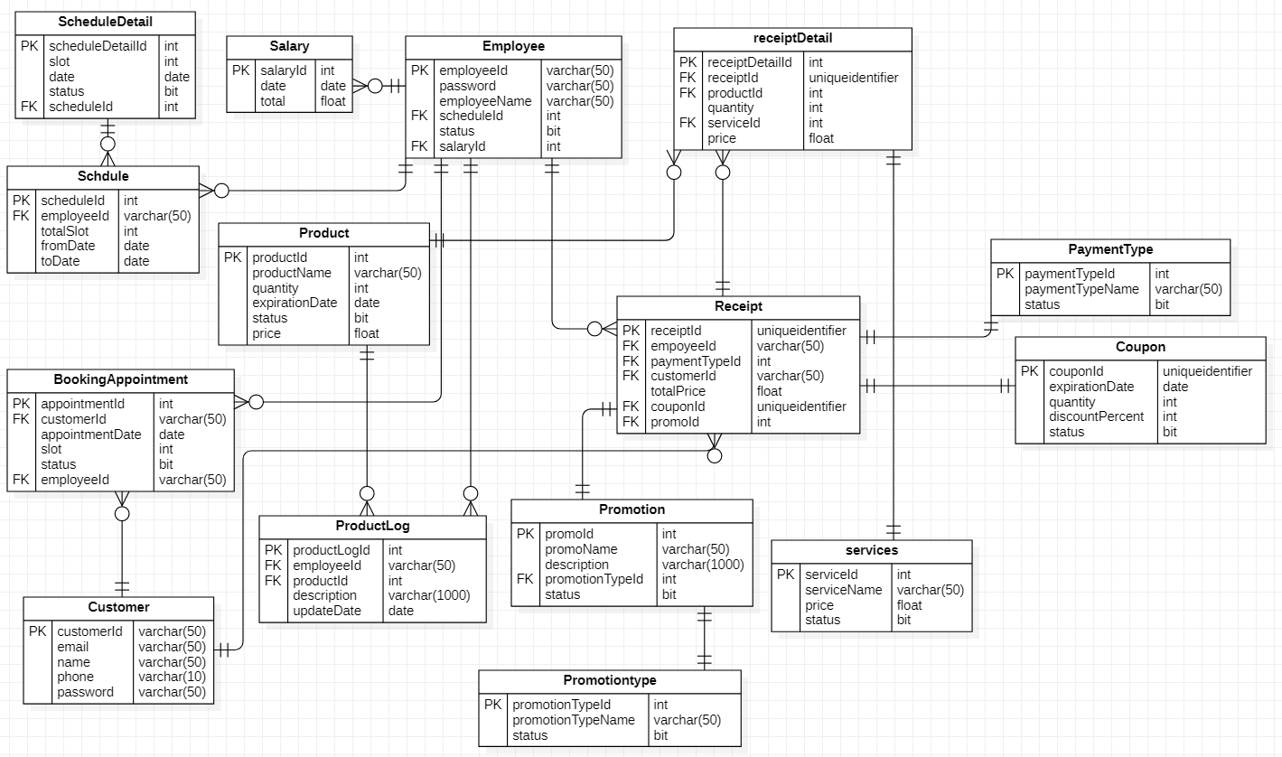

## Data Dictionary

|  |  |  |  |  |
| --- | --- | --- | --- | --- |
| Data Element | Description | Composition or Data Type | Length | Values |
| Customer | Record information of customer  Which consists of customer id, name, email, phone. | Customer   * customerId * Email * Name * Phone * password |  |  |
| customerId | Id of the customer who booked appointment and check out. | alphanumeric | 50 |  |
| email | Customer’s email. | alphanumeric | 50 |  |
| name | Customer’s full name. | alphabetic | 50 |  |
| phone | Customer’s phone number. | integer | 10 |  |
| password | Customer’s account password to login mobile application. | alphanumeric | 50 |  |
| BookingAppointment | Record information of booked appointment. | BookingAppointment   * appointmentId * customerId * appointmentDate * Slot * status * employeeId |  |  |
| appointmentId | Id number of booked appointments. | Integer |  |  |
| customerId | Id of customer who booked appointment. | alphanumeric | 50 |  |
| appointmentDate | Date of booked appointment. | date | yyyy/MM/dd | Min date = current date |
| slot | slot number of booked appointments. | Integer |  | Min = 1, max = 6 |
| Customer.status | status of booked appointment. Status is false and the booking date has not passed shows that the appointment had been canceled. | bit |  | Default = true |
| employeeId | Id employee who booked this appointment for customer if customer come to spa and booked directly. Employee’s Id to login the system. | alphanumeric | 50 |  |
| Employee | Record information of employee | Employee   * employeeId * password * employeeName * scheduleId * status * salaryId |  |  |
| Employee.password | Employee’s password to login the system. | alphanumeric | 50 |  |
| employeeName | Employee’s full name | alphabetic | 50 |  |
| scheduleId | Employee’s schedule id. | Integer |  |  |
| Employee.status | Employee’s status. Status = false means employees no longer working for spa system. | bit |  | Default = false |
| salaryId | Employee’s salaryId. | Integer |  |  |
| Salary | Record information about employee’s salary each month. | Salary   * salaryId * date * total |  |  |
| Salary.date | Employee’s salary summary date each month. | date |  |  |
| Salary.total | Employee’s total salary each month. | float |  |  |
| Schedule | Record information about employee’s schedule each month. | Schedule   * scheduleId * employeeId * totalSlot * fromDate * toDate |  |  |
| totalSlot | Total number of slot that employee sign up to do each month. | Integer |  |  |
| fromDate | Starting date of schedule. | date |  |  |
| toDate | Ending date of schedule | date |  |  |
| ScheduleDetail | Record information date and slot in employee’s schedule | ScheduleDetail   * scheduleDetailId * slot * date * status * schedualId |  |  |
| scheduleDetailId | Id of scheduleDetail record. | Integer |  |  |
| ScheduleDetail.slot | Slot of ScheduleDetail record | int |  | Min = 1, max = 6 |
| ScheduleDetail.date | Date of ScheduleDetail record | date |  |  |
| ScheduleDetail.status | Status of ScheduleDetail record. Status is true means employee had working in these slots. Status is false means working date has not yet come or employess had not working. | bit |  |  |
| Product | Record information of product in stock. | Product   * productId * productName * quantity * expirationDate * status * price |  |  |
| productId | Id number for product. | Integer |  |  |
| productName | Product’s name. | alphanumeric | 50 |  |
| quantity | Current number of products in stock. | Integer |  |  |
| Product.status | Product’s status. Status is true means spa are still trading this item. Status is false means are no longer trading this item or its out of stock. | bit |  | Default = true |
| Product.price | Product’s price | float |  |  |
| ProductLog | Record the information for each time update product | ProductLog   * productLogId * employeeId * productId * description * updateDate |  |  |
| ProductLog.employeeId | Employee’s id who updated product. | alphanumeric | 50 |  |
| ProductLog.description | Description for updated product. | alphanumeric | 50 |  |
| updateDate | Date which product updated | date |  |  |
| Receipt | Record the information of receipt. | Receipt   * receiptId * employeeId * paymentTypeId * customerId * totalPrice * couponId * promoId |  |  |
| receiptId | Unique Id of receipt. | uniqueidentifier |  |  |
| paymentTypeId | Id of payment type customer chose. | Integer |  |  |
| totalPrice | Total price of receipt. | float |  |  |
| couponId | Id of coupon if customer used. | uniqueidentifier |  |  |
| promoId | Numeric id of promotion if customer had. | Integer |  |  |
| ReceiptDetail | Record products or services of each receipt. | ReceiptDetail   * receiptDetailId * receiptId * productId * quantity * serviceId * price |  |  |
| receiptDetailId | Numeric Id of receipt detail. | Integer |  |  |
| ReceiptDetail.quantity | Quantity of product or service of each record. | Integer |  |  |
| ReceiptDetail.price | Price of product or service of each record. | float |  |  |
| Service | Record information of services of spa. | Service   * serviceId * serviceName * price * status |  |  |
| serviceId | Numeric Id of service. | Integer |  |  |
| serviceName | Name of service. | alphabetic | 50 |  |
| Service.price | Price of service. | float |  |  |
| Service.status | Status of service. | bit |  | Default = true |
| PaymentType | Record information about payment type spa have. | PaymentType   * paymentTypeId * paymentTypeName * status |  |  |
| paymentTypeId | Id of payment type. | Integer |  |  |
| paymentTypeName | Payment type name. | alphanumeric | 50 |  |
| PaymentType.status | Status of payment type. | bit |  | Default = true |
| Promotion | Record information of spa’s promotion. | Promotion   * promoId * promoName * description * promotionTypeId * status |  |  |
| promoId | Numeric id of promotion. | Integer |  |  |
| promoName | Promotion’s name. | alphanumeric | 50 |  |
| Promotion.description | Description about promotion. | alphanumeric | 1000 |  |
| promotionTypeId | Numeric id of promotion type. | Integer |  |  |
| PromotionType | Record information about spa’s promotion type. | Promotion   * promotionTypeId * promotiontypeName * status |  |  |
| promotionTypeName | Name of promotion type. | alphanumeric | 50 |  |
| PromotionType.status | Status of promotion type. | bit |  |  |
| Coupon | Record information of spa’s coupon. | Coupon   * couponId * expirationDate * quantity * discountPercent * status |  |  |
| Coupon.expirationDate | Date coupon expiration. | date |  |  |
| Coupon.quantity | Quantity available of coupon. | Integer |  |  |
| discountPercent | Amount percent that coupon discount. | Integer |  |  |
| Coupon.status | Status of coupon. | bit |  |  |

# External Interface Requirements

## User Interfaces

UI-1: The Spa Salon Management System screen displays shall conform to the *Process Impact Internet Application User Interface Standard, Version 2.0* [3].

UI-2: The system shall provide a help link from each displayed webpage to explain how to use that page.

UI-3: The webpages shall permit complete navigation, product item selection and button to book appointment by using the keyboard alone, in addition to using mouse and keyboard combinations.

## Software Interfaces

SI-1: Booking Appointment System

SI-1.1: The SSMS shall show the available slots to user interface through a programmatic interface.

SI-1.2: When customers book an appointment, the SSMS stores in database and changes the status of this slot “unavailable”.

SI-1.3: The SSMS sends message to customers to reminder them about their appointment before 1 day and change status in database “send”.

SI-2: Product Management System

SI-2.1: The SSMS allows manager insert new products to save in database.

SI-2.2: The SSMS allows employees and manager modify products then saving them in database.

SI-2.3: When customers buy products, the quantity of these products reduce automatically in database.

SI-3: Checkout System

SI-2.1: The SSMS connect to all banks to allow customers pay.

SI-2.2: The SSMS connect to all banks to allow customers pay.

## Hardware Interfaces

No hardware interfaces have been identified.

## Communications Interfaces

CI-1: The COS shall send an email or text message (based on user account settings) to the customers to remind their appointment before 1 day.

CI-2: The COS shall send an email or text message (based on user account settings) to the Patron to recommend about promotion.

# Quality Attributes

## Usability

USE-1: All new customers shall be able to register account without any problems.

USE-2: 95% of new customers shall be able to successfully book an appointment without errors on their first try.

## Performance

PER-1: The system shall accommodate a total of 300 users and a maximum of 100 concurrent users during the peak usage time window, local time, with an estimated average session duration of 8 minutes.

PER-2: 95% of webpages generated by the SSMS shall download completely within 4 seconds from the time the user requests the page over a 20Mbps or faster Internet connection.

PER-3: The system shall display reminder messages to users before 6P.M.

## Security

SEC-1: All network transactions that involve financial information or personally identifiable information shall be encrypted per SHA-256.

SEC-2: Customers, employees and managers shall be required to log on to the SSM for all operations.

SEC-3: Only authorized Managers shall be permitted to work with coupons, promotion and revenue report.

SEC-4: The system shall permit customers to update their information.

## Safety

SAF-1: The user shall be able to see a list of all ingredients in any product items, with ingredients highlighted that are known to cause allergic reactions.

## Availability Requirements

AVL-1: The SSMS shall be available at least 98% of the time between 5:00 A.M. and midnight local time and at least 90% of the time between midnight and 5:00 A.M. local time, excluding scheduled maintenance windows.

## Robustness Requirements

ROB-1: If the connection between the user and the SSMS is broken prior to a new appointment or buying products being either confirmed or terminated, the COS shall enable the customer to recover an incomplete appointment or the process of buying products and continue working on it.

# Internationalization and Localization Requirements

The SSMS is currently use for spa salon in Vietnam, so the currency is VND and date according to UTC+7.

# Other Requirements

Appendix A: Analysis Models

