**Deploy Program**

Cd to the python folder,and run the python file



**Menu Panel:**

Users can select the page in the menu bar.

**Penalty Page:**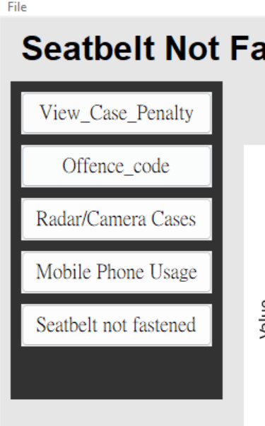

Choose the start data and end date, the system will auto fetch the data.

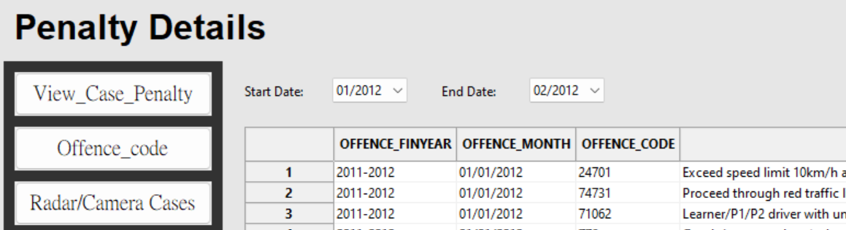

**Offence Code Trend Page:**

Select the start and end data ,and enter the code number ,and click the generate trend. The chart will auto display.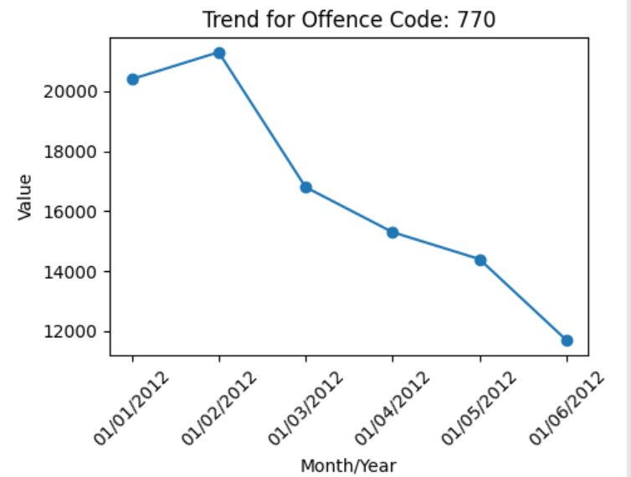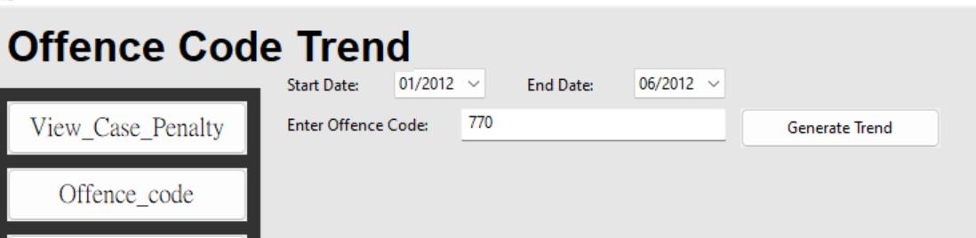

**Radar and Camera Page:**

It also selects the start and end date,and clicks the retrieve cases button to display the data.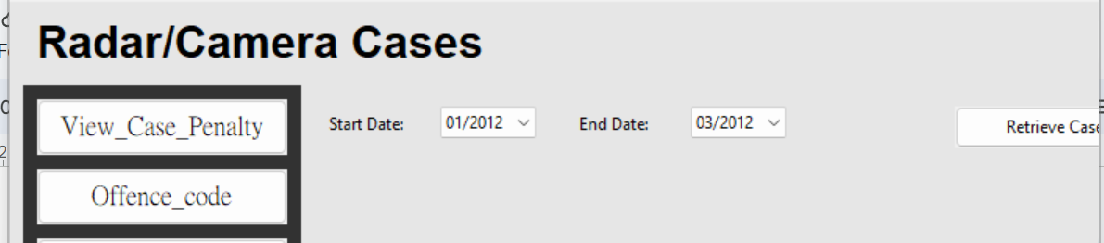

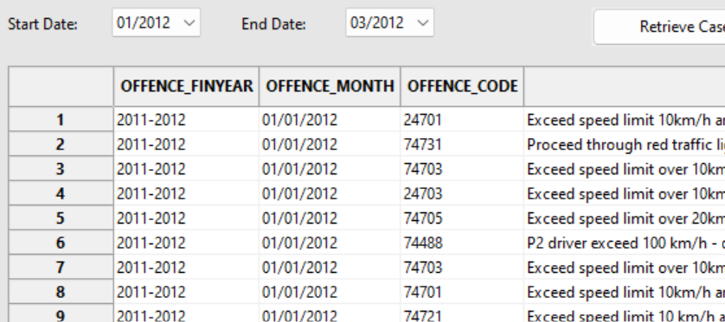

**Mobile Phone Usage Trend:**

Select the start and end date, and click generate mobile trend to show the chart.

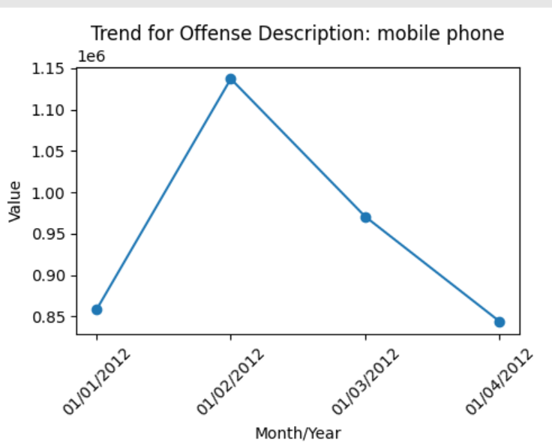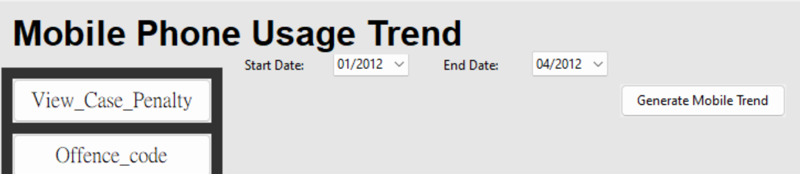

**Seatbelt Not Fastened Page:**

Select the start and end date, and click generate trend to show the chart.