# COMP 135

# Human-Computer Interface Design

# 

# Meal Planning

# Project Proposal

# 

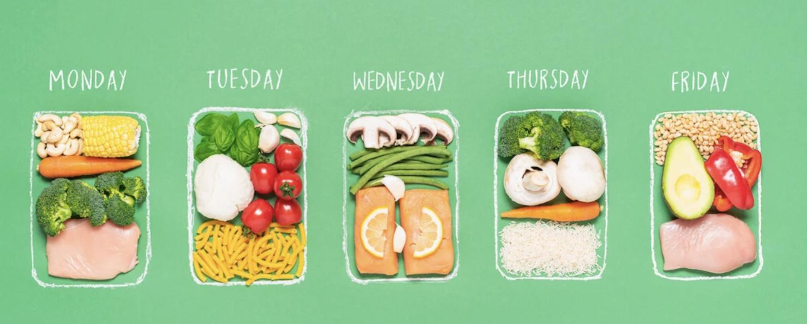

February 3, 2023

Aisha Thompson-Jones

Santi Gutierrez

Vy Nguyen

Marissa Morones

Miguel Contreras

**Proposal**

**What is the problem in brief?**

* Not having enough time to plan an entire week of meals
* Not being able to come up with a healthy eating plans with enough nutritions
* Not enough budget to follow meal plans on the Internet
* Not enough options for diets, such as vegetarian and keto, and for those with diet restrictions, such as low fodmap.

**How will your project change the status quo? For whom?**

* The meal planning website will be more accessible and have options for healthier options to choose from.
* Our target audience is college students and those who need assistance with meal planning and help with maintaining a healthier lifestyle.
  + As college students, we do not always have time to plan out meal plans and this app will assist with planning
* Additional audiences would be college students who live certain lives with different hobbies / play sports / work.

**What is (at least) one naïve design idea (rough sketch)? How does this idea address what you see as the core problem?**

We plan to create a prototype for an app that can have the following features:

* Add ingredients to a grocery list from the desired food prep item.
* Some ingredients may only be found in certain stores, so we could provide a link to the grocery store that carries the item.
* Show nutritional information for each meal
* Plan meals for every day in the week
* Create your own recipe and share with friends

**What information do you need to collect? How will you collect it? How will you meet your target users, or who can serve as effective proxies for them?**

* We need to know meal preferences.
* Diet Restrictions/ Food allergies
* We would do research on the internet to look for the current most popular diet plans.
* Creating multiple surveys with different audiences to gather enough information on types of foods and nutritional preference.
* We would perform interviews and ask what the top 3 preferences are when it comes to their specific diet needs.

**How will your team work together to accomplish these goals (as well as your individual learning goals)?**

* Our team's goal is to end up with a well organized prototype that meets the users needs.
* In order to accomplish our goals we would need to work together, efficiently, in gathering as much data as we can.
* My Individual goal is to be able to find enough data so that the users aren’t limited on their choices. - Santi