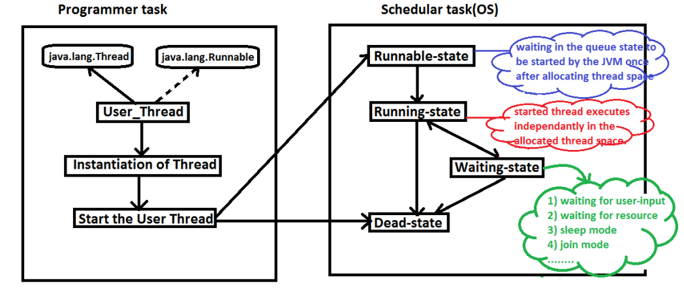

Types of Thread Applications:

1. Single Threaded Applications
2. Multi Threaded Applications

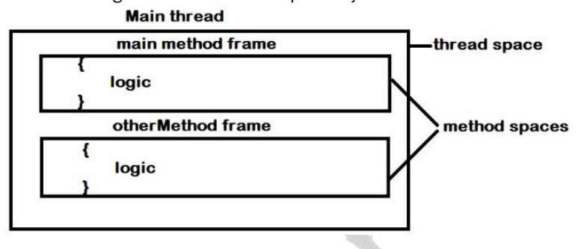

class SingleThreaded {

public static void main(String[] args) {

SingleThreaded obj = new SingleThreaded();

obj.printNumbers();

for(int j=1 ; j<=200 ; j++){

System.out.print("j : "+j+"\t");

}

}

void printNumbers(){

for(int i=1 ; i<=200 ; i++){

System.out.print("i : "+i+"\t");

}

}

}

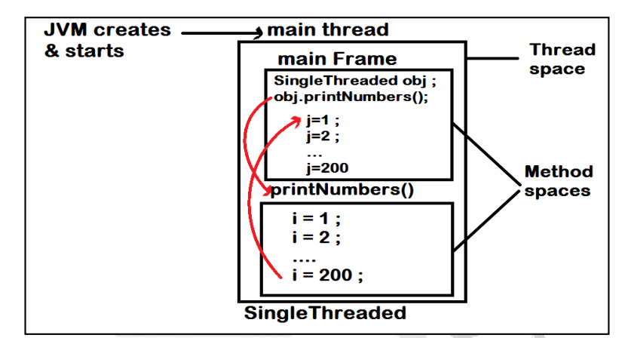

**Multi Threaded Application:**

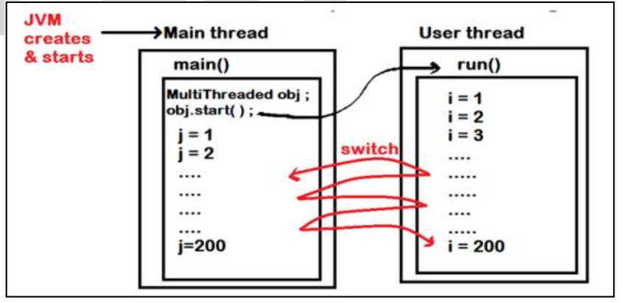

class MultiThreaded extends Thread{

public static void main(String[] args) {

MultiThreaded obj = new MultiThreaded();

obj.start();

for(int j=1 ; j<=200 ; j++)

{

System.out.print("j : "+j+"\t");

}

}

public void run(){

for(int i=1 ; i<=200 ; i++){

System.out.print("i : "+i+"\t");

}

}