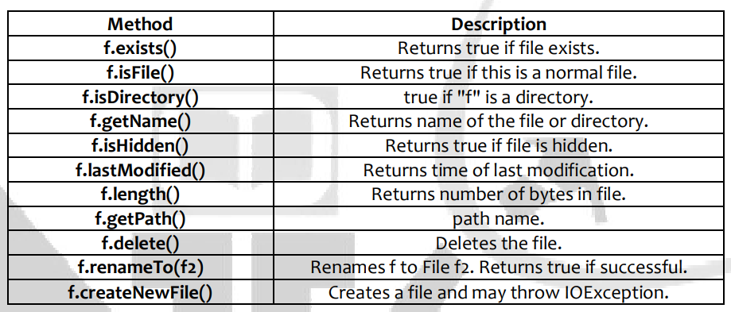

**Creating a File:**

import java.io.File ;

class CreateFile {

public static void main(String[] args) throws Exception{

File f = new File("g:/test.txt");

if(f.exists()){

System.out.println("File is present");

}

else{

f.createNewFile();

System.out.println("File created...");

}

}

**Creating directories:**

import java.io.*;

class CreateDirectory {

public static void main(String[] args) {

String s1 = "d:/test" ;

String s2 = "d:/test1/test2/test3";

File d1 = new File(s1);

File d2 = new File(s2);

if(d1.mkdir())

System.out.println(s1+" created...");

if(d2.mkdirs())

System.out.println(s2+" created...");

}

}

}

Deleting Files & Directories:

import java.io.File ;

class Deletion {

public static void main(String list[ ]) {

if(list.length == 0){

System.out.println("no input......");

}

else{

for(int i=0 ; i<list.length ; i++){

Deletion.fileRemove(list[i]); //calling method

}

}

}

static void fileRemove(String name){ //called method

File target = new File(name);

if(target.exists()){

if(target.delete())

System.out.println(name+" deleted...");

else

System.out.println("failed in deletion of "+name);

}

else{

System.out.println(name+" not present");

}

}

}

Renaming the file:

import java.io.File;

import java.io.IOException;

public class Rename {

public static void main(String[] argv) throws IOException {

File f = new File("F:/in.txt");

f.renameTo(new File("out.java"));

}

}

File copy:

import java.io.*;

public class Copy {

public static void main(String[] args) throws IOException {

File inputFile = new File("Copy.java");

File outputFile = new File("OutCopy.java");

FileReader in = new FileReader(inputFile);

FileWriter out = new FileWriter(outputFile);

int c;

while ((c = in.read()) != -1)

out.write(c);

in.close();

out.close();

}

}

Check if the file permission allows:

boolean canExecute(); – return true, file is executable; false is not.

boolean canWrite(); – return true, file is writable; false is not.

boolean canRead(); – return true, file is readable; false is not.

Set the file permission:

boolean setExecutable(boolean); – true, allow execute operations; false to disallow it.

boolean setReadable(boolean); – true, allow read operations; false to disallow it.

boolean setWritable(boolean); – true, allow write operations; false to disallow it.

import java.io.File;

public class SetWritableTest{

public static void main(String[] args)throws SecurityException {

File file = new File("ddd.txt");

if (file.exists()) {

boolean bval = file.setWritable(false);

System.out.println("set the owner's write permission: "+ bval);

} else {

System.out.println("File cannot exists: ");

}

}

}

**Hidden file: a file is considered to be hidden, if it’s marked as hidden in the file properties.**

import java.io.File;

import java.io.IOException;

public class FileHidden{

public static void main(String[] args) throws IOException{

File file = new File("FileHidden.java");

if(file.isHidden()){

System.out.println("This file is hidden");

}else{

System.out.println("This file is not hidden");

}

}

}