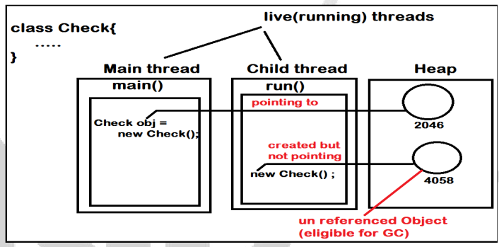

class GC1 {

File file ;

GC1(File file){

this.file = file ;

}

public static void main(String[] args) {

GC1 obj = new GC1(new File("test1.txt"));

new GC1(new File("test2.txt"));

}

protected void finalize(){

this.file.close();

}

}

