Cybersecurity Intrusion Detection Using Machine Learning
[Institution / University Name]
Course: ECSCI24302 - [Course title as per syllabus]
Team: [Team member names]
Supervisor: [Supervisor / Course coordinator]
Date: [Allotted date]

Abstract
A leak-free supervised pipeline detects malicious flows in the UNSW-NB15 official partitioned release: 175,341 raw training rows (deduplicated to 107,740) and 82,332 untouched testing flows. With identical leakage-controlled pipelines, the selected HistGradientBoosting (tuned) achieves on the testing partition accuracy 0.8712, precision 0.8154, recall 0.9903, F1 0.8944, ROC-AUC 0.9868 and average precision 0.9903 at a validation-chosen threshold of 0.480. Findings are reported honestly: 440 missed attacks (FNR 0.97%) but 10,164 false alarms (FPR 27.47%) - the official train/test distribution shift explains the FPR, and the leakage sensitivity check (4,247 shared exact flows, 5.16%; F1 0.8944 vs 0.8902 unique-only) quantifies the release's own inflation. Feature importance is reported with an explicit caveat: permuting sttl costs 0.3748 F1, but sttl is partly a schema artifact of the synthetic capture.

Table of Contents
- 1. Introduction and problem definition
- 2. Background and related work
- 3. Dataset and provenance
- 4. Methodology and leakage-control rules
- 5. Data quality audit
- 6. Exploratory data analysis
- 7. Model zoo and pipelines
- 8. Hyper-parameter tuning
- 9. Validation, selection and operating threshold
- 10. Evaluation on the untouched testing partition
- 11. Model comparison
- 12. Error analysis
- 13. Interpretation and caveats
- 14. Robustness, leakage sensitivity and limitations
- 15. Optional multi-class extension
- 16. Conclusion and future work
- 17. References and reproduction instructions

1. Introduction and problem definition
This project answers a single measurable question: on UNSW-NB15, how well can a leak-free supervised pipeline separate malicious from benign flows, and with what honest caveat on deployment readiness: the operational aim is to miss few attacks while reporting an honest false-alarm rate. The scope is an academic benchmark, NOT a production NIDS; generalisation claims stop at the dataset.

2. Background and related work
UNSW-NB15 (2015) established a benchmark that mixes real Waterloo and UNSW captures with synthetically generated modern attacks; the Moustafa & Slay papers describe design and statistical properties including the train/test distribution differences. Class imbalance work (SMOTE line) motivates class_weight choices. For legacy KDD99/CICIDS comparisons see the referenced survey literature. Structured trees follow Breiman (CART, Random Forests); gradient boosting follows Hastie et al.'s generic treatment.

3. Dataset and provenance
Official partitioned UNSW-NB15 release. Access page: https://www.kaggle.com/datasets/mrwellsdavid/unsw-nb15. The automated downloader (`python -m src.download_data`) fetches a row-count-verified mirror (https://huggingface.co/datasets/Mireu-Lab/UNSW-NB15) because the Kaggle listing requires credentials; the downloaded files match the official counts exactly: 175,341 training and 82,332 testing rows, 45 columns. Accessed date: 2026-10-26. License per the access page. Verified facts: 0 missing cells and 0 label/attack_cat mismatches in both files; attack families: Analysis, Backdoor, DoS, Exploits, Fuzzers, Generic, Normal, Reconnaissance, Shellcode, Worms.
Split discipline: the training partition (deduplicated) is the modeling source; the testing partition (untouched, unreleased-style rows kept as-is) is evaluated exactly once.

4. Methodology and leakage-control rules
- The official training partition is the only fitting source; the official testing partition is held out until a single final evaluation.
- Data-dependent preprocessing is fitted on training data only and after the tuning/validation split.
- No model/hyper-parameter/threshold choice uses the test partition in any way (one final predict only).
- id, label, attack_cat are excluded from inputs (no target-derived predictor).
- Every model shares one Pipeline (FeatureEngineer -> preprocessor -> estimator) so processing is identical.
- All randomness is seeded (random_state=42) making the run fully deterministic.
Compliance evidence: results/quality_audit.json and dataset_facts.json are written by the same run, so claim and proof share one source.

5. Data quality audit
check | training | testing
rows | 175,341 | 82,332
missing cells | 0 | 0
exact duplicate rows (excl. id) | 67,601 | 26,387
label/attack_cat mismatches | 0 | 0
Decision recorded in code: 67,601 exact duplicate rows are removed from the TRAINING partition only; the 26,387 duplicate test rows are kept exactly as released (deployment realism; testing is never cleaned).
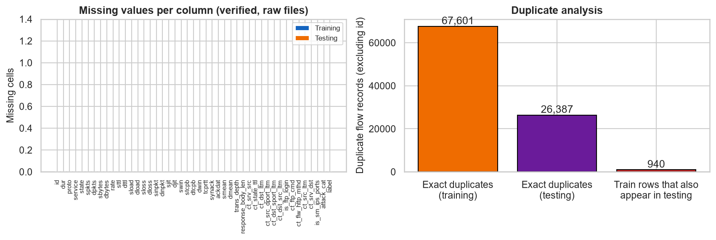
Figure 6: Missing cells and duplicate counts.
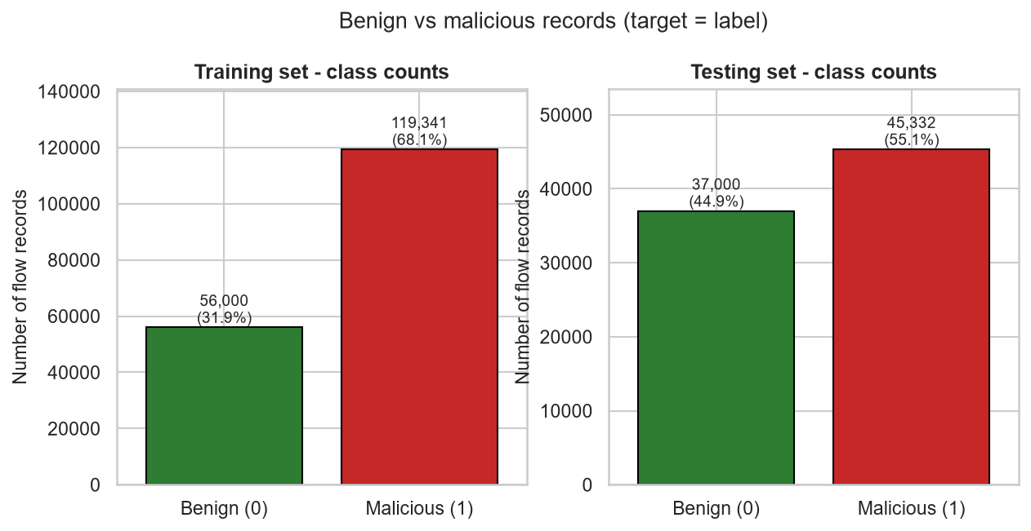
Figure 1: Class balance - benign vs malicious per partition.

6. Exploratory data analysis
Most positively correlated with 'malicious': sttl (0.693), ct_state_ttl (0.578), ct_dst_sport_ltm (0.357), rate (0.338), ct_src_dport_ltm (0.306), ct_dst_src_ltm (0.304), ct_src_ltm (0.238), ct_dst_ltm (0.230)
Interpretive note: medians differ genuinely (e.g. sttl 31 vs 254, dttl 29 vs 0, swin/dwin 255 vs 0) - these differences are descriptive, not proof of predictiveness; predictiveness is established only with the held-out test evaluation.
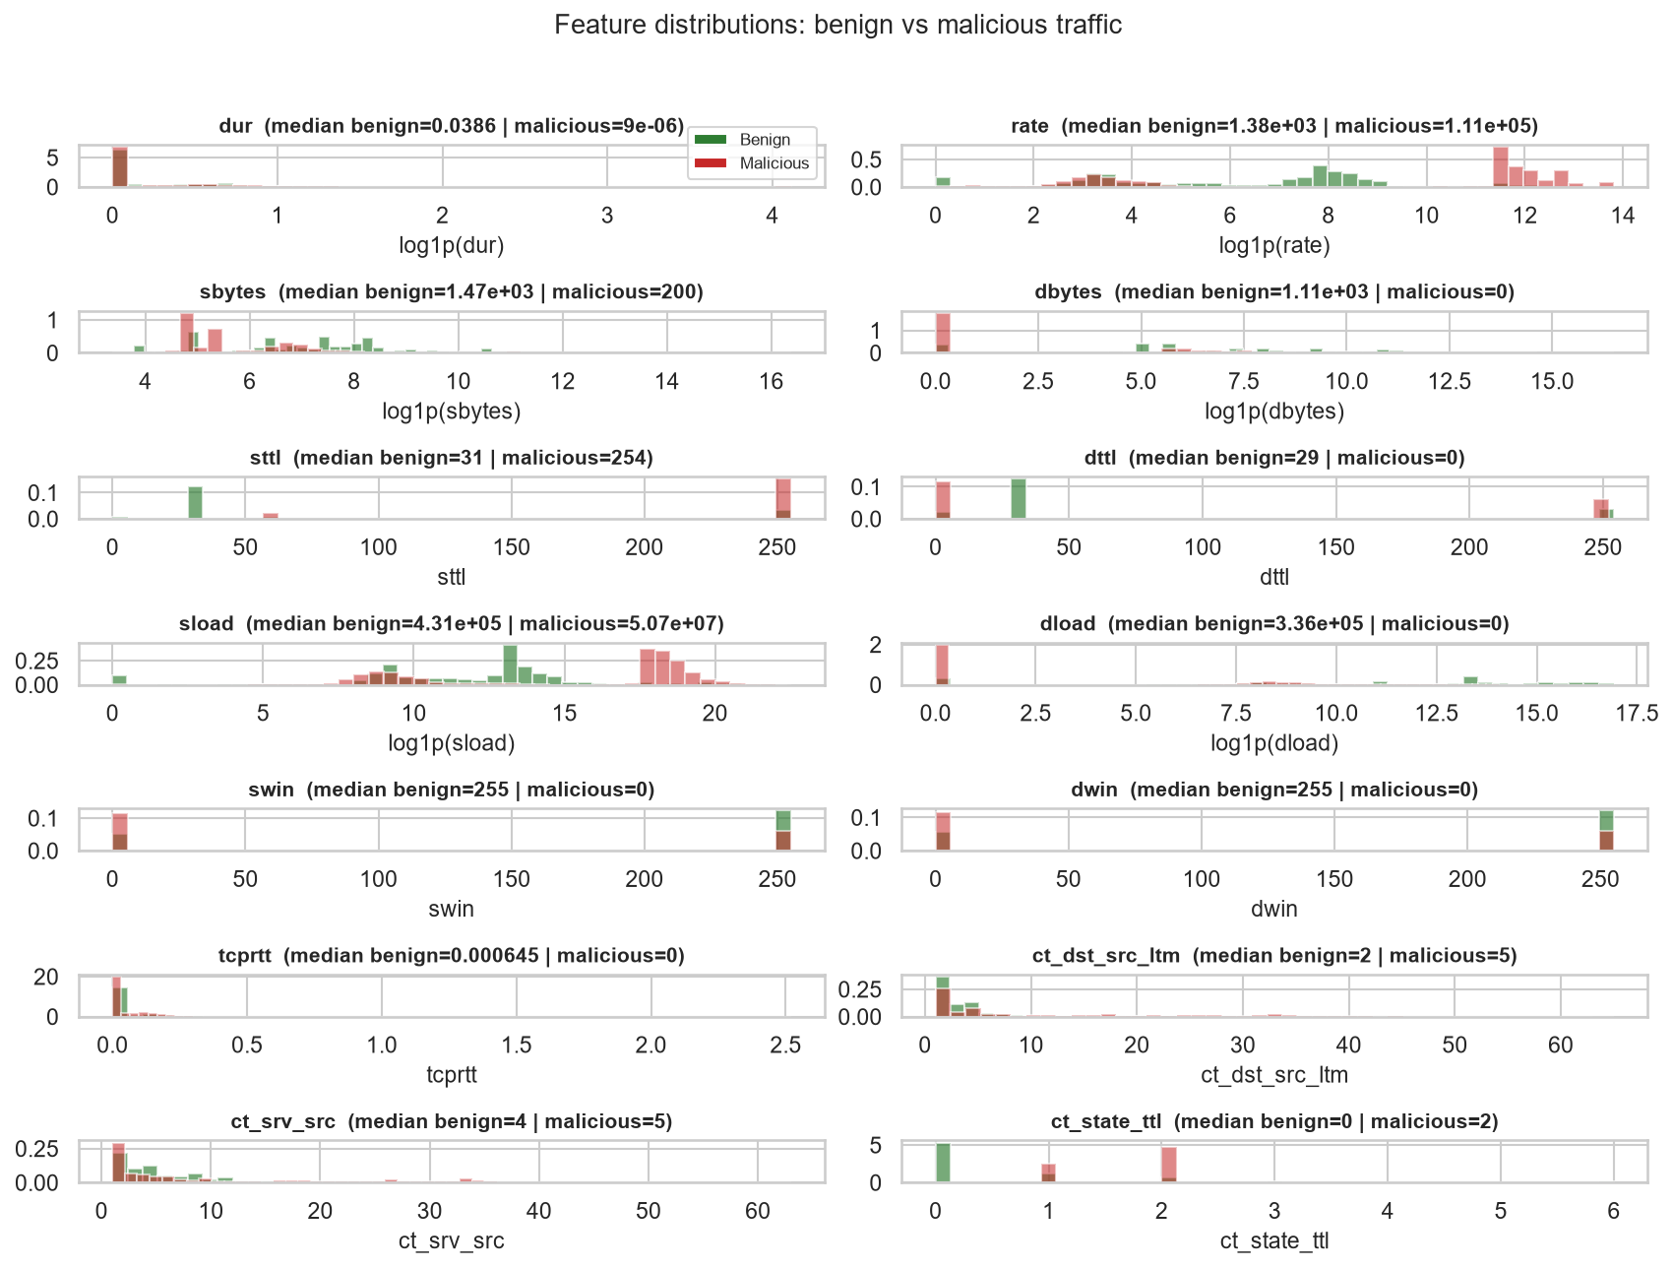
Figure 3: Key feature histograms by class.
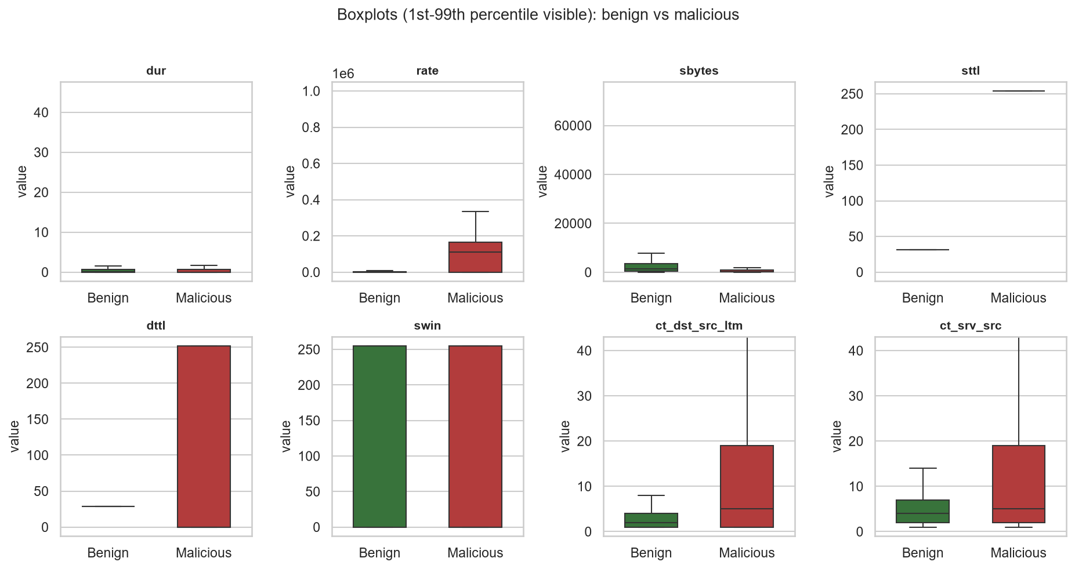
Figure 4: Box plots separating benign and malicious flows.
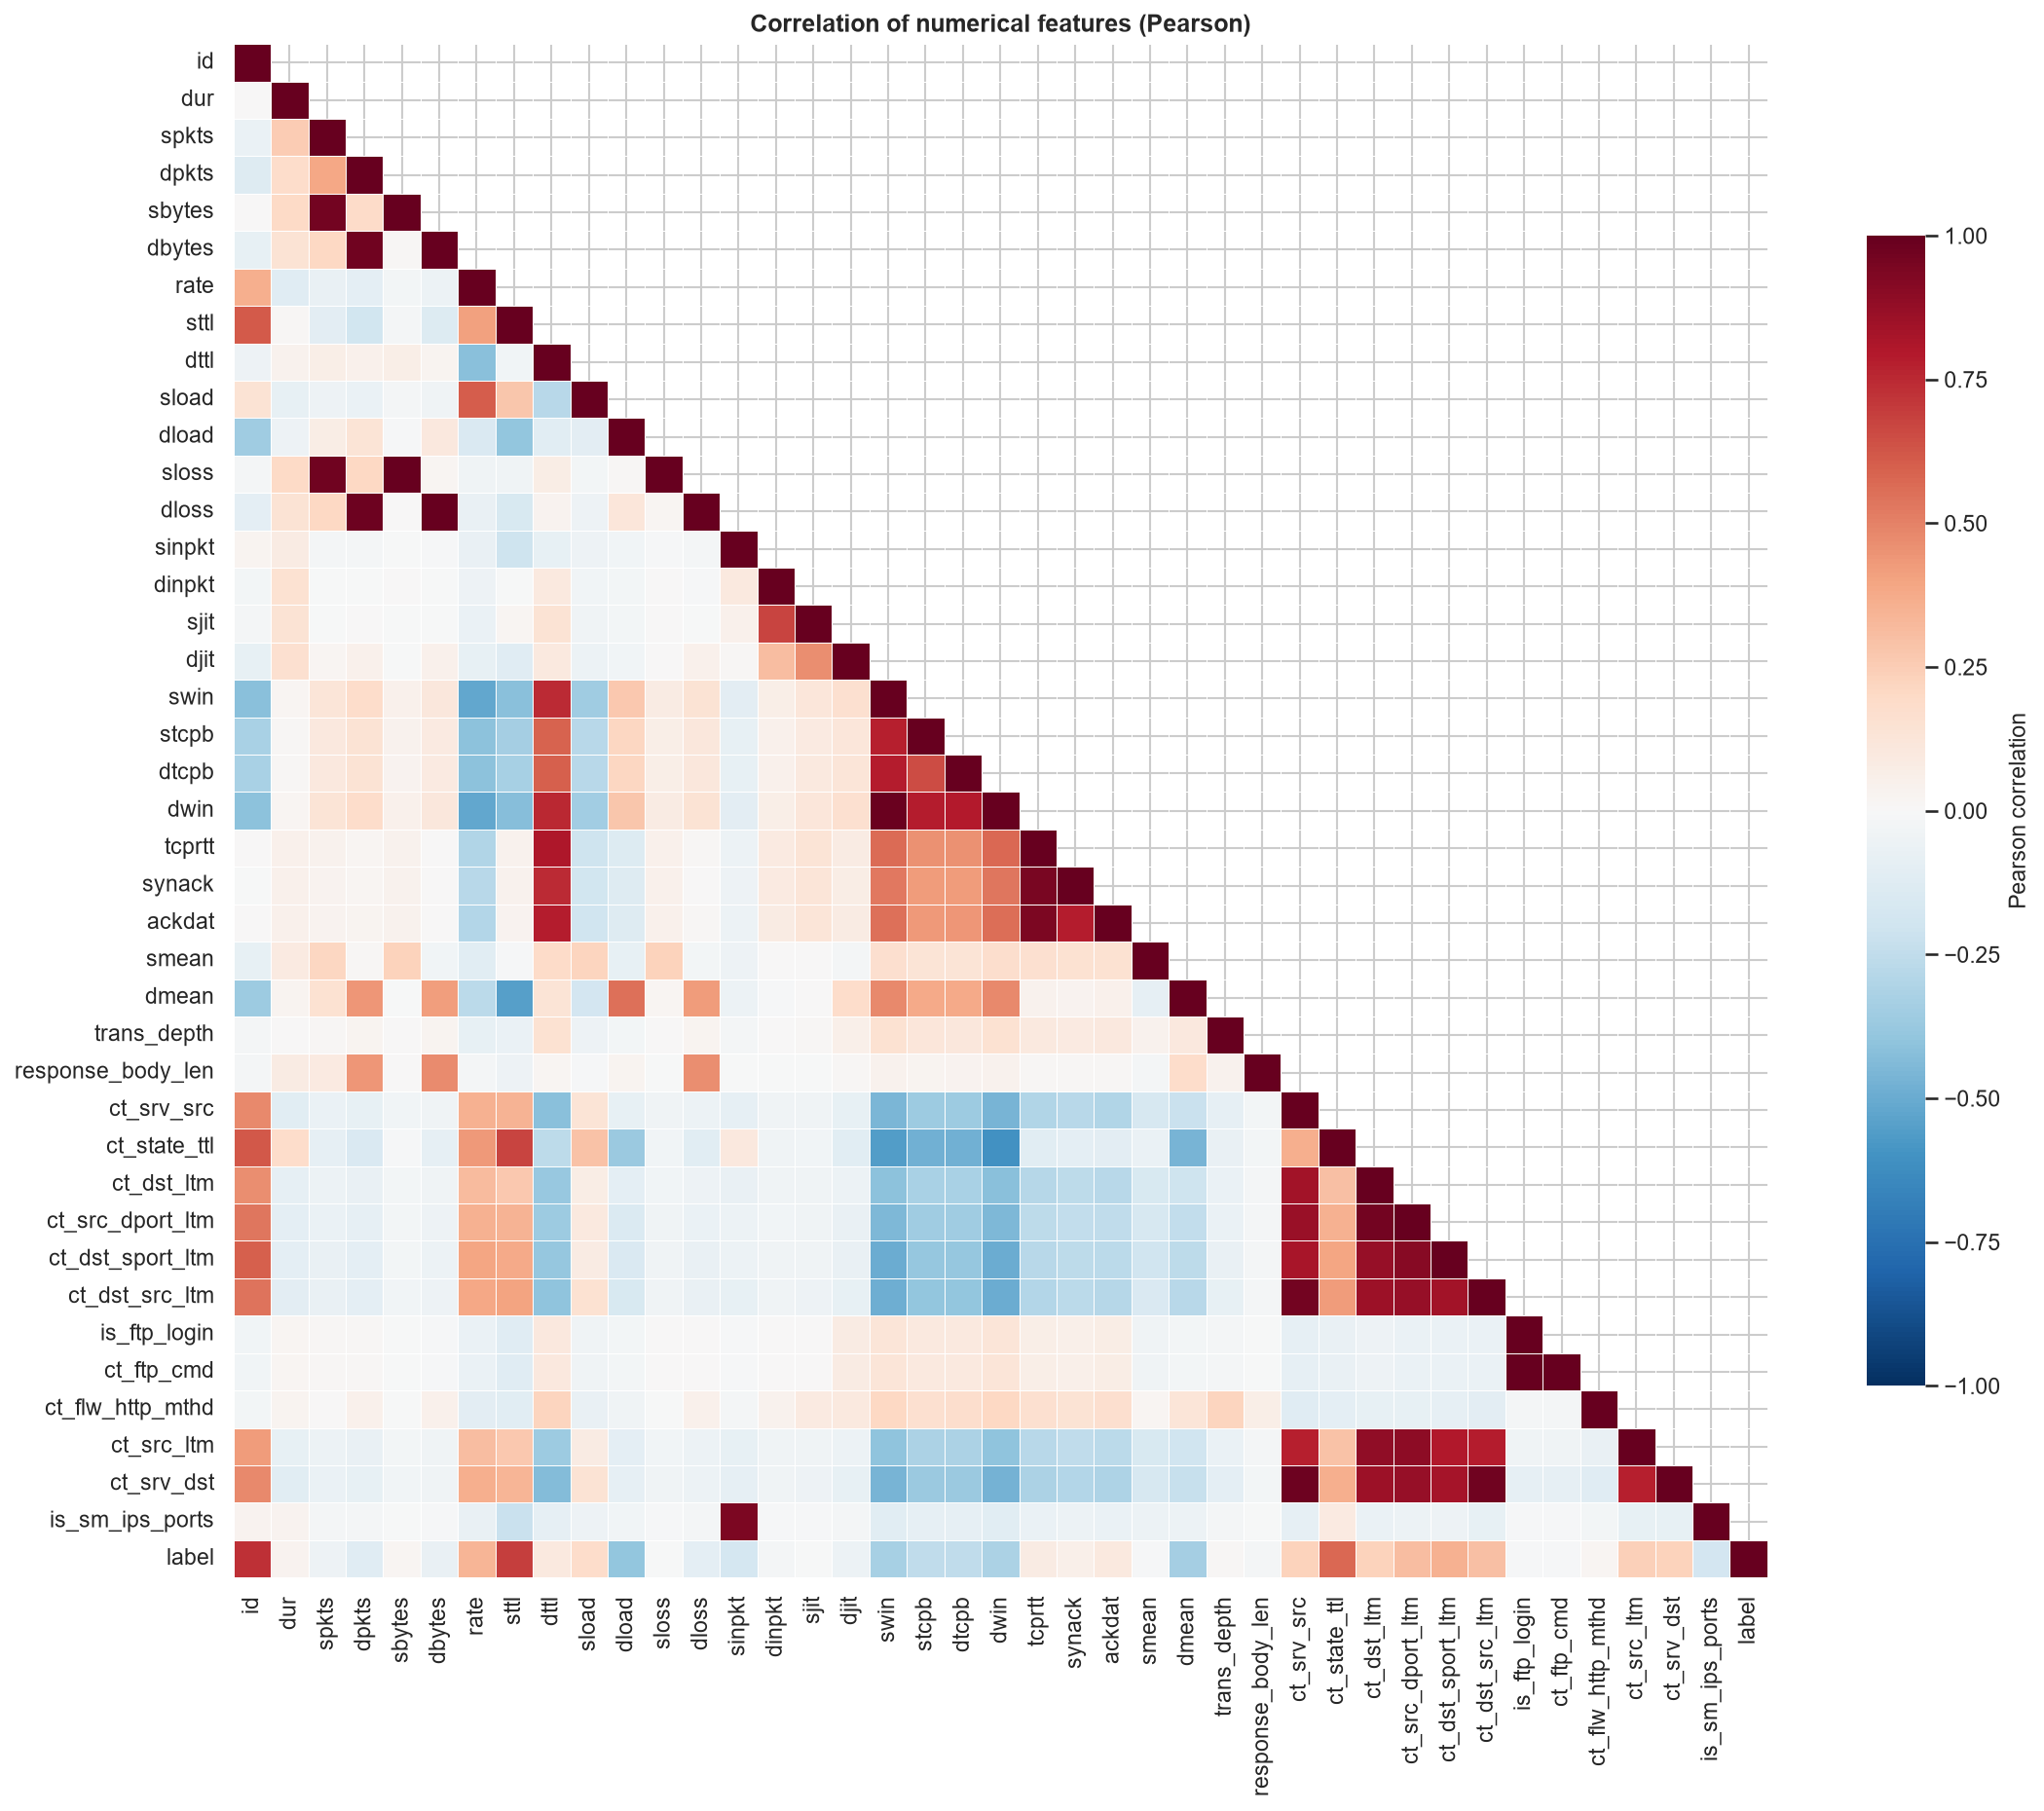
Figure 5: Feature correlation matrix.
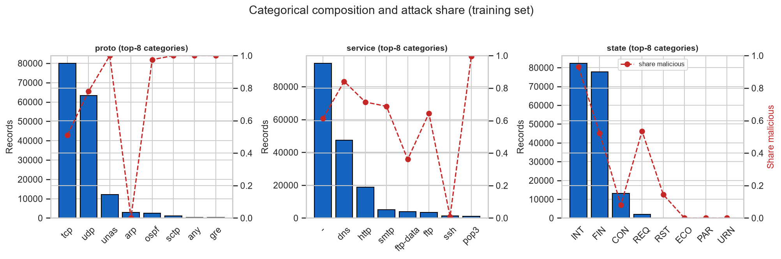
Figure 7: proto/service/state by attack share.
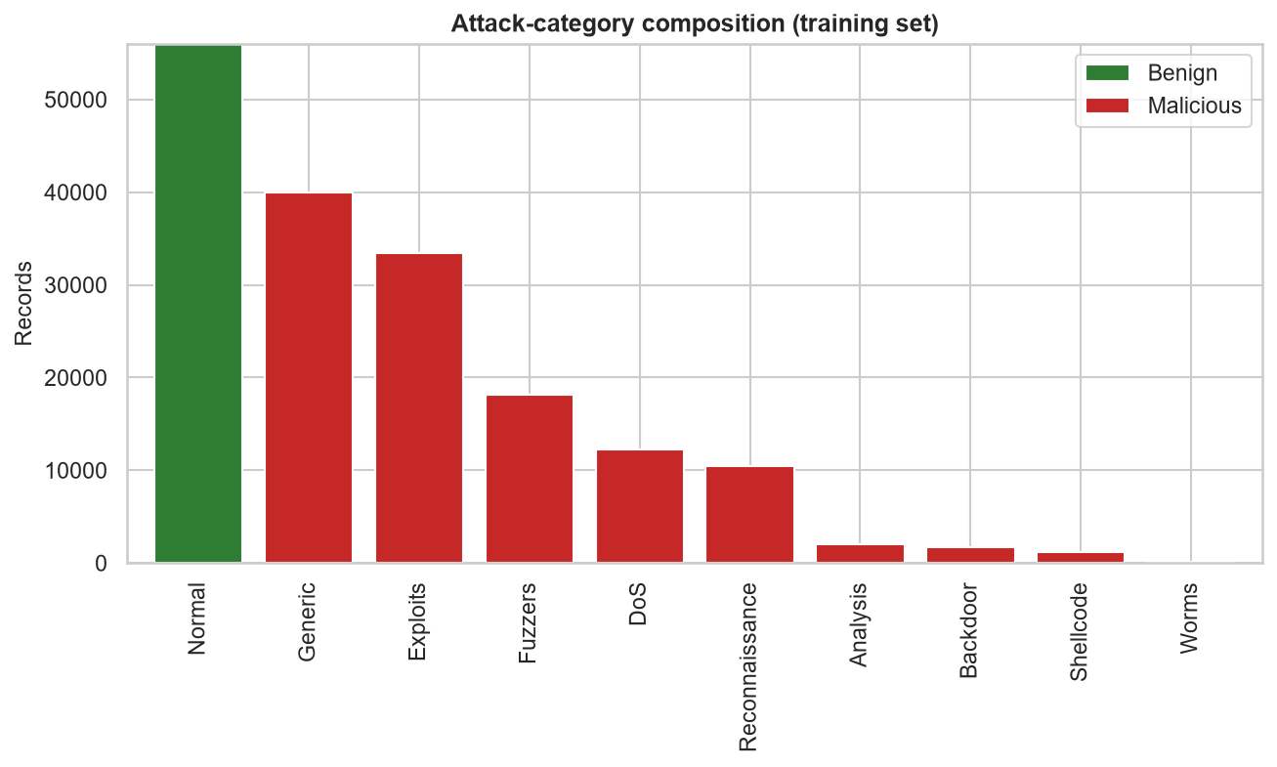
Figure 2: Attack-family counts per partition.

7. Model zoo and pipelines
- Dummy (most_frequent) - floor baseline; never eligible for selection.
- LogisticRegression (C=1.0 start, class_weight='balanced', StandardScaler pipeline).
- DecisionTree (max_depth=12, class_weight='balanced').
- RandomForest (200 estimators, class_weight='balanced_subsample').
- HistGradientBoosting (max_iter=250 default before tuning).
Each pipeline = FeatureEngineer (16 engineered features: totals, bytes/packet, send/receive ratios, loss rates, load_gap, log1p twins of six skewed magnitudes, ftp/http flags) -> preprocessor (median imputer; StandardScaler only for the linear model; OneHotEncoder(handle_unknown='infrequent_if_exist', min_frequency=25) on proto/service/state) -> estimator.

8. Hyper-parameter tuning
model | searcher | best hyper-parameters | best CV F1 (subsample)
logregression | GridSearchCV | {"C": 3.0} | 0.9119
dtree | GridSearchCV | {"class_weight": null, "max_depth": 12, "min_samples_leaf": 1} | 0.9209
forest | RandomizedSearchCV | {"n_estimators": 400, "min_samples_leaf": 2, "max_features": 0.3, "max_depth": 16, "class_weight": null} | 0.9346
gb | RandomizedSearchCV | {"min_samples_leaf": 40, "max_leaf_nodes": 63, "max_iter": 300, "learning_rate": 0.03, "l2_regularization": 1.0} | 0.9359
Search design: cv=3, scoring=F1, stratified 60,000-row subsample of the training partition (documented compute constraint); search spaces fixed a priori and printed in full in results/tuning_*.json. Two models use GridSearchCV (LogisticRegression, DecisionTree) and two use RandomizedSearchCV (RandomForest, HistGradientBoosting).

9. Validation, selection and operating threshold
5-fold stratified CV on the full training partition (validation table):
model | CV F1 | std | accuracy | AUC
HistGradientBoosting (tuned) | 0.9390 | 0.0013 | 0.9357 | 0.9872
RandomForest (tuned) | 0.9382 | 0.0011 | 0.9344 | 0.9870
DecisionTree (tuned) | 0.9268 | 0.0015 | 0.9227 | 0.9788
LogisticRegression (tuned) | 0.9125 | 0.0009 | 0.9037 | 0.9695
Dummy | 0.6828 | 0.0000 | 0.5184 | 0.5000
Selection rule (fixed a priori): highest mean CV F1 among tuned candidates; the dummy baseline is never eligible. Selected: HistGradientBoosting (tuned) with CV F1 0.9390 +/- 0.0013. Operating threshold: maximise F1 on the stratified 20% internal validation slice of the training partition - never on test. Resulting threshold = 0.480.
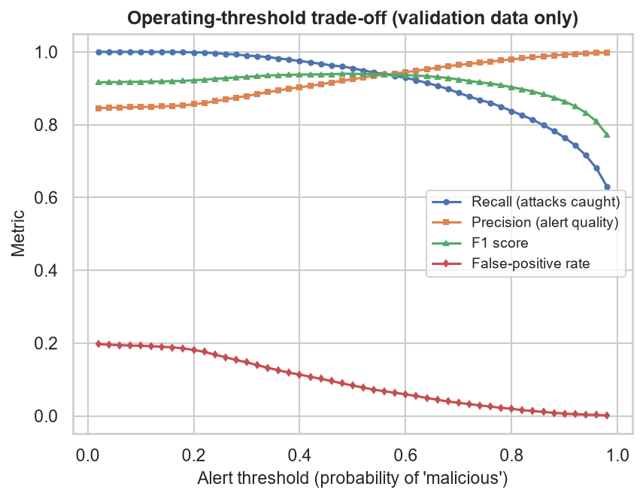
Figure 12: Operating-threshold trade-off (validation slice).

10. Evaluation on the untouched testing partition
The single pass. All five pipelines (dummy + 4 tuned) scored at the fixed threshold (0.480): the chosen model's full metrics: accuracy 0.8712, precision 0.8154, recall 0.9903, F1 0.8944, ROC-AUC 0.9868, average precision 0.9903, FPR 27.47%, FNR 0.97%. Confusion (benign first): tn=26,836, fp=10,164, fn=440, tp=44,892.
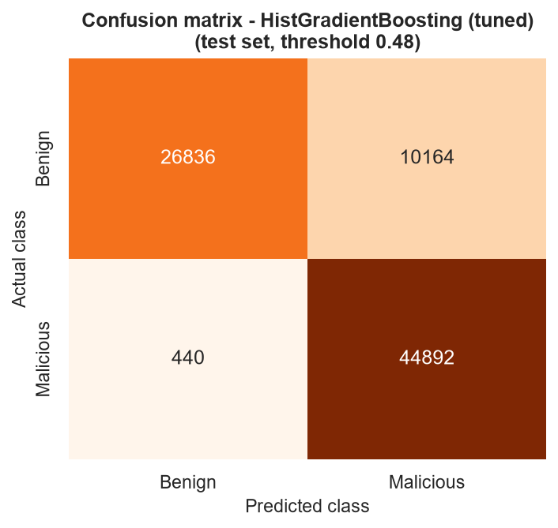
Figure 10: Confusion matrix of the chosen model (test).
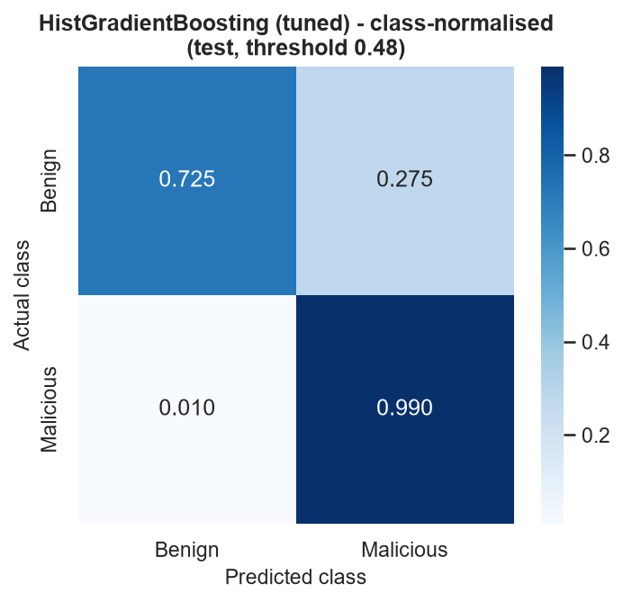
Figure 10b: Class-normalised confusion matrix.
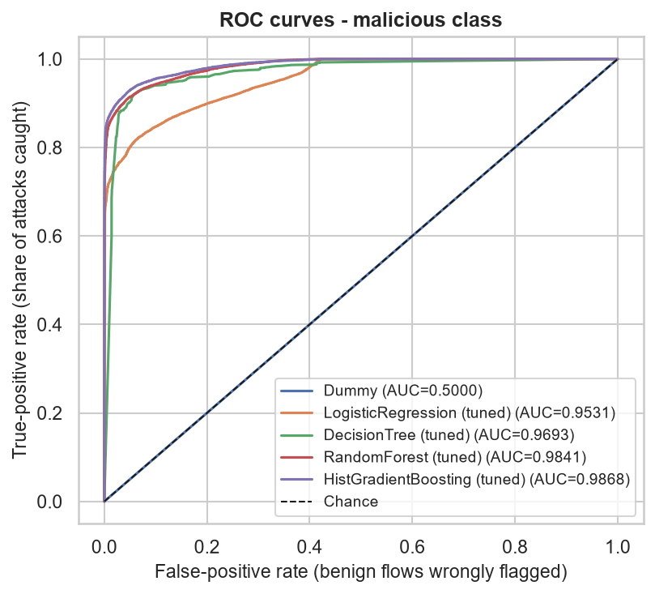
Figure 8: ROC curves on the untouched testing partition.
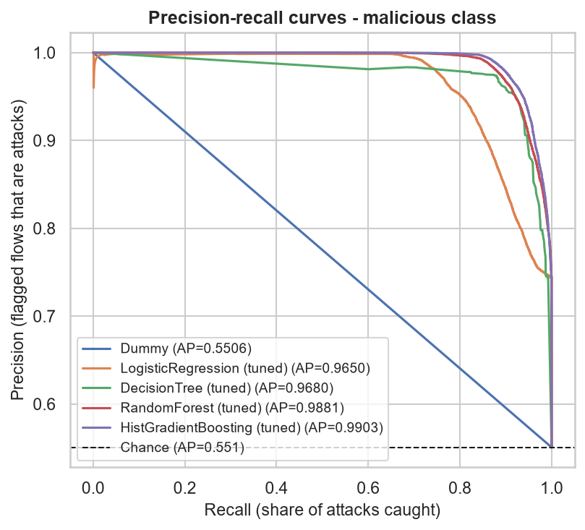
Figure 9: Precision-recall curves on the testing partition.
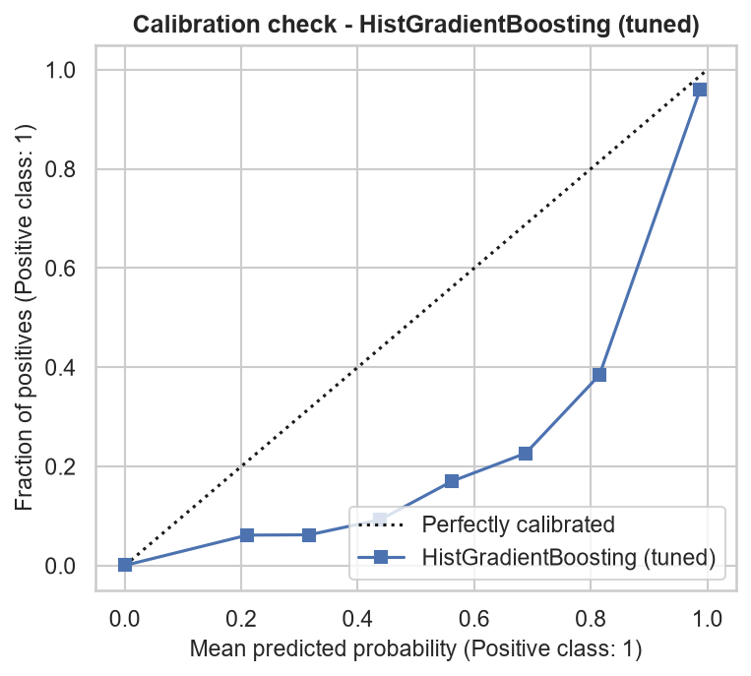
Figure 14: Calibration of the chosen model.

11. Model comparison
model | accuracy | precision | recall | F1 | AUC | AP
HistGradientBoosting (tuned) | 0.8712 | 0.8154 | 0.9903 | 0.8944 | 0.9868 | 0.9903
RandomForest (tuned) | 0.8663 | 0.8099 | 0.9894 | 0.8907 | 0.9841 | 0.9881
DecisionTree (tuned) | 0.8601 | 0.8098 | 0.9749 | 0.8847 | 0.9693 | 0.9680
LogisticRegression (tuned) | 0.8100 | 0.7550 | 0.9696 | 0.8490 | 0.9531 | 0.9650
Dummy | 0.5506 | 0.5506 | 1.0000 | 0.7102 | 0.5000 | 0.5506
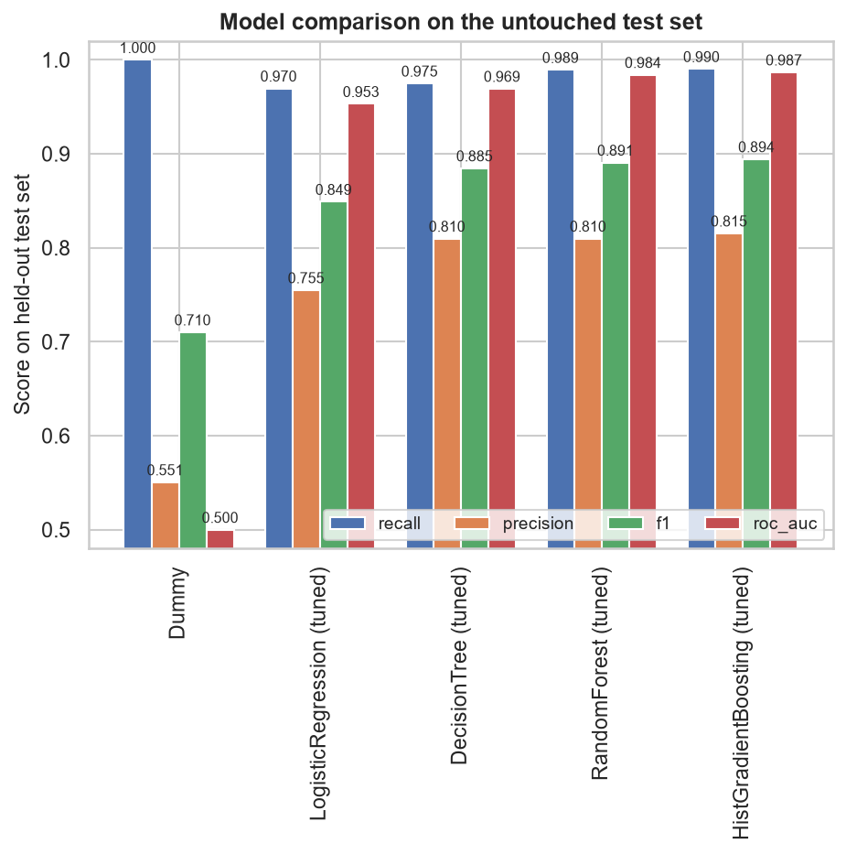
Figure 11: Test-metric comparison across models.

12. Error analysis
False positives: 10,164 (27.47% of benign) - FPs skew toward long-lived, high-TTL benign flows (FP medians: dur 0.676 vs 0.063 for correctly-benign; rate 27.2 vs 654.5; sttl 254 vs 31). FP protocol/state composition: 71% TCP / 29% udp; 71% FIN / 29% INT. False negatives: 440 (0.97% of attacks). Hardest family: Fuzzers (372 of 6,062 missed, 6.14%); easiest: Backdoor (0 missed). Representative error rows ship in results/error_examples.csv.
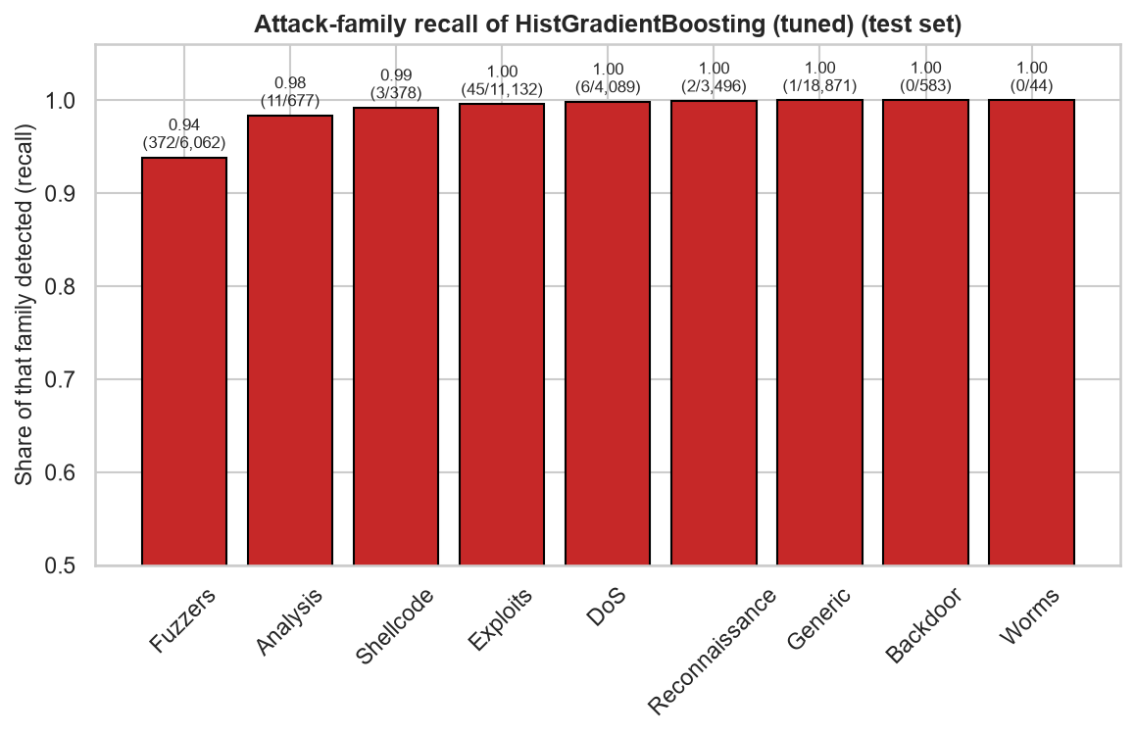
Figure 15: Recall by attack family (test).

13. Interpretation and caveats
Permutation importance on a stratified 10% sample of the training partition (validation-side lens; test stays reserved): sttl dominating (0.3748) - the top feature is a known schema artifact of synthetic capture; the next features (dbytes 0.0228, sbytes 0.0202, ct_srv_dst 0.0174) are classic flow-shape signals. Importance is statistical, not causal: an important feature does NOT prove malicious intent, and sttl's dominance should not be read as a deployment-grade signal beyond UNSW-NB15-like traffics.
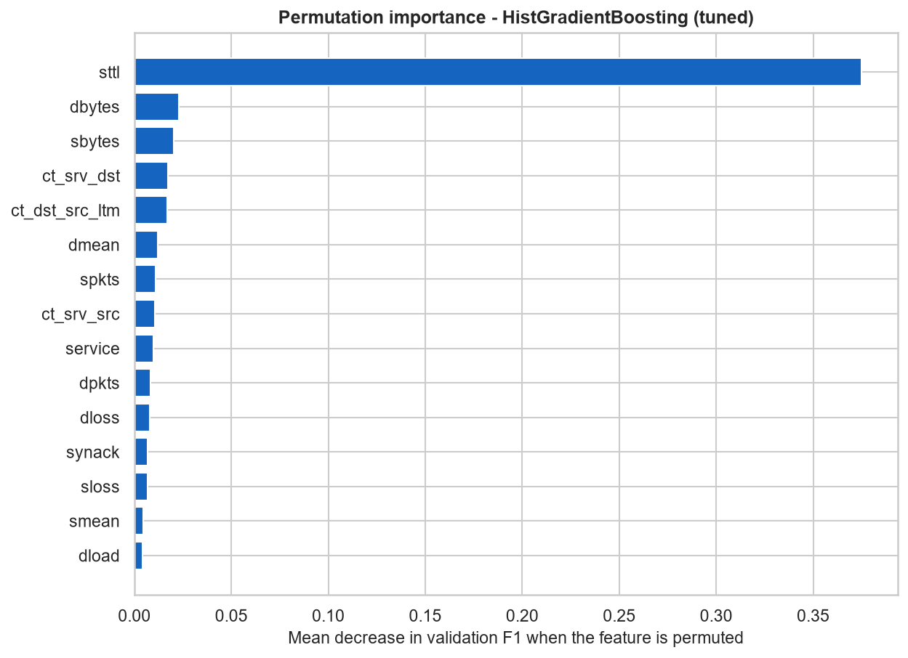
Figure 13: Permutation importance.

14. Robustness, leakage sensitivity and limitations
Leakage sensitivity: the official release itself shares exact flows across the partitions - 4,247 test rows (5.16%) exactly duplicate training flows. Primary published metrics stand on all test rows; metrics on the unique-only subset are also disclosed (accuracy 0.8679, precision 0.8090, recall 0.9896, F1 0.8902), quantifying the release's own inflation.
- FPR 27.47%: major limitation; consequence of the official train/test shift and the recall-favouring threshold; honest deployment-wise follow-up is threshold/cost calibration per environment.
- sttl dominance (0.3748): synthetic-capture schema artifact; does not extrapolate to other networks.
- Multi-class macro-F1 0.5129: Analysis (recall 38.26%), DoS (recall 12.40%) are genuinely hard in UNSW-NB15.
- Demo accuracy 80% on 10 held-out records: a small-sample sanity check, not a validation claim.
- Dataset is a fixed benchmark; no new attack families can appear beyond the released 10.

15. Optional multi-class extension
Constrained RandomForest (150 trees, depth 20, leaf 2, balanced_subsample) on 10 families: test accuracy 0.6814, macro-F1 0.5129, weighted-F1 0.7345. Analysis and DoS recall genuinely weak (below 0.5) - a benchmark limitation, documented not ignored.
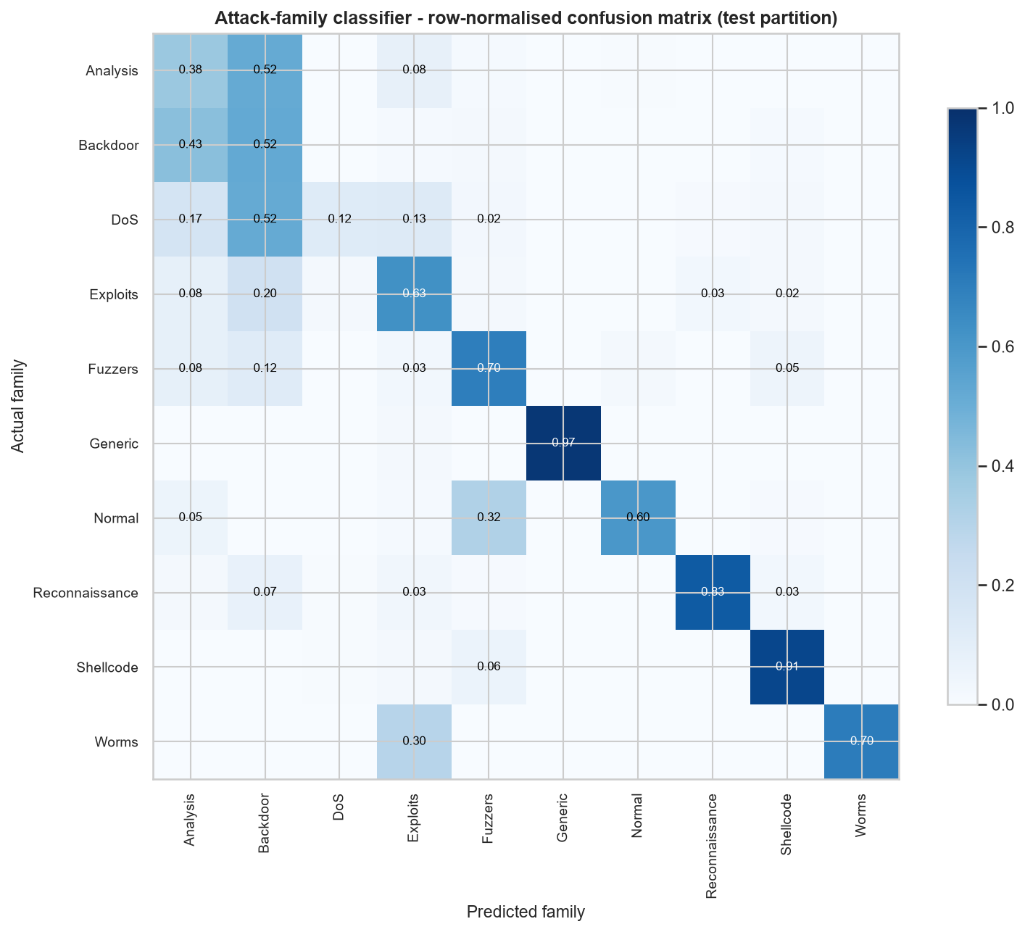
Figure 16: 10-family confusion matrix.

16. Conclusion and future work
Under one strict leakage regime, HistGradientBoosting (tuned) delivers test F1 0.8944 (accuracy 0.8712, recall 0.9903) with the honest caveat of a 27.47% false-alarm rate rooted in the release's own train/test shift. Future work: distribution-aware thresholds, cost-sensitive selection, calibration per deployment environment, external validation on other captures, and per-family threshold tuning.
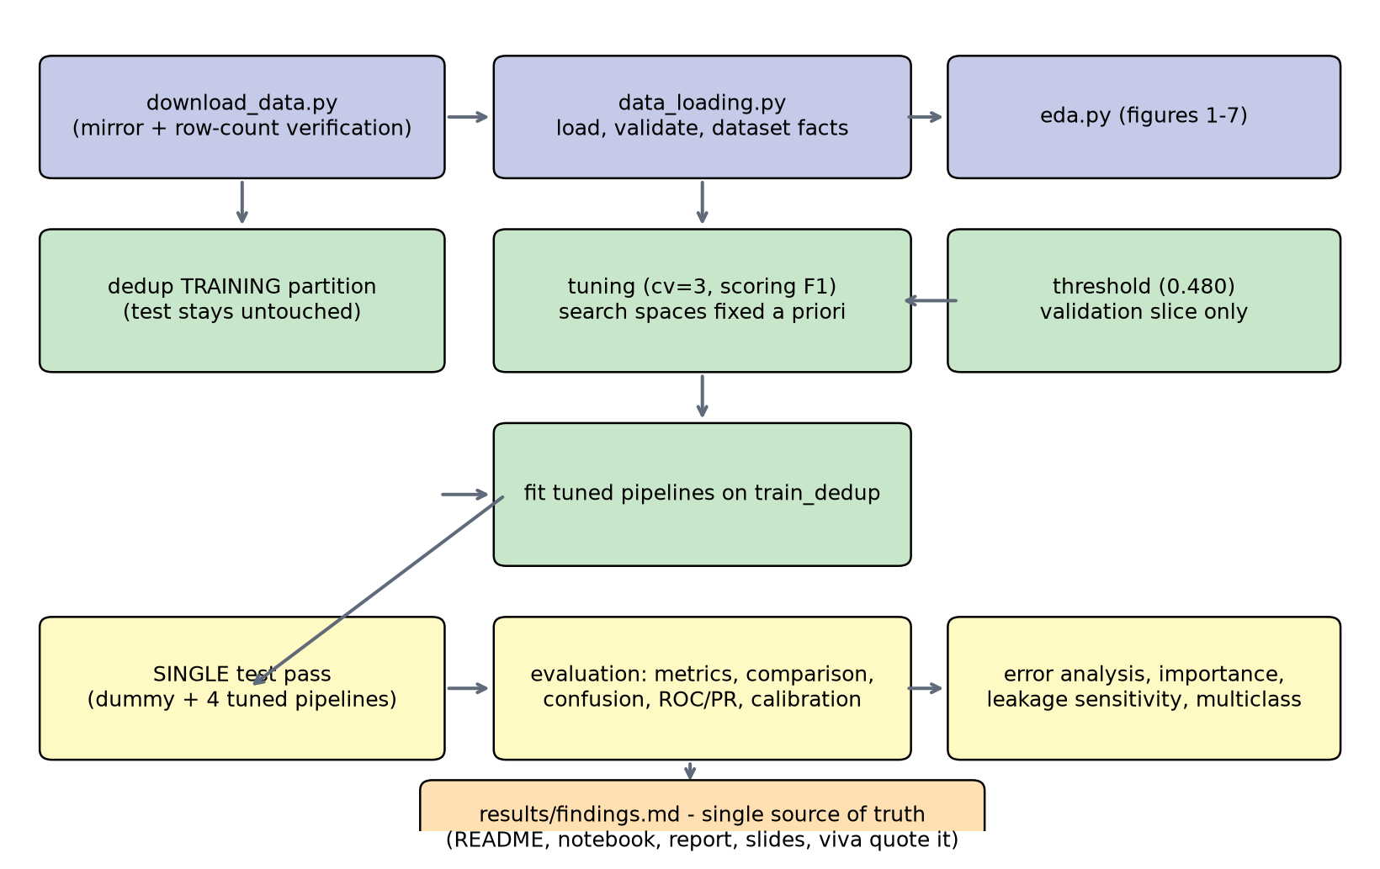
Figure 17: Project architecture (data to findings).

17. References
- N. Moustafa and J. Slay, "UNSW-NB15: a comprehensive data set for network intrusion detection systems." Military Communications and Information Systems Conference (MilCIS), 2015.
- N. Moustafa, G. Creech, and J. Slay, "Big data analytics for large scale wireless network security and attack detection." AFRICOMM, 2015.
- N. Moustafa and J. Slay, "The evaluation of network anomaly detection systems: statistical analysis of the UNSW-NB15 dataset and the comparison with the KDD99 dataset." Information Security Journal: A Global Perspective, 25(1-3):18-31, 2016.
- L. Breiman, "Random forests." Machine Learning, 45(1):5-32, 2001.
- L. Breiman, J. Friedman, R. Olshen, and C. Stone, "Classification and Regression Trees." Chapman & Hall/CRC, 1984.
- T. Hastie, R. Tibshirani, and J. Friedman, "The Elements of Statistical Learning: Data Mining, Inference, and Prediction," 2nd ed. Springer, 2009.
- F. Pedregosa et al., "Scikit-learn: machine learning in Python." Journal of Machine Learning Research, 12:2825-2830, 2011.
- W. McKinney, "Data structures for statistical computing in Python." SciPy 2010 (pandas).
- C. R. Harris et al., "Array programming with NumPy." Nature, 585:357-362, 2020.
- J. D. Hunter, "Matplotlib: a 2D graphics environment." Computing in Science & Engineering, 9(3):90-95, 2007.

Appendix A - Reproduction instructions
- pip install -r requirements.txt
- python -m src.download_data # fetch + verify UNSW-NB15
- python -m src.train # full pipeline (~6.2 min on a 20-core machine)
- jupyter lab notebooks/Cybersecurity_Intrusion_Detection.ipynb
- streamlit run app/app.py
- pytest

Appendix B - Figure and table register
- Figure 1: Class balance - benign vs malicious per partition.
- Figure 2: Attack-family counts per partition.
- Figure 3: Key feature histograms by class.
- Figure 4: Box plots separating benign and malicious flows.
- Figure 5: Feature correlation matrix.
- Figure 6: Missing cells and duplicate counts.
- Figure 7: proto/service/state by attack share.
- Figure 8: ROC curves on the untouched testing partition.
- Figure 9: Precision-recall curves on the testing partition.
- Figure 10: Confusion matrix of the chosen model (test).
- Figure 10b: Class-normalised confusion matrix.
- Figure 11: Test-metric comparison across models.
- Figure 12: Operating-threshold trade-off (validation slice).
- Figure 13: Permutation importance.
- Figure 14: Calibration of the chosen model.
- Figure 15: Recall by attack family (test).
- Figure 16: 10-family confusion matrix.
- Figure 17: Project architecture (data to findings).

Appendix C - Honesty statement
Every number in this report is verbatim from results/findings.md or sibling result files produced by one pipeline run; no metric or reference is invented. Unflattering results (FPR ~27%, macro-F1 0.5129, demo 80%) are disclosed, not hidden.
Data redistribution note: UNSW-NB15 files are not shipped with the repository - use src/download_data.py.

