**Canonical Account Quote Model**

Version 1.0.0 (meta rev 5)

# Abstract

This document is part of the Vision2030 initiative to establish a canonical, technology-agnostic entity model for quoting workflows. It defines three core models—Account, Census, and Quote—and the model-level referencing that binds them. Models are published as JSON Schema (Draft 2020‑12) with clear semantic versioning (what the model means) and metaVersion (document revision). The guide standardizes naming, constraints, and validation practices; explains how Quote reuses Account and Census via $ref; and provides a FHIR-aligned mapping for interop with clinical/insurance ecosystems. Expected outcomes include faster integration, consistent governance, and safer change management across services, data stores, and analytics.

# 1.1 Introduction

The canonical model organizes business data into three entity models: Account (the customer organization), Census (population snapshot used for underwriting), and Quote (pricing proposal derived from the Account and Census).

Each model is published as an independent JSON Schema with its own semantic version and metaVersion. Quote references Account and Census by model-level $ref, enabling consistent validation of embedded sub-objects across services and databases.

Figure 1 shows the high-level UML structure and relationships.

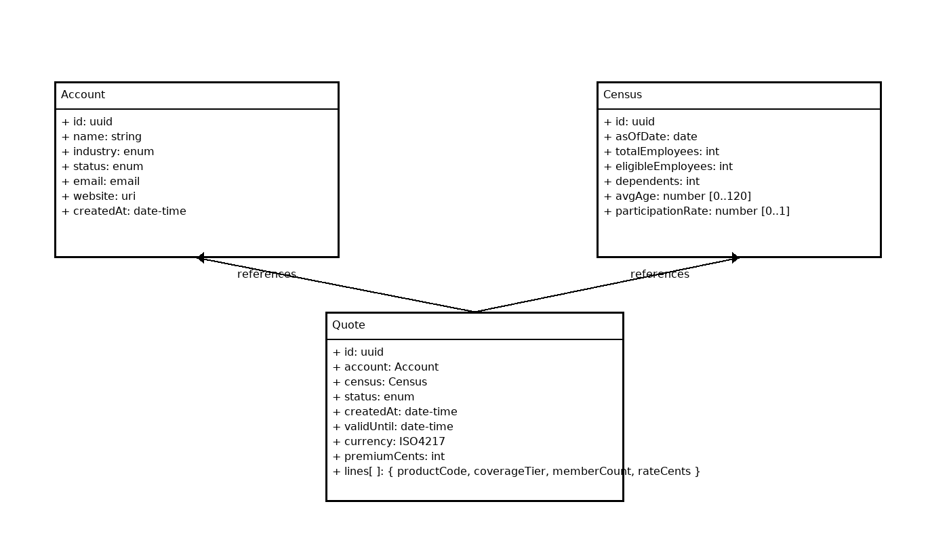

Figure 1 — UML-style structure: Quote references Account and Census.

# 1.2 Key Concepts

Model-level references: Use $ref to import the structure of another entity model at design time (not instance IDs).

Semantic version: SemVer string that signals meaning/shape changes (e.g., 1.2.0).

Meta version: Document revision counter for republishing without meaning change.

Closed content: Use additionalProperties:false (and when composed, unevaluatedProperties:false) to prevent typos.

Validation: Schemas target JSON Schema Draft 2020‑12 with standard format, enum, and numeric constraints.

Instance-level options: Foreign keys, link objects, or embedded snapshots (out of scope here).

# 1.3 JSON Entity Modeling Best Practices

• Naming: lowerCamelCase for properties; avoid abbreviations; positive booleans (isActive).

• Identity: Use opaque IDs (UUID/ULID). Don’t encode semantics in identifiers.

• Dates & money: ISO‑8601 UTC date-time; currency in minor units (integer) or decimal string; avoid binary float for currency.

• Nullability: missing = unknown; null = intentionally empty; model nullable with type: [T, "null"].

• Versioning: Pin $id with semantic version; bump metaVersion on non‑functional republishes; keep old IDs resolvable.

• Documentation: Use description annotations; provide examples; maintain a changelog.

# 1.4 Quote Model Structure — JSON

The Quote schema references Account and Census models by their versioned $id and $anchor. Business rules and field constraints are captured with standard JSON Schema keywords.

{  
 "$schema": "https://json-schema.org/draft/2020-12/schema",  
 "$id": "https://schemas.example.com/models/Quote/1.0.0",  
 "$anchor": "Quote",  
 "title": "Quote",  
 "type": "object",  
 "additionalProperties": false,  
 "model": {  
 "canonical": "https://schemas.example.com/models/Quote",  
 "version": "1.0.0",  
 "metaVersion": 5,  
 "status": "active",  
 "dependsOn": {  
 "https://schemas.example.com/models/Account": "^1.0.0",  
 "https://schemas.example.com/models/Census": "^1.0.0"  
 }  
 },  
 "properties": {  
 "id": {  
 "type": "string",  
 "format": "uuid",  
 "description": "Quote identifier (opaque UUID)."  
 },  
 "account": {  
 "$ref": "https://schemas.example.com/models/Account/1.0.0#Account",  
 "description": "The Account this quote is for (typed by the Account model)."  
 },  
 "census": {  
 "$ref": "https://schemas.example.com/models/Census/1.0.0#Census",  
 "description": "Census data used to produce this quote (typed by the Census model)."  
 },  
 "status": {  
 "type": "string",  
 "enum": [  
 "draft",  
 "proposed",  
 "accepted",  
 "rejected",  
 "expired"  
 ],  
 "description": "Quote lifecycle status."  
 },  
 "createdAt": {  
 "type": "string",  
 "format": "date-time",  
 "description": "UTC creation timestamp."  
 },  
 "validUntil": {  
 "type": "string",  
 "format": "date-time",  
 "description": "UTC expiration timestamp for this quote."  
 },  
 "currency": {  
 "type": "string",  
 "pattern": "^[A-Z]{3}$",  
 "description": "ISO 4217 currency (e.g., 'USD')."  
 },  
 "premiumCents": {  
 "type": "integer",  
 "minimum": 0,  
 "description": "Total premium in minor units (e.g., cents)."  
 },  
 "lines": {  
 "type": "array",  
 "minItems": 1,  
 "description": "Line items comprising the quote.",  
 "items": {  
 "type": "object",  
 "additionalProperties": false,  
 "properties": {  
 "productCode": {  
 "type": "string",  
 "maxLength": 50,  
 "pattern": "^[A-Z0-9_.-]{1,50}$",  
 "description": "Product/plan identifier (system-specific)."  
 },  
 "coverageTier": {  
 "type": "string",  
 "enum": [  
 "EE",  
 "ES",  
 "EC",  
 "EF"  
 ],  
 "description": "Coverage tier: Employee, Employee+Spouse, Employee+Children, Employee+Family."  
 },  
 "memberCount": {  
 "type": "integer",  
 "minimum": 1,  
 "description": "Members covered by this line."  
 },  
 "rateCents": {  
 "type": "integer",  
 "minimum": 0,  
 "description": "Rate per member or unit, in minor units."  
 }  
 },  
 "required": [  
 "productCode",  
 "coverageTier",  
 "memberCount",  
 "rateCents"  
 ]  
 }  
 },  
 "notes": {  
 "type": [  
 "string",  
 "null"  
 ],  
 "maxLength": 2000,  
 "description": "Underwriting comments or caveats."  
 }  
 },  
 "required": [  
 "id",  
 "account",  
 "census",  
 "status",  
 "createdAt",  
 "currency",  
 "premiumCents",  
 "lines"  
 ]  
}

Business Rules (informative):

• validUntil SHALL be >= createdAt (enforced in service logic).

• status transitions: draft → proposed → accepted | rejected; expired is terminal.

• currency SHALL be a valid ISO 4217 code (pattern enforces 3 letters; service validates membership).

• premiumCents equals the sum of lines.memberCount × lines.rateCents (computed rule).

# 1.5 Quote Model Structure — FHIR-aligned

A price quote can be represented in FHIR using the Claim resource with use='predetermination'. The adjudicated totals may be returned as a ClaimResponse. The customer account maps to Organization, and the census (population snapshot) maps to Group (type=person, actual=true).

Alternative/adjacent flow: CoverageEligibilityRequest/Response can be used to check eligibility and plan-specific benefits; however, for full pricing with line items, Claim/ClaimResponse is the canonical fit.

FHIR Bundle (Quote as Predetermination)

Bundle.type = 'collection'  
 - Organization (Account)  
 - Group (Census)  
 - Claim (use='predetermination')  
 .provider -> Organization  
 .item[n].productOrService -> CodeableConcept (plan/benefit code)  
 .item[n].quantity.value -> memberCount  
 .item[n].unitPrice -> rate (Money)  
 - ClaimResponse (optional result, totals)

Notes:

• Group captures the employee population; characteristics or contained members may be used depending on privacy and size.

• Organization identifies the quoting customer (your Account).

• Claim.item lines map naturally from Quote.lines; totals belong in ClaimResponse.

• Use standard terminologies where available; internal product codes may be profiled as CodeSystems.

# 1.5 Glossary

Semantic version: SemVer string indicating meaning/shape changes of the model (e.g., 1.2.0).

Meta version: Document revision counter for republishing without meaning change.

$id: Canonical, version-pinned URI of a schema, used as the base for $ref resolution.

$anchor: Local anchor name to reference a particular schema location (e.g., the root).

$ref: Reference to another schema location (can be absolute URL + #anchor).

additionalProperties:false: Disallow unspecified properties to catch typos and ensure closed content.

FHIR Claim (predetermination): A 'what-if' claim used for quoting or cost estimation.

FHIR Group: Collection of persons used to represent a census/population.

FHIR Organization: Entity representing an account/customer organization.

# 1.6 References

- JSON Schema Draft 2020-12 — Validation: https://json-schema.org/draft/2020-12/json-schema-validation

- JSON (RFC 8259): https://www.rfc-editor.org/info/rfc8259

- JSON Pointer (RFC 6901): https://www.rfc-editor.org/info/rfc6901

- FHIR Claim (use: predetermination): https://build.fhir.org/claim.html

- FHIR ValueSet: claim-use: https://build.fhir.org/valueset-claim-use.html

- FHIR Group: https://build.fhir.org/group.html

- FHIR Organization: https://build.fhir.org/organization.html

- CoverageEligibilityRequest: https://build.fhir.org/coverageeligibilityrequest.html