难点：
- 由于加载文档的图片页数多，而且图片比较占用资源，所以不能储存过多图片在内存中。这样容易造成OutOfMemory错误。所以实现了异步加载，并用软引用缓存图片，并用弱引用缓存放大缩小后的图片。处理过程放在输出到显示器的函数上。
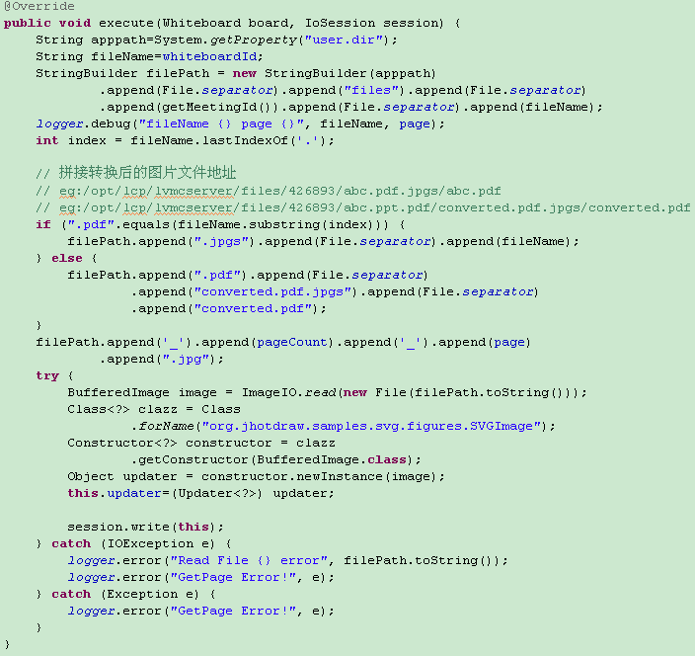

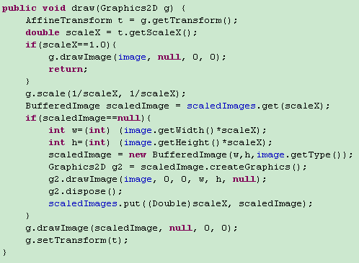
- 视频点播执行删除操作后，界面上的数据依然存在。因为执行界面组件操作必须在图形界面操作线程中进行，并执行repaint方法重绘相关区域，才能保证最快地更新到界面上。可参考SwingUtilities.invokeLater。
- 使用命令模式方便扩展重构。需要增加功能的话，只需要找相近的功能类覆盖所需方法即可。例如BroadcastConvertedCommand 类BroadcastCommand 类功能相似，所以通过继承覆盖所需方法实现了加载文档的功能。

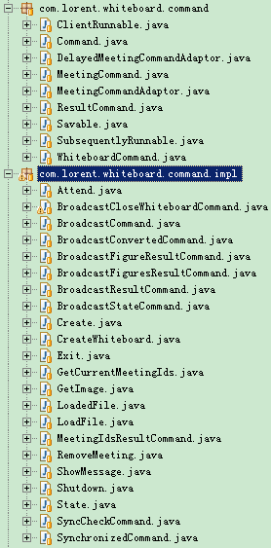
- 使用Kryo开发服务器数据储存功能。Kryo会把Java的类以二进制的方式输出到io流中。但其不支持反序列化没有公开构造函数的类。由于项目所用开源项目JHotdraw含有大量没有公开构造函数的类，所以通过扩展Kryo的功能而不是修改类来解决这个问题。改进其反射类实例功能，使其能实例化没有公开构造函数的类：

public class Kryox extends Kryo {

private final ReflectionFactory REFLECTION_FACTORY = ReflectionFactory
.getReflectionFactory();

private final ConcurrentHashMap<Class<?>, Constructor<?>> _constructors = new ConcurrentHashMap<Class<?>, Constructor<?>>();

@Override
public <T> T newInstance(Class<T> type) {
try {
return super.newInstance(type);
} catch (Exception e) {
return (T) newInstanceFromReflectionFactory(type);
}
}

private Object newInstanceFrom(Constructor<?> constructor) {
try {
return constructor.newInstance();
} catch (final Exception e) {
throw new RuntimeException(e);
}
}

@SuppressWarnings("unchecked")
public <T> T newInstanceFromReflectionFactory(Class<T> type) {
Constructor<?> constructor = _constructors.get(type);
if (constructor == null) {
constructor = newConstructorForSerialization(type);
Constructor<?> saved = _constructors.putIfAbsent(type, constructor);
if(saved!=null)
constructor=saved;
}
return (T) newInstanceFrom(constructor);
}

private <T> Constructor<?> newConstructorForSerialization(
Class<T> type) {
try {
Constructor<?> constructor = REFLECTION_FACTORY
.newConstructorForSerialization(type,
Object.class.getDeclaredConstructor());
constructor.setAccessible(true);
return constructor;
} catch (Exception e) {
throw new RuntimeException(e);
}
}

}
- 由于Kryo功能限制，不能序列化复制关系的对象。通过扩展Kryo序列化反序列化功能，使其能序列化复杂的对象：

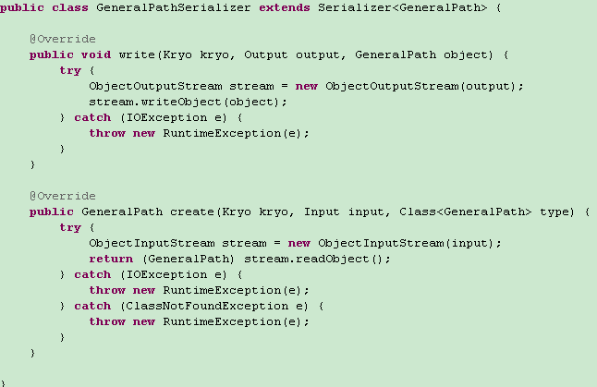
- 解决多人同时操作同一图像，造成各客户端可能不同步现象。把jhotdraw原来相对位置移动，改成绝对位置移动。同时命令经过服务器处理后再发到结果到客户端执行。
- 加载文档功能流程：客户端发送LoadFile命令到服务端。服务端首先以真实文件名申请白板资源，如果已经达到配置的最大值，则返回相关提示。如果申请成功，如果白板已经加载，则返回相关提示。否则进入加载流程。程序会先将办公文档（doc、xls）等文档通过openoffice转换成pdf，再通过icepdf转换成一张张图片。再把数据返回各个客户端。如果转换过程发生问题，则返回相关提示。失败原因主要有：1.服务端内存资源不足2.文档格式有问题。

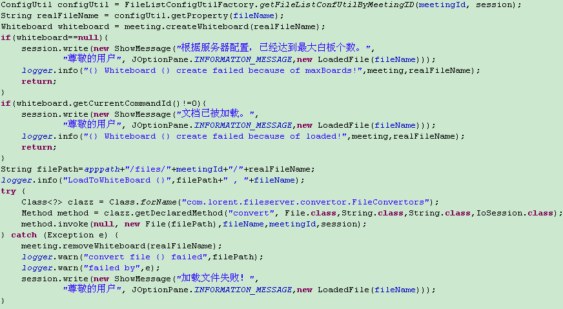
- 利用rxtx实现了云台控制功能。通过继承PanTiltDrive 类，覆盖所需方法，即可方便地实现多种协议。可参考PelcoDPanTiltDrive 类。
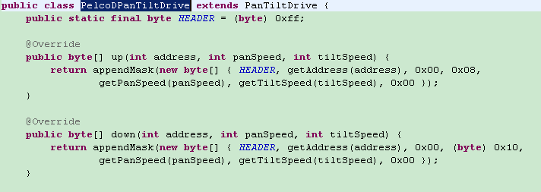
- 与炳发协商定义json协议格式

服务端反馈
{"type":101,"whiteboardId":"1","oldCommandId":52,"commandId":52}
移动图象,删除白板
{"type":102,"whiteboardId":"1","oldCommandId":52,"commandId":52,"figureId":2}
创建图像
{"type":103,"whiteboardId":"1","oldCommandId":52,"commandId":52,"figureIds":[4,2,3]}
复制粘贴
{"type":104}
同步完成

{"type":1,"meetingId":"111"}
加入111会议

{"type":2,"meetingId":"111","whiteboardId":"123"}
在会议111中，创建白板123，whiteboardId为空就由服务器生成白板名字

{"type":3,"meetingId":"111","commandIds":{"1":2,"123":3},"states":{}}
同步命令

{"type":4,"meetingId":"111","whiteboardId":"1","commandId":13}
删除白板1

{"type":201,"meetingId":"111","whiteboardId":"1","commandId":13,"page":1,"updater":{"x1":51,"y1":74,"x2":351,"y2":35,"stroke":{"r":0,"g":0,"b":0,"alpha":255}}}
在会议111中的白板1，画一条直线

{"type":202,"meetingId":"111","whiteboardId":"1","commandId":2,"page":1,"updater":{"d":"M 104.0 92.0 C 112.81520613515762 101.12633105757496 121.0764751757129 112.89658720578673 133.3 116.3 C 160.93216360725546 123.99366123966719 189.86173067938364 125.9591809804564 218.3 129.7 C 287.0441649602569 138.74272608388102 359.45127661380036 130.3969919357932 425.0 153.0","stroke":{"r":0,"g":0,"b":0,"alpha":255}}}
在会议111中的白板123，画一条曲线

{"type":203,"meetingId":"111","whiteboardId":"1","commandId":4,"page":1,"updater":{"cx":91,"cy":173.5,"rx":58,"ry":38.5,"stroke":{"r":0,"g":0,"b":0,"alpha":255},"fill":{"r":255,"g":0,"b":0,"alpha":255}}}
在会议111中的白板1，画一个椭圆

{"type":204,"meetingId":"111","whiteboardId":"1","commandId":2,"page":1,"updater":{"x":85,"y":79,"width":147,"height":94,"rx":20,"ry":20,"stroke":{"r":0,"g":0,"b":0,"alpha":255},"fill":{"r":255,"g":0,"b":0,"alpha":255}}}
在会议111中的白板1，画一个矩形

{"type":205,"meetingId":"111","whiteboardId":"1","commandId":3,"page":1,"updater":{type:"png",data:"图片数据"}}
在会议111中的白板1，添加图片,二进制数据使用Base64进行编码解码

{"type":206,"meetingId":"111","whiteboardId":"1","commandId":5,"page":1,"updater":{"x":370,"y":177,"text":"Text","size":36,"stroke":{"r":0,"g":0,"b":0,"alpha":255}}}
在会议111中的白板1，添加文字

{"type":207,"meetingId":"111","whiteboardId":"1","commandId":7,"page":1,"updater":{"id":1,"transform":[1,0,0,1,152,-15]}}
在会议111中的白板1，移动文本1——相对移动单个图象

{"type":208,"meetingId":"111","whiteboardId":"1","commandId":7,"page":1,"updater":{"ids":[1,2],"transform":[1,0,0,1,152,-15]}}
在会议111中的白板1，移动椭圆1——相对移动多个图象

{"type":209,"meetingId":"111","whiteboardId":"1","commandId":5,"page":1,"updater":[2,3]]}
在会议111中的白板1，删除id为2的矩形

{"type":210,"meetingId":"111","whiteboardId":"1","commandId":3,"page":1,"updater":{"id":1,"key":"text","value":"aaa"}}
在会议111中的白板1，设置id为2的文本为aaa

{"type":211,"meetingId":"111","whiteboardId":"1","commandId":3,"page":1,"updater":{"ids":[1],"attributes":{"strokeWidth":1}}}
在会议111中的白板1，设置id为1的图形的粗细为1，属性可以是strokeWidth、strokeColor、fillColor、strokeType等。

{"type":213,"meetingId":"111","whiteboardId":"1","commandId":13,"page":1,"updater":{"4":"309.0,148.0,72.0,36.0"}}
绝对移动单个图象

{"type":214,"meetingId":"111","whiteboardId":"2","commandId":9,"page":1,"updater":{"1":"174.0,86.0,40.0,39.0","2":"231.0,129.0,46.0,35.0","3":"307.0,139.0,24.0,29.0","4":"366.52569580078125,142.0,29.47430419921875,35.0","5":"440.0,162.0,72.0,36.0"}}
绝对移动多个图象

