DAY 5

Name : Hariharan J

Roll No : 727722EUCS509

1)

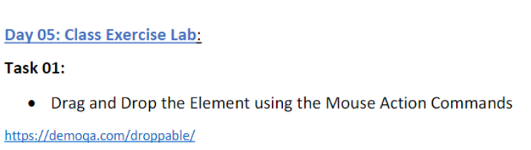

Coding:

package com.Day5;

import org.openqa.selenium.By;

import org.openqa.selenium.WebDriver;

import org.openqa.selenium.WebElement;

import org.openqa.selenium.chrome.ChromeDriver;

import org.openqa.selenium.chrome.ChromeOptions;

import org.openqa.selenium.interactions.Actions;

import io.github.bonigarcia.wdm.WebDriverManager;

public class CE1 {

public static void main(String[] args) {

// TODO Auto-generated method stub

ChromeOptions co = new ChromeOptions();

co.addArguments("--remote-allow-origins=*");

WebDriverManager.chromedriver().setup();

WebDriver driver = new ChromeDriver();

driver.get("https://demoqa.com/droppable/");

driver.manage().window().maximize();

WebElement source = driver.findElement(By.id("draggable"));

WebElement des = driver.findElement(By.id("droppable"));

Actions a = new Actions(driver);

a.dragAndDrop(source, des).build().perform();

}

}

Output:

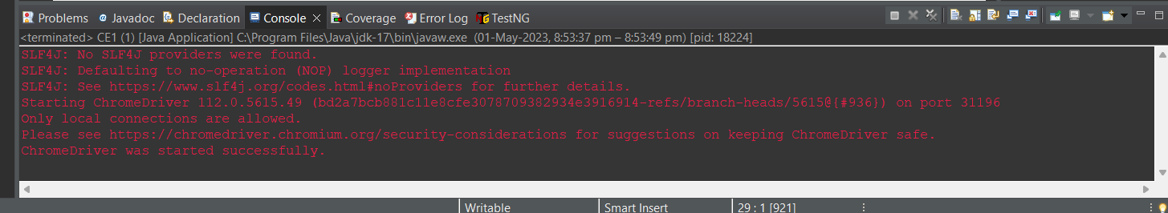

2)

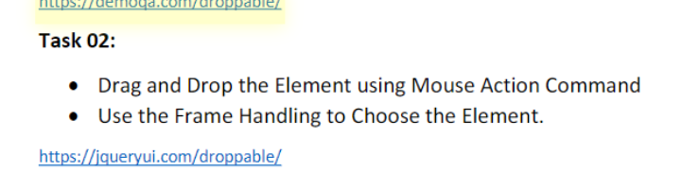

Coding:

package com.Day5;

import org.openqa.selenium.By;

import org.openqa.selenium.WebDriver;

import org.openqa.selenium.WebElement;

import org.openqa.selenium.chrome.ChromeDriver;

import org.openqa.selenium.chrome.ChromeOptions;

import org.openqa.selenium.interactions.Actions;

import io.github.bonigarcia.wdm.WebDriverManager;

public class CE2 {

public static void main(String[] args) {

// TODO Auto-generated method stub

ChromeOptions co = new ChromeOptions();

co.addArguments("--remote-allow-origins=*");

WebDriverManager.chromedriver().setup();

WebDriver driver = new ChromeDriver();

driver.get("https://jqueryui.com/droppable/");

driver.switchTo().frame(0);

driver.manage().window().maximize();

WebElement source = driver.findElement(By.id("draggable"));

WebElement des = driver.findElement(By.id("droppable"));

Actions a = new Actions(driver);

a.dragAndDrop(source, des).build().perform();

}

}

Output:

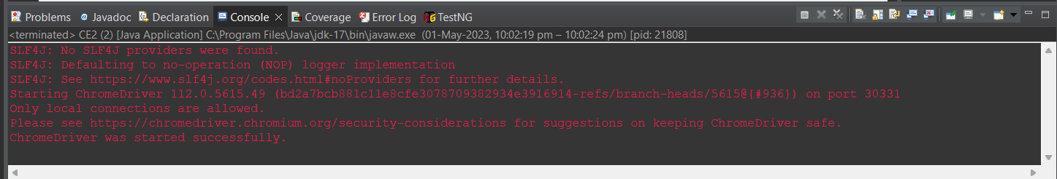

3)

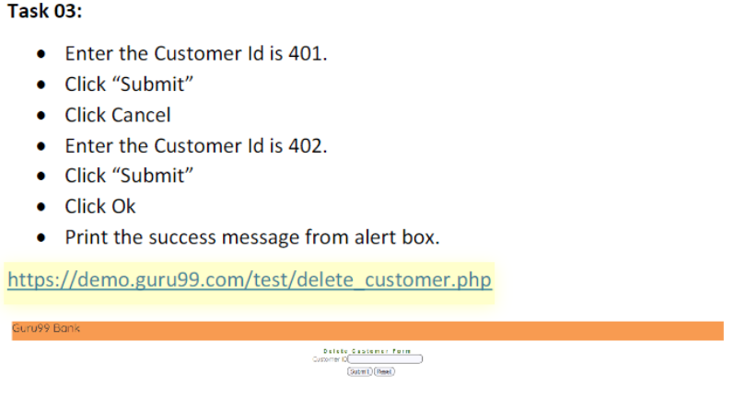

Coding:

package com.Day5;

import org.openqa.selenium.Alert;

import org.openqa.selenium.By;

import org.openqa.selenium.WebDriver;

import org.openqa.selenium.WebElement;

import org.openqa.selenium.chrome.ChromeDriver;

import org.openqa.selenium.chrome.ChromeOptions;

import io.github.bonigarcia.wdm.WebDriverManager;

public class CE3 {

public static void main(String[] args) throws InterruptedException{

// TODO Auto-generated method stub

ChromeOptions co = new ChromeOptions();

co.addArguments("--remote-allow-origins=*");

WebDriverManager.chromedriver().setup();

WebDriver driver = new ChromeDriver();

driver.get("https://demo.guru99.com/test/delete_customer.php");

driver.manage().window().maximize();

WebElement txt = driver.findElement(By.xpath("/html/body/form/table/tbody/tr[2]/td[2]/input"));

WebElement button = driver.findElement(By.xpath("/html/body/form/table/tbody/tr[3]/td[2]/input[1]"));

txt.sendKeys("401");

button.click();

Alert a1 = driver.switchTo().alert();

a1.dismiss();

Thread.sleep(2000);

txt.clear();

txt.sendKeys("402");

button.click();

driver.switchTo().alert().accept();

System.out.print(a1.getText());

Thread.sleep(3000);

driver.switchTo().alert().accept();

}

}

Output:

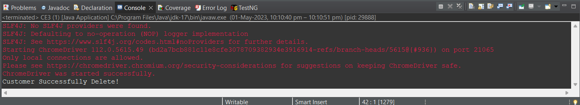

4)

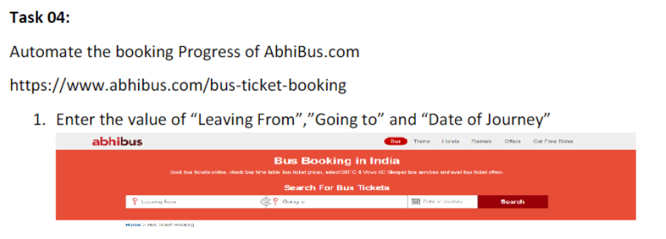

Coding:

package com.Day5;

import org.openqa.selenium.By;

import org.openqa.selenium.WebDriver;

import org.openqa.selenium.chrome.ChromeDriver;

import org.openqa.selenium.chrome.ChromeOptions;

import io.github.bonigarcia.wdm.WebDriverManager;

public class CE4 {

public static void main(String[] args) throws InterruptedException {

// TODO Auto-generated method stub

ChromeOptions co = new ChromeOptions();

co.addArguments("--remote-allow-origins=*");

WebDriverManager.chromedriver().setup();

WebDriver driver = new ChromeDriver();

driver.get("https://www.abhibus.com/bus-ticket-booking");

driver.manage().window().maximize();

Thread.sleep(3000);

driver.findElement(By.xpath("//*[@id=\"source\"]")).sendKeys("Chennai");

Thread.sleep(3000);

driver.findElement(By.xpath("//*[@id=\"destination\"]")).sendKeys("Goa");

Thread.sleep(3000);

driver.findElement(By.xpath("//*[@id=\"datepicker1\"]")).click();

Thread.sleep(3000);

driver.findElement(By.xpath("//*[@id=\"ui-datepicker-div\"]/div[2]/table/tbody/tr[2]/td[7]/a")).click();

Thread.sleep(3000);

driver.findElement(By.xpath("//*[@id=\"seo_search_btn\"]")).click();

}

}

Output:

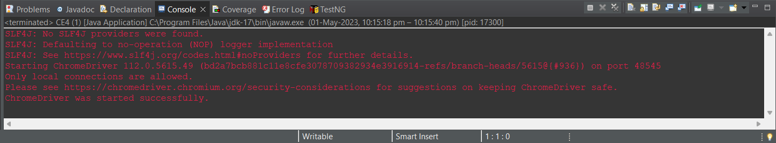

5)

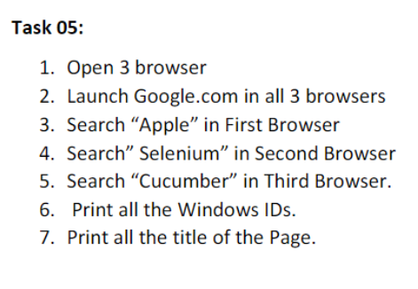

Coding:

package com.day5;

import org.openqa.selenium.By;

import org.openqa.selenium.Keys;

import org.openqa.selenium.WebDriver;

import org.openqa.selenium.WebElement;

import org.openqa.selenium.chrome.ChromeDriver;

import org.openqa.selenium.chrome.ChromeOptions;

import org.openqa.selenium.edge.EdgeDriver;

import io.github.bonigarcia.wdm.WebDriverManager;

public class CE5 {

public static void main(String[] args) {

ChromeOptions co = new ChromeOptions();

co.addArguments("--remote-cross-origin=*");

WebDriverManager.chromedriver().setup();

WebDriver driver1 = new ChromeDriver();

driver1.get("https://www.google.com/");

WebElement search1 = driver1.findElement(By.xpath("//*[@id=\"APjFqb\"]"));

search1.sendKeys("Apple");

search1.sendKeys(Keys.ENTER);

String currentWindowId1 = driver1.getWindowHandle();

String currentTitle1 = driver1.getTitle();

System.out.println("Window Id 1 : " + currentWindowId1);

System.out.println("Window Title 1 : " + currentTitle1);

WebDriver driver2 = new EdgeDriver();

driver2.get("https://www.google.com/");

WebElement search2 = driver2.findElement(By.xpath("//*[@id=\"APjFqb\"]"));

search2.sendKeys("Selenium");

search2.sendKeys(Keys.ENTER);

String currentWindowId2 = driver2.getWindowHandle();

String currentTitle2 = driver2.getTitle();

System.out.println("Window Id 2 : " + currentWindowId2);

System.out.println("Window Title 2 : " + currentTitle2);

ChromeOptions brv = new ChromeOptions();

brv.setBinary("C:\\Program Files\\BraveSoftware\\Brave-Browser\\Application\\brave.exe");

WebDriver driver3 = new ChromeDriver(brv);

driver3.get("https://www.google.com/");

WebElement search3 = driver3.findElement(By.xpath("//*[@id=\"APjFqb\"]"));

search3.sendKeys("Cucumber");

search3.sendKeys(Keys.ENTER);

String currentWindowId3 = driver3.getWindowHandle();

String currentTitle3 = driver3.getTitle();

System.out.println("Window Id 3 : " + currentWindowId3);

System.out.println("Window Title 3 : " + currentTitle3);

}

}

Output:

