Domestic waste management (191)
Overview & Problem Statement
- PS ID: SIH1322
- Theme: Clean & Green Technology
- Organization: Government of Kerala (Directorate of Technical Education)
- Category: Software
- The Problem: Domestic waste management in urban and semi-urban areas suffers from irregular waste pickup, improper household segregation (dry, wet, hazardous), lack of real-time monitoring for municipal workers, and zero incentives or feedback loops for citizens.
Project Goal
To build a scalable, tech-driven Domestic Waste

Management System that streamlines household waste collection, verifies waste segregation at the source using computer vision/AI, optimizes collection truck routes, and gamifies public participation.
Where & Why It Is Used
- Where: Deployed across municipal corporations, urban local bodies (ULBs), residential societies, and waste collection agencies.
- Why:
- Prevents land contamination and illegal dumping.
- Reduces municipal operational costs through optimized pickup routes.
- Ensures compliance with local waste segregation regulations.

How It Works (Core Features)
- Citizen Mobile App: Schedule pickups, scan household waste using AI for real-time segregation check, report illegal dumping spots via geotagged photos, and earn rewards/points.
- Collector / Driver App: Receive daily dynamic optimized route maps, update bin collection statuses, and verify bin fill levels.
- Admin Dashboard (Municipal Desk): Monitor fleet tracking (GIS), view area-wise waste generation heatmaps, track collector attendance, and handle citizen complaints.
- Smart Verification / AI: Deep learning model to classify scanned waste into biodegradable, recyclable, or hazardous categories before disposal.

Recommended Tech Stack
- Mobile App (Citizens & Collectors): Flutter or React Native (cross-platform iOS/Android)
- Web Admin Dashboard: React.js or Next.js with Tailwind CSS
- Backend Framework: Node.js (Express) or Python (FastAPI/Django)
- Database: PostgreSQL / MongoDB (data storage) + Firebase (real-time notifications)
- AI / ML Model: PyTorch or TensorFlow Lite (YOLOv8 / MobileNet for fast waste classification)
- GIS / Mapping API: Mapbox API or Google Maps API for route optimization and geotagging
Team Task Breakdown

Member Role | Primary Responsibilities | Deliverables
Frontend / Mobile Lead | Build Citizen & Collector UI/UX. | Mobile App screens (Booking, Geotagging, Rewards, Collector Route view).
Backend & Database Engineer | Design REST APIs, database schemas, user authentication, and admin web panel. | Secure API endpoints, PostgreSQL DB, Admin Control Dashboard.
AI / ML Engineer | Train and deploy a lightweight image classification model for waste segregation. | TFLite / ONNX model integrated with mobile app camera feed.
GIS & Algorithm Specialist | Integrate map tracking, routing algorithms (Dijkstra/TSP) for truck route optimization. | Dynamic driver route planning service & GIS heatmap rendering.

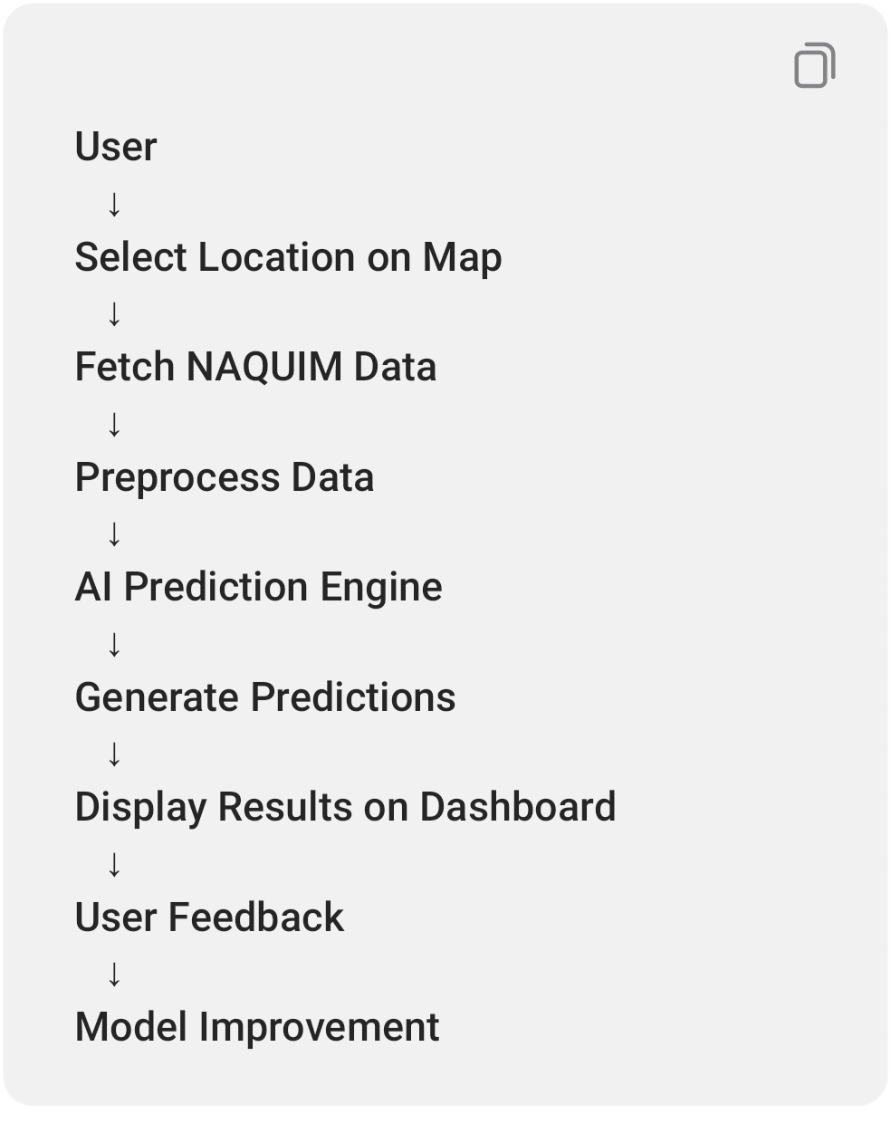

Pros and Cons
- Pros:
- Direct Social & Govt. Impact: Solves a real civic challenge faced by local municipalities.
- High Scalability: Easy to expand from small towns to national-level smart city setups.
High Scope for Innovation: Integration of AI, GIS, and gamification in a single workflow.
- Cons:
- Adoption Friction: Relies on citizen willingness to download and use the app regularly.
Hardware Dependence (if offline): Requires reliable GPS and internet connectivity on field worker devices.
- What Judges Expect

- Working End-to-End Prototype: A functional demo connecting the citizen app, backend database, AI model, and admin panel.
- Real-Time Feasibility & Cost Effectiveness: Lightweight solution requiring minimal hardware expense for local bodies.
- Scalability & Security: Role-based access control (Citizen, Collector, Govt. Admin) and ability to scale to high transaction volumes.
Clear Business / Civic Model: Detailed operational strategy showing how local governments can adopt and sustain the system.
- How to Stand Out & Score Extra Points
- Gamified Citizen Incentives: Include a "Green Points" module where proper segregation yields tax discounts, utility bills rebate, or coupon codes.

- Offline First Architecture: Allow collectors to log pickups in low-connectivity areas and auto-sync when online.
- WhatsApp / SMS Bot Integration: Allow non-smartphone users or senior citizens to request pickups via a simple WhatsApp query or SMS.
Predictive Analytics for Municipalities: Use historical pickup data to predict high-waste days (holidays/festivals) and suggest proactive resource deployment.

SIH 2025 – PS ID: SIH1292 ( 221)
AI-Based Groundwater Well Decision Support System using NAQUIM Data
Theme: Clean & Green Technology

───

1. Problem Statement
India relies heavily on groundwater for drinking, agriculture, and industries. Every year, thousands of borewells fail because people drill without scientific knowledge.
- Problems include:
- Dry borewells after spending lakhs of rupees.
- Groundwater depletion.
- Poor water quality (fluoride, salinity, arsenic, iron, etc.).
- No easy way for common people to understand geological reports.
Government groundwater data (NAQUIM) exists but is difficult for non-experts to use.

───

2. Goal of the Project
Build an AI-powered web application that helps users decide whether a borewell should be drilled at a selected location.
- The system should predict:
- Is the location suitable for drilling?
- Expected groundwater depth.
- Expected water yield.
- Recommended drilling technique.
- Groundwater quality.
Additional geological information.
The aim is to reduce failed borewells and promote sustainable groundwater use.

───

3. Why is this Needed?
- Current Situation:
- People depend on local advice or guesswork.
- Huge financial loss due to failed borewells.
- Excessive groundwater extraction.
Unsafe groundwater affects health.
- Expected Benefits:
- Scientific decision-making.
- Better groundwater conservation.
- Reduced drilling costs.
Increased success rate of borewells.

───

- 4. Where is it Used?
- Farmers
- Rural households
- Municipal corporations
- Groundwater departments
- Borewell contractors
- Industries
- Urban planners
Smart city projects

───

5. Type of Work Involved
- AI / Machine Learning
- Predict borewell success.

- Predict groundwater depth.
- Predict water quality.
Estimate water discharge.
- GIS (Geographical Information System)
- Interactive maps.
- Aquifer visualization.
Location-based predictions.
- Data Analytics
- Process groundwater datasets.
Analyze geological trends.
- Web Development
- User dashboard.
- Map interface.
Reports.

- Database Management
- Store groundwater data.
- User history.
Feedback.

───

6. Government Dataset Used
- Main Dataset:
NAQUIM (National Aquifer Mapping and Management Programme)
- Provided by:
Central Ground Water Board (CGWB)
- Data includes:

- Aquifer maps.
- Lithology.
- Water levels.
- Water quality.
- Geophysical logs.
- Existing borewell information.
Recharge zones.

───

7. Technologies Required
- AI / ML
- Random Forest
- XGBoost
- LightGBM
- CatBoost

Neural Networks (optional)
- GIS
- QGIS
- Leaflet.js
- OpenLayers
PostGIS
- Backend
- Python
- FastAPI (recommended)
Flask
- Frontend
- React.js
Next.js (optional)

- Database
- PostgreSQL + PostGIS
MongoDB (optional)
- Data Analysis
- Pandas
- GeoPandas
NumPy
- Visualization
- Plotly
Chart.js
- Cloud
AWS / Azure / GCP

───

8. System Workflow
Layer | Technology
Frontend | React.js + Leaflet
Backend | FastAPI (Python)
AI/ML | XGBoost / Random Forest + Scikit-learn
Database | PostgreSQL + PostGIS
GIS | Leaflet + QGIS
Data Processing | Pandas, GeoPandas, NumPy
Visualization | Plotly / Chart.js
Deployment | Docker + AWS/Azure

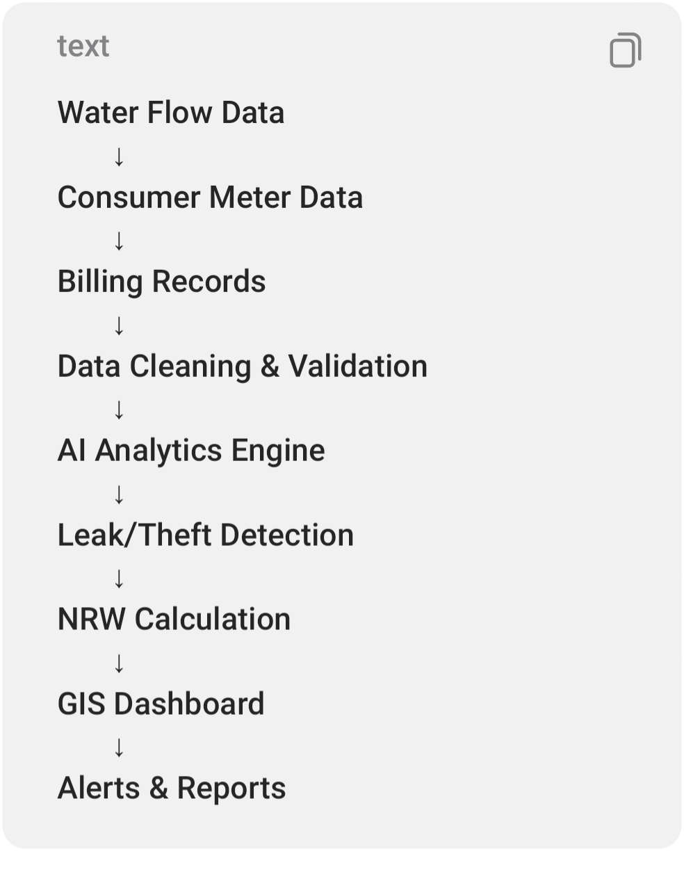

───

- 9. Features
- Location Selection
- Click on map.
Search village/city.
Enter coordinates.

───

- AI Prediction
- Predict:
- Borewell success probability.

- Groundwater depth.
- Water-bearing layers.
- Water yield.
Water quality.
Suitable drilling method.

───

- Dashboard
- Display:
- Interactive GIS map.
- Geological layers.
- Aquifer information.
- Prediction confidence.
Charts.
Downloadable report.

───

- User Feedback
- Users can submit:
- Actual drilling depth.
- Water found or not.
Water quality.
Borewell success.
This helps retrain the AI model over time.

───

- 10. AI Models
- Possible Models:
- Random Forest
- XGBoost

- Gradient Boosting
Decision Trees
- Neural Networks
- Model Outputs:
- Classification:
- Suitable / Not Suitable
- Regression:
- Water depth
Yield
Water quality values

───

- 11. GIS Components
- Use maps to display:
- Aquifer boundaries.

- Groundwater levels.
- Existing wells.
- Geological layers.
Water quality zones.
Recharge areas.

───

- 12. Database Tables
- Store:
- User details.
- Locations searched.
- Geological records.
- Prediction history.
User feedback.
Reports.

───

- 13. Challenges
- Large datasets.
- Missing values.
- Different geological conditions.
- Seasonal groundwater changes.
- Prediction accuracy.
GIS integration.
Fast response time.

───

- 14. Advantages
- Saves money on failed borewells.
- Scientific decision support.

- Conserves groundwater.
- Easy for common users.
- Supports government planning.
Promotes sustainable water use.
Better groundwater management.

───

- 15. Limitations
- Depends on dataset quality.
- AI predictions cannot be 100% accurate.
- Seasonal rainfall affects groundwater.
Some remote areas may have limited data.
Requires periodic dataset updates.

───

16. How to Improve (High-Impact Features)
1. Satellite Image Integration
Use satellite imagery to improve predictions.

───

2. Rainfall Prediction
Include rainfall forecasts to estimate groundwater recharge.

───

- 3. Explainable AI
- Show why a location is recommended, such as:

- Good aquifer depth.
Favorable rock type.
High historical yield.

───

4. Mobile Version
Support field engineers and farmers.

───

5. Voice Assistant
Allow users to ask questions in local languages.

───

6. Multilingual Support

Hindi, Gujarati, Tamil, Marathi, etc.

───

7. Offline Mode
Useful for rural areas with poor internet.

───

8. IoT Integration (Future)
Connect groundwater monitoring sensors for live updates.

───

- 17. Future Scope
- Predict groundwater depletion.

- Suggest artificial recharge methods.
- Detect drought-prone areas.
- Government planning dashboard.
Climate change impact analysis.
Borewell permit recommendation system.

───

- 18. Team Task Distribution
- Member 1 – Research & Data
- Study NAQUIM and CGWB datasets.
Understand lithology, aquifers, and groundwater concepts.
- Clean and prepare datasets.
- Member 2 – AI/ML

- Build prediction models.
Train and evaluate models.
- Optimize accuracy and generate confidence scores.
- Member 3 – Backend & Database
- Develop APIs.
Manage PostgreSQL/PostGIS.
- Integrate AI with the frontend.
- Member 4 – Frontend & GIS
- Build the web interface.
Integrate interactive maps.
- Create dashboards and reports.
- Member 5 – Testing & Documentation
- Test the application.
Validate predictions.

Prepare documentation, presentation, and deployment.

───

- 19. Judges' Expectations
- Practical use of NAQUIM/CGWB data rather than a generic AI demo.
- Accurate, explainable AI predictions with confidence scores.
- Smooth GIS-based interface where users can click a location and get instant results.
- A scalable solution that can be adopted by government agencies and farmers.
Clear demonstration of environmental impact by reducing failed borewells and promoting sustainable groundwater management.

Clean architecture, good UI/UX, and realistic deployment strategy.

───

20. Suggested Tech Stack
Layer | Technology
Frontend | React.js + Leaflet
Backend | FastAPI (Python)
AI/ML | Isolation Forest, XGBoost, Scikit-learn
Database | PostgreSQL + PostGIS
GIS | Leaflet, QGIS
Data Processing | Pandas, NumPy
Visualization | Plotly / Chart.js
Deployment | Docker + AWS/Azure

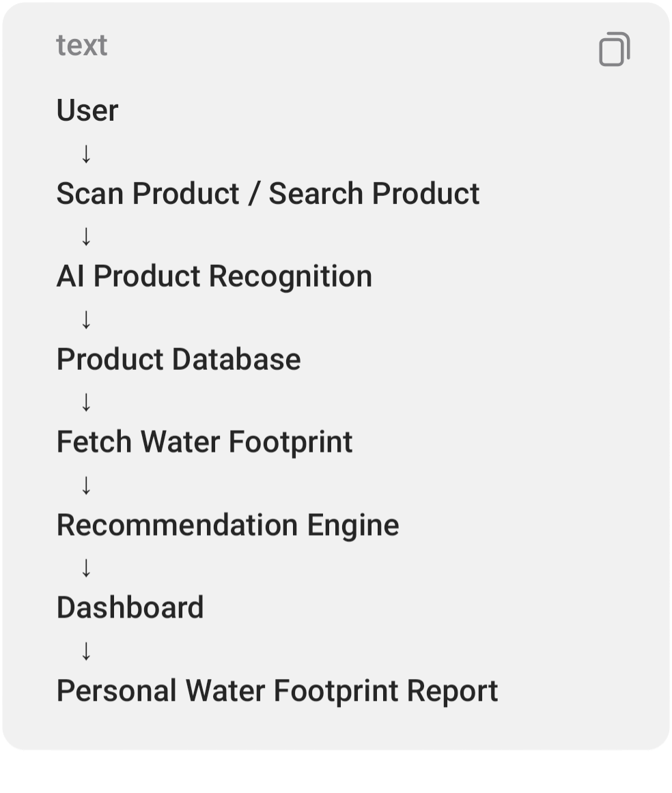
Overall Difficulty: ⭐⭐⭐⭐☆ (4.5/5)
Winning Potential: ⭐⭐⭐⭐⭐ (5/5)
This project stands out because it combines AI, GIS, government data, and environmental sustainability to solve a real-world problem with clear social impact, making it highly aligned with what SIH judges typically look for in the Clean & Green Technology domain.

SIH 2025 – PS ID: SIH1288 (225)

AI-Based Non-Revenue Water (NRW) Detection & Smart Water Distribution Management System
Theme: Clean & Green Technology

───

1. Problem Statement
- Water utilities lose a large amount of water before it reaches consumers. This lost water is called Non-Revenue Water (NRW).
- NRW = Total Water Supplied − Water Billed to Consumers
- Water is lost due to:
- Leakage in pipelines.
- Illegal water connections (water theft).
- Faulty water meters.

Burst pipelines.
Billing and data errors.
Old distribution infrastructure.
Many water boards know water is being lost, but they don't know exactly where, why, or how much, because the available data is often incomplete or inaccurate.

───

- 2. Goal of the Project
- Develop an AI-powered digital platform that helps water authorities:
- Detect water losses in the distribution network.
- Identify possible leaks and illegal connections.

Calculate Non-Revenue Water (NRW).
Convert NRW into Revenue Water by reducing losses.
Improve water conservation and utility revenue.
The aim is to save water, reduce financial losses, and improve the efficiency of water distribution systems.

───

- 3. Why is this Needed?
- Current Situation
- Huge quantities of treated water never reach paying customers.
- Water utilities lose significant revenue.
Leak detection is often manual and slow.

- Water theft is difficult to identify.
- Maintenance usually happens only after major failures.
- Expected Benefits
- Save millions of liters of water.
- Increase revenue for water utilities.
Reduce maintenance costs.
Improve water supply reliability.
Enable predictive maintenance instead of reactive repairs.

- ───

- 4. Where is it Used?
- Municipal Water Boards
- Smart Cities

- Jal Jeevan Mission
- Water Distribution Departments
- Industries with internal water networks
Apartment complexes and townships
Industrial parks
Water supply control centers

───

- 5. Type of Work Involved
- AI / Machine Learning
- Leak prediction.
Water theft detection.
- Anomaly detection.
- Demand forecasting.
- Data Analytics

- Water consumption analysis.
Revenue analysis.
- NRW calculation.
- Trend analysis.
- GIS
Pipeline mapping.
- Leak hotspot visualization.
- Zone monitoring.
- Web Development
Dashboards.
- Live monitoring.
- Reports.
- IoT Integration (Optional)
Smart water meters.
Flow sensors.

Pressure sensors.

───

- 6. Data Sources
- Possible inputs:
- Water flow meter readings.
- Consumer smart meter data.
- Pressure sensor data.
- Billing records.
- Customer complaints.
GIS pipeline maps.
Historical maintenance records.
SCADA (Supervisory Control and Data Acquisition) data (if available).

───

- 7. Technologies Required
- AI / ML
- Random Forest
- XGBoost
Isolation Forest (anomaly detection)
- LSTM (time-series forecasting)
- LightGBM
- Backend
Python
- FastAPI
- Flask
Frontend
- React.js

- Next.js (optional)
- Database
PostgreSQL
- MongoDB
- PostgreSQL + PostGIS (for GIS)
Data Processing
- Pandas
- NumPy
- GIS
Leaflet.js
- QGIS
- OpenLayers
Visualization

- Plotly
- Chart.js
- Cloud
AWS
Azure
Google Cloud

───

8. System Workflow
Layer | Technology
Frontend | Flutter (Mobile) / React.js (Web)
Backend | FastAPI (Python)
AI/ML | TensorFlow, MobileNet, Scikit-learn
Computer Vision | OpenCV, Google ML Kit, OCR
Database | PostgreSQL / Firebase
Data Processing | Pandas, NumPy
Cloud | AWS / Firebase
Deployment | Docker + AWS/Firebase

- ───

- 9. Features
- Data Monitoring
Import water meter readings.
Monitor flow rates.

Compare supplied vs billed water.
View pressure variations.

- ───

- AI Prediction
- Detect:
- Pipeline leaks.
Water theft.
Abnormal consumption.
Meter failures.
High-risk zones.

- ───

- GIS Dashboard

- Display:
- Pipeline network.
Leak locations.
High-loss zones.
Pressure maps.
Water flow direction.

- ───

- Analytics
- Show:
- NRW percentage.
Daily water loss.
Revenue loss estimate.
Consumption trends.
Zone-wise performance.

- ───

- Alerts
- Notify authorities about:
Sudden pressure drops.
Unusual flow changes.
High NRW zones.
Suspected illegal connections.

- ───

- Reports
- Generate:
Daily/weekly/monthly NRW reports.
Maintenance recommendations.
Revenue-loss reports.
Utility performance summaries.

- ───

- 10. AI Models
- Possible Models:
- Isolation Forest (anomaly detection)
Random Forest
- XGBoost
- LightGBM
- LSTM (forecasting)
- Model Outputs:
Leak probability.
Theft risk score.
Predicted water demand.
Maintenance priority.

- ───

- 11. GIS Components
- Display:
- Water pipeline network.
- Consumer locations.
Leak hotspots.
Pressure zones.
Valve locations.
Maintenance history.

- ───

- 12. Database Tables
- Store:
- Consumer details.

- Water meter readings.
- Billing records.
- Pipeline information.
Leak reports.
Maintenance logs.
Alerts.
AI predictions.

- ───

- 13. Challenges
- Missing or inaccurate meter data.
- Old infrastructure without smart sensors.
Distinguishing leaks from theft.
Integrating multiple data sources.
Processing large volumes of real-time data.
Minimizing false alarms.

- ───

- 14. Advantages
- Conserves treated water.
- Increases utility revenue.
- Detects leaks early.
Supports predictive maintenance.
Reduces repair costs.
Improves service reliability.
Helps authorities make data-driven decisions.

- ───

- 15. Limitations

AI depends on the quality of input data.
Areas without digital meters provide limited information.
Initial deployment can be costly if IoT sensors are added.
Predictions require regular model updates as network conditions change.

───

16. How to Improve (High-Impact Features)
1. Digital Twin
Create a virtual model of the water distribution network to simulate leaks and maintenance.

───

2. Explainable AI
Show why the system flagged an area (e.g., sudden pressure drop + abnormal flow).

───

3. Predictive Maintenance
Forecast which pipeline sections are likely to fail before they actually do.

───

4. Citizen Mobile App
Allow residents to report leaks with photos and GPS locations.

───

5. SCADA Integration
Connect with existing utility monitoring systems for real-time data.

───

6. Weather & Rainfall Integration
Adjust demand predictions using weather forecasts and seasonal trends.

───

7. Offline Mode
Allow field engineers to collect inspection data without internet and sync later.

───

8. Multilingual Dashboard
Support regional languages for utility staff across India.

- ───

- 17. Future Scope
- City-wide smart water management.
- Integration with IoT smart meters.
Automatic valve control to reduce losses.
AI-driven demand forecasting.
Smart city integration.
Carbon and energy savings analysis from reduced water losses.

- ───

- 18. Team Task Distribution
Member 1 – Research & Data
- Study NRW concepts and water distribution systems.
- Collect sample datasets (meter readings, billing, pipeline maps).
- Understand utility workflows.
Member 2 – AI/ML
- Develop anomaly detection models.
- Build leak and theft prediction algorithms.
- Evaluate model accuracy and confidence.
Member 3 – Backend & Database

- Build APIs.
- Design PostgreSQL/PostGIS database.
- Integrate AI models with backend services.
Member 4 – Frontend & GIS
- Develop dashboard.
- Integrate GIS maps.
- Build analytics charts and reporting interface.
Member 5 – Testing & Documentation
Test workflows and dashboards.
Prepare documentation, deployment, and presentation.
Validate system using sample scenarios.

- ───

- 19. Judges' Expectations
- A practical solution that can be used by municipal water utilities, not just a theoretical AI model.
- Accurate detection of leaks and abnormal water losses with low false positives.
Clear GIS-based visualization of problem areas.
Actionable recommendations, not just dashboards (e.g., maintenance priorities).
Scalable architecture that can work with or without IoT sensors.
Strong focus on water conservation, cost savings, and operational efficiency.

───

- 20. Suggested Tech Stack

- Overall Difficulty
- Difficulty: ⭐⭐⭐⭐☆ (4/5)
Winning Potential: ⭐⭐⭐⭐☆ (4.5/5)
Key difference from SIH1514:
SIH1514 focuses on inspecting pipelines directly using images/video to detect cracks, leaks, and damage.
SIH1288 focuses on analyzing water-distribution data (flow, pressure, billing, meters, GIS) to detect where water is being lost and improve the overall efficiency of the distribution network. This makes it more software- and analytics-oriented, with less dependence on inspection hardware.

(226)SIH 2025 – PS ID: SIH1287

AI-Based Water Footprint Analyzer & Sustainable Product Recommendation System
Theme: Clean & Green Technology

───

- 1. Problem Statement
- Most people are unaware of the hidden amount of water used to produce the products they consume every day. This hidden usage is called the Water Footprint.
- For example:
1 cup of coffee ≈ 140 liters of water
- 1 cotton T-shirt ≈ 2700 liters
- 1 kg of rice ≈ 2500 liters
- 1 kg of beef ≈ 15,000 liters

- Because consumers don't know this:
- High water-footprint products are overused.
Freshwater resources are depleted.
Groundwater levels continue to fall.
Water pollution increases.
People unknowingly contribute to water scarcity.
The challenge is to build a digital solution that educates people and helps them make water-efficient choices.

- ───

- 2. Goal of the Project
- Develop an AI-powered mobile app or website where users can:
- Scan products using the camera (similar to

Google Lens).
- Search products manually.
- View the water footprint of products.
Compare products.
Receive sustainable alternatives.
Track their personal water footprint.
Support multiple Indian languages.
The aim is to create awareness and encourage sustainable purchasing decisions.

- ───

- 3. Why is this Needed?
- Current Situation
Most people only see product price and quality.
- Almost nobody considers water

consumption.
- Water scarcity is increasing every year.
- Existing water-footprint information is scattered across research papers and websites.
- Expected Benefits
- Increase public awareness.
Promote responsible shopping.
Reduce unnecessary water consumption.
Support water conservation.
Encourage sustainable lifestyles.

- ───

- 4. Where is it Used?
- General consumers.

- Schools & colleges.
- Environmental NGOs.
- Government awareness campaigns.
Supermarkets.
E-commerce platforms.
Sustainability education programs.
Smart city initiatives.

- ───

- 5. Type of Work Involved
AI / Machine Learning
- Product recognition.
- Image classification.
- Recommendation system.
Computer Vision

- Camera scanning.
- Product identification.
- Barcode recognition (optional).
Web/Mobile Development
- Mobile app.
- User dashboard.
- Product search.
Data Analytics
- Water footprint calculations.
- User behavior analysis.
- Sustainability reports.
Cloud Computing
- Store product database.
User history.
- Reports.

Big Data (Optional)
Large-scale product and footprint datasets.
Blockchain (Optional)
Verify product sustainability records.

- ───

- 6. Data Sources
- Possible datasets:
- Water Footprint Network (WFN).
- FAO (Food and Agriculture Organization) datasets.
Government agriculture and water reports.
Product catalogs.
Barcode databases (optional).

User feedback data.

- ───

- 7. Technologies Required
AI / ML
- TensorFlow
- PyTorch
- Scikit-learn
- Computer Vision
OpenCV
- YOLO (optional)
- Google ML Kit
- OCR (Tesseract)

Backend
- Python
- FastAPI
Flask
- Frontend
- Flutter (recommended for mobile)
- React.js (for web)
Database
- PostgreSQL
- MongoDB
Firebase
- Data Processing
- Pandas

- NumPy
Cloud
- AWS
Azure
Google Cloud
Translation
Multilingual APIs or AI translation models.

───

8. System Workflow

- ───

- 9. Features
Product Recognition
Camera scan.

Barcode scan (optional).
Manual search.
OCR for product labels.

- ───

- Water Footprint Information
- Display:
Total water footprint.
Blue Water (surface & groundwater).
Green Water (rainwater).
Grey Water (pollution-related water).
Environmental impact.

- ───

Product Comparison

Compare:
Product A vs Product B.
Show which option uses less water.
Suggest eco-friendly alternatives.

- ───

Recommendation Engine
Recommend:
Low water-footprint products.
Water-saving alternatives.
Sustainable purchasing tips.

- ───

- Dashboard

- Show:
- Daily footprint.
Weekly footprint.
Monthly footprint.
Water saved.
Sustainability score.
Product history.

- ───

Reports
Generate:
Personal water footprint report.
Product comparison report.
Sustainability progress.

- ───

- 10. AI Models
Possible Models:
- Product Recognition
- MobileNet
- EfficientNet
YOLO
- Recommendation System
- Content-based filtering.
Collaborative filtering.
- Rule-based recommendations.
- OCR
- Tesseract.
Google ML Kit.

Outputs:
Product identified.
Water footprint calculated.
Sustainable alternative suggested.

- ───

- 11. Database Tables
- Store:
- Product details.
- Water footprint values.
User profiles.
Search history.
Scan history.
Recommendations.
- User reports.

- ───

- 12. Challenges
- Creating a reliable water-footprint database.
Recognizing products with different packaging.
Supporting local and unbranded products.
Maintaining accurate and updated data.
Providing multilingual support.
- Ensuring fast AI predictions on mobile devices.

- ───

- 13. Advantages

- Increases environmental awareness.
Promotes sustainable shopping habits.
Encourages water conservation.
Easy to use through camera scanning.
Suitable for users across India with multilingual support.
- Can integrate with e-commerce and retail platforms.

- ───

- 14. Limitations
Water-footprint values may vary by region and production method.
Product recognition accuracy depends on image quality.
Some products may not exist in the

database.
Continuous database updates are required.
AI recommendations depend on data quality.

───

15. How to Improve (High-Impact Features)
1. Barcode Scanner
Quickly identify products without relying only on image recognition.

───

2. E-commerce Integration
Show water footprints directly while users shop

online.

───

3. Carbon Footprint Integration
Display both water and carbon footprints together.

- ───

4. AI Chatbot
Answer questions such as:
"Why does rice use more water than wheat?"
- "Suggest a low-water breakfast."

- ───

5. Gamification
Green badges.
Daily challenges.
Leaderboards.
Reward points.

───

6. QR Code Support
Businesses can place QR codes on products to display verified water-footprint information.

───

7. Offline Mode
Cache common products for use without

internet access.

───

8. Personalized Sustainability Score
- Analyze user purchases over time and suggest ways to reduce their overall water footprint.

- ───

- 16. Future Scope
- Integration with online grocery and shopping apps.
Retailer dashboard for sustainable product labeling.
AI meal planner based on water footprint.
School awareness programs.
Government water-conservation campaigns.

International product support.

- ───

17. Team Task Distribution
- Member 1 – Research & Data
- Collect water-footprint datasets.
- Build the product database.
Validate information from trusted sources.
- Member 2 – AI/ML
- Develop product recognition model.
- Build recommendation engine.
Improve recognition accuracy.
- Member 3 – Backend & Database

- Build APIs.
- Manage database.
Handle user authentication and reports.
- Member 4 – Frontend & UI
- Develop Flutter app or React web app.
- Implement camera scanning.
- Build dashboard and multilingual interface.
Member 5 – Testing & Documentation
Test AI accuracy.
Prepare reports and documentation.
Deploy the application.
- Create the final SIH presentation.

- ───

- 18. Judges' Expectations
- Accurate AI-based product recognition.
A trusted and explainable water-footprint database rather than random values.
A smooth, multilingual user experience.
Practical recommendations that help users reduce their water footprint.
A scalable solution that could integrate with retail stores or e-commerce platforms.
Clear environmental impact and measurable awareness generation.

───

19. Suggested Tech Stack

- 20. Overall Evaluation
- Difficulty: ⭐⭐⭐☆☆ (3.5/5)
Winning Potential: ⭐⭐⭐⭐☆ (4/5)
- Strengths
Strong public awareness and environmental impact.
Easy to demonstrate with a live mobile app.
Good use of AI (computer vision + recommendation systems).
Scalable to retail and e-commerce.
Weaknesses
The biggest challenge is building or obtaining a reliable water-footprint database. Judges are likely to question the source and accuracy of the footprint values,

so your data sources and methodology must be well justified.

