PRACTICAL SUBMISSION
Data Structures
Student Name: KUSHVAHA VYOM MAHENDRASINH
Enrollment No.: 12502080501120
Subject: Data Structure
Faculty Name: Jay Pandya
Semester: Odd (3rd)
Department of Information Technology

Practical 2: Dynamic Memory Allocation

Q1. Print Array Elements in Reverse Order Using Dynamic Memory Allocation
Statement:
Write a program to dynamically allocate memory for an array of n elements. Input the elements from the user, print the array elements in reverse order, and finally deallocate the dynamically allocated memory to prevent memory leaks.

Algorithm
- Start the program and prompt the user to enter the size of the array (n).
- Dynamically allocate memory for an integer array of size n using the new operator.
- Prompt the user to input n array elements and store them in the dynamically allocated array.
- Display the array elements in reverse order:
a. Initialize a loop from n - 1 down to 0.
b. Print each array element during the loop.
- Deallocate the dynamically allocated memory using the delete[] operator.
- End the program.

Source Code (C++)

#include <iostream>
using namespace std;

int main() {
int n;

// Input array size
cout << "Enter the size of the array: ";
cin >> n;

// Dynamic memory allocation
int *arr = new int[n];

// Input array elements
cout << "Enter " << n << " array elements:" << endl;
for (int i = 0; i < n; i++) {
cin >> arr[i];
}

// Print array in reverse order
cout << "Array elements in reverse order: ";
for (int i = n - 1; i >= 0; i--) {
cout << arr[i] << " ";
}

// Deallocate memory
delete[] arr;

return 0;
}

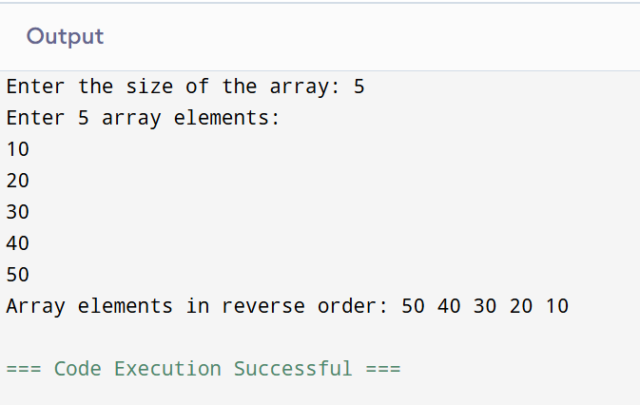
Output

Q2(A). Demonstrate Call by Value

Statement:
Write a program to demonstrate Call by Value. Pass a variable to a function by value, modify it inside the function, and observe that the original value in the calling function remains unchanged.

Algorithm
- Start the program.
- Declare an integer variable a.
- Initialize a with a value.
- Display the value of a before calling the function.
- Call the callByValue(a) function by passing the value of a.
- Inside the function:
a. Receive a copy of the variable.
b. Modify the copied value.
c. Display the modified value.
- Return to the main() function.
- Display the value of a after the function call.
- Observe that the original value remains unchanged.
- End the program.

Source Code (C++)

#include <iostream>
using namespace std;
// Function to demonstrate Call by Value
void callByValue(int a) {
a = a + 10;
cout << "Value of a inside the function: " << a << endl;
}
int main() {
int a;
// Input value
cout << "Enter the value of a: ";
cin >> a;
cout << "Value of a before function call: " << a << endl;
// Function call
callByValue(a);
// Display value after function call
cout << "Value of a after function call: " << a << endl;
return 0;
}
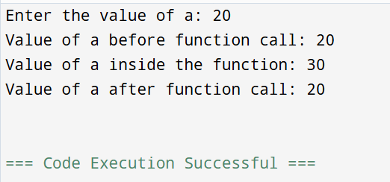
Output

Q2 (B). Demonstrate Call by Reference

Statement:
Write a program to demonstrate Call by Reference. Pass the address of a variable to a function, modify its value using a pointer, and observe that the original value in the calling function is changed.

Algorithm
- Start the program.
- Declare an integer variable b.
- Initialize b with a value.
- Display the value of b before calling the function.
- Call the callByReference(&b) function by passing the address of b.
- Inside the function:
a. Receive the address of b using a pointer.
b. Modify the value stored at that address.
c. Display the modified value.
- Return to the main() function.
- Display the updated value of b after the function call.
- Observe that the original variable has been modified.
- End the program.
Source Code (C++)

#include <iostream>
using namespace std;

// Function to demonstrate Call by Reference
void callByReference(int *b) {
*b = *b + 10;
cout << "Value of b inside the function: " << *b << endl;
}
int main() {
int b;

// Input value
cout << "Enter the value of b: ";
cin >> b;

// Display original value
cout << "Value of b before function call: " << b << endl;
// Function call
callByReference(&b);

// Display value after function call
cout << "Value of b after function call: " << b << endl;
return 0;
}

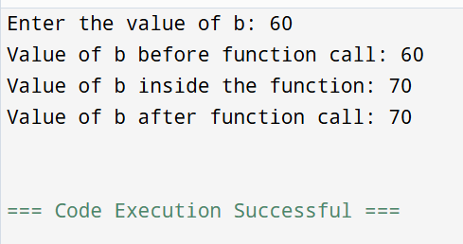
Output

