ASSIGNMENT SUBMISSION
Data Structures
Student Name: KUSHVAHA VYOM MAHENDRASINH
Enrollment No.: 12502080501120
Subject: Data Structure
Faculty Name: Jay Pandya
Semester: Odd (3rd)
Submission Date: 12-07-2026
Department of Information Technology

Problem 1: Pascal's Triangle
Problem Statement:
Given an integer numRows, return the first numRows of Pascal's triangle.
In Pascal's triangle, each number is the sum of the two numbers directly above it.
Algorithm
1. Start the program and prompt the user to input the number of rows (row).
2. Define a helper function nCr(n, r) to compute combinations:
a. If r is out of bounds (r > n or r < 0), return 0.
b. If r == 0 or r == n, return 1.
c. Optimize computation by setting r = n - r if r > n - r.
d. Compute the value using a loop multiplying successive factors.
3. In main(), read 'row' and loop through each row from i = 0 to row - 1.
4. For each row, loop through elements from j = 0 to i, print nCr(i, j) formatted inside brackets.
5. End the program.

Source Code (C++)
#include<iostream>
using namespace std;
int nCr(int n, int r) { // function for nCr
if (r > n || r < 0) return 0;// r not negetive or greater than form n.
if (r == 0 || r == n) return 1;
if (r > n - r) {
r = n - r;
}
int result = 1;
for (int i = 1; i <= r; ++i) {
result *= (n - r + i);
result /= i;
}
return result;
}
int main()
{
int row;
int i,j;
cout<<"Enter how many rows you want:";
cin>>row;
cout<<"[";
for(i=0;i<row;i++)
{
cout<<"[";
for(j=0;j<=i;j++)
{
cout<<nCr(i,j);
if(j != i)
cout<<",";
}
cout<<"]";
}
cout<<"]";
return 0;
}

Output 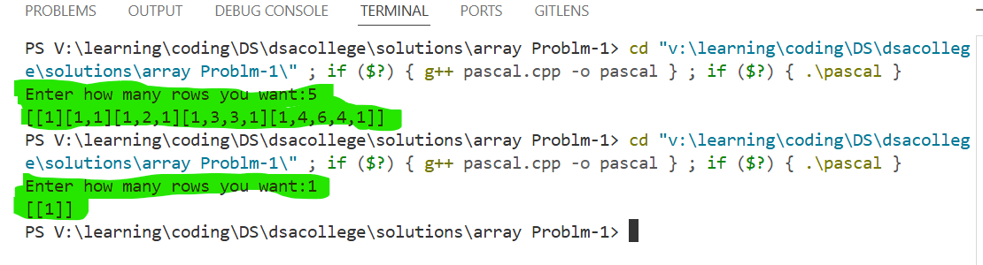

Problem 2: Majority Number

Problem Statement:
Given an array nums of size n, return the majority element. The majority element is the element that appears more than ⌊n / 2⌋ times.
Algorithm
1. Start the program and take the size of the array as input.
2. Declare an array of the given size and read all elements from the user.
3. Use a nested loop configuration to pick each element as a candidate (outer loop).
4. Count the frequency of the candidate element throughout the array (inner loop).
5. If the count exceeds size / 2, set majorityElement to that candidate.
6. If a majority element is found, print it; otherwise, indicate no majority element exists.
7. End the program.

Source Code (C++)
#include<iostream>
using namespace std;
int main(){
int size;
cout<<"Enter size of array:";
cin>>size;
int arr[size];
cout<<"Enter "<<size<<" element of arrays:";
for(int i = 0; i < size; i++)
{
cin>>arr[i];
}
int count,majorityElement = -1;
for(int i=0;i<size;i++)
{
count = 0;
for(int j=0;j<size;j++)
{
if(arr[i] == arr[j])
{
count++;
}
}
if ( count > size/2 )
{
majorityElement = arr[i];
}
}
if( majorityElement != -1)
{
cout<<"majority element is : "<<majorityElement<<endl;
}
else
{
cout<<"not any element is majority";
}
return 0;
}

Output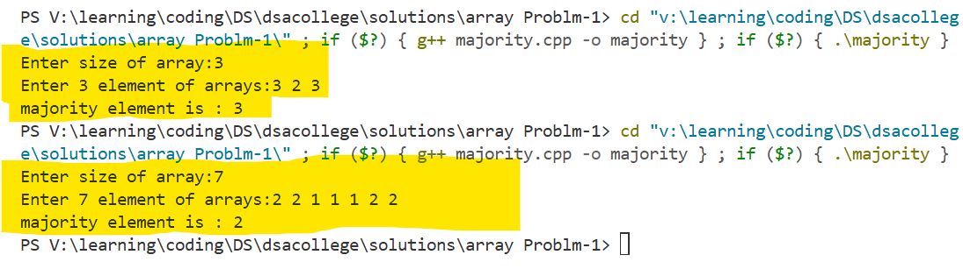

Problem 3: Best Time to Buy and Sell Stock
Problem Statement:
You are given an array prices where prices[i] is the price of a given stock on the i-th day. You want to maximize your profit by choosing a single day to buy one stock and choosing a different day in the future to sell that stock.
Algorithm
1. Start the program and get the total number of days (size).
2. Input the price array elements from the user.
3. Initialize minPrice to the first element and maxProfit to 0.
4. Loop through the prices from the second day to the last day:
a. Compute potential profit = current price - minPrice.
b. If profit > maxProfit, update maxProfit.
c. If current price < minPrice, update minPrice.
5. Print the max profit achieved, or print "Don't Buy Or Sell" if maxProfit is 0.
6. End the program.

Source Code (C++)
#include <iostream>
using namespace std;
int main() {
int size;
cout << "Enter how many days price to you want to enter: ";
cin >> size;
int arr[size];
cout << "Enter " << size << " day's price:" << endl;
for(int i = 0; i < size; i++) {
cin >> arr[i];
}
int minPrice = arr[0];
int maxProfit = 0;
for(int i = 1; i < size; i++) {
int profit = arr[i] - minPrice;
if(profit > maxProfit) {
maxProfit = profit;
}
if(arr[i] < minPrice) {
minPrice = arr[i];
}
}
if(maxProfit == 0) {
cout << "Don't Buy Or Sell";
} else {
cout << "Maximum profit is: " << maxProfit;
}
return 0;
}

Output

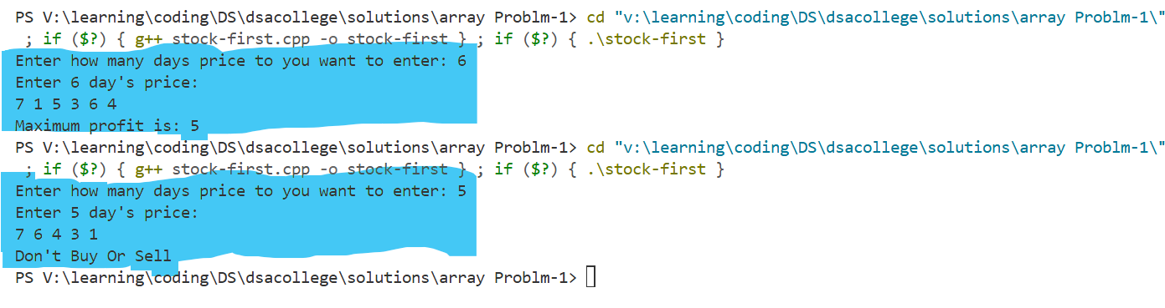

Problem 4: Best Time to Buy and Sell Stock II

Problem Statement:
You are given an array prices where prices[i] is the price of a given stock on the i-th day. Find the maximum profit you can achieve. You may complete at most two transactions.
Algorithm
1. Start the program and enter the number of days.
2. Input the price array values.
3. Track the best choice using state variables for two transactions:
buy1, buy2 (initialized to high value 100000) and profit1, profit2 (initialized to 0).
4. Traverse the prices array once and compute dynamically:
- buy1 = min(buy1, price)
- profit1 = max(profit1, price - buy1)
- buy2 = min(buy2, price - profit1)
- profit2 = max(profit2, price - buy2)
5. Print total profit2 or alternative message if zero.
6. End the program.
Source Code (C++)
#include <iostream>
using namespace std;
int main() {
int n;
cout << "Enter number of days: ";
cin >> n;
int prices[n];
cout << "Enter " << n << " day's prices:" << endl;
for(int i = 0; i < n; i++) {
cin >> prices[i];
}
int buy1 = 100000, buy2 = 100000;
int profit1 = 0, profit2 = 0;
for(int i = 0; i < n; i++) {
buy1 = min(buy1, prices[i]);
profit1 = max(profit1, prices[i] - buy1);
buy2 = min(buy2, prices[i] - profit1);
profit2 = max(profit2, prices[i] - buy2);
}
if(profit2 == 0) {
cout << "Don't Buy Or Sell";
} else {
cout << "Maximum profit is: " << profit2;
}
return 0;
}

Output
