SIH2026

Problem Statement- 260085
REPORT

Urban Flood Nowcasting System

PRESENTED BY THE TEAM
THE OUTTHINKERS

SUMMARY

Urban flooding is a hyper-local problem influenced by rainfall, terrain, urban surfaces, and drainage capacity. Traditional rainfall forecasting alone cannot determine where floodwater will accumulate or how it will flow.
Our proposed system integrates rainfall, DEM, drainage, land-use/land-cover, and satellite data to analyze terrain, surface flow, and flood-prone areas. The processed data is used to predict potential flood zones and probable water-flow paths, which are visualized through an interactive map.
The system is validated using historical events and observed data to assess prediction reliability. It can support early warning, emergency response, drainage planning, and urban flood management.
Overall, the solution aims to provide a data-driven, location-specific approach to urban flood prediction, helping authorities shift from reactive response to proactive preparedness.

TABLE OF CONTENT

Section pages
1. Problem Context
2. Problem Understanding & Root Causes
3. Existing Solutions & Gap Analysis
4. Proposed Solution
5. Data Sources & Data Verification
6. Technical Methodology
7. Flood/Drainage Modelling Concepts
8. System Architecture & Implementation
9. Validation & Evaluation Methodology
10. Expected Results, Impact & Limitations
11. Future Scope & References

1. Problem Context
Urban flooding is no longer driven by rainfall alone. In rapidly growing cities, intense short-duration rainfall interacts with impervious surfaces, uneven terrain, congested drainage networks, and inadequate flow capacity, causing water to accumulate within a very small area and often within a short period of time.
The key challenge is therefore not simply predicting how much rain will fall, but understanding where that rainfall will travel, where it will accumulate, and which urban locations are likely to become vulnerable first. Conventional rainfall forecasts and broad-scale flood maps often lack the spatial detail required for such street-level decision-making. information to identify probable water-flow and accumulation zones before the situation becomes critical.

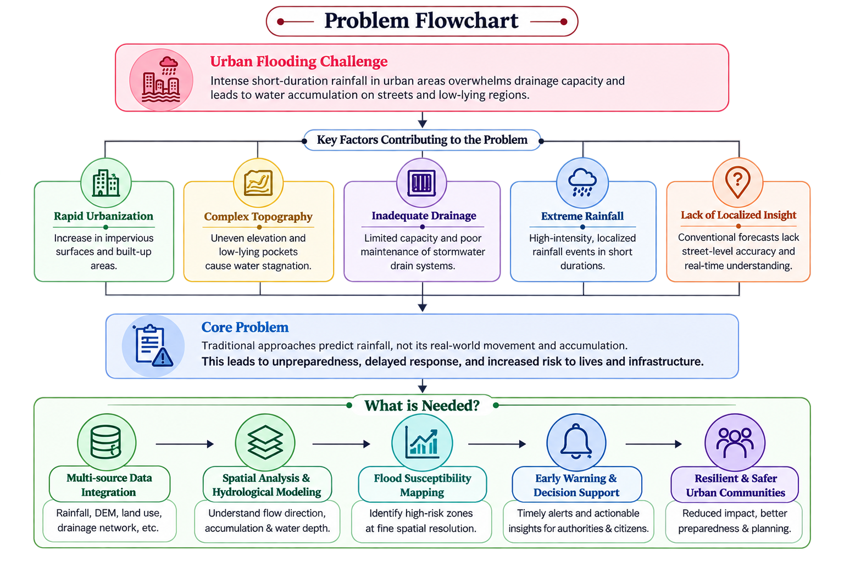

2. Problem Understanding & Root Causes
Urban flooding results from the interaction of rainfall, urban terrain, land cover, and drainage capacity. A high-intensity rainfall event becomes critical when surface runoff exceeds the ability of the ground and drainage network to absorb and convey water.
Key Root Causes
- Rapid Urbanization: Impervious surfaces reduce infiltration and increase surface runoff.
- Intense Rainfall: Short-duration, high-intensity rainfall can quickly exceed drainage capacity.
- Complex Topography: Elevation differences, slopes, and low-lying pockets determine where water flows and accumulates.
- Drainage Constraints: Limited capacity, blockages, poor maintenance, and disconnected networks restrict water discharge.
- Localized Vulnerability: Areas receiving similar rainfall can experience different impacts because their terrain, land cover, and drainage conditions differ.
Why Existing Solutions Struggle
Approach | Limitation
Rainfall Forecasting | Predicts rainfall, but not its localized flood impact
Historical Flood Maps | Depend on past events and may not reflect current conditions
Static GIS Maps | Provide spatial information but lack real-time updates
Hydrological / Hydraulic Models | Can require detailed data, calibration, and significant computation
Reactive Response | Action often begins after flooding has already occurred

3. Existing Solutions & Gap Analysis
Several technologies are already used for urban flood management. Weather and rainfall forecasting systems provide information about upcoming precipitation, while GIS-based flood maps help identify historically vulnerable areas. Hydrological and hydraulic models can further simulate runoff, drainage behaviour, and water accumulation under defined conditions.
However, these solutions often operate as separate components. Rainfall forecasts indicate the incoming weather conditions, static maps describe spatial vulnerability, and detailed hydraulic models may require extensive data and computation. This makes it difficult to convert continuously changing rainfall conditions into a simple, localized picture of where flooding is likely to occur.
The key gap is therefore integration and localization. What is missing is a practical framework that combines rainfall with terrain, land use, drainage characteristics, and spatial analysis to continuously estimate potential flood-prone zones.

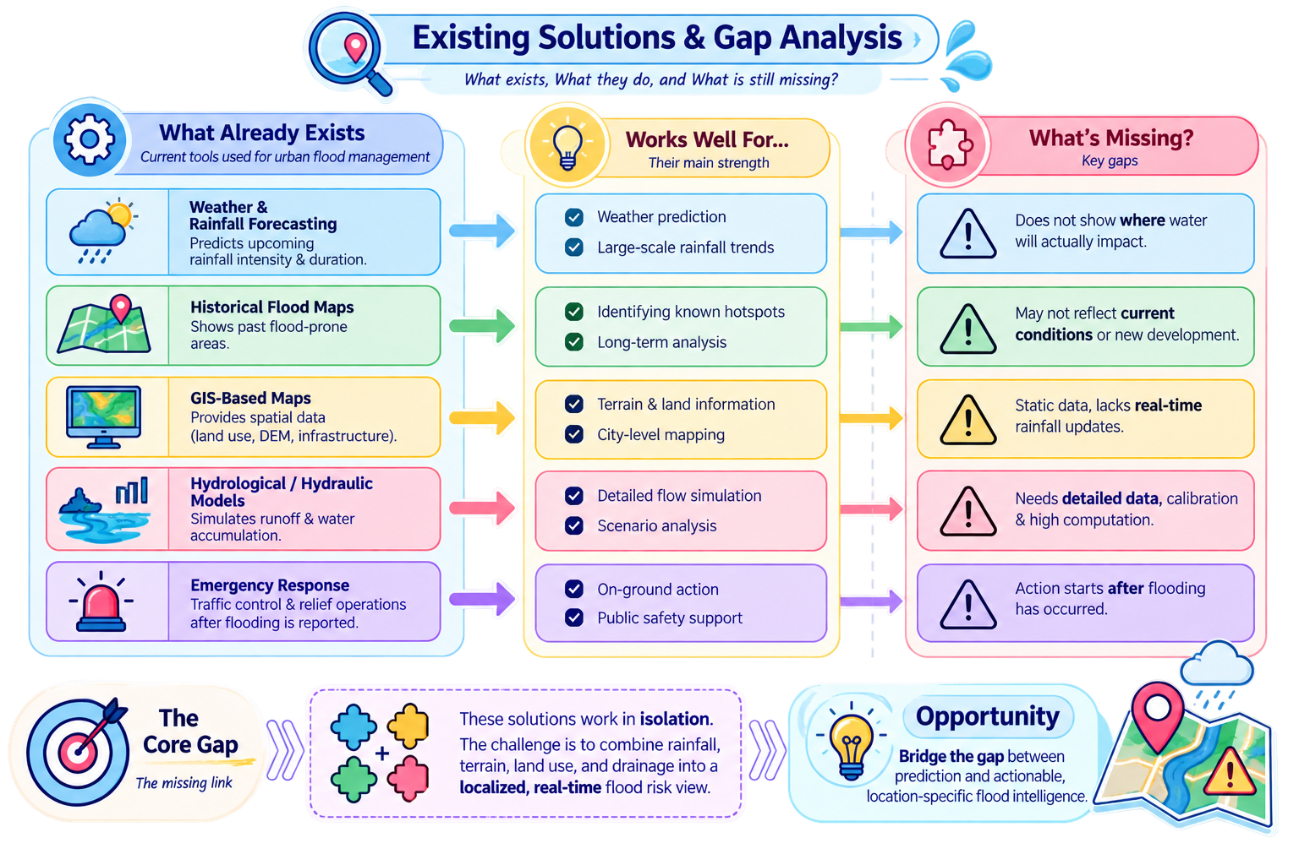

4. Proposed Solution
We propose a data-driven urban flood nowcasting and decision-support system that converts short-term rainfall forecasts into a localized prediction of how water is likely to move and accumulate across an urban area.
The system begins with real-time and forecast rainfall data, which is processed to estimate rainfall conditions over the next few hours. This information is combined with a high-resolution Digital Elevation Model (DEM) and land-cover data to understand the natural and built pathways through which surface runoff can travel.
The predicted runoff is then evaluated together with the urban drainage network, represented through connected elements such as inlets, manholes, junctions, pipes, pumps, and outfalls. By considering both surface flow and drainage capacity, the system can identify locations where water is likely to accumulate or where drainage may become insufficient.
The resulting information is transformed into a dynamic flood-risk layer, indicating probable flow paths, accumulation zones, and areas of higher flood susceptibility. Instead of presenting only raw model outputs, the system delivers these results through an intuitive GIS-based dashboard, enabling authorities and users to understand where the risk is developing and how severe it may become.
The central objective is to bridge the gap between “rain is expected” and “this specific urban location is likely to experience flooding.” By integrating meteorological, topographical, land-use, and drainage information, the proposed system aims to provide localized, timely, and actionable flood intelligence for proactive urban flood management.
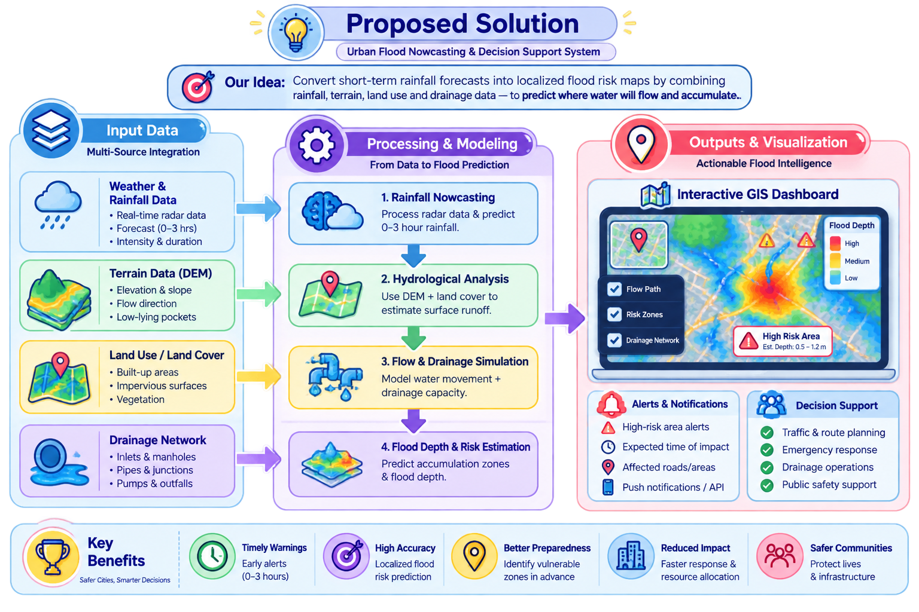

5. Data Sources & Data Verification
The proposed system depends on multiple spatial and temporal datasets. Each dataset represents a different part of the urban flood process, and their integration allows rainfall to be translated into localized flood-risk information.
Key Data Sources
Digital Elevation Model (DEM)
Provides elevation and terrain information for the study area. It is used to derive slope, flow direction, drainage pathways, and low-lying accumulation zones. The DEM forms the basis for understanding how surface water is likely to move across the city. The DEM for this project is collected from https://bhoonidhi.nrsc.gov.in/
Rainfall Data
Provides rainfall intensity, duration, and spatial distribution. Real-time observations and short-term forecasts can be used to estimate incoming rainfall and drive the flood prediction process. IMD provides rainfall observations as well as radar-based and forecast products.
Land Use / Land Cover Data
Helps distinguish between built-up surfaces, vegetation, open land, and other land-cover classes. This is important because impervious urban surfaces generally generate more surface runoff than permeable areas.
Drainage Network Data
Represents stormwater infrastructure such as drains, pipes, junctions, inlets, outlets, and pumping facilities, where available. It helps determine whether generated runoff can be conveyed away or is likely to accumulate.
Satellite / Remote-Sensing Data
Provides updated information about urban expansion, surface characteristics, and land-cover changes. ISRO's Bhoonidhi provides access to Earth-observation datasets from multiple satellites and missions.
Data Verification
Before being used in the model, datasets are checked for:
- Spatial coverage – Does the dataset completely cover the study area?
- Resolution – Is the spatial resolution suitable for urban-scale analysis?
- Coordinate Reference System (CRS) – Are all layers correctly aligned?
- Temporal relevance – Does the data represent current or appropriate conditions?
- Missing / erroneous values – Are there gaps, outliers, or invalid pixels?
- Cross-validation – Can important features be verified against another reliable source or observed conditions?
This verification ensures that different datasets can be correctly aligned and combined, reducing errors before they enter the flood modelling workflow.
Data Provenance
Every dataset used in the project should be recorded with its source, product name, date, resolution, format, and processing steps. This makes the model reproducible and allows the reliability of the final flood-risk output to be assessed.

6. Technical Methodology
The system follows a multi-stage geospatial and hydrological pipeline that converts rainfall information into localized flood-risk predictions.
Core Technical Pipeline
1. Data Pre-processing
Rainfall, DEM, land-cover, and drainage datasets are cleaned, standardized, and aligned to a common spatial reference.
2. Rainfall Nowcasting
Recent rainfall observations and short-term forecasts are used to estimate rainfall intensity and distribution for the next few hours.
3. Terrain & Runoff Analysis
DEM data is used to derive elevation, slope, flow direction, and flow accumulation. Combined with land-cover information, this identifies likely surface-runoff pathways.
4. Drainage Interaction
Estimated runoff is compared with the available stormwater drainage network and its capacity, helping identify locations where water may accumulate.
5. Flood Risk Estimation
Flow behaviour and accumulation are used to estimate probable flood depth and risk levels across the study area.
6. GIS Visualization & Alerts
The results are displayed through a dynamic GIS interface showing flow paths, accumulation zones, risk levels, and alerts for timely decision-making.
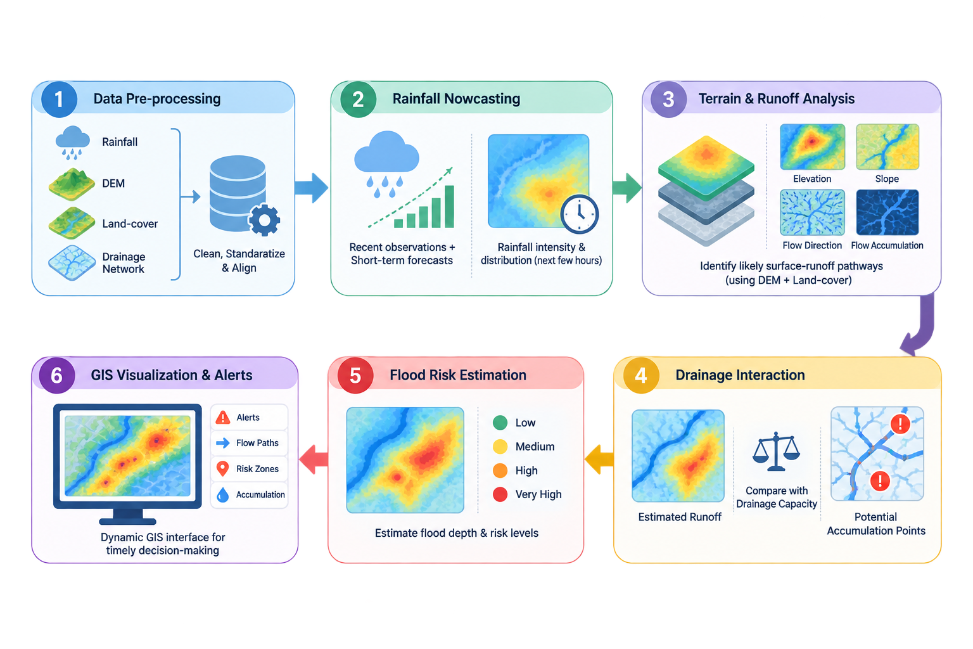

7. Flood / Drainage Modelling Concepts
Urban flood modelling focuses on understanding how rainfall is converted into runoff, how the runoff moves according to terrain, and how effectively the drainage network can carry the resulting flow. These concepts form the basis for identifying locations where water is likely to accumulate.
Concept | Explanation & Role
Rainfall–Runoff | Rainfall generates surface runoff, particularly over impervious urban surfaces such as roads and buildings. The amount of runoff determines the water entering the drainage system.
Terrain & DEM | A Digital Elevation Model (DEM) represents ground elevation. It helps determine slopes, low-lying regions and the natural direction in which surface water flows.
Flow Direction | Determines the direction water moves from higher to lower elevations and helps establish potential surface-water pathways.
Flow Accumulation | Identifies locations where runoff from surrounding areas converges. High-accumulation regions can indicate natural drainage paths and potential water-logging zones.
Drainage Network | Storm drains, channels and outlets provide artificial pathways for moving runoff away from urban areas. Their location and connectivity influence flood behaviour.
Drainage Capacity | Every drainage system has a limited carrying capacity. When incoming runoff exceeds this capacity, water may accumulate or overflow into surrounding areas.
Flood Inundation | The combined effect of runoff, terrain and drainage limitations determines where water accumulates, allowing estimation of flood-prone areas and inundation extent/depth.

8. System Architecture & Implementation
System Architecture
The system follows a layered, data-driven architecture that transforms heterogeneous geospatial and real-time inputs into actionable flood-risk insights.
1. Data Acquisition Layer
- Rainfall & weather/radar data
- High-resolution DEM
- Drainage network
- Roads & land-use data
- Citizen-reported flood observations
2. Processing & Hydraulic Modelling Layer
- Data cleaning, spatial alignment & preprocessing
- Rainfall → runoff estimation
- 2D surface-flow modelling
- Drainage capacity & blockage analysis
- Backflow and surface–drainage coupling
3. AI & Analytics Layer
- Flood-depth and risk analysis
- Critical drainage-node identification
- Short-term flood forecasting
- Pattern detection using AI/ML
4. Application & Visualization Layer
- Interactive GIS flood maps
- Water-depth visualization
- Flooded-street identification
- Flood-aware route recommendations
- Alerts and decision-support outputs
Technology Integration
- Cloud: AWS / GCP — scalable computation & deployment
- Database: SQL + PostGIS — spatial data management
- Stream Processing: Real-time rainfall & citizen inputs
- AI/ML: Python + PyTorch — prediction & risk analysis
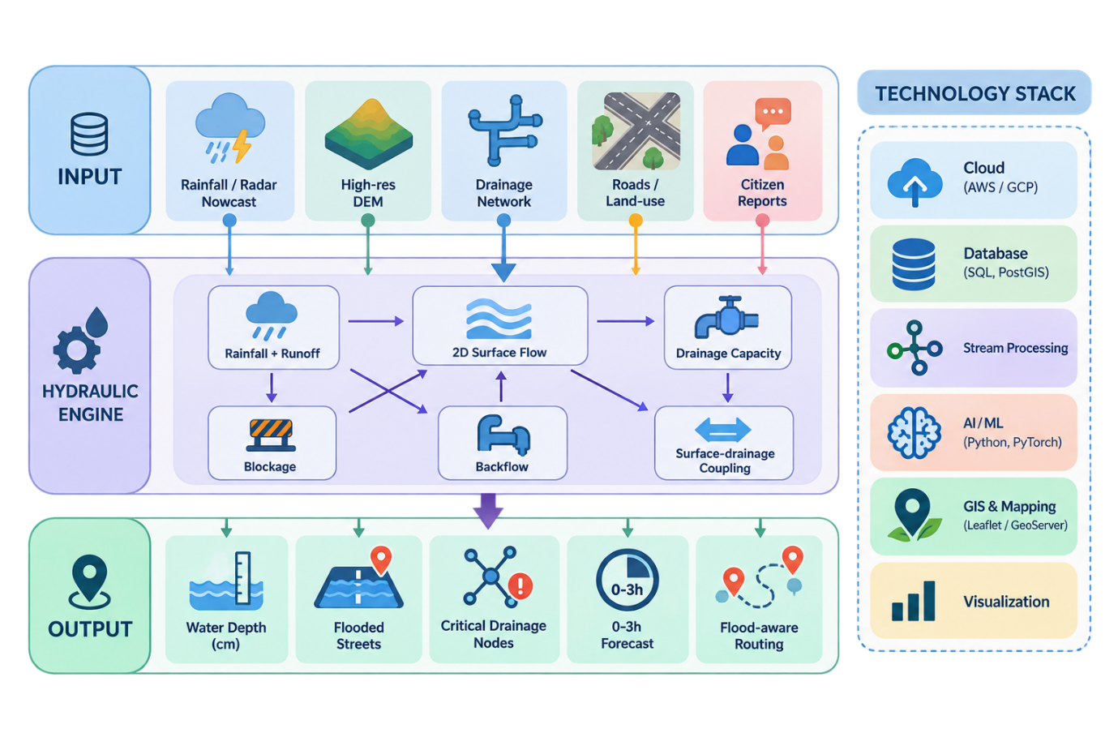
- GIS: Leaflet / GeoServer — spatial visualization & mapping

9. Validation & Evaluation Methodology
The system will be validated by comparing its predicted flood-prone areas with historical flood observations and available reference data. Validation will be performed at multiple levels to assess the accuracy of the terrain analysis, flood extent, and overall system performance.

Validation Stage | Method
Historical Comparison | Compare predicted flood-prone locations with documented flood events and historical inundation maps/images.
Spatial Validation | Overlay predicted flood zones with observed flood locations to measure their spatial agreement.
Model Accuracy | Evaluate prediction using metrics such as Precision, Recall, F1-score and IoU where labelled reference data is available.
Terrain & Drainage Verification | Check whether predicted accumulation zones correspond with low-elevation areas, flow-accumulation paths and known drainage constraints.
Scenario Testing | Test the system under different rainfall intensities to verify whether flood extent changes logically with increasing rainfall.
Visual & Functional Testing | Verify map accuracy, layer display, response time and consistency of the web application.

10. Expected Results, Impact & Limitations
The proposed system is expected to convert rainfall, terrain, drainage and land-cover information into localized flood-risk insights that can support faster identification of vulnerable urban areas.
Expected Results
Output | Expected Result
Flood-Prone Zones | Identification of areas likely to experience water accumulation or inundation.
Flood Extent / Depth | Estimation or visualization of the expected spatial extent and severity of flooding, depending on available data.
Flow & Drainage Paths | Identification of major surface-water flow routes and potential drainage bottlenecks.
Interactive Flood Map | Web-based visualization of flood zones along with relevant terrain, rainfall and drainage layers.
Risk Information | Location-based information that can help authorities prioritize vulnerable areas and response actions.

Expected Impact
- Faster flood-risk assessment at a localized urban scale.
- Supports early preparedness and response planning.
- Helps identify drainage bottlenecks and vulnerable locations.
- Provides a common GIS-based platform for interpreting multiple datasets.
- Can be extended to additional cities and updated with new rainfall or geospatial data.
Limitations

Limitation | Impact
Data Quality & Resolution | Prediction quality depends on the accuracy and spatial resolution of DEM, rainfall and drainage data.
Incomplete Drainage Information | Missing or outdated underground drainage data can reduce modelling accuracy.
Extreme Weather Uncertainty | Very intense or unusual rainfall events may behave differently from model assumptions.
Model Simplifications | A prototype cannot represent every real-world hydraulic factor such as blocked drains, sudden infrastructure failure or detailed underground flow.
Validation Data Availability | Reliable ground-truth flood observations may not be available for every location or event.

11. Future Scope & References
Future Scope
The proposed system can be further enhanced to improve its accuracy, automation, real-time capability and scalability.
Extension | Future Enhancement
Real-Time Nowcasting | Integrate live rainfall and weather data for continuous flood-risk updates.
AI/ML Integration | Use historical flood events and rainfall patterns to improve prediction accuracy.
Detailed Hydraulic Modelling | Incorporate advanced hydraulic models for more accurate flood depth and flow estimation.
IoT Integration | Use water-level and drainage sensors for real-time monitoring and model correction.
Alert System | Generate location-based warnings for authorities and affected areas.
Scalability | Extend the platform from a single study area to multiple cities and urban regions.

