Practical 1
Part A
1) | Vending machine (VendingMachine.java, main in this file)  (a) Define an enum Coin with constants ONE, TWO, FIVE, TEN.  (b) In main, set a snack price of 15 and a running total of 0; create a Scanner.  (c) Loop: read a coin name, use a switch expression to convert the Coin to its value  (ONE→1, TWO→2, FIVE→5, TEN→10), add it to the total, and print the total so  far.  (d) Stop the loop once the total reaches 15 or more.  (e) Print the change to return (total − 15).
 | VendingMachine.java
Code | import java.util.Scanner;  enum Coin { ONE, TWO, FIVE, TEN }  public class VendingMachine {  public static void main(String[] args) {  Scanner sc = new Scanner(System.in);  int price = 15;  int total = 0;  while (total < price) {  System.out.print("Enter coin: ");  Coin coin = Coin.valueOf(sc.next().toUpperCase());  int value = switch (coin) {  case ONE -> 1;  case TWO -> 2;  case FIVE -> 5;  case TEN -> 10;  };  total += value;  System.out.println("Total: " + total);  }  System.out.println("Paid. Change: " + (total - price));  }  }
Output | 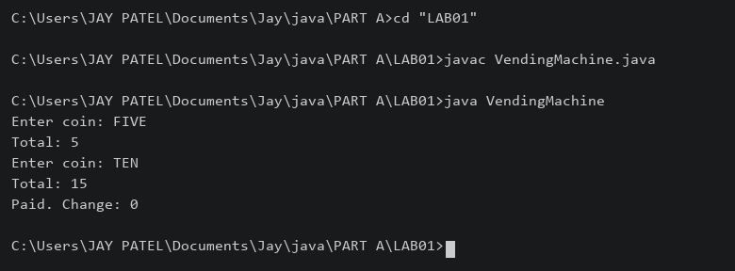

2) | Toll booth (TollBooth.java, main in this file)  (a) Define a record Vehicle(String number, String type).  (b) In main, keep a running toll total and three counters (bike, car, truck).  (c) Loop until the user types “done” for the number: build a Vehicle, use a switch  expression on its type for the toll (bike→20, car→50, truck→150), add to the total,  and increment that type’s counter.  (d) After the loop, print the total toll and the type with the highest count.
 | TollBooth.java
Code | import java.util.Scanner;  record Vehicle(String number, String type) {}  public class TollBooth {  public static void main(String[] args) {  Scanner sc = new Scanner(System.in);  int total = 0, bikes = 0, cars = 0, trucks = 0;  while (true) {  System.out.print("Number or done: ");  String number = sc.next();  if (number.equalsIgnoreCase("done")) { break; }  System.out.print("Type: ");  Vehicle v = new Vehicle(number, sc.next().toLowerCase());  int toll = switch (v.type()) {  case "bike" -> 20;  case "car" -> 50;  case "truck" -> 150;  default -> 0;  };  switch (v.type()) {  case "bike" -> bikes++;  case "car" -> cars++;  case "truck" -> trucks++;  default -> System.out.println("Invalid type");  }  total += toll;  }  System.out.println("Total toll: " + total);  if (bikes + cars + trucks == 0) {  System.out.println("Most frequent: none");  } else {  int max = Math.max(bikes, Math.max(cars, trucks));  if (bikes == max) { System.out.println("Most frequent: bike"); }  if (cars == max) { System.out.println("Most frequent: car"); }  if (trucks == max) { System.out.println("Most frequent: truck"); }  }  }  }
Output | 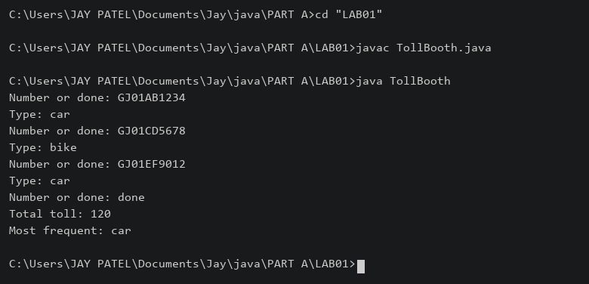

3) | (For Advanced Learners – home) Rock-Paper-Scissors-Lizard-Spock (RPSLS.java)  (a) Define an enum Move with ROCK, PAPER, SCISSORS, LIZARD, SPOCK.  (b) Write winner(Move a, Move b) returning 1 if a beats b, -1 if b beats a, 0 for a tie —  use a switch expression listing what each move beats (Scissors cut Paper, Paper  covers Rock, Rock crushes Lizard, Lizard poisons Spock, Spock smashes Scissors,  and the five mirror cases).  (c) In main, play 5 rounds: pick a random computer Move, read the player’s Move, call  winner(), print the round result and keep score.  (d) After 5 rounds, print the overall winner.
 | RPSLS.java
Code | import java.util.Random;  import java.util.Scanner;  enum Move { ROCK, PAPER, SCISSORS, LIZARD, SPOCK }  public class RPSLS {  static int winner(Move a, Move b) {  if (a == b) { return 0; }  boolean win = switch (a) {  case ROCK -> b == Move.SCISSORS || b == Move.LIZARD;  case PAPER -> b == Move.ROCK || b == Move.SPOCK;  case SCISSORS -> b == Move.PAPER || b == Move.LIZARD;  case LIZARD -> b == Move.PAPER || b == Move.SPOCK;  case SPOCK -> b == Move.ROCK || b == Move.SCISSORS;  };  if (win) { return 1; }  return -1;  }  public static void main(String[] args) {  Scanner sc = new Scanner(System.in);  Random random = new Random();  int player = 0, computer = 0;  for (int i = 1; i <= 5; i++) {  System.out.print("Your move: ");  Move a = Move.valueOf(sc.next().toUpperCase());  Move b = Move.values()[random.nextInt(5)];  System.out.println("You: " + a + " Computer: " + b);  int result = winner(a, b);  if (result == 1) { player++; System.out.println("You win round"); }  else if (result == -1) { computer++; System.out.println("Computer wins round"); }  else { System.out.println("Tie"); }  }  if (player > computer) { System.out.print("You win "); }  else if (computer > player) { System.out.print("Computer wins "); }  else { System.out.print("Draw "); }  System.out.println(player + "-" + computer);  }  }
Output | 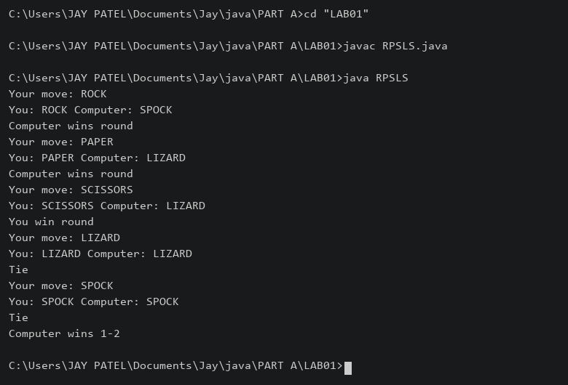

Practical 2
Part A
1) | Smart thermostat (Thermostat.java, main in this file)  (a) Create class Thermostat with private String location, private int temperature, private  static final int MIN=16 and MAX=30, and private static int activeCount=0.  (b) Constructor(location, startTemp): store location; set temperature to startTemp if it is  within MIN..MAX else 22; increment activeCount.  (c) Constructor(location): chain with this(location, 22).  (d) raise(): if temperature < MAX add 1, else print “Already at maximum (30)”.  (e) lower(): if temperature > MIN subtract 1, else print “Already at minimum (16)”.  (f) Add getTemperature() (no setter) and static getActiveCount().  (g) In main: create two thermostats, call raise() 10 times then lower() 20 times in loops  (printing the temperature each time), then print getActiveCount().
 | Thermostat.java
Code | public class Thermostat {  private String location;  private int temperature;  private static final int MIN = 16, MAX = 30;  private static int activeCount = 0;  Thermostat(String location, int startTemp) {  this.location = location;  temperature = 22;  if (startTemp >= MIN && startTemp <= MAX) { temperature = startTemp; }  activeCount++;  }  Thermostat(String location) { this(location, 22); }  void raise() {  if (temperature < MAX) { temperature++; }  else { System.out.println("Already at maximum (30)"); }  }  void lower() {  if (temperature > MIN) { temperature--; }  else { System.out.println("Already at minimum (16)"); }  }  int getTemperature() { return temperature; }  static int getActiveCount() { return activeCount; }  public static void main(String[] args) {  Thermostat a = new Thermostat("Room 1");  Thermostat b = new Thermostat("Room 2", 24);  for (int i = 0; i < 10; i++) {  a.raise(); System.out.println(a.getTemperature());  }  for (int i = 0; i < 20; i++) {  a.lower(); System.out.println(a.getTemperature());  }  System.out.println("Active: " + getActiveCount());  }  }
Output | 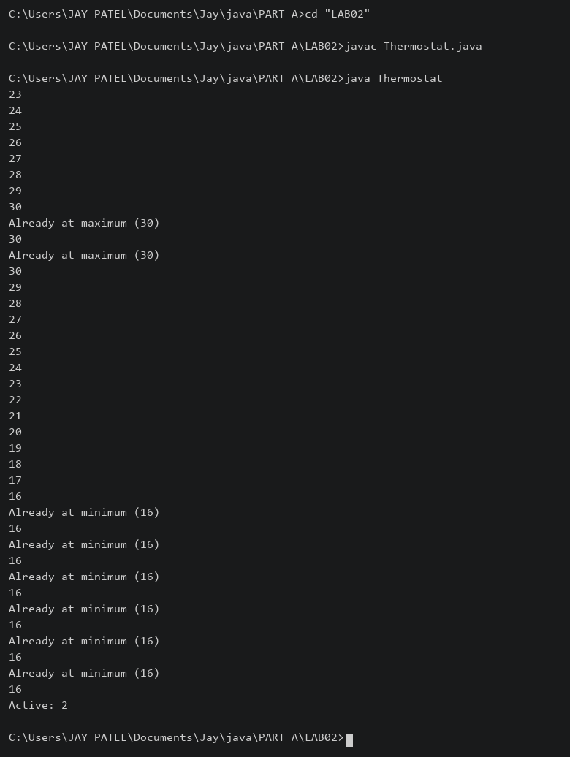

2) | Cinema show (CinemaShow.java, main in this file)  (a) Create class CinemaShow with private String title, private int seatsAvailable, private  final int capacity, and private static int totalBooked=0.  (b) Constructor(title, capacity): set both and seatsAvailable = capacity.  Constructor(title): chain with this(title, 100).  (c) book(int n): if n ≤ seatsAvailable, reduce seatsAvailable by n, add n to totalBooked,  return true; else return false unchanged.  (d) cancel(int n): increase seatsAvailable by n but never above capacity.  (e) Add getSeatsAvailable() and static getTotalBooked().  (f) In main: run a sequence of book and cancel calls, printing the result and seats after  each, then print getTotalBooked().
 | CinemaShow.java
Code | public class CinemaShow {  private String title;  private int seatsAvailable;  private final int capacity;  private static int totalBooked = 0;  CinemaShow(String title, int capacity) {  this.title = title;  this.capacity = capacity;  seatsAvailable = capacity;  }  CinemaShow(String title) { this(title, 100); }  boolean book(int n) {  if (n > 0 && n <= seatsAvailable) {  seatsAvailable -= n; totalBooked += n; return true;  }  return false;  }  void cancel(int n) {  if (n > 0) { seatsAvailable = Math.min(capacity, seatsAvailable + n); }  }  int getSeatsAvailable() { return seatsAvailable; }  static int getTotalBooked() { return totalBooked; }  public static void main(String[] args) {  CinemaShow s = new CinemaShow("Movie", 10);  System.out.println(s.book(6) + " Seats: " + s.getSeatsAvailable());  System.out.println(s.book(8) + " Seats: " + s.getSeatsAvailable());  s.cancel(2);  System.out.println("After cancel: " + s.getSeatsAvailable());  System.out.println(s.book(3) + " Seats: " + s.getSeatsAvailable());  System.out.println("Total booked: " + getTotalBooked());  }  }
Output | 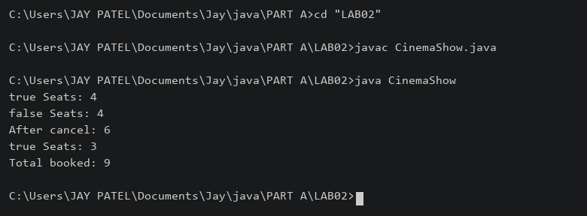

3) | (For Advanced Learners – home) Parking lot (ParkingLot.java)  (a) Create class ParkingLot with private int twoWheelers and fourWheelers, private final  int twoCap and fourCap, and private static long revenue=0.  (b) park(String type): for “two”, if twoWheelers < twoCap increment and add 20 to  revenue; for “four”, if fourWheelers < fourCap increment and add 40; otherwise print  “Full” and reject.  (c) leave(String type): decrement the matching count but never below 0.  (d) In main: simulate a sequence of park/leave events, printing each outcome, then print  final occupancy and revenue.
 | ParkingLot.java
Code | public class ParkingLot {  private int twoWheelers, fourWheelers;  private final int twoCap, fourCap;  private static long revenue = 0;  ParkingLot(int twoCap, int fourCap) {  this.twoCap = twoCap; this.fourCap = fourCap;  }  void park(String type) {  if (type.equals("two") && twoWheelers < twoCap) {  twoWheelers++; revenue += 20; System.out.println("Two parked");  } else if (type.equals("four") && fourWheelers < fourCap) {  fourWheelers++; revenue += 40; System.out.println("Four parked");  } else { System.out.println("Full or invalid type"); }  }  void leave(String type) {  if (type.equals("two") && twoWheelers > 0) { twoWheelers--; }  else if (type.equals("four") && fourWheelers > 0) { fourWheelers--; }  System.out.println("Occupancy: " + twoWheelers + ", " + fourWheelers);  }  public static void main(String[] args) {  ParkingLot p = new ParkingLot(1, 1);  p.park("two"); p.park("two"); p.park("four");  p.leave("two"); p.park("two");  System.out.println("Final: " + p.twoWheelers + ", " + p.fourWheelers);  System.out.println("Revenue: " + revenue);  }  }
Output | 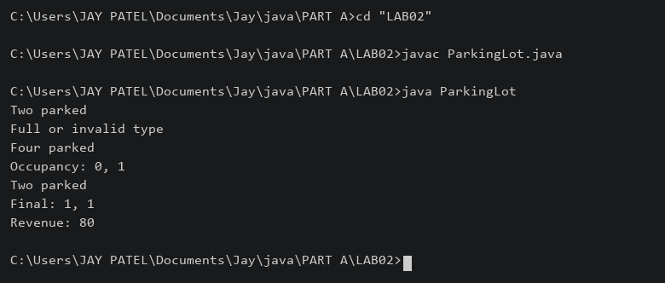

Practical 3
Part A
1) | Distinct points (Point.java + Driver.java with main)  (a) Create class Point with private int x, y and a constructor.  (b) Override toString() to return “(x, y)”.  (c) Override equals(Object) to be true when both x and y match, and hashCode() to agree  (e.g. Objects.hash(x, y)).  (d) In Driver.main: build a Point[] with some repeated coordinates.  (e) Count distinct points: for each point, use equals() to check whether it already  appeared earlier; count those that did not.  (f) Print “Distinct: N”.
 | Point.java
Code | import java.util.Objects;  public class Point {  private int x, y;  Point(int x, int y) { this.x = x; this.y = y; }  public String toString() { return "(" + x + ", " + y + ")"; }  public boolean equals(Object o) {  if (!(o instanceof Point p)) { return false; }  return x == p.x && y == p.y;  }  public int hashCode() { return Objects.hash(x, y); }  }
 | Driver.java
Code | public class Driver {  public static void main(String[] args) {  Point[] points = {new Point(1,2), new Point(3,4), new Point(1,2),  new Point(5,6), new Point(3,4)};  int count = 0;  for (int i = 0; i < points.length; i++) {  boolean found = false;  for (int j = 0; j < i; j++) {  if (points[i].equals(points[j])) { found = true; break; }  }  if (!found) { count++; }  }  System.out.println("Distinct: " + count);  }  }
Output | 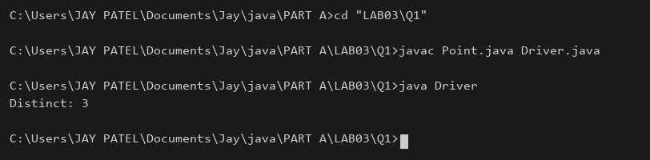

2) | Duplicate card check (Card.java + Driver.java)  (a) Create class Card with private String rank, suit and a constructor.  (b) Override toString() to return rank + “ of ” + suit (e.g. “Queen of Hearts”).  (c) Override equals()/hashCode() by rank + suit.  (d) In Driver.main: add cards to a Card[] one at a time; before adding each, use equals()  to check it against the earlier cards.  (e) Print “Duplicate found: <card>” the first time a repeat appears.
 | Card.java
Code | import java.util.Objects;  public class Card {  private String rank, suit;  Card(String rank, String suit) { this.rank = rank; this.suit = suit; }  public String toString() { return rank + " of " + suit; }  public boolean equals(Object o) {  if (!(o instanceof Card c)) { return false; }  return rank.equals(c.rank) && suit.equals(c.suit);  }  public int hashCode() { return Objects.hash(rank, suit); }  }
 | Driver.java
Code | public class Driver {  public static void main(String[] args) {  Card[] input = {new Card("Ace", "Spades"), new Card("Queen", "Hearts"),  new Card("Ace", "Spades")};  Card[] cards = new Card[input.length];  int size = 0;  for (Card c : input) {  boolean duplicate = false;  for (int i = 0; i < size; i++) {  if (c.equals(cards[i])) { duplicate = true; break; }  }  if (duplicate) {  System.out.println("Duplicate found: " + c); break;  }  cards[size++] = c;  }  }  }
Output | 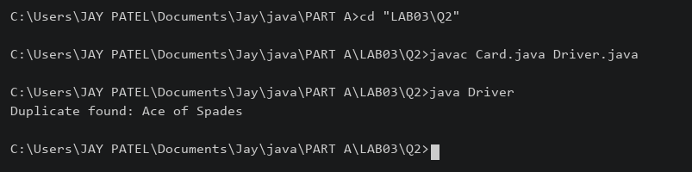

3) | (For Advanced Learners – home) Fractions (Fraction.java + Driver.java)  (a) Create class Fraction with private int num, den.  (b) In the constructor, reduce to lowest terms: compute g = gcd(num, den) and divide  both by g.  (c) Override toString() to return num + “/” + den.  (d) Override equals()/hashCode() using the reduced num and den.  (e) In Driver.main: create several equivalent fractions (1/2, 2/4, 3/6) and confirm they  are all equal and print the same.
 | Fraction.java
Code | import java.util.Objects;  public class Fraction {  private int num, den;  Fraction(int num, int den) {  if (den == 0) { throw new IllegalArgumentException("Zero denominator"); }  if (den < 0) { num = -num; den = -den; }  int g = gcd(Math.abs(num), den);  this.num = num / g; this.den = den / g;  }  private int gcd(int a, int b) {  while (b != 0) { int t = a % b; a = b; b = t; }  return a;  }  public String toString() { return num + "/" + den; }  public boolean equals(Object o) {  if (!(o instanceof Fraction f)) { return false; }  return num == f.num && den == f.den;  }  public int hashCode() { return Objects.hash(num, den); }  }
 | Driver.java
Code | public class Driver {  public static void main(String[] args) {  Fraction a = new Fraction(1, 2);  Fraction b = new Fraction(2, 4);  Fraction c = new Fraction(3, 6);  System.out.println(a + " " + b + " " + c);  System.out.println(a.equals(b) && b.equals(c));  }  }
Output | 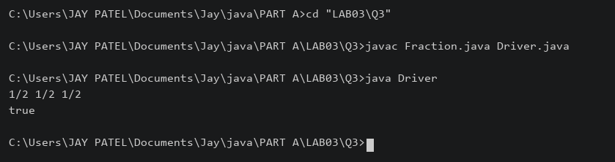

Practical 4
Part A
1) | Password strength (PasswordChecker.java + Driver.java)  (a) In PasswordChecker, check four rules — length ≥ 8, contains an uppercase letter,  contains a digit, contains a special character — using regex (e.g. “.*[A-Z].*”) or  String methods.  (b) Write strength(String pw) that counts how many rules pass and returns “Weak” (0–  1), “Medium” (2–3) or “Strong” (4).  (c) In Driver.main: test several passwords; for each, print which rules passed and the  final label.
 | PasswordChecker.java
Code | public class PasswordChecker {  static boolean[] rules(String pw) {  return new boolean[]{pw.length() >= 8, pw.matches(".*[A-Z].*"),  pw.matches(".*[0-9].*"), pw.matches(".*[^a-zA-Z0-9].*")};  }  static String strength(String pw) {  int count = 0;  for (boolean pass : rules(pw)) { if (pass) { count++; } }  if (count <= 1) { return "Weak"; }  if (count <= 3) { return "Medium"; }  return "Strong";  }  }
 | Driver.java
Code | import java.util.Arrays;  public class Driver {  public static void main(String[] args) {  String[] passwords = {"abc", "Abcd1234!", "abcd1234"};  for (String pw : passwords) {  System.out.println(pw);  System.out.println("Length, uppercase, digit, special: "  + Arrays.toString(PasswordChecker.rules(pw)));  System.out.println(PasswordChecker.strength(pw));  }  }  }
Output | 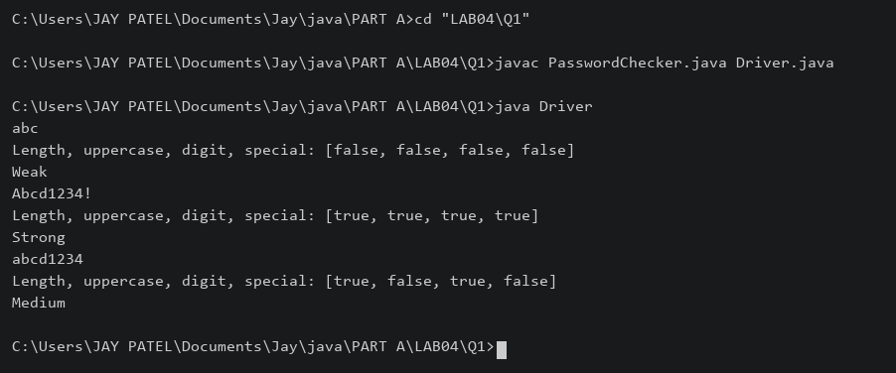

2) | Chat-log filter (ChatFilter.java + Driver.java)  (a) In Driver.main, define a String[] of log lines like “10:05 alice Hello there” (include  one malformed line with fewer than 3 parts).  (b) Read a keyword from the user.  (c) For each line, split into time/user/message with split(“ ”, 3); skip lines that do not  have 3 parts.  (d) If the message contains the keyword (case-insensitive), increment a counter and  append “time user: message” to a StringBuilder.  (e) Print “Matches: N” and the built report.
 | ChatFilter.java
Code | public class ChatFilter {  static String filter(String[] lines, String keyword) {  int count = 0;  StringBuilder report = new StringBuilder();  for (String line : lines) {  String[] p = line.split(" ", 3);  if (p.length != 3) { continue; }  if (p[2].toLowerCase().contains(keyword.toLowerCase())) {  count++;  report.append(p[0]).append(" ").append(p[1]).append(": ")  .append(p[2]).append("\n");  }  }  return "Matches: " + count + "\n" + report;  }  }
 | Driver.java
Code | import java.util.Scanner;  public class Driver {  public static void main(String[] args) {  String[] lines = {"10:05 alice Hello there", "10:06 bob Good morning", "bad"};  System.out.print("Keyword: ");  String keyword = new Scanner(System.in).nextLine();  System.out.print(ChatFilter.filter(lines, keyword));  }  }
Output | 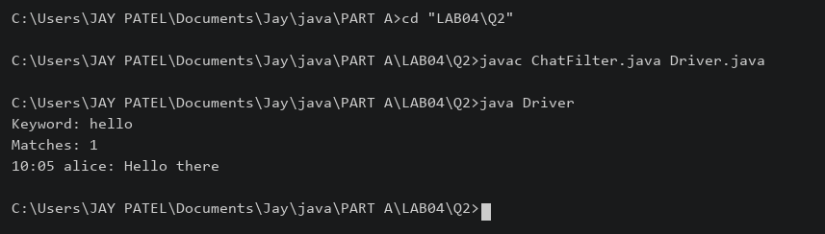

3) | (For Advanced Learners – home) Template filler (TemplateFiller.java +  Driver.java)  (a) In Driver.main, define a template like “Dear {name}, order {id} ships {date}.” and  two parallel arrays: names {“name”, “id”} and values {“Riya”, “A07”} (note {date}  is not supplied).  (b) Compile a Pattern for \{(\w+)\} and get a Matcher on the template.  (c) Walk the matches with a StringBuilder: for each {placeholder}, look up its value in  the names array and replace with the value, or with “[?]” if not found.  (d) Print the filled template.
 | TemplateFiller.java
Code | import java.util.regex.*;  public class TemplateFiller {  static String fill(String template, String[] names, String[] values) {  Matcher m = Pattern.compile("\\{(\\w+)\\}").matcher(template);  StringBuilder result = new StringBuilder();  while (m.find()) {  String value = "[?]";  for (int i = 0; i < names.length; i++) {  if (names[i].equals(m.group(1))) { value = values[i]; break; }  }  m.appendReplacement(result, Matcher.quoteReplacement(value));  }  m.appendTail(result);  return result.toString();  }  }
 | Driver.java
Code | public class Driver {  public static void main(String[] args) {  String template = "Dear {name}, order {id} ships {date}.";  String[] names = {"name", "id"};  String[] values = {"Riya", "A07"};  System.out.println(TemplateFiller.fill(template, names, values));  }  }
Output | 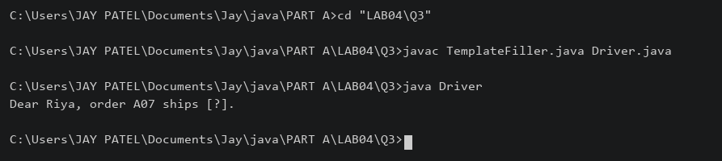

Practical 5
Part A
1) | Shape areas: an abstract Shape with abstract area(); subclasses Circle, Rectangle,  Triangle. Put a mix in a Shape[] and loop once to print each area and the running total,  tracking the largest — one loop handling every shape through polymorphism.
 | ShapeDemo.java
Code | abstract class Shape { abstract double area(); }  class Circle extends Shape {  double radius;  Circle(double radius) { this.radius = radius; }  double area() { return Math.PI * radius * radius; }  }  class Rectangle extends Shape {  double length, width;  Rectangle(double length, double width) { this.length = length; this.width = width; }  double area() { return length * width; }  }  class Triangle extends Shape {  double base, height;  Triangle(double base, double height) { this.base = base; this.height = height; }  double area() { return base * height / 2; }  }  public class ShapeDemo {  public static void main(String[] args) {  Shape[] shapes = {new Circle(2), new Rectangle(4,5), new Triangle(3,6)};  double total = 0, largest = -1;  String name = "";  for (Shape s : shapes) {  double area = s.area(); total += area;  System.out.println(s.getClass().getSimpleName() + ": " + area  + " Running total: " + total);  if (area > largest) { largest = area; name = s.getClass().getSimpleName(); }  }  System.out.println("Largest: " + name + " " + largest);  }  }
Output | 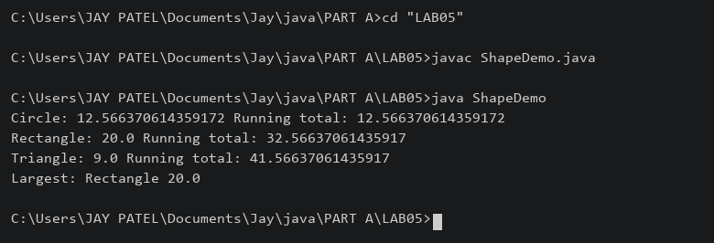

2) | Payroll: an abstract Employee with abstract monthlySalary(); FullTime (fixed), PartTime  (hours × rate) and Intern (stipend), each calling super for the shared name/id. Loop a  mixed array to print each salary and the total; use instanceof to add a note only for  interns.
 | Payroll.java
Code | abstract class Employee {  String name, id;  Employee(String name, String id) { this.name = name; this.id = id; }  abstract double monthlySalary();  }  class FullTime extends Employee {  double salary;  FullTime(String n, String id, double salary) { super(n,id); this.salary = salary; }  double monthlySalary() { return salary; }  }  class PartTime extends Employee {  int hours; double rate;  PartTime(String n, String id, int hours, double rate) {  super(n,id); this.hours = hours; this.rate = rate;  }  double monthlySalary() { return hours * rate; }  }  class Intern extends Employee {  double stipend;  Intern(String n, String id, double stipend) { super(n,id); this.stipend = stipend; }  double monthlySalary() { return stipend; }  }  public class Payroll {  public static void main(String[] args) {  Employee[] staff = {new FullTime("Tej","E1",30000),  new PartTime("Riya","E2",40,200), new Intern("Aman","E3",5000)};  double total = 0;  for (Employee e : staff) {  System.out.println(e.id + " " + e.name + " " + e.monthlySalary());  total += e.monthlySalary();  if (e instanceof Intern) { System.out.println("Intern stipend"); }  }  System.out.println("Total: " + total);  }  }
Output | 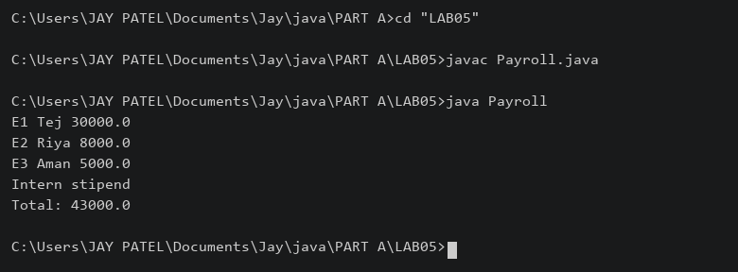

3) | (For Advanced Learners – home) Model a few media types that each compute a late fee  differently and total the fees for a returned batch. Design the hierarchy and rules yourself.
 | MediaDemo.java
Code | abstract class Media {  String title; int daysLate;  Media(String title, int daysLate) { this.title = title; this.daysLate = daysLate; }  abstract double lateFee();  }  class Book extends Media {  Book(String title, int days) { super(title, days); }  double lateFee() { return Math.max(0, daysLate) * 2; }  }  class DVD extends Media {  DVD(String title, int days) { super(title, days); }  double lateFee() { return Math.max(0, daysLate) * 5; }  }  class Magazine extends Media {  Magazine(String title, int days) { super(title, days); }  double lateFee() { return Math.max(0, daysLate - 1); }  }  public class MediaDemo {  public static void main(String[] args) {  Media[] items = {new Book("Java",3), new DVD("Movie",2),  new Magazine("Science",4)};  double total = 0;  for (Media m : items) {  System.out.println(m.title + ": " + m.lateFee()); total += m.lateFee();  }  System.out.println("Total fees: " + total);  }  }
 | Rules: Book Rs 2/day; DVD Rs 5/day; Magazine one free day, then Rs 1/day.
Output | 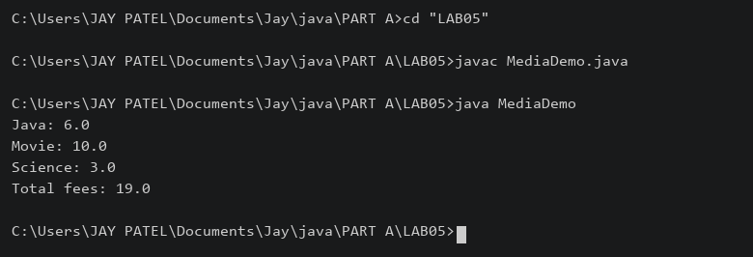

Practical 6
Part A
1) | Remote control: an interface Switchable with on()/off() and a default toggle(); Fan and  Light implement it. Loop over a Switchable[] toggling each. Then add a functional  interface that decides, given a device and an hour, whether it may switch on, and supply it  once as an anonymous class and once as a lambda.
 | RemoteDemo.java
Code | interface Switchable {  void on();  void off();  default void toggle() { on(); off(); }  }  class Fan implements Switchable {  public void on() { System.out.println("Fan ON"); }  public void off() { System.out.println("Fan OFF"); }  }  class Light implements Switchable {  public void on() { System.out.println("Light ON"); }  public void off() { System.out.println("Light OFF"); }  }  @FunctionalInterface  interface Permission { boolean allow(Switchable device, int hour); }  public class RemoteDemo {  public static void main(String[] args) {  Switchable[] devices = {new Fan(), new Light()};  for (Switchable d : devices) { d.toggle(); }  Permission p1 = new Permission() {  public boolean allow(Switchable d, int hour) { return hour < 22; }  };  Permission p2 = (d, hour) -> hour < 22;  System.out.println(p1.allow(devices[0], 10));  System.out.println(p2.allow(devices[0], 10));  }  }
Output | 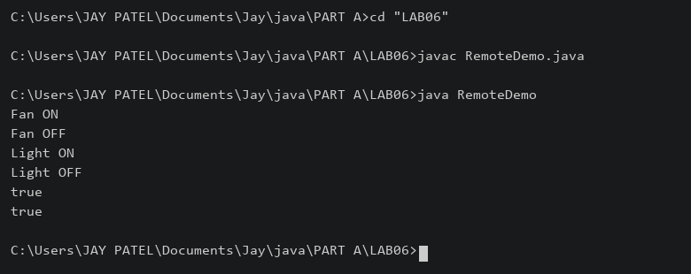

2) | Notification senders: a functional interface Notifier with send(String); make email and  SMS senders as lambdas, hold them in an array, and broadcast one message through all.  Add a marker interface Urgent and send twice for senders marked urgent.
 | NotificationDemo.java
Code | @FunctionalInterface  interface Notifier { void send(String message); }  interface Urgent {}  public class NotificationDemo {  public static void main(String[] args) {  Notifier email = message -> System.out.println("Email: " + message);  Notifier sms = (Notifier & Urgent) message -> System.out.println("SMS: " + message);  Notifier[] senders = {email, sms};  for (Notifier sender : senders) {  sender.send("Meeting at 10 AM");  if (sender instanceof Urgent) { sender.send("Meeting at 10 AM"); }  }  }  }
Output | 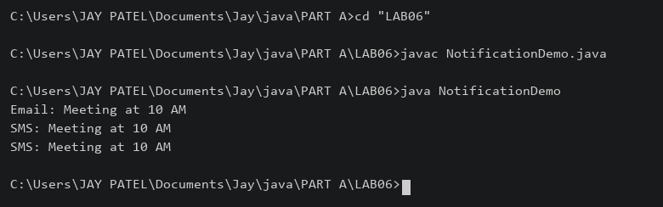

3) | (For Advanced Learners – home) Build a small discount engine where each rule is a  lambda the user picks at runtime and applies to a list of prices; organise it into packages  and ship it as a runnable JAR.
 | rules/Discount.java
Code | package rules;  @FunctionalInterface  public interface Discount { double apply(double price); }
 | app/DiscountApp.java
Code | package app;  import java.util.Scanner;  import rules.Discount;  public class DiscountApp {  public static void main(String[] args) {  double[] prices = {100, 200, 500};  Discount[] rules = {p -> p, p -> p * 0.9, p -> p * 0.8};  System.out.println("1. No discount\n2. 10% discount\n3. 20% discount");  int choice = new Scanner(System.in).nextInt();  if (choice < 1 || choice > 3) { System.out.println("Invalid choice"); return; }  Discount selected = rules[choice - 1];  for (double p : prices) { System.out.println(p + " -> " + selected.apply(p)); }  }  }
Build and run from the folder containing app and rules:
javac -d out rules/Discount.java app/DiscountApp.java
jar --create --file discount.jar --main-class app.DiscountApp -C out .
java -jar discount.jar
Output | 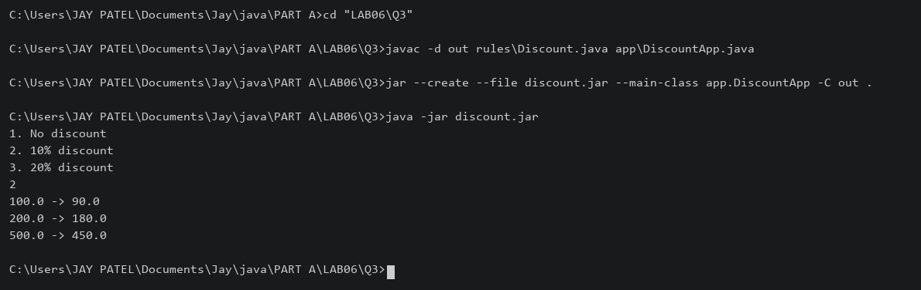

Practical 7
Part A
1) | Form validator: define @NotBlank and @MaxLength(int) for fields and annotate a  SignupForm. Write a checker that uses reflection to read each field’s annotations and  returns the list of validation errors for a given object.
 | FormDemo.java
Code | import java.lang.annotation.*;  import java.lang.reflect.Field;  import java.util.ArrayList;  @Retention(RetentionPolicy.RUNTIME)  @Target(ElementType.FIELD)  @interface NotBlank {}  @Retention(RetentionPolicy.RUNTIME)  @Target(ElementType.FIELD)  @interface MaxLength { int value(); }  class SignupForm {  @NotBlank @MaxLength(10) String name;  @NotBlank String email;  SignupForm(String name, String email) { this.name = name; this.email = email; }  }  public class FormDemo {  static ArrayList<String> check(Object obj) throws IllegalAccessException {  ArrayList<String> errors = new ArrayList<>();  for (Field f : obj.getClass().getDeclaredFields()) {  f.setAccessible(true);  Object value = f.get(obj);  if (f.isAnnotationPresent(NotBlank.class)  && (value == null || value.toString().isBlank())) {  errors.add(f.getName() + " must not be blank");  }  MaxLength rule = f.getAnnotation(MaxLength.class);  if (rule != null && value != null && value.toString().length() > rule.value()) {  errors.add(f.getName() + " is too long");  }  }  return errors;  }  public static void main(String[] args) throws Exception {  System.out.println(check(new SignupForm("VeryLongUserName", "")));  System.out.println(check(new SignupForm("Tej", "tej@test.com")));  }  }
Output | 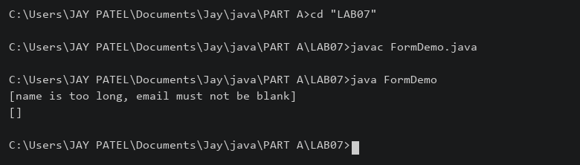

2) | Mini test runner: define a @Run annotation and mark some no-arg methods of a class  with it. Use reflection to find and invoke only the @Run methods and report how many  ran — the idea behind how JUnit finds @Test methods.
 | MiniRunner.java
Code | import java.lang.annotation.*;  import java.lang.reflect.*;  @Retention(RetentionPolicy.RUNTIME)  @Target(ElementType.METHOD)  @interface Run {}  class Checks {  @Run public void first() { System.out.println("First ran"); }  @Run public void second() { System.out.println("Second ran"); }  public void helper() { System.out.println("Helper"); }  }  public class MiniRunner {  public static void main(String[] args) throws Exception {  Checks checks = new Checks();  int count = 0;  for (Method m : Checks.class.getDeclaredMethods()) {  if (m.isAnnotationPresent(Run.class) && m.getParameterCount() == 0) {  m.setAccessible(true);  try { m.invoke(checks); }  catch (InvocationTargetException e) {  System.out.println("Failed: " + e.getCause().getMessage());  }  count++;  }  }  System.out.println("Methods ran: " + count);  }  }
Output | 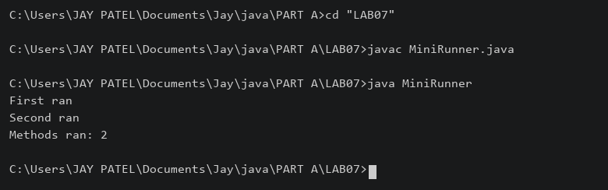

3) | (For Advanced Learners – home) Define a @Column(name) annotation and, by  reflection, populate an object’s fields from a header row and a data row by matching  column names; decide how to handle a missing column.
 | ColumnDemo.java
Code | import java.lang.annotation.*;  import java.lang.reflect.Field;  @Retention(RetentionPolicy.RUNTIME)  @Target(ElementType.FIELD)  @interface Column { String name(); }  class Student {  @Column(name="name") String name;  @Column(name="age") int age;  @Column(name="city") String city;  }  public class ColumnDemo {  static void populate(Object obj, String[] headers, String[] row) throws Exception {  for (Field f : obj.getClass().getDeclaredFields()) {  Column column = f.getAnnotation(Column.class);  if (column == null) { continue; }  int index = -1;  for (int i = 0; i < headers.length; i++) {  if (headers[i].equals(column.name())) { index = i; break; }  }  if (index < 0 || index >= row.length) {  System.out.println("Missing column: " + column.name()); continue;  }  f.setAccessible(true);  if (f.getType() == int.class) { f.setInt(obj, Integer.parseInt(row[index])); }  else { f.set(obj, row[index]); }  }  }  public static void main(String[] args) throws Exception {  Student s = new Student();  populate(s, new String[]{"name", "age"}, new String[]{"Tej", "19"});  System.out.println(s.name + " " + s.age + " " + s.city);  }  }
 | A missing column is reported and the field keeps its default value.
Output | 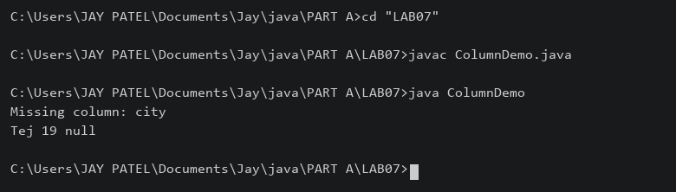

Practical 8
Part A
1) | Guarded calculator: read two numbers and an operator; throw a custom  DivideByZeroException and catch invalid-number input separately, printing a clear  message each time; loop until a valid calculation succeeds and use finally to log each  attempt.
 | Calculator.java
Code | import java.util.Scanner;  class DivideByZeroException extends Exception {  DivideByZeroException() { super("Cannot divide by zero"); }  }  public class Calculator {  public static void main(String[] args) {  Scanner sc = new Scanner(System.in);  boolean done = false;  while (!done) {  try {  System.out.print("First number: ");  double a = Double.parseDouble(sc.nextLine());  System.out.print("Second number: ");  double b = Double.parseDouble(sc.nextLine());  System.out.print("Operator: ");  String op = sc.nextLine();  double result;  switch (op) {  case "+" -> result = a + b;  case "-" -> result = a - b;  case "*" -> result = a * b;  case "/" -> {  if (b == 0) { throw new DivideByZeroException(); }  result = a / b;  }  default -> throw new IllegalArgumentException("Invalid operator");  }  System.out.println("Result: " + result); done = true;  } catch (NumberFormatException e) { System.out.println("Invalid number"); }  catch (DivideByZeroException e) { System.out.println(e.getMessage()); }  catch (IllegalArgumentException e) { System.out.println(e.getMessage()); }  finally { System.out.println("Attempt logged"); }  }  }  }
Output | 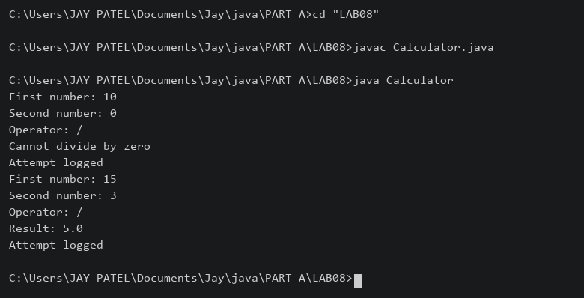

2) | Stock issue: a Warehouse where issue(item, qty) throws a custom checked  OutOfStockException carrying the shortfall, and InvalidQuantityException for qty ≤ 0.  Process a list of requests, catching and reporting each failure without stopping the run.
 | StockDemo.java
Code | import java.util.HashMap;  class OutOfStockException extends Exception {  private int shortfall;  OutOfStockException(int shortfall) {  super("Short by " + shortfall); this.shortfall = shortfall;  }  int getShortfall() { return shortfall; }  }  class InvalidQuantityException extends Exception {  InvalidQuantityException() { super("Quantity must be positive"); }  }  class Warehouse {  HashMap<String,Integer> stock = new HashMap<>();  Warehouse() { stock.put("Pen", 10); stock.put("Book", 5); }  void issue(String item, int qty)  throws OutOfStockException, InvalidQuantityException {  if (qty <= 0) { throw new InvalidQuantityException(); }  int available = stock.getOrDefault(item, 0);  if (qty > available) { throw new OutOfStockException(qty - available); }  stock.put(item, available - qty);  System.out.println("Issued " + qty + " " + item);  }  }  public class StockDemo {  public static void main(String[] args) {  Warehouse w = new Warehouse();  String[] items = {"Pen", "Book", "Pen", "Book"};  int[] qty = {4, 8, 0, 2};  for (int i = 0; i < items.length; i++) {  try { w.issue(items[i], qty[i]); }  catch (OutOfStockException e) { System.out.println(e.getMessage()); }  catch (InvalidQuantityException e) { System.out.println(e.getMessage()); }  }  }  }
Output | 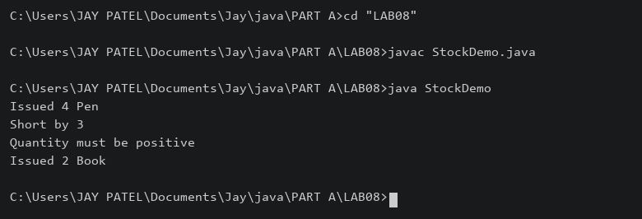

3) | (For Advanced Learners – home) Create an AutoCloseable resource and use try-with-  resources to prove it always closes — even when an exception is thrown inside the block  — and that the original error is the one reported. Decide what to model as the resource.
 | ResourceDemo.java
Code | class ReportSession implements AutoCloseable {  public void close() throws Exception {  System.out.println("Session closed");  throw new Exception("Close error");  }  }  public class ResourceDemo {  public static void main(String[] args) {  try (ReportSession session = new ReportSession()) {  System.out.println("Session opened");  throw new Exception("Original processing error");  } catch (Exception e) {  System.out.println("Reported: " + e.getMessage());  for (Throwable error : e.getSuppressed()) {  System.out.println("Suppressed: " + error.getMessage());  }  }  }  }
Output | 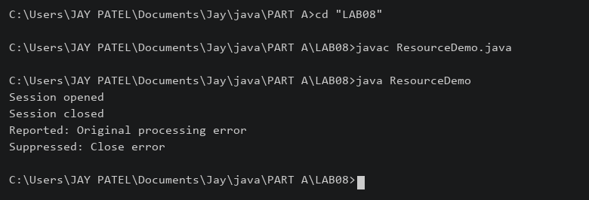

Practical 9
Part A
1) | Counter race: several threads each increment a shared counter many times. Run it  without synchronization to watch the total come out too low, then make the increment  synchronized and confirm it is exactly right every run.
 | CounterRace.java
Code | public class CounterRace {  static class Counter {  int value;  void unsafe() { value++; }  synchronized void safe() { value++; }  }  static void run(boolean safe) throws InterruptedException {  Counter counter = new Counter();  Thread[] threads = new Thread[10];  for (int i = 0; i < threads.length; i++) {  threads[i] = new Thread(() -> {  for (int j = 0; j < 100000; j++) {  if (safe) { counter.safe(); } else { counter.unsafe(); }  }  });  threads[i].start();  }  for (Thread t : threads) { t.join(); }  System.out.println("Synchronized: " + safe + " Total: " + counter.value);  }  public static void main(String[] args) throws Exception { run(false); run(true); }  }
 | Race results vary; an unsafe run can occasionally produce the expected total.
Output | 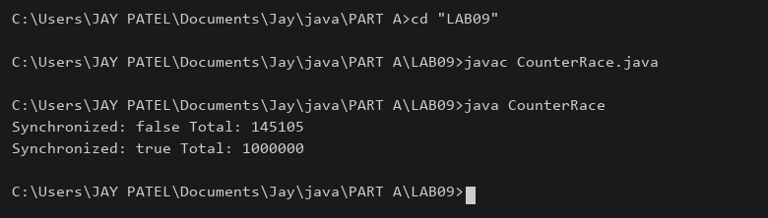

2) | Seat booking race: a shared seatsLeft of 5 with about 10 threads each trying to book one  seat. Without synchronization show that more than 5 can succeed (oversell); with a  synchronized book() exactly 5 do.
 | SeatRace.java
Code | public class SeatRace {  static class Booking {  int seatsLeft = 5;  boolean unsafe() {  if (seatsLeft > 0) {  try { Thread.sleep(10); }  catch (InterruptedException e) { Thread.currentThread().interrupt(); return false; }  seatsLeft--; return true;  }  return false;  }  synchronized boolean book() {  if (seatsLeft > 0) { seatsLeft--; return true; }  return false;  }  }  static void run(boolean safe) throws Exception {  Booking booking = new Booking();  Thread[] threads = new Thread[10];  boolean[] success = new boolean[10];  for (int i = 0; i < 10; i++) {  final int id = i;  threads[i] = new Thread(() -> {  if (safe) { success[id] = booking.book(); }  else { success[id] = booking.unsafe(); }  });  threads[i].start();  }  for (Thread t : threads) { t.join(); }  int count = 0;  for (boolean booked : success) { if (booked) { count++; } }  System.out.println("Synchronized: " + safe + " Booked: " + count);  }  public static void main(String[] args) throws Exception { run(false); run(true); }  }
Output | 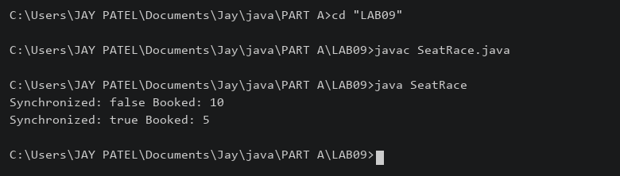

3) | (For Advanced Learners – home) Split a large array of numbers across several threads  that add into one shared total, show the wrong result, then fix it two ways and compare;  decide how to measure the difference.
 | SumDemo.java
Code | import java.util.concurrent.atomic.AtomicLong;  public class SumDemo {  static long total;  static synchronized void add(long n) { total += n; }  static void run(int mode, int[] values) throws Exception {  total = 0;  AtomicLong atomic = new AtomicLong();  Thread[] threads = new Thread[4];  long start = System.nanoTime();  for (int i = 0; i < 4; i++) {  int from = i * values.length / 4;  int to = (i + 1) * values.length / 4;  threads[i] = new Thread(() -> {  for (int j = from; j < to; j++) {  if (mode == 0) { total += values[j]; }  else if (mode == 1) { add(values[j]); }  else { atomic.addAndGet(values[j]); }  }  });  threads[i].start();  }  for (Thread t : threads) { t.join(); }  long result = total;  if (mode == 2) { result = atomic.get(); }  System.out.println("Mode " + mode + " Sum " + result  + " Time ns " + (System.nanoTime() - start));  }  public static void main(String[] args) throws Exception {  int[] values = new int[1000000];  java.util.Arrays.fill(values, 1);  run(0, values); run(1, values); run(2, values);  }  }
 | Mode 0 is unsafe; mode 1 uses synchronization; mode 2 uses AtomicLong. Times include thread creation and are illustrative.
Output | 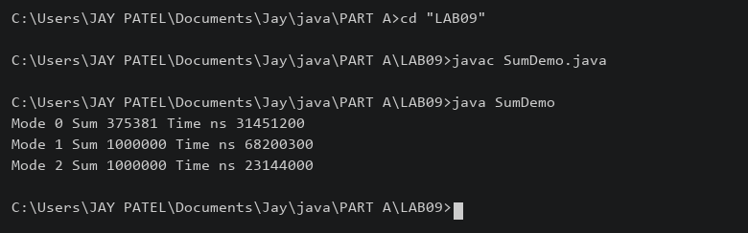

Practical 10
Part A
1) | Thread-pool runner: with a fixed pool of 3 (ExecutorService), submit about 10 Runnable  tasks that print their id and sleep briefly; shut down and await completion, observing the  few threads being reused.
 | PoolDemo.java
Code | import java.util.concurrent.*;  public class PoolDemo {  public static void main(String[] args) throws Exception {  ExecutorService pool = Executors.newFixedThreadPool(3);  for (int i = 1; i <= 10; i++) {  final int id = i;  pool.execute(() -> {  System.out.println("Task " + id + " " + Thread.currentThread().getName());  try { Thread.sleep(100); }  catch (InterruptedException e) { Thread.currentThread().interrupt(); }  });  }  pool.shutdown();  if (!pool.awaitTermination(1, TimeUnit.MINUTES)) { pool.shutdownNow(); }  }  }
Output | 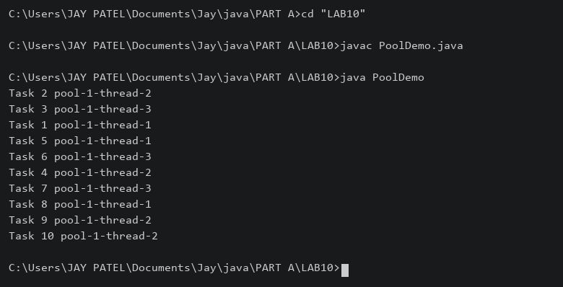

2) | Producer–consumer: one thread adds numbers to a small shared buffer and another  removes them, coordinated with wait()/notify(); produce and consume a fixed number of  items in order with none lost.
 | BufferDemo.java
Code | class Buffer {  private int value;  private boolean full;  synchronized void put(int n) throws InterruptedException {  while (full) { wait(); }  value = n; full = true;  System.out.println("Produced: " + n); notify();  }  synchronized int take() throws InterruptedException {  while (!full) { wait(); }  int n = value; full = false;  System.out.println("Consumed: " + n); notify(); return n;  }  }  public class BufferDemo {  public static void main(String[] args) throws Exception {  Buffer buffer = new Buffer();  Thread producer = new Thread(() -> {  try { for (int i = 1; i <= 5; i++) { buffer.put(i); } }  catch (InterruptedException e) { Thread.currentThread().interrupt(); }  });  Thread consumer = new Thread(() -> {  try { for (int i = 1; i <= 5; i++) { buffer.take(); } }  catch (InterruptedException e) { Thread.currentThread().interrupt(); }  });  producer.start(); consumer.start(); producer.join(); consumer.join();  }  }
Output | 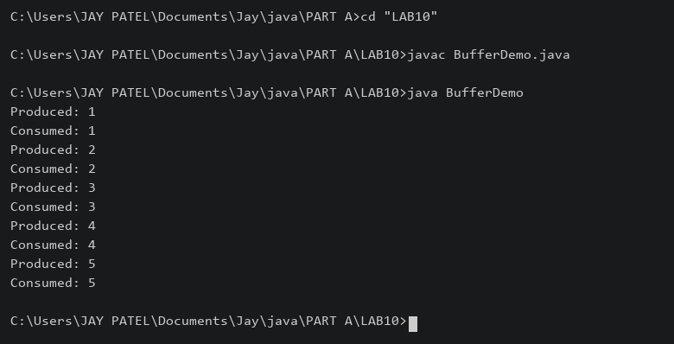

3) | (For Advanced Learners – home) Reproduce a deadlock between two threads that lock  two objects in opposite order, then remove it with a consistent lock order. Choose the  scenario yourself.
 | LockDemo.java
Code | import java.util.concurrent.CountDownLatch;  public class LockDemo {  static void pause() {  try { Thread.sleep(50); }  catch (InterruptedException e) { Thread.currentThread().interrupt(); }  }  static void lock(Object a, Object b) {  synchronized (a) { pause(); synchronized (b) { System.out.println("Completed"); } }  }  public static void main(String[] args) throws Exception {  Object a = new Object(), b = new Object();  if (args.length > 0 && args[0].equals("deadlock")) {  CountDownLatch held = new CountDownLatch(2);  Runnable first = () -> {  synchronized (a) {  held.countDown();  try { held.await(); } catch (InterruptedException e) { return; }  synchronized (b) { System.out.println("A then B"); }  }  };  Runnable second = () -> {  synchronized (b) {  held.countDown();  try { held.await(); } catch (InterruptedException e) { return; }  synchronized (a) { System.out.println("B then A"); }  }  };  new Thread(first).start(); new Thread(second).start();  } else {  Thread t1 = new Thread(() -> lock(a,b));  Thread t2 = new Thread(() -> lock(a,b));  t1.start(); t2.start(); t1.join(); t2.join();  }  }  }
 | java LockDemo deadlock deliberately hangs; stop it with Ctrl+C. java LockDemo runs the fixed version.
Output | 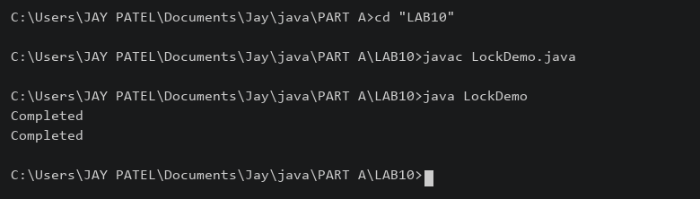

Practical 11
Part A
1) | Save/load: make a small class Serializable, save an array of its objects to a file with  ObjectOutputStream, then read it back into fresh objects and confirm the values survived.  Mark one field transient and show it is not saved.
 | SaveDemo.java
Code | import java.io.*;  class Student implements Serializable {  private static final long serialVersionUID = 1L;  String name;  int marks;  transient String password;  Student(String name, int marks, String password) {  this.name = name; this.marks = marks; this.password = password;  }  }  public class SaveDemo {  public static void main(String[] args) throws Exception {  Student[] students = {new Student("Tej",90,"abc"), new Student("Riya",85,"xyz")};  try (ObjectOutputStream out = new ObjectOutputStream(new FileOutputStream("students.dat"))) {  out.writeObject(students);  }  Student[] loaded;  try (ObjectInputStream in = new ObjectInputStream(new FileInputStream("students.dat"))) {  loaded = (Student[]) in.readObject();  }  for (Student s : loaded) {  System.out.println(s.name + " " + s.marks + " Password: " + s.password);  }  System.out.println("Fresh object: " + (students[0] != loaded[0]));  }  }
Output | 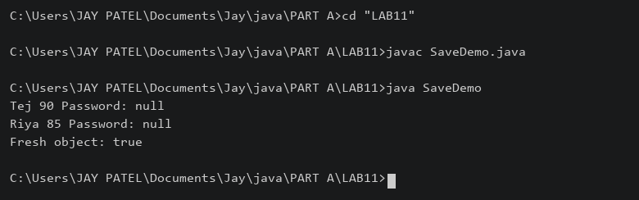

2) | Log analyzer: create a few text files, then use Path/Files to read each line by line and  count the total lines and how many contain a keyword across all files; also print each  file’s size from its attributes.
 | LogAnalyzer.java
Code | import java.nio.file.*;  import java.nio.file.attribute.BasicFileAttributes;  import java.io.BufferedReader;  public class LogAnalyzer {  public static void main(String[] args) throws Exception {  Path folder = Path.of("samplelogs"); Files.createDirectories(folder);  Files.writeString(folder.resolve("one.log"), "login OK\nlogin ERROR\n");  Files.writeString(folder.resolve("two.log"), "payment ERROR\n");  String keyword = "ERROR";  int lines = 0, matches = 0;  try (DirectoryStream<Path> files = Files.newDirectoryStream(folder, "*.log")) {  for (Path file : files) {  BasicFileAttributes attr = Files.readAttributes(file, BasicFileAttributes.class);  System.out.println(file + " Size: " + attr.size());  try (BufferedReader reader = Files.newBufferedReader(file)) {  String line;  while ((line = reader.readLine()) != null) {  lines++;  if (line.contains(keyword)) { matches++; }  }  }  }  }  System.out.println("Lines: " + lines + " Matches: " + matches);  }  }
Output | 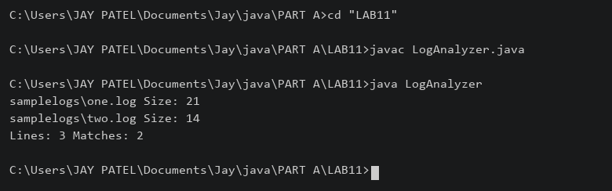

3) | (For Advanced Learners – home) Walk a folder tree with NIO and produce a report of  the files it contains (name, size, modified time), writing the summary to a file; decide  what to include.
 | TreeReport.java
Code | import java.nio.file.*;  import java.nio.file.attribute.BasicFileAttributes;  import java.util.stream.Stream;  public class TreeReport {  public static void main(String[] args) throws Exception {  Path root = Path.of("sampletree"); Files.createDirectories(root.resolve("sub"));  Files.writeString(root.resolve("sub/a.txt"), "Hello");  Path report = Path.of("tree-report.txt");  StringBuilder text = new StringBuilder();  try (Stream<Path> paths = Files.walk(root)) {  for (Path file : paths.filter(Files::isRegularFile).toList()) {  BasicFileAttributes a = Files.readAttributes(file, BasicFileAttributes.class);  text.append(root.relativize(file)).append(" ").append(a.size())  .append(" ").append(a.lastModifiedTime()).append("\n");  }  }  Files.writeString(report, text); System.out.print(text);  }  }
Output | 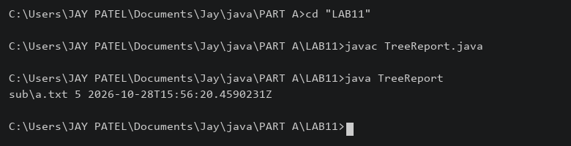

Practical 12
Part A
1) | Word frequency: split a paragraph into words, count each in a HashMap, and print the  words sorted by frequency (highest first) using a Comparator.
 | WordFrequency.java
Code | import java.util.*;  public class WordFrequency {  public static void main(String[] args) {  String paragraph = "Java is simple. Java is useful. Java supports objects.";  HashMap<String,Integer> counts = new HashMap<>();  for (String word : paragraph.toLowerCase().split("[^a-z]+")) {  if (!word.isEmpty()) { counts.put(word, counts.getOrDefault(word,0) + 1); }  }  ArrayList<Map.Entry<String,Integer>> list = new ArrayList<>(counts.entrySet());  list.sort(Comparator.<Map.Entry<String,Integer>>comparingInt(e -> e.getValue())  .reversed().thenComparing(e -> e.getKey()));  for (Map.Entry<String,Integer> e : list) {  System.out.println(e.getKey() + ": " + e.getValue());  }  }  }
Output | 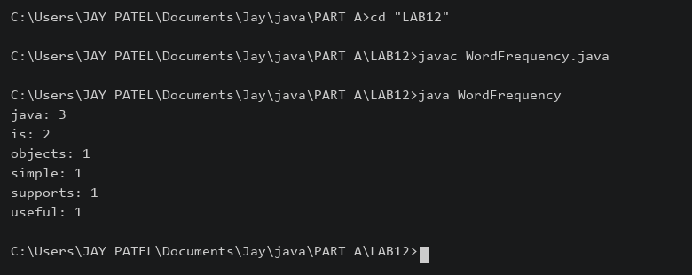

2) | Unique visitors: from a list of login names with repeats, use a HashSet to count unique  users and a LinkedHashSet to keep first-seen order; print the unique count and the first  three distinct names.
 | Visitors.java
Code | import java.util.*;  public class Visitors {  public static void main(String[] args) {  List<String> names = Arrays.asList("Tej","Riya","Tej","Aman","Riya","Neha");  HashSet<String> unique = new HashSet<>(names);  LinkedHashSet<String> ordered = new LinkedHashSet<>(names);  System.out.println("Unique users: " + unique.size());  int count = 0;  for (String name : ordered) {  if (count == 3) { break; }  System.out.println(name); count++;  }  }  }
Output | 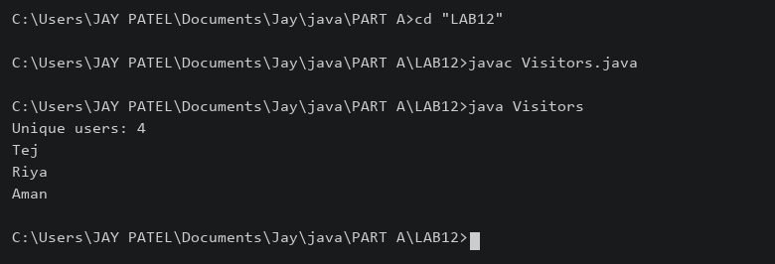

3) | (For Advanced Learners – home) Build a leaderboard from player scores held in a Map  and print the top-N sorted by score (ties broken by name); choose the data and sorting  details.
 | Leaderboard.java
Code | import java.util.*;  public class Leaderboard {  public static void main(String[] args) {  Map<String,Integer> scores = new HashMap<>();  scores.put("Tej",90); scores.put("Riya",95);  scores.put("Aman",90); scores.put("Neha",80);  ArrayList<Map.Entry<String,Integer>> list = new ArrayList<>(scores.entrySet());  list.sort(Comparator.<Map.Entry<String,Integer>>comparingInt(e -> e.getValue())  .reversed().thenComparing(e -> e.getKey()));  int n = 3;  for (int i = 0; i < Math.min(n,list.size()); i++) {  System.out.println((i + 1) + ". " + list.get(i).getKey()  + " " + list.get(i).getValue());  }  }  }
Output | 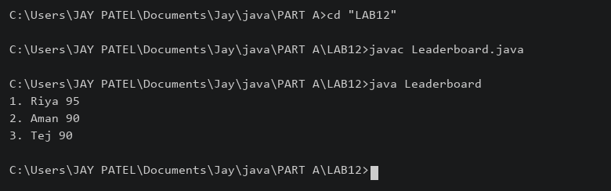

Practical 13
Part A
1) | Generic containers: a generic Box<T> with get/set and a Pair<A,B>; use them with  different types to show type safety without casts, and write a generic method that returns  the first element of any array.
 | ContainerDemo.java
Code | class Box<T> {  private T value;  void set(T value) { this.value = value; }  T get() { return value; }  }  class Pair<A,B> {  private A first; private B second;  Pair(A first, B second) { this.first = first; this.second = second; }  A getFirst() { return first; }  B getSecond() { return second; }  }  public class ContainerDemo {  static <T> T first(T[] values) {  if (values.length == 0) { throw new IllegalArgumentException("Empty array"); }  return values[0];  }  public static void main(String[] args) {  Box<String> names = new Box<>(); names.set("Tej");  Box<Integer> marks = new Box<>(); marks.set(90);  Pair<String,Integer> pair = new Pair<>(names.get(), marks.get());  System.out.println(pair.getFirst() + " " + pair.getSecond());  System.out.println(first(new String[]{"Java","Python"}));  System.out.println(first(new Integer[]{10,20}));  }  }
Output | 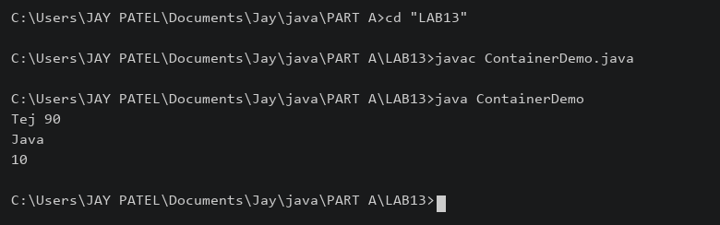

2) | Bounded stats: a generic method <N extends Number> double average(N[] values) that  works for Integer[], Double[] and Long[]; note why it refuses non-Number types.
 | Stats.java
Code | public class Stats {  static <N extends Number> double average(N[] values) {  if (values.length == 0) { throw new IllegalArgumentException("Empty array"); }  double sum = 0;  for (N n : values) { sum += n.doubleValue(); }  return sum / values.length;  }  public static void main(String[] args) {  System.out.println(average(new Integer[]{10,20,30}));  System.out.println(average(new Double[]{1.5,2.5}));  System.out.println(average(new Long[]{100L,200L}));  }  }
 | String[] is rejected at compile time because String does not extend Number.
Output | 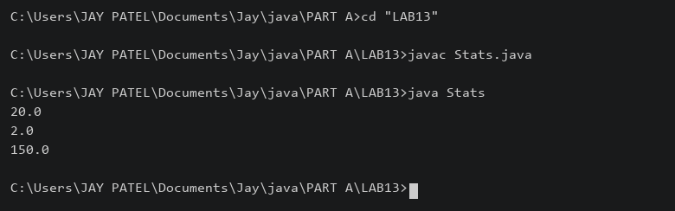

3) | (For Advanced Learners – home) Implement a small generic container of your choice  (e.g. a stack) backed by an array, reuse it for two different types, and handle the empty  case sensibly.
 | StackDemo.java
Code | import java.util.EmptyStackException;  class Stack<T> {  private Object[] data;  private int size;  Stack(int capacity) { data = new Object[capacity]; }  void push(T item) {  if (size == data.length) { throw new IllegalStateException("Stack full"); }  data[size++] = item;  }  @SuppressWarnings("unchecked")  T pop() {  if (size == 0) { throw new EmptyStackException(); }  T item = (T) data[--size]; data[size] = null; return item;  }  }  public class StackDemo {  public static void main(String[] args) {  Stack<Integer> numbers = new Stack<>(3); numbers.push(10); numbers.push(20);  Stack<String> names = new Stack<>(2); names.push("Tej");  System.out.println(numbers.pop()); System.out.println(names.pop());  try { names.pop(); }  catch (EmptyStackException e) { System.out.println("Stack empty"); }  }  }
Output | 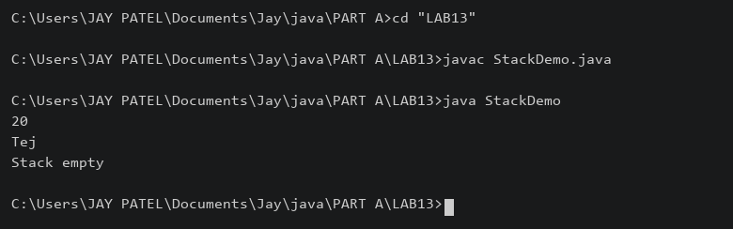

Practical 14
Part A
1) | Assemble and test: build a tiny layered app (a model, a service using an ArrayList, and a  menu main), then write two or three JUnit @Test methods checking that adding increases  the count and an invalid action throws — practice before testing MiniBank.
 | Item.java
Code | public record Item(String name) {}
 | ItemService.java
Code | import java.util.ArrayList;  public class ItemService {  private ArrayList<Item> items = new ArrayList<>();  public void add(String name) {  if (name == null || name.isBlank()) { throw new IllegalArgumentException("Name required"); }  items.add(new Item(name));  }  public int count() { return items.size(); }  public ArrayList<Item> all() { return new ArrayList<>(items); }  }
 | ItemApp.java
Code | import java.util.Scanner;  public class ItemApp {  public static void main(String[] args) {  ItemService service = new ItemService();  Scanner sc = new Scanner(System.in);  while (true) {  System.out.println("1. Add\n2. List\n3. Exit");  String choice = sc.nextLine();  if (choice.equals("3")) { break; }  try {  if (choice.equals("1")) {  System.out.print("Name: "); service.add(sc.nextLine());  } else if (choice.equals("2")) { System.out.println(service.all()); }  else { System.out.println("Invalid choice"); }  } catch (IllegalArgumentException e) { System.out.println(e.getMessage()); }  }  }  }
 | ItemServiceTest.java
Code | import org.junit.jupiter.api.Test;  import static org.junit.jupiter.api.Assertions.*;  public class ItemServiceTest {  @Test void addIncreasesCount() {  ItemService service = new ItemService();  service.add("Book"); assertEquals(1,service.count());  }  @Test void blankNameThrows() {  assertThrows(IllegalArgumentException.class, () -> new ItemService().add(" "));  }  @Test void listContainsAddedItem() {  ItemService service = new ItemService(); service.add("Pen");  assertEquals("Pen",service.all().get(0).name());  }  }
Place JUnit Platform Console Standalone 1.10.2 in lib/junit.jar.
javac -d out Item.java ItemService.java ItemApp.java
javac -cp "out;lib/junit.jar" -d out ItemServiceTest.java
java -jar lib/junit.jar execute --class-path out --scan-class-path
On Linux/macOS replace the classpath semicolon with a colon.
Output | 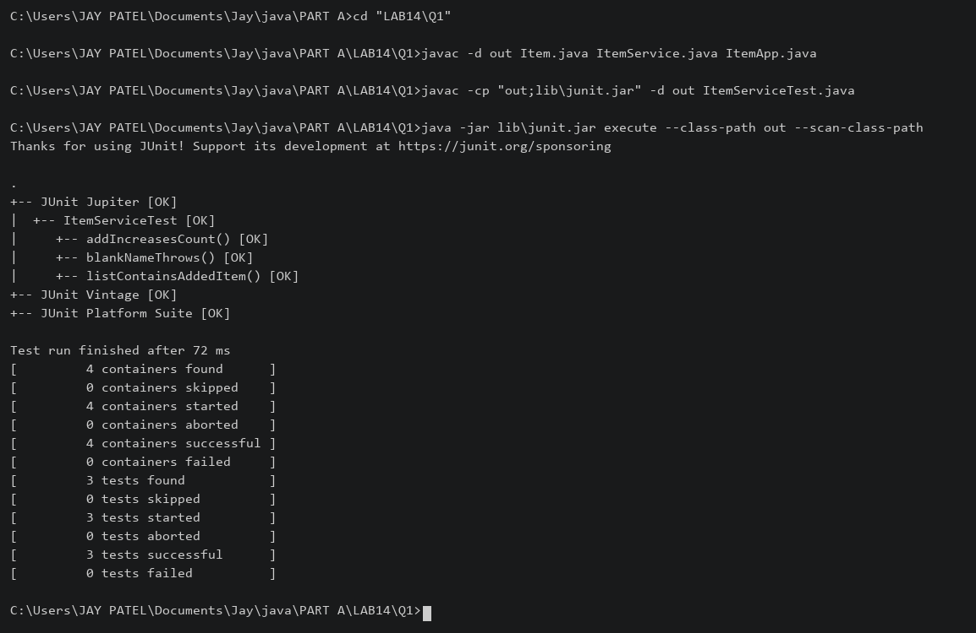

2) | (For Advanced Learners – home) Organise that app into packages, build a runnable JAR,  and add a test that saves and reloads its data unchanged.
 | model/Item.java
Code | package model;  import java.io.Serializable;  public record Item(String name) implements Serializable {}
 | service/ItemService.java
Code | package service;  import model.Item;  import java.io.*;  import java.nio.file.*;  import java.util.ArrayList;  public class ItemService {  private ArrayList<Item> items = new ArrayList<>();  public void add(String name) {  if (name == null || name.isBlank()) { throw new IllegalArgumentException("Name required"); }  items.add(new Item(name));  }  public void save(Path file) throws IOException {  try (ObjectOutputStream out = new ObjectOutputStream(Files.newOutputStream(file))) {  out.writeObject(items);  }  }  @SuppressWarnings("unchecked")  public void load(Path file) throws IOException, ClassNotFoundException {  try (ObjectInputStream in = new ObjectInputStream(Files.newInputStream(file))) {  items = (ArrayList<Item>) in.readObject();  }  }  public int count() { return items.size(); }  public ArrayList<Item> all() { return new ArrayList<>(items); }  }
 | app/ItemApp.java
Code | package app;  import service.ItemService;  import java.util.Scanner;  public class ItemApp {  public static void main(String[] args) {  ItemService service = new ItemService();  Scanner sc = new Scanner(System.in);  while (true) {  System.out.println("1. Add\n2. List\n3. Exit");  String choice = sc.nextLine();  if (choice.equals("3")) { break; }  try {  if (choice.equals("1")) {  System.out.print("Name: "); service.add(sc.nextLine());  } else if (choice.equals("2")) { System.out.println(service.all()); }  else { System.out.println("Invalid choice"); }  } catch (IllegalArgumentException e) { System.out.println(e.getMessage()); }  }  }  }
 | test/ItemServiceTest.java
Code | package test;  import service.ItemService;  import java.nio.file.*;  import org.junit.jupiter.api.Test;  import static org.junit.jupiter.api.Assertions.*;  public class ItemServiceTest {  @Test void addIncreasesCount() {  ItemService service = new ItemService();  service.add("Book"); assertEquals(1,service.count());  }  @Test void blankNameThrows() {  assertThrows(IllegalArgumentException.class, () -> new ItemService().add(" "));  }  @Test void listContainsAddedItem() {  ItemService service = new ItemService(); service.add("Pen");  assertEquals("Pen",service.all().get(0).name());  }  @Test void saveAndLoad() throws Exception {  Path file = Files.createTempFile("items", ".dat");  try {  ItemService first = new ItemService(); first.add("Pen"); first.save(file);  ItemService second = new ItemService(); second.load(file);  assertEquals(first.all(),second.all());  } finally { Files.deleteIfExists(file); }  }  }
Build from the folder containing model, service, app and test.
javac -d out model/Item.java service/ItemService.java app/ItemApp.java
jar --create --file items.jar --main-class app.ItemApp -C out .
java -jar items.jar
javac -cp "out;lib/junit.jar" -d test-out test/ItemServiceTest.java
java -jar lib/junit.jar execute --class-path "out;test-out" --scan-class-path
On Linux/macOS use a colon in classpaths.
Output | 

