Facial Landmark Detection using Tasks-Constrained Deep Convolutional Network

Vyom Shrivastava  University of Georgia  vyom.shrivastav25@uga.edu | Prajay Shetty  University of Georgia  prajay.shetty25@uga.edu | Yu Dong-Yu  University of Georgia  dongyu.yu25@uga.edu

Abstract

Facial Landmark detection is one of the most essential aspect in facial recognition. The accuracy of Face Landmark detection directly influences the quality of recognition.
Our aim is to create a model that identifies the facial landmarks on the input images and produce a marked image that highlights the facial landmarks on the given face in the image.
We implemented the research paper by Zhang et al. [1] to create the deep learning neural network TCDCN (Task Constrained Deep Convolutional Network) and created a tool that takes images as input and produces images with 5 landmarks on both eyes, both end of lips and nose.

Introduction
Facial landmark detection is a fundamental component in many face analysis tasks like face recognition, face verification and facial attribute inference. Facial landmark detection is traditionally considered as a single and independent problem. In the paper. In papers by Sun et al. [3] they detect facial landmarks by coarse-to-fine regression using a cascaded deep convolutional neural network, other approaches previously used include template fitting approaches and regression based methods.

The papers by Zhang et al. [1,2] use a different approach. They did not view the facial landmark detection as a single stand-alone problem but considered number of heterogeneous and correlated factors affect the estimation of facial landmarks. They considered factors like the changes in distance of lip end point because of smiling, the face position, if a person is wearing glasses, gender and inter ocular distance. We use the same approach where we try to optimize the problem of facial landmark detection while considering these other factors.

Learning the facial landmarks while also trying to learn the other tasks such as gender, if wearing glasses, head pose, if smiling etc. can be a challenge. Therefore, we adopt the same approach that is used in the paper Zhang et al. [1] i.e. Multi-task learning.

Multi-task learning is a subfield in Machine Learning which tries to solve multiple problems, at the same time while exploiting commonalities and differences across tasks [4]. In the context of our project, Multi-task learning learns the multiple classification tasks jointly hence improving the performance. Multi-task learning has proved to be very efficient in cases where all the tasks were of same difficulty i.e. the tasks are of same convergence rate. Tasks like learning ‘if wearing glasses’ is easier than learning ‘if smiling’ and they both have different convergence rate. To tackle this problem, we use early stopping.

Early stopping refers to stopping the learning of auxiliary task before they begin to overfit the training data and therefore harm the main task. In TCDCN as the training proceeds, certain auxiliary task may cause overfitting and are not beneficial to the main task, when such task reaches the peak point of their performance we halt their learning process.

For optimization of our tasks, we use stochastic gradient descent to update the weights of the tasks and filters of the network. In our implementation we kept the learning rate η as 0.003. We tried adam optimization, but the results were degraded, thus we decided on using Stochastic Gradient Descent which was also used in the paper by Zhang et al. [1,2].

The loss calculated for back-propagation of TCDCN is the combined loss for all the tasks together. The loss is calculated by calculating the loss for the facial landmarks which is our main task and the loss of each auxiliary task is subtracted from the landmark loss to calculate the combined loss which is then back propagated in the network.

For calculating the loss of the landmarks, we used Mean-Squared Error (MSE) loss over the landmarks as the landmark task is a regression problem. For calculating the loss of the auxiliary task (smiling, wearing glasses, gender and head pose) we calculate categorical cross-entropy loss as these tasks are classification problems. The sum of categorical cross-entropy loss of all tasks is then subtracted from the MSE of the landmark to obtain the final loss to be backpropagated.
The TCDCN model that we finally created can detect the five facial landmarks quite well. We tested our model with two types of images, one with the complete images from our testing dataset and another with images cropped according to a bounding box only over the face. The images with the bounding box performed quite well with an error rate of less than 10% whereas the images without the bounding box performed poorly with an error rate over 400%. The baseline for the error rate is the actual inter-ocular distance and therefore error can be greater than 100%

- Dataset Description

We used two datasets for our project. The first dataset that we used is the MTFL (Multi-Task Facial Landmark) dataset [5]. We used this dataset for our training purpose. The MTFL dataset consists 12,995 images out of which 10,000 were annotated. The MTFL dataset itself is comprised of two different datasets. The first is the celebA faces dataset which consists of 5,590 facial images of celebrities of which only 4,150 images were annotated with facial landmark information. Each image in this dataset is of size 250x250. The second dataset in the MTFL dataset is a facial dataset of random people, the images are randomly crawled from internet. This dataset consists of 7,876 images out of which only 5,853 images are annotated. Each image in this dataset is of size 260x160. We used all the annotated images to train our dataset.

For testing purpose, we used the AFLW (Annotated Facial Landmark in the Wild) dataset [6]. Each image in this dataset are facial image of people, the size of each image is 150x150 and the total number of images we used are 2,995 images.

Both the training and testing dataset were annotated which we used to calculate loss for backpropagation and to calculate error rate respectively. The annotation of the dataset included 10 landmark points which are the coordinates of the landmarks, the first five coordinates are the x coordinate values and the next five value area the y coordinate values of the landmark at left eye, right eye, nose, left corner of lips and right corner of lips in the respective order. The next 4 values in the annotation were the encodings for the auxiliary tasks, the first one representing 1 for male gender and 2 for female gender; the next annotation includes 1 for smiling and 2 for not smiling; the next annotation is for wearing glasses, 1 if wearing and 2 if not wearing glasses; the last annotation could be one of 5 values representing head pose where 1 represents left profile, 2 represents left, 3 for frontal, 4 for right and 5 for right profile.

- Implementation Details
Our project is basically the implementation of the Task Constrained Deep Convolution Network specifies in the papers by Zhang et al. [1,2]. The source code for the implementation of the paper is not available therefore our implementation is completely based on the theoretical information and formulas provided in the paper. Our implementation can be subdivided in to three phases: pre-processing, network design, post-processing.
The following sub-section will describe all our phases in detail.

Pre-Processing
The images used in our training and testing dataset are of different sizes i.e. some of 250x250, some of 216x160 and remaining of 150x150. To be used in a model for similar training and learning the images need to be of similar i.e. of same size channels.

The first thing that we did in the pre-processing phase is to change the image to grayscale images. Each image originally was RGB images, that is of 3 channels. The TCDCN network is designed to work on only one channel that is why we modify the image to be of one channel i.e. grayscale images. We used OpenCV python for our task. We used cvtColor method of openCV with parameters COLOR_BGR2GRAY / COLOR_RGB2GRAY to convert our 3 channel images to grayscale images.

Next, we apply bounding box over the image to crop out only the face portion of the image. This was a challenging task as for this we needed to detect the face of the person in the image and acquire the bounding box annotation to crop the image to the size of the bounding box. To detect the face in the image and to obtain the bounding box annotations we used Multitask Cascaded Convolutional Networks (MTCNN) [7]. We used the tensorflow implementation of MTCNN by cyberfire [8] and we created a python script to which would extract the bounding box information from the MTCNN network. From this MTCNN tool we used the bounding box information for each image to crop the image to the size of the bounding box i.e. only include the facial portion of the image.
After the image was converted to gray scale and cropped, we then resize the image. As the images of datasets are of different dimensions we resize the images to the same dimensions. We reshaped the cropped image to 40x40 which can be then sent to be used as input for the model.
We also had to modify the annotations according to the cropped and resized image of the model. As the annotations were according to the original size of the images we had to rescale them according to the cropped and rescaled image. We use the formula (1) to rescale the annotation.

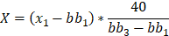 (1)

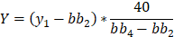
X, Y represents the scaled coordinated and x, y represent the original coordinates of landmark. bb1, bb2, bb3 and bb4 are the x and y axis readings of the bounding box generated.

Model Implementation
The model that we implemented is based on the TCDCN model (Figure 1). We implemented our model using the PyTorch library. The input layer of the model takes images of shape 1,40,40 i.e. grayscale images of 40x40. The model consists of four convolutional layers. The first convolution layer of 5x5 is followed by max-pooling of 2x2 and activated by tanH activation. The second and third convolution layers of 3x3 and are also followed by max-pooling layers of 2x2 but no pooling is applied after the last convolution layer of 2x2. The activation function used is the absolute tangent function. The last layer of the model is a fully connected layer which consists of all the share features. We also added a dropout layer after the fully connected layer as a regularization to avoid overfitting. The output of this fully connected layer after applying dropout is passed to different loss functions each for different auxiliary tasks and the main task.
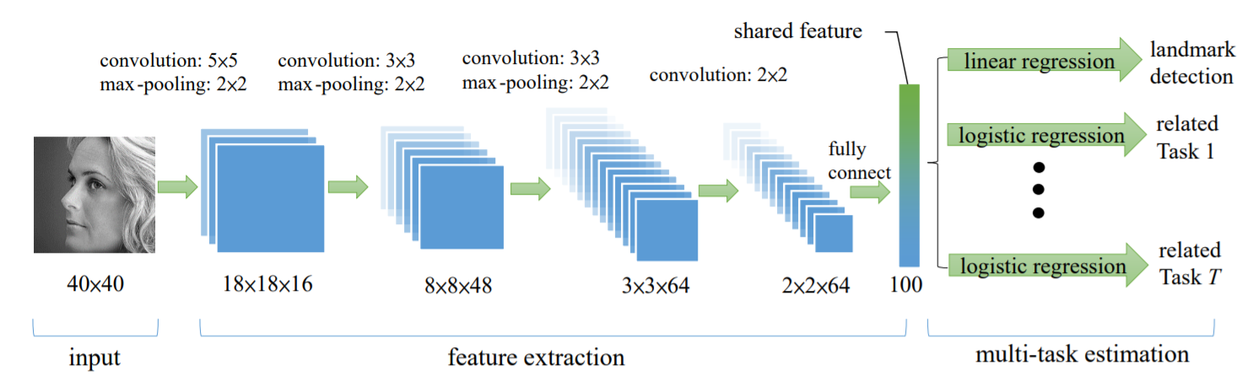
Figure 1: TCDCN Model [1]
The loss for each task is calculated separately and then combined to create a final loss function (2) that is back-propagated in the network to adjust the parameters and weights.

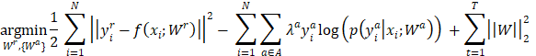
(2)
The first term in the loss function represents the Mean Squared Error (MSE) calculated for the 10 predicted landmark points. The calculation of the landmarks in the main task of the model. The second term in the loss function is the combined sum of the categorical cross-entropy loss of each auxiliary task. This summed categorical cross-entropy loss of each task is then subtracted from the MSE loss of the main task. The third term in the loss function that represents the regularization term which is responsible to control the overfitting of the data.

For optimization of the tasks we use Stochastic Gradient Descent with a learning rate of 0.003. As each task has different level of difficulty and learning rate and hence some tasks converge faster than the other tasks. Therefore, we applied early stoppings in one of our model to avoid the overfitting of easier tasks that converge fast like the wearing glasses task. We set a threshold for each task and once the threshold is reached i.e. the task has similar error rate for each epoch, we stop including that task in the combined loss and stop the backpropagation of that task loss thus avoiding overfitting in that task.

We ran our implemented models for 100 epochs and were able to get satisfactory results for the landmarks with an error rate of less than 10%

Post-Processing
After we were able to generate the predictions of the landmarks using our model we plotted them over the original images to produce a viewable output. The predictions were still for 40x40 cropped images. We scaled back the predicted points to the ratio according to the size of the original image and plotted the new scaled-back points over their original images using OpenCV. The ratio to scale back the predictions to original size can be obtained by the inverse of formula (1) i.e. calculating the points x1 and y1.

- Experiments

References
- Zhanpeng Zhang, Ping Luo, Chen Change Loy, Xiaoou Tang. Facial Landmark Detection by Deep Multi-task Learning, in Proceedings of European Conference on Computer Vision (ECCV), 2014

- Zhanpeng Zhang, Ping Luo, Chen Change Loy, Xiaoou Tang. Learning Deep Representation for Face Alignment with Auxiliary Attributes. to appear in IEEE Transactions on Pattern Analysis and Machine Intelligence (TPAMI).

- Sun, Y., Wang, X., Tang, X.: Deep convolutional network cascade for facial point detection. In: CVPR. pp. 3476–3483 (2013)

- Baxter, J. A model of inductive bias learning" Journal of Artificial Intelligence Research (2000). 12:149—198

- Multi-Task Facial Landmark Dataset. http://mmlab.ie.cuhk.edu.hk/projects/TCDCN/data/MTFL.zip

- Annotated Facial Landmark Dataset in the Wild. https://www.tugraz.at/institute/icg/research/team-bischof/lrs/downloads/aflw/

- K. Zhang and Z. Zhang and Z. Li and Y. Qiao, Joint Face Detection and Alignment Using Multitask Cascaded Convolutional Networks, IEEE Signal Processing Letters (2016).

- Tensorflow-MTCNN github implemented tool. https://github.com/cyberfire/tensorflow-mtcnn

