Online Power Browser
PYTHON

NAME : VYOM DUBEY
ENROLL_NO : 161B276
BATCH : B-9(BZ)

INTRO : This project can accurately be defined as one of the fastest,multi-browsing blocks of code,potential enough to save much time and bring comfort to the user.You can search on three big browser-giants offering three different platforms on the same window at same time.This project brings-“Google,YouTube,Amazon”,all at your window all at once.

Purpose :The simple purpose which it serve is to improve the “Browsing experience” and saving time of Users at best.Users can experience the power of browsing with these three giants all at one time.

REQUIREMENTS : This project requires installed atleast Python 2.7 on system with “pip-scripts”,and a icon file attached with this,and you are good to go.

RED_CODE_WINDOW :

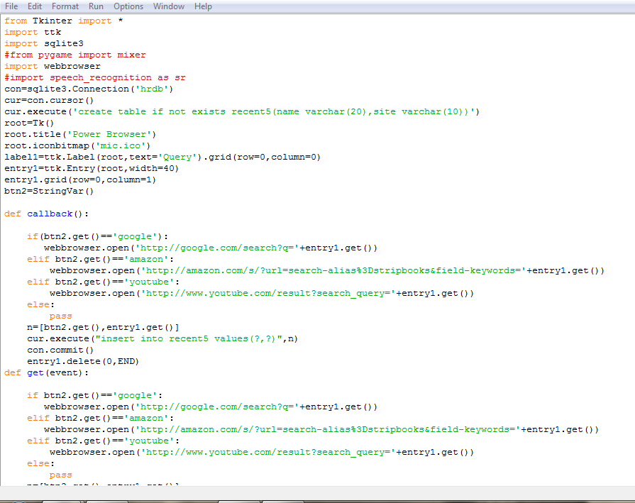

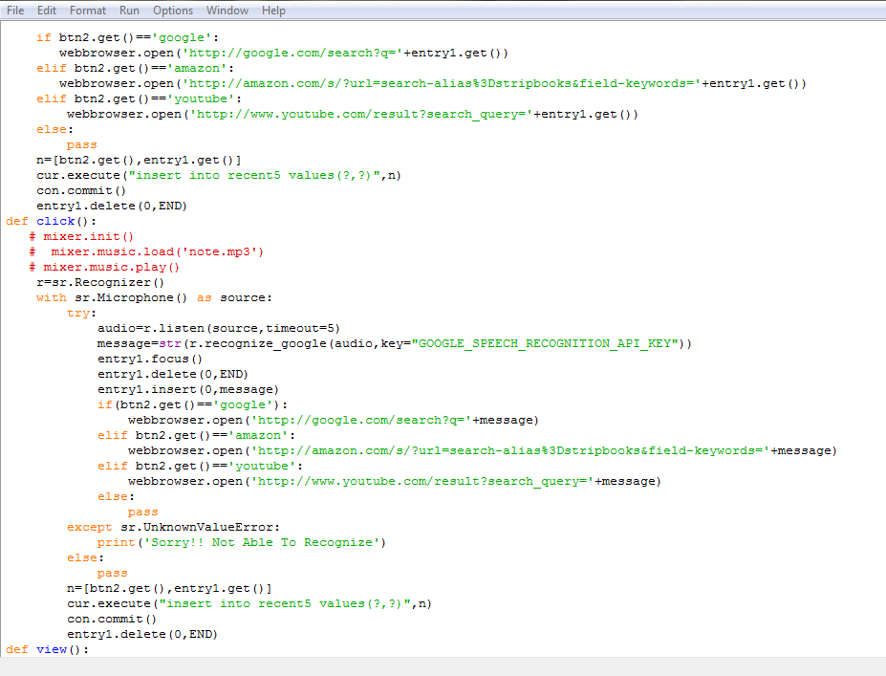

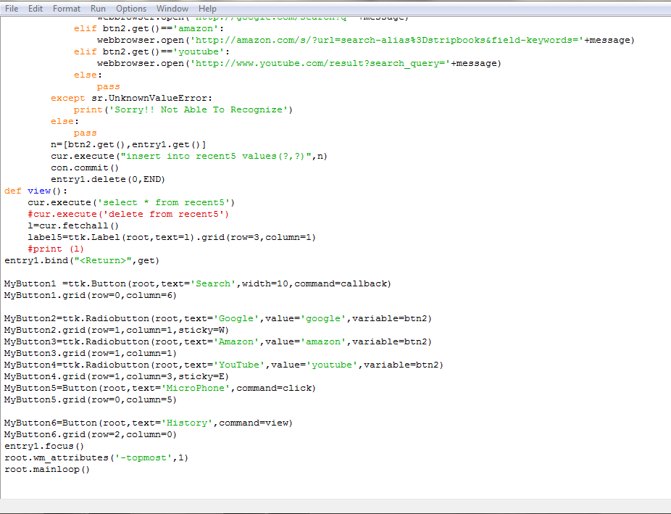

RUNNING(WINDOW:1)

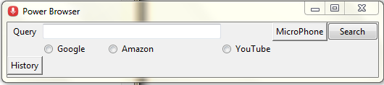

->This is the main window which pop up right
after pressing “F5”.
->Here you can see various browsing options
under different categories.
->Type in the label corresponding search,and
select the engine you wanna use.
->Right after selecting press “Enter” key or
select “Search” button.

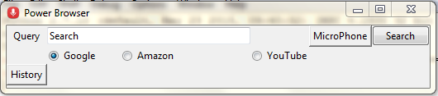

->Next window pops up with results.

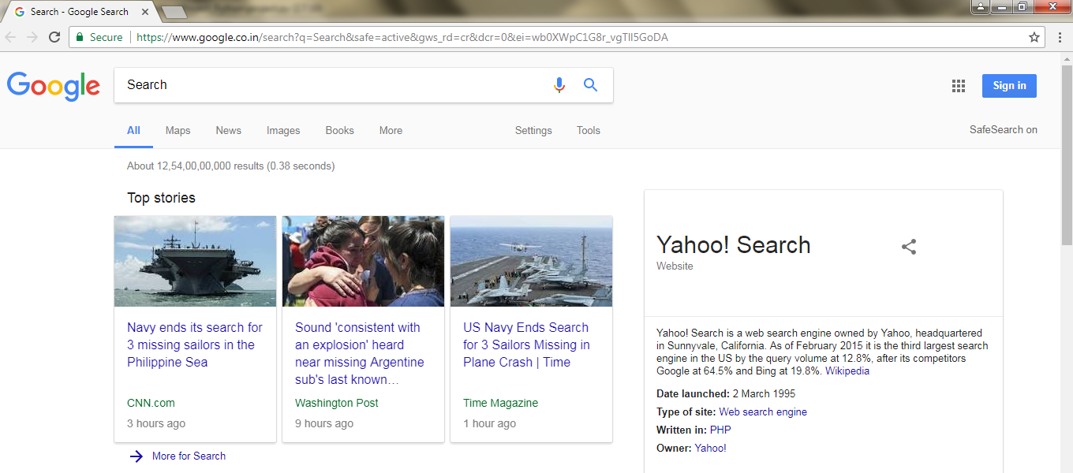
->Now choose different browsing options and
enjoy.

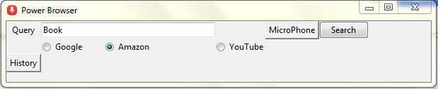

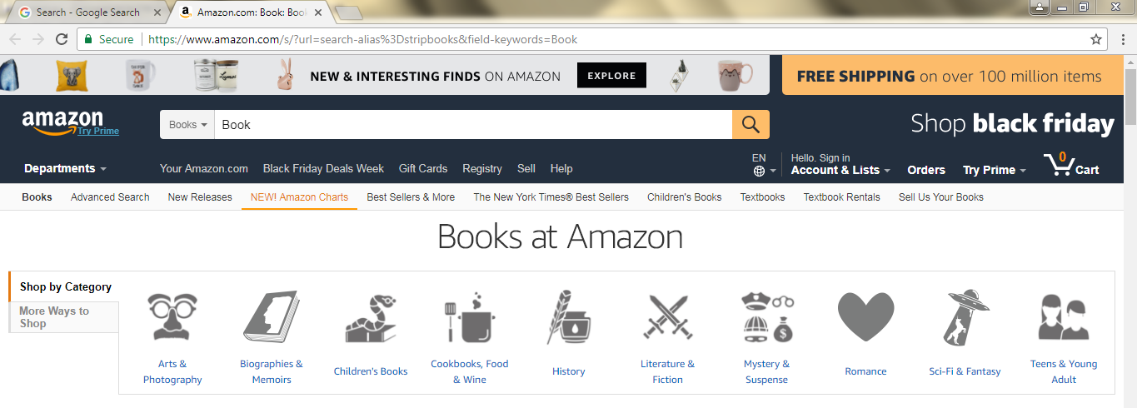

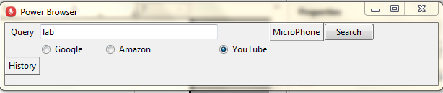

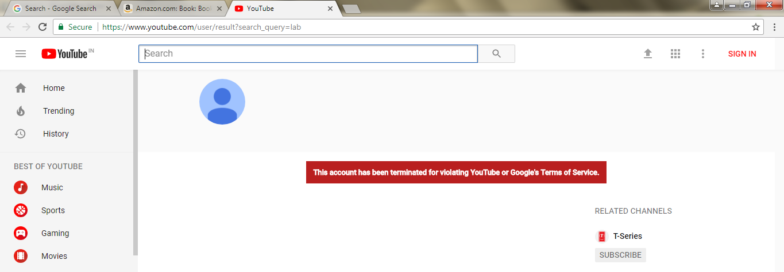
#Comment : Oops,our server don't support “YouTube”.

->You can check your browsing history too by
selecting “History” button.

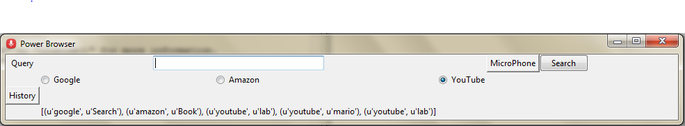

->And the history is disclosed in the label right
down the “History” button.

Thus,hereby I Conclude this project.Major learning was the “Power of Python”,and the powerful experiences and projects which comes with it.

Thanks,hope you liked the project.

I can experience the power of python running through my veins ^-^.

