DOM --> Document Object Model

https://github.com/ngdhuy

TREE

Root

HTML

Document

Title

Meta

Meta

Meta

HEAD

BODY

NODE

li

Ul text

Tag = Element

Text

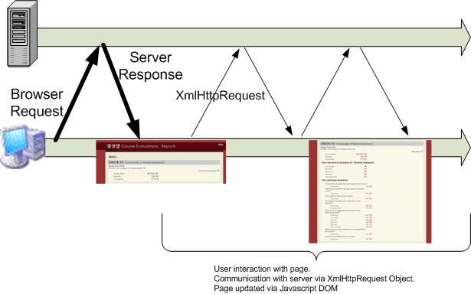

UTM GET: domain? pa.1 = value1 &

pa.2 = value2

Submit

POST domain

parameter package