|  |  |  |  |
| --- | --- | --- | --- |
| **Date** | **Time** | **Subject** | **Work** |
| 18/4 | 18 – 22:00 | - Sientific Socialism | - Ask to do test again |

Deadline:

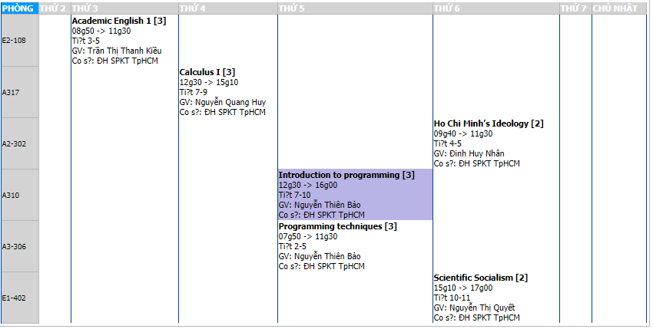

Schedule:

|  |  |  |  |  |  |  |  |
| --- | --- | --- | --- | --- | --- | --- | --- |
|  | 2 | 3 | 4 | 5 | 6 | 7 | CN |
| Morning | Program techniques |  |  |  |  | Scientific Socialism |  |
| Afternoon | Academic English 1 | Calculus 1 |  |  |  | C++ |  |
| Night |  |  | Intro to Pro | HCM’s Ideology |  |  |  |