|  |  |
| --- | --- |
|  | PORTFOLIO |
|  |  |
|  | Vysali Pughazhendi (1001750473)  2198-CSE-5335-003-WEB DATA MANAGEMENT  11/17/19 |

DATABASE SCHEMA :

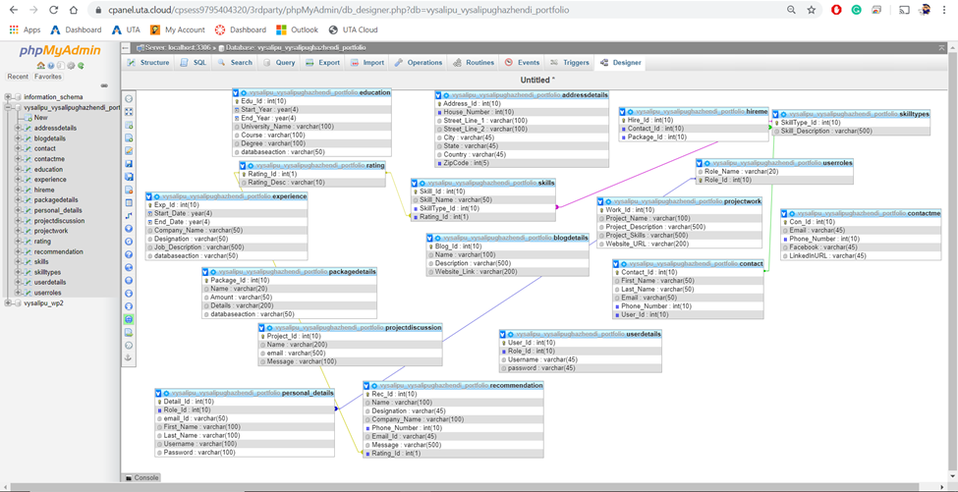

SCREENSHOT OF THE EMAIL ():

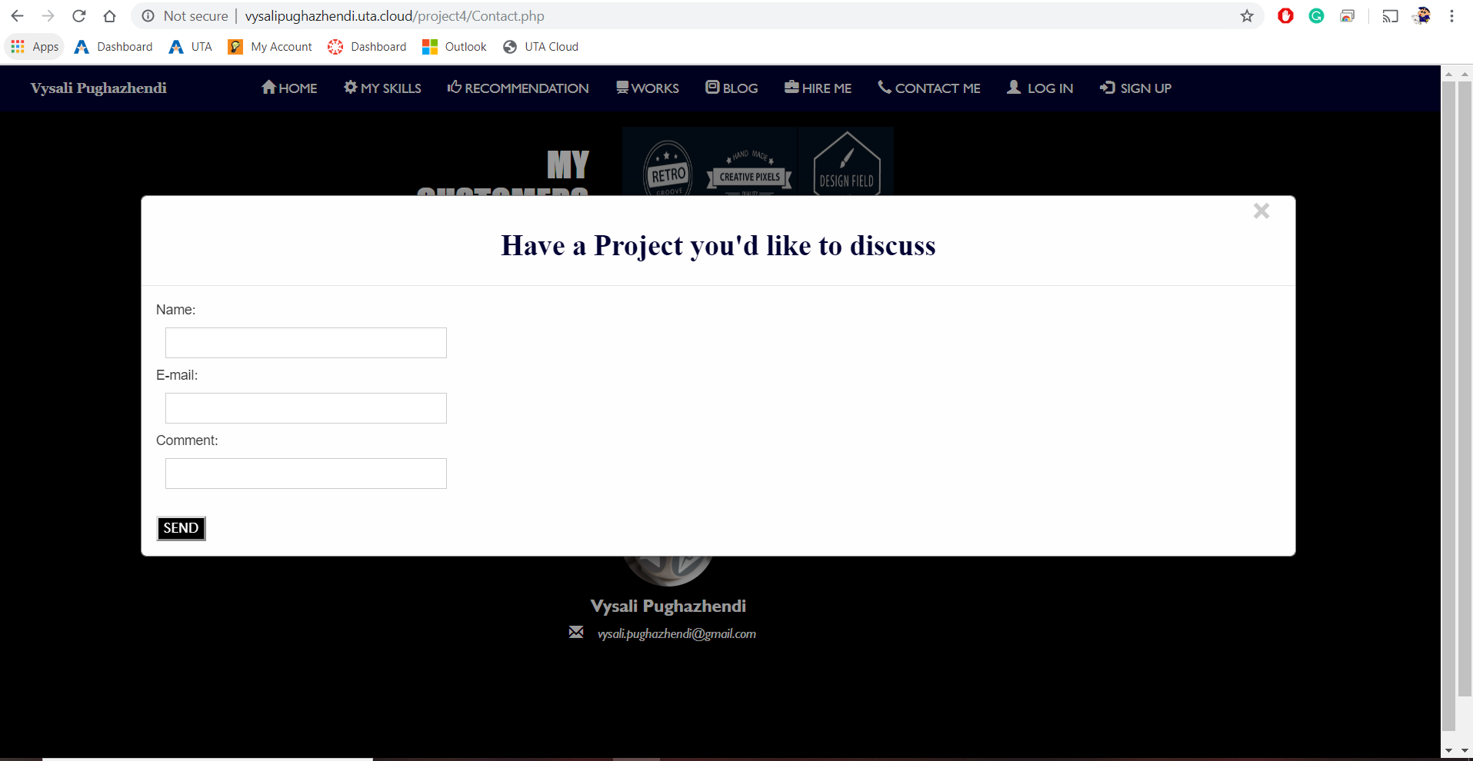

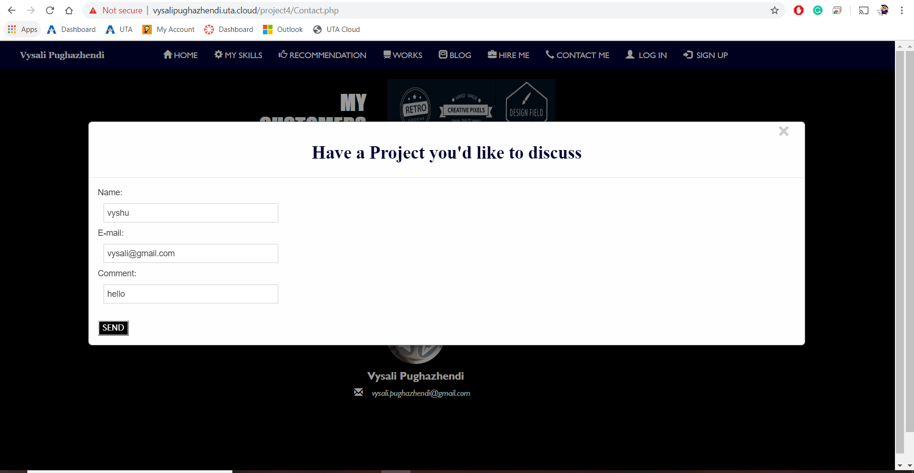

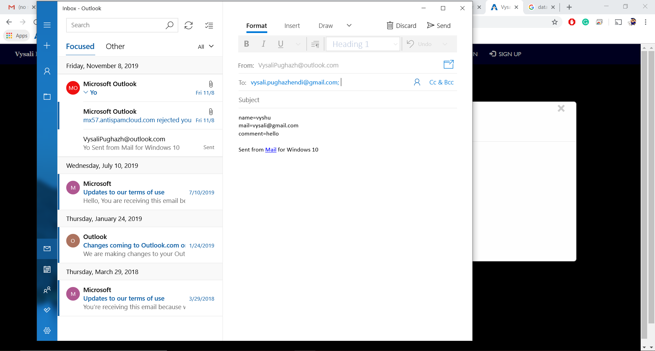

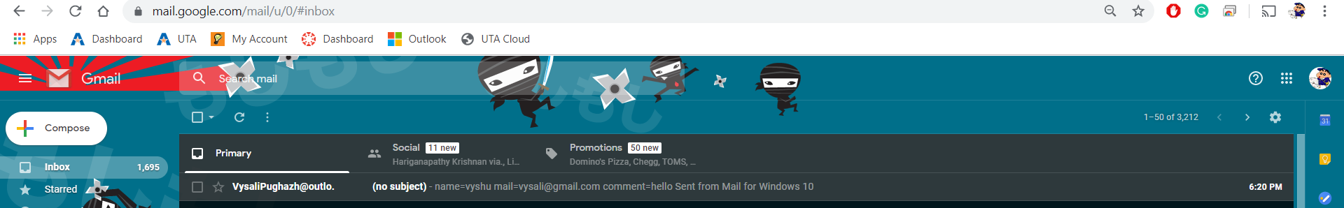

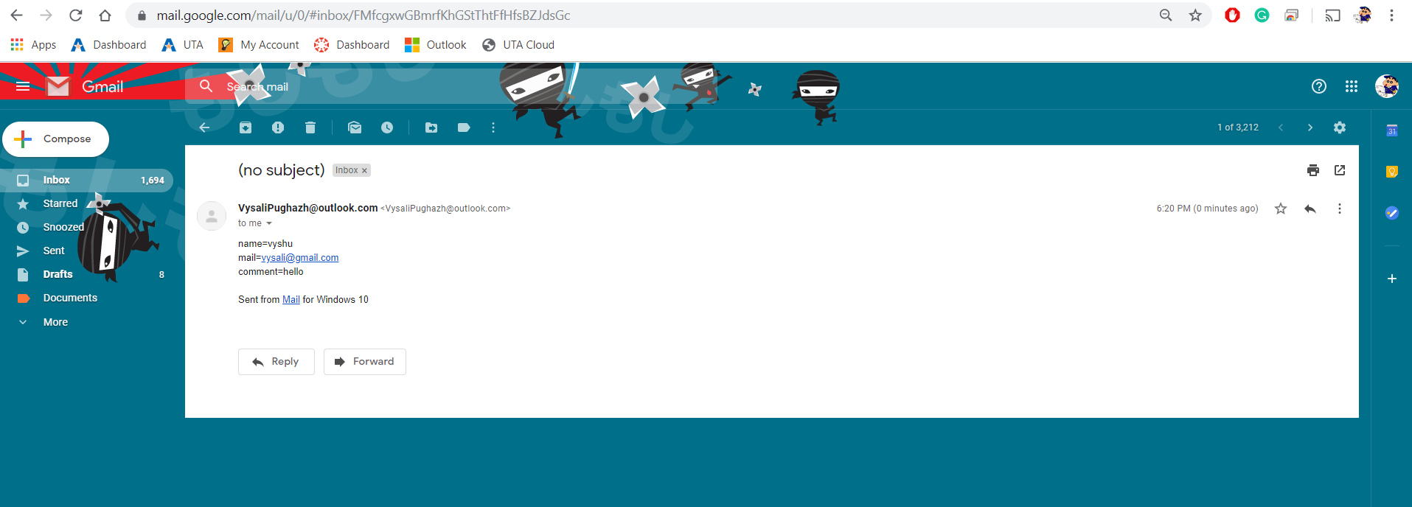

USERNAME AND PASSWORD FOR ADMIN AND CUSTOMER :

ADMIN:

Username : vysali

Password : vysalipughaz

CUSTOMER:

Username : diyag

Password : diyaistalking