Task-2:

Prompt: Write a python program to generate a is_prime() Python function.

Code :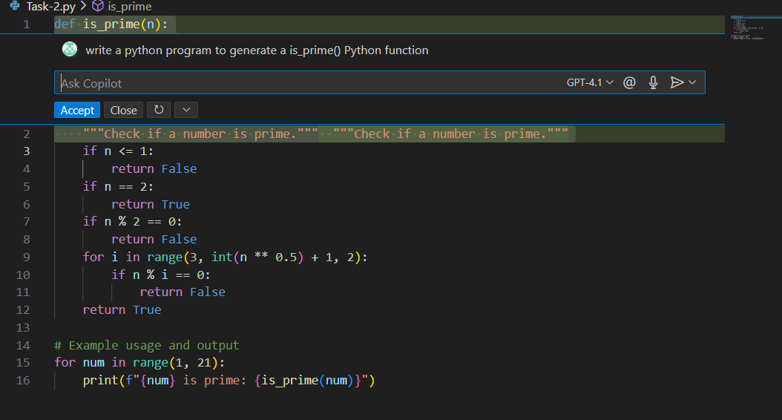

Output:

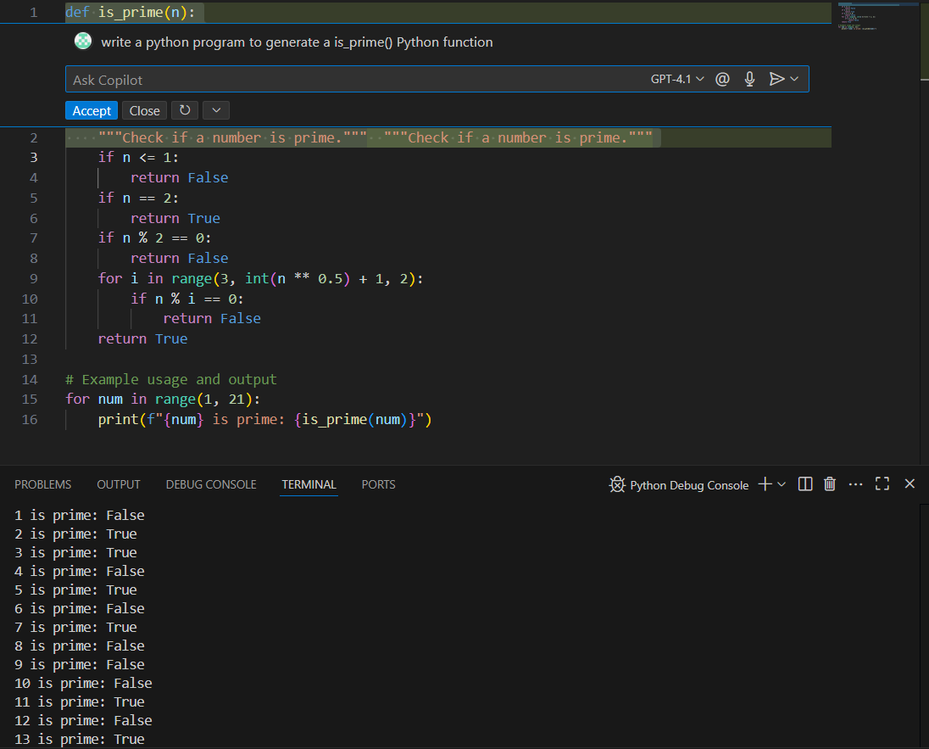

Task-3:

Prompt: Generate a function for function to reverse a string with output.

Code:

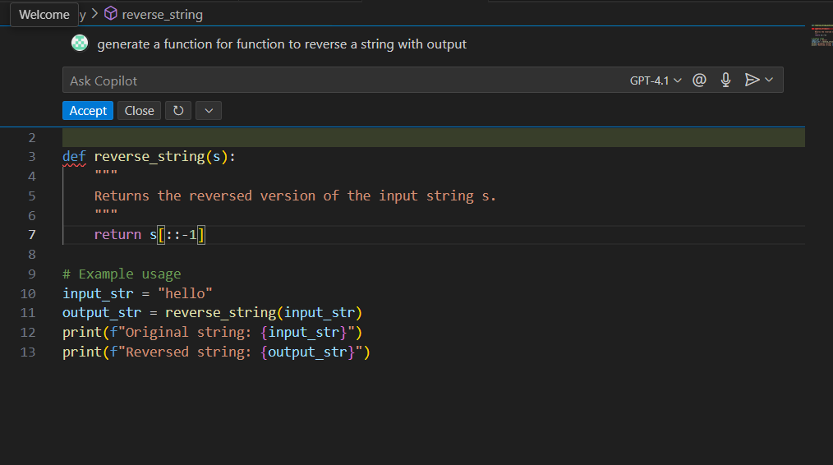

Output:

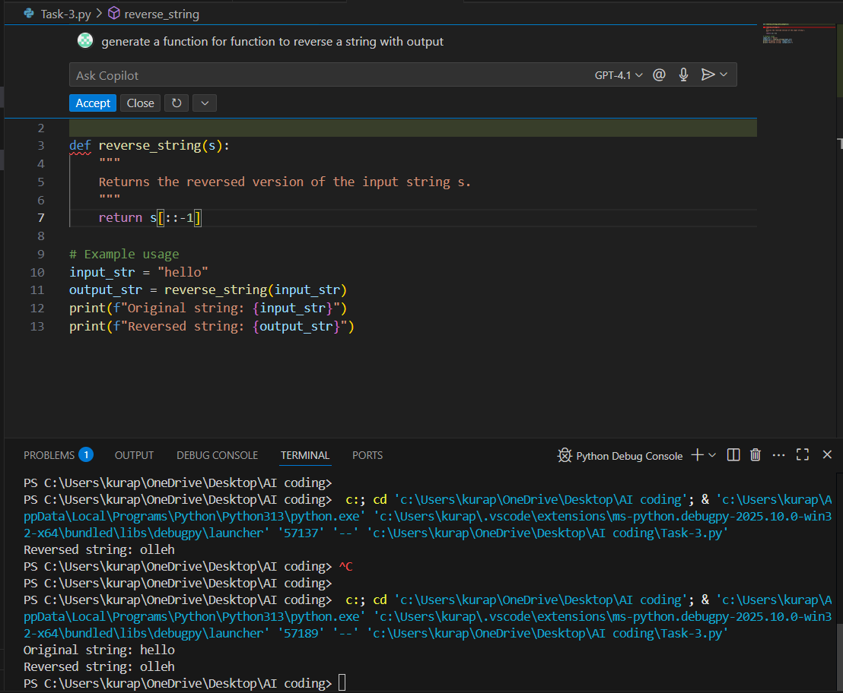

Task-4:

Prompt : Write a python code to generate both recursive and iterative versions of a factorial using comments.

Code:

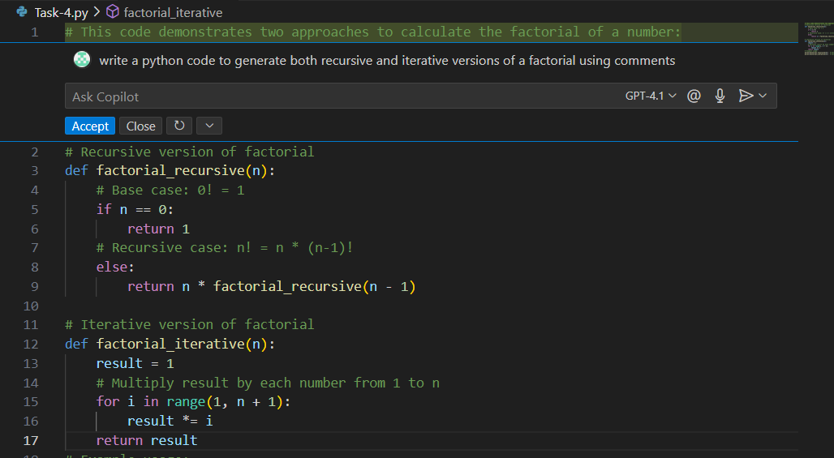

Output:

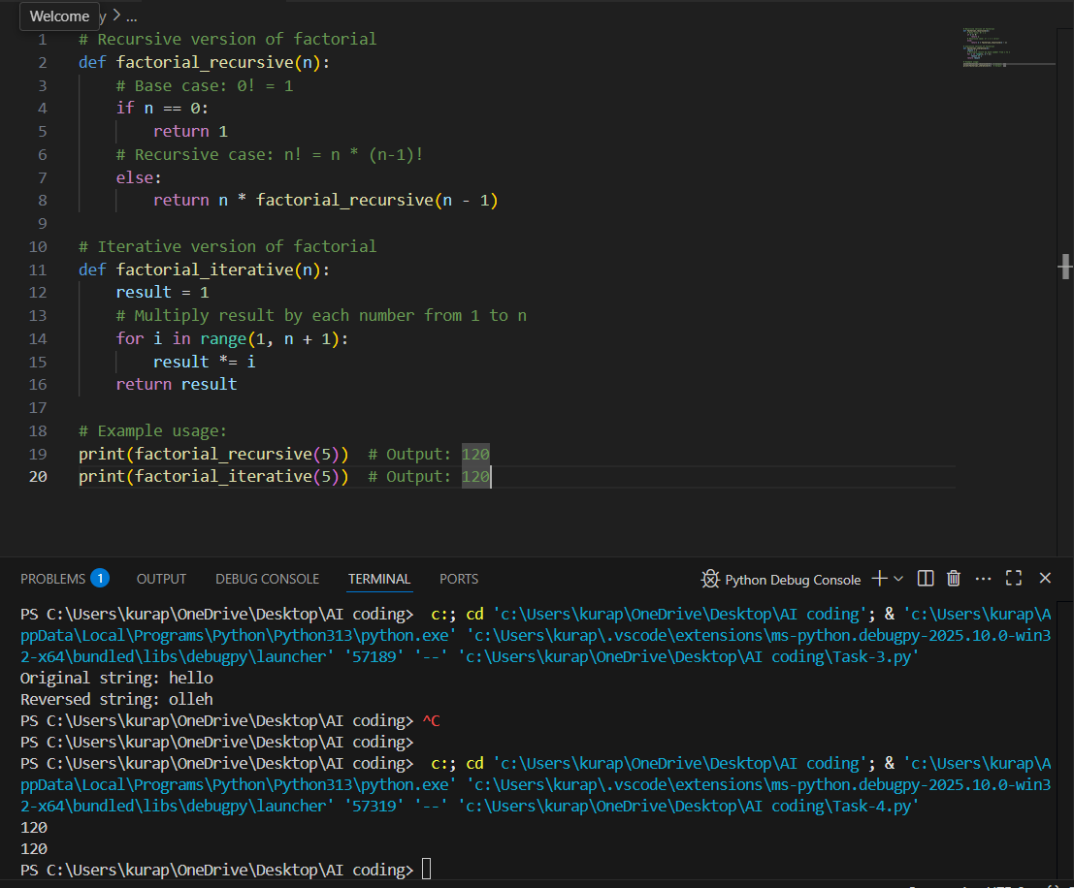

Task-5:

Prompt : write a python program to generate largest number in a list with output.

Code: 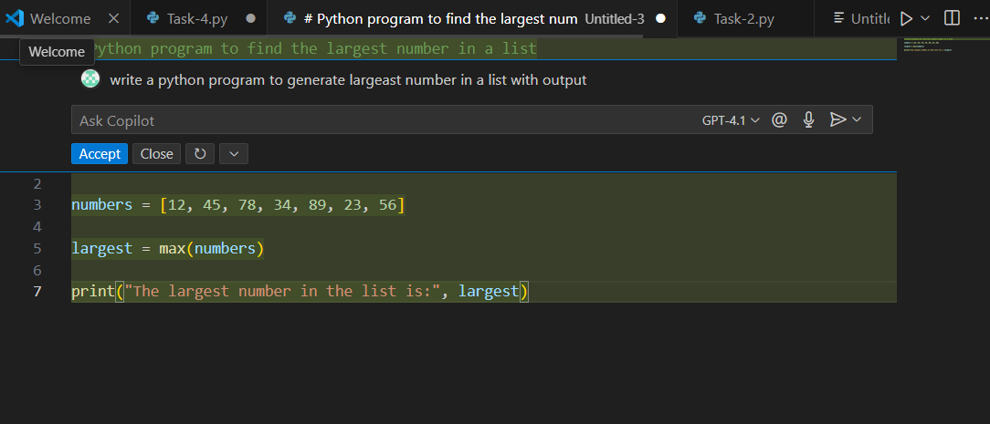

Output:

