S4 Hana 2025 FPS01 on AWS via SAP Cloud Appliance Library
System Details:
Appliance name – S4Hana-Lab
Cloud provider – AWS
Region - us-east-1 (N. Virginia)
SAP Release – S4 Hana 2025 FPS01 , Fully activated
SID – S4H
Instance number – 00
Application server - vhcals4hci_S4H_00
Hostname - vhcals4hci
S4 Hana + Hana DB VM - r6i.8xlarge (32 cores, 256GB RAM)
Java VM - r6i.xlarge (4 cores, 32GB RAM)
SAP Web - https://[PublicIP]:44300/sap/bc/gui/sap/its/webgui
Fiori URL - https://[PublicIP]:44300/sap/bc/ui5_ui5/ui2/ushell/shells/abap/FioriLaunchpad.html
Process:
1. SAP CAL trail account created linked to AWS free tier (Vysh_Learner), chose SAP S4Hana 2025 FPS01 fully activated appliance template (valid only for 30 days)
2. Issues faced before S4 Hana deployment:
- vCPU quota (service quota limit issues on free tier) first activation attempt failed.
By default AWS free tier account provided 16 service quotas but S4 Hana appliance has minimum requirement of 2 VMs which require atleast 36 quotas, so requested Running On-Demand Standard instances AWS to provide 40 vCPUs before proceeding
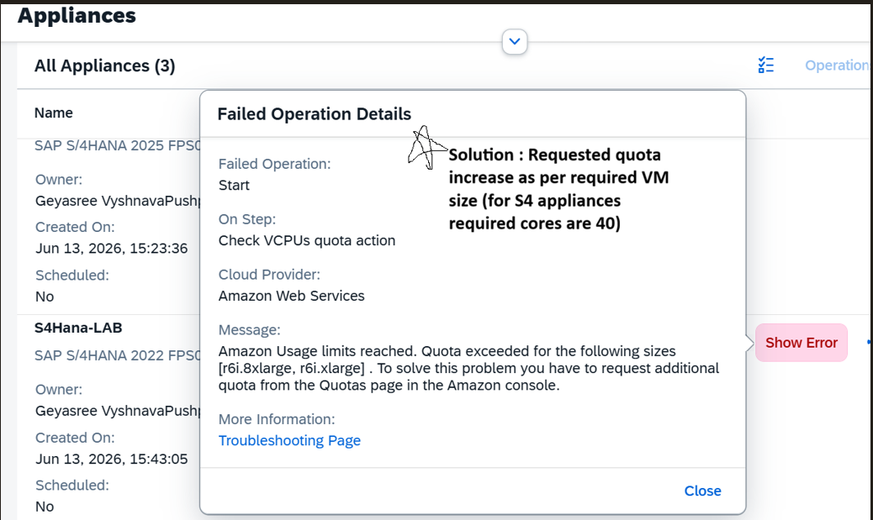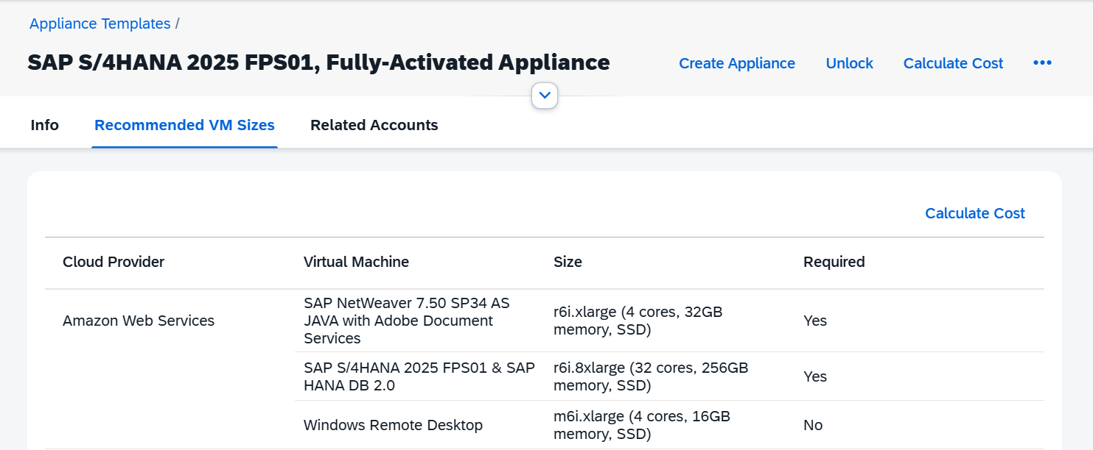
- AWS free tier restriction, 2nd time activation failed due to the error “Specified instance type is not eligible for free tier” because my AWS account was on free tier which does not allow large instaces such as r6i and m6i , free tier is only limited to t2.micro/t3.micro, AWS support says this restriction is applied independently of credit balance or payment method. My AWS account has $200 credits when signed in as free tier.
Sol: Raised a support case with AWS billing team and asked them to remove the free tier flag on my account so that I could utilize those credits. They provided a solution asking me to upgrade the account from free tier to pay as you go standard account, which utilizes the credits first and they remain mindful of the running instances.
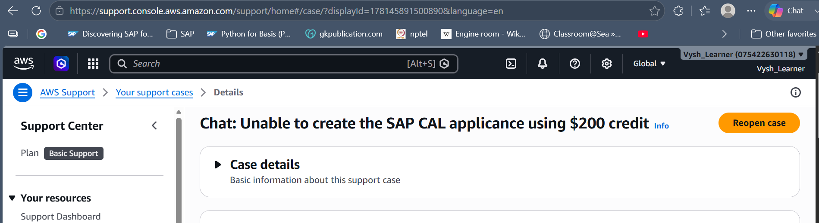
- Next activation attempt after account upgrade has been failed due to the error “we currently do not have sufficient m6i.xlarge capacity in us-east-1a, change the region to us-west or us-east-1b”, not my account issue, AWS said it does not have enough m6i servers available to provide and asked to chose another region.
Sol: I chose to deselect the windows RDP server which uses m6i instance and it is not a definite requirement to deploy S4 Hana, it is a optional server. So, I removed the RDP from selection and proceeded with deployment.
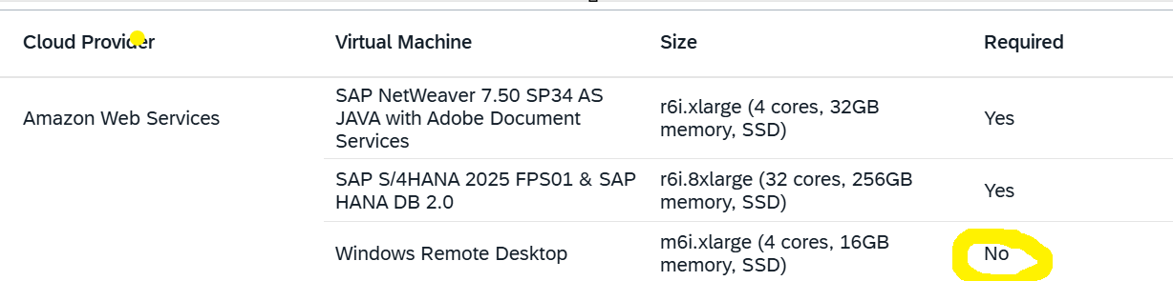
It also save my credit usage, with RDP it says $2.85/hr with out RDP $2.56/hr
And I chose to use SAP logon pad which was installed locally to access the S4 Hana on SAP CAL
- After approx. 2 hours S4 Hana was successfully deployed on SAP CAL , did all system health verifications along with screenshots(saved in screenshots folder)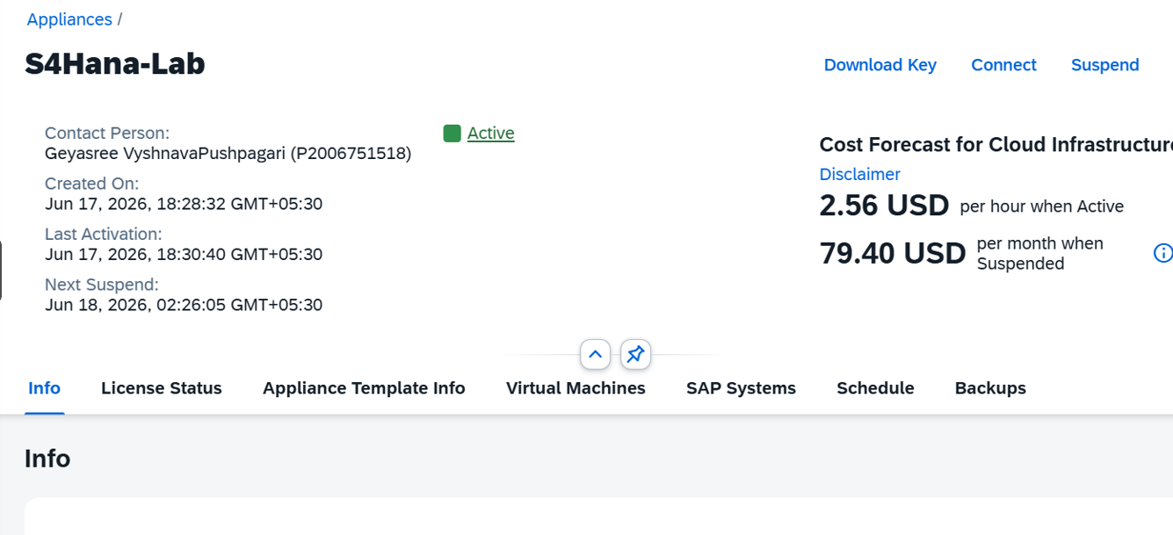
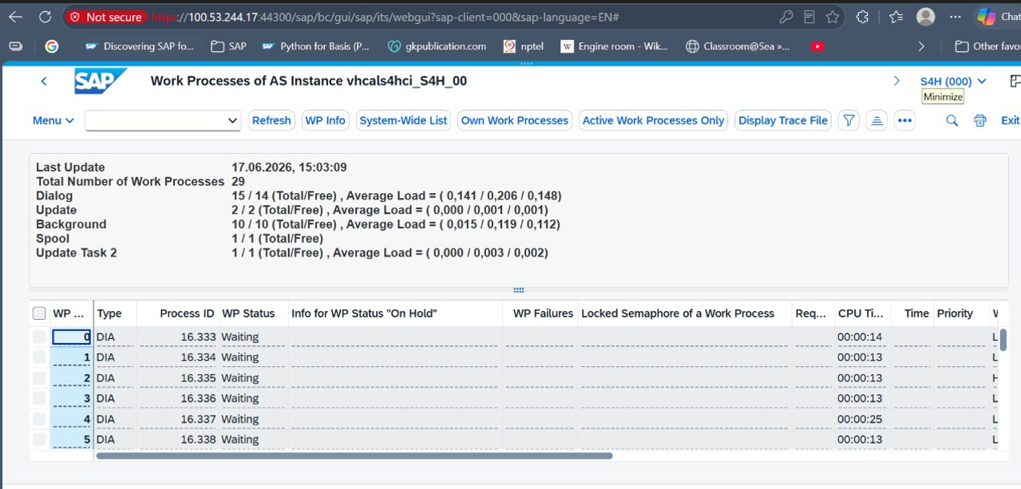
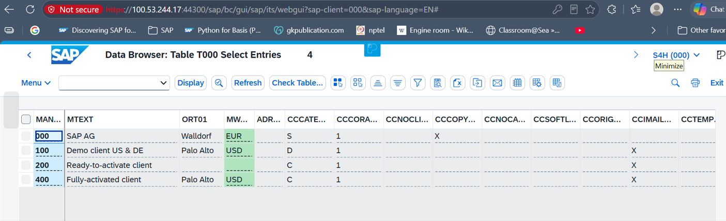
Access Details:
- Port Used: 44300 (HTTPS)
- Client: 000 (admin) / 100 (business)
- Web GUI URL: https://[Public_IP]/sap/bc/gui/sap/its/webgui

