# Web Design Homework - Web Visualization Dashboard (Latitude)

## Background

Data is more powerful when we share it with others! Let's take what we've learned about HTML and CSS to create a dashboard showing off the analysis we've done.

## Latitude - Latitude Analysis Dashboard with Attitude

For this homework we'll be creating a visualization dashboard website using visualizations we've created in a past assignment. Specifically, we'll be plotting [weather data](Resources/cities.csv).

In building this dashboard, we'll create individual pages for each plot and a means by which we can navigate between them. These pages will contain the visualizations and their corresponding explanations. We'll also have a landing page, a page where we can see a comparison of all of the plots, and another page where we can view the data used to build them.

### Website Requirements

For reference, see the "Screenshots" section below.

The website must consist of 7 pages total, including:

* A landing page containing:

* An explanation of the project.

* Links to each visualizations page. There should be a sidebar containing preview images of each plot, and clicking an image should take the user to that visualization.

* Four visualization pages, each with:

* A descriptive title and heading tag.

* The plot/visualization itself for the selected comparison.

* A paragraph describing the plot and its significance.

* A "Comparisons" page that:

* Contains all of the visualizations on the same page so we can easily visually compare them.

* Uses a Bootstrap grid for the visualizations.

* The grid must be two visualizations across on screens medium and larger, and 1 across on extra-small and small screens.

* A "Data" page that:

* Displays a responsive table containing the data used in the visualizations.

* The table must be a bootstrap table component.

**You can visit Weather Dashboard at:**

### Screenshots

#### <a id="landing-page"></a>Landing page

Large screen:

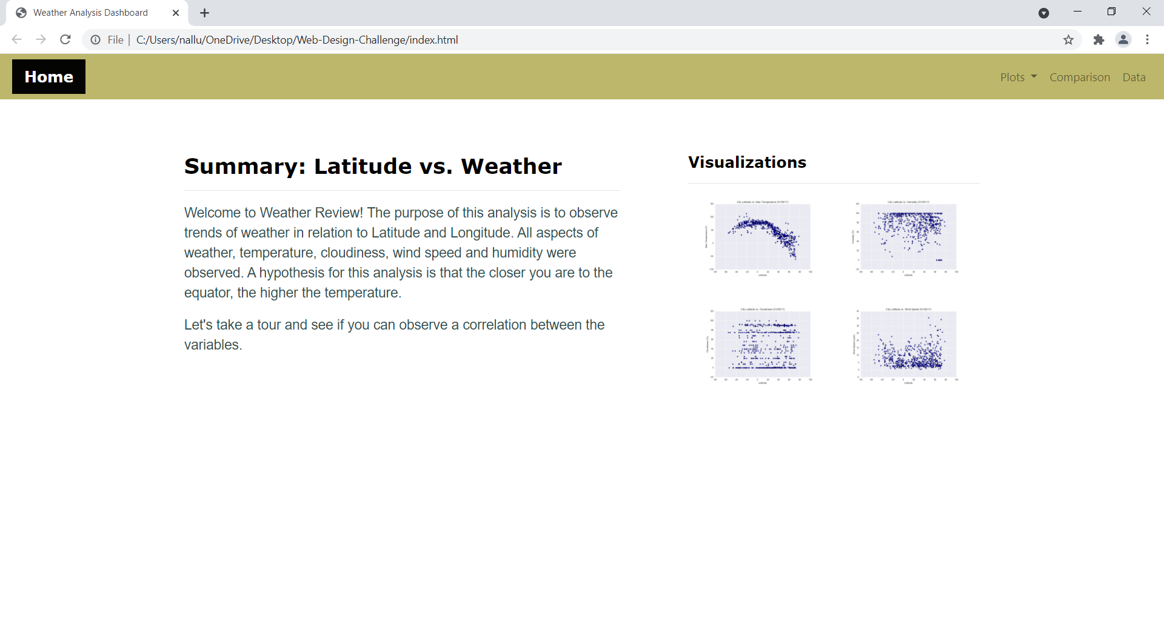

Small screen:

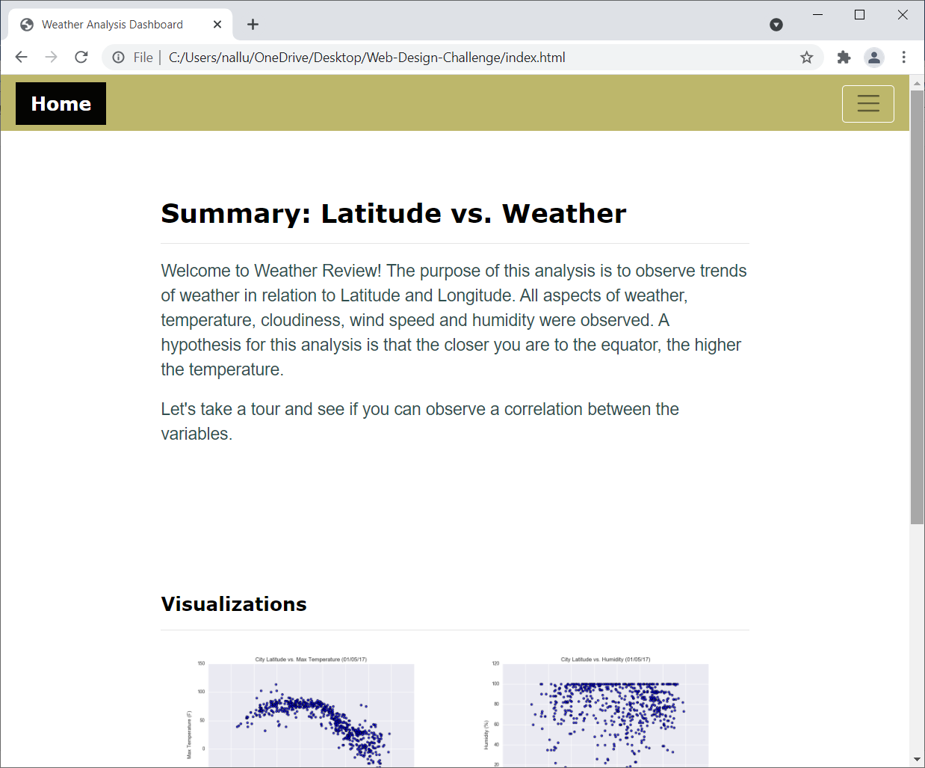

#### <a id="comparisons-page"></a>Comparisons page

Large screen:

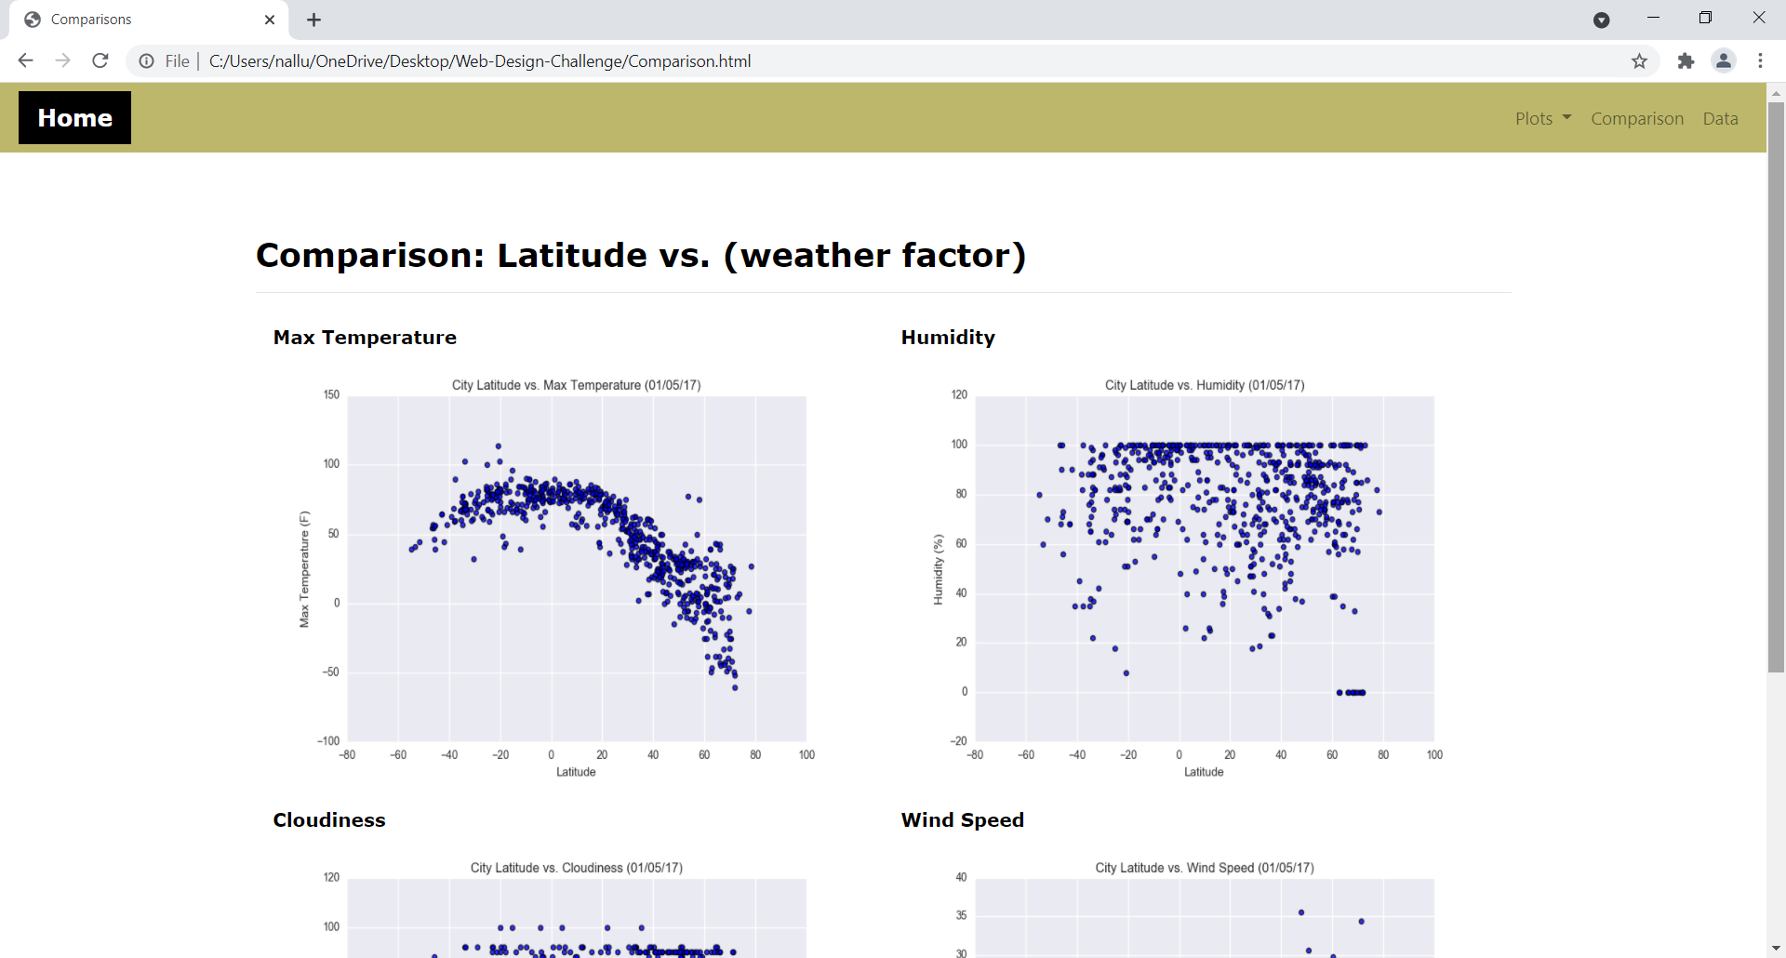

Small screen:

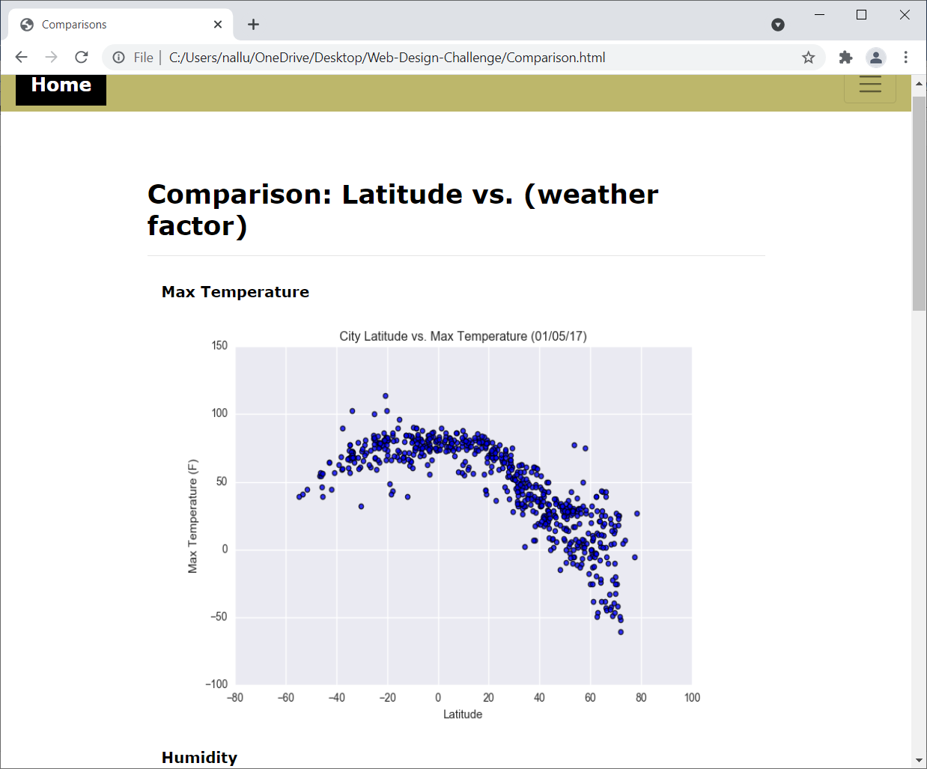

#### <a id="data-page"></a>Data page

Large screen:

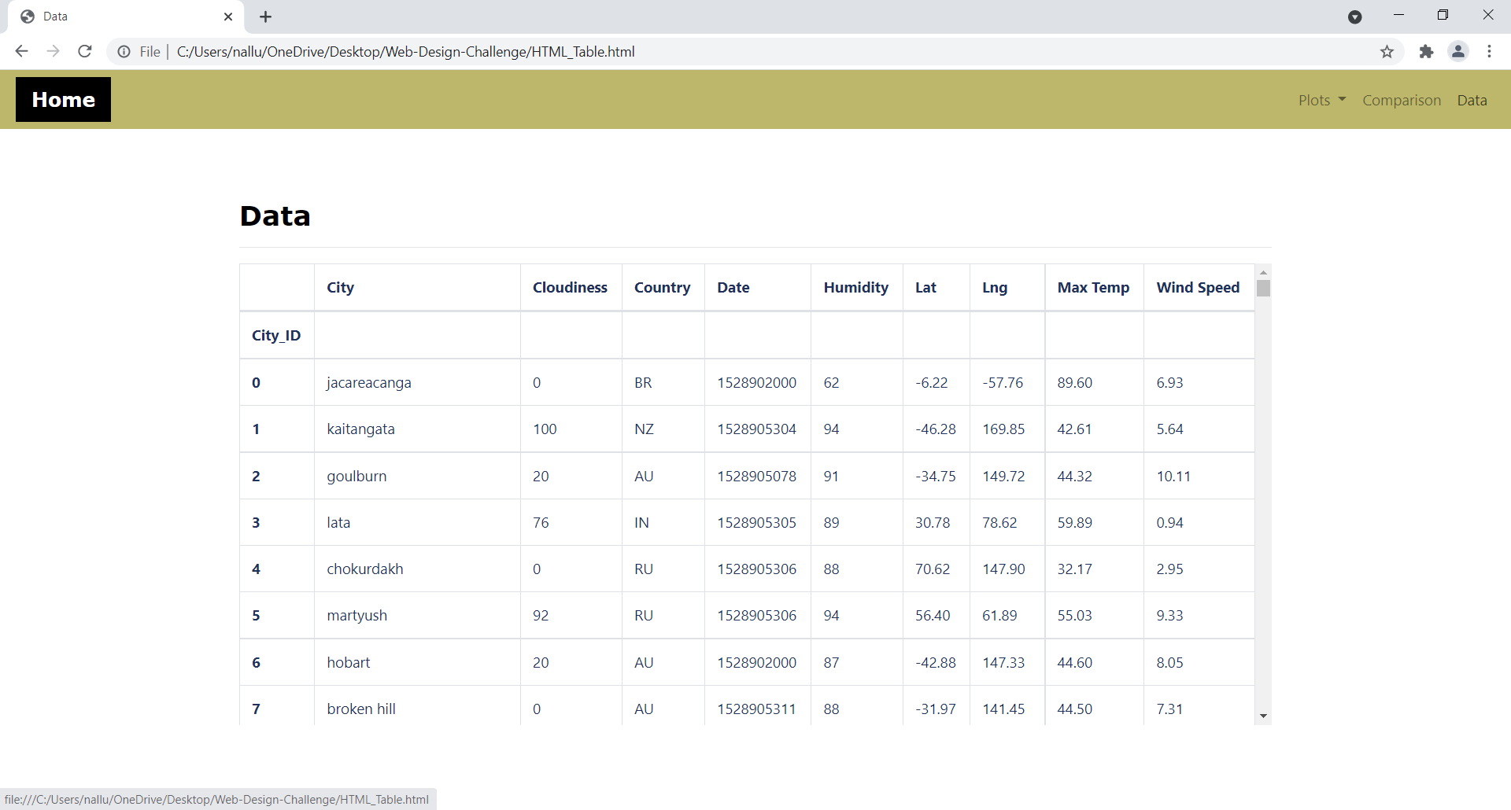

Small screen:

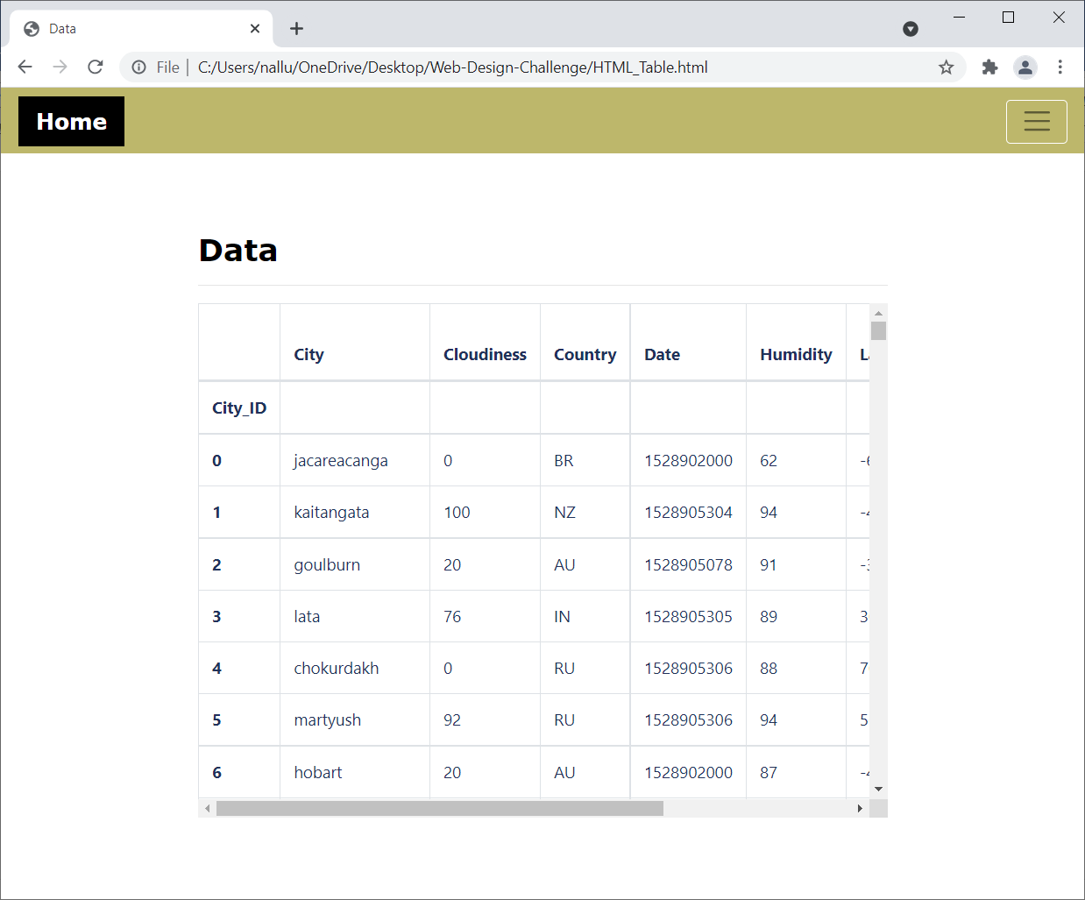

#### <a id="visualization-pages"></a>Visualization pages

Temperature:

Large screen:

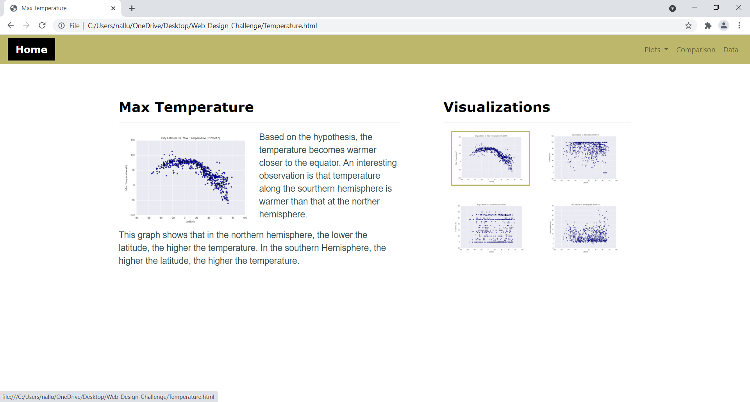

Small screen:

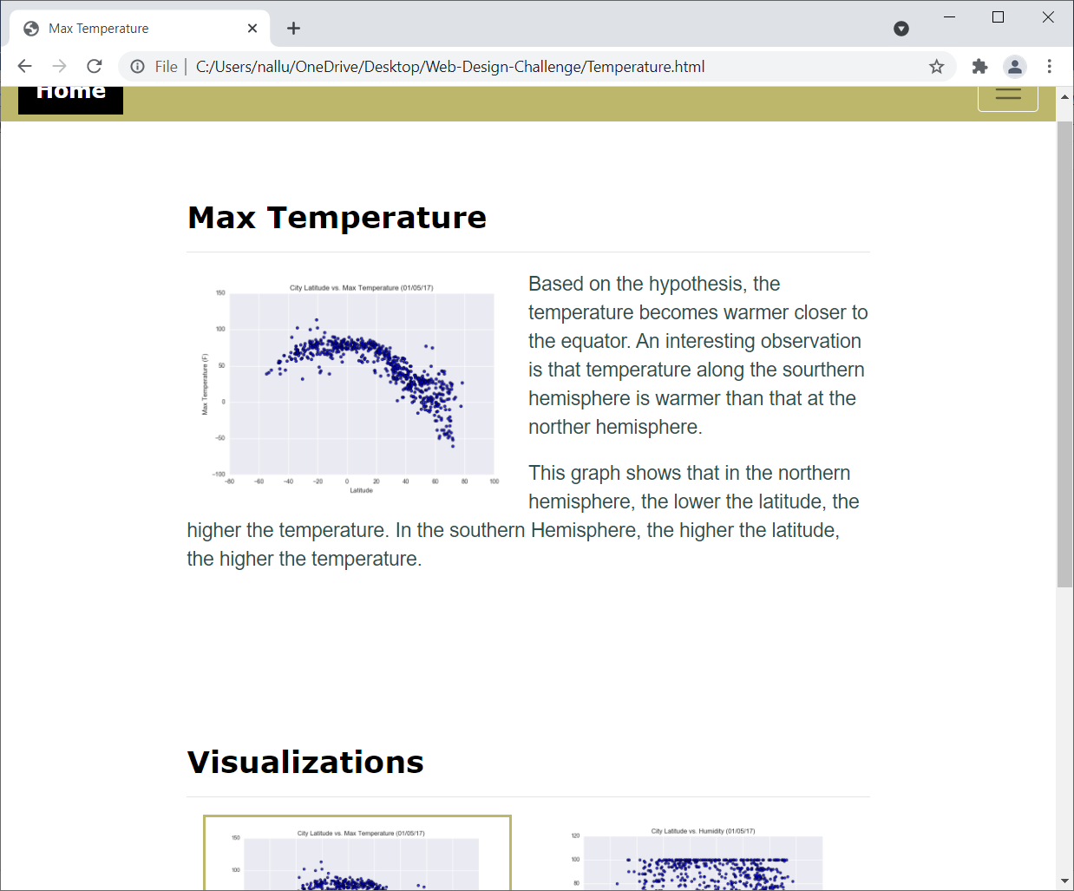

Humidity:

Large Screen:

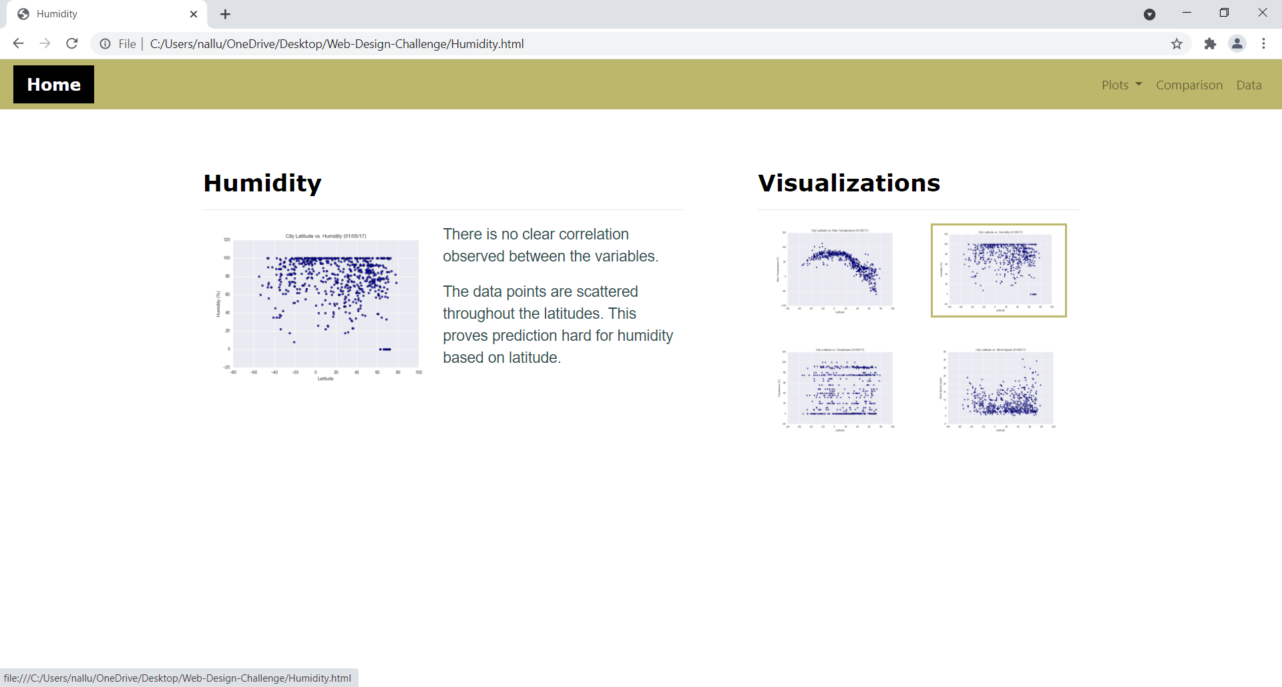

Small Screen: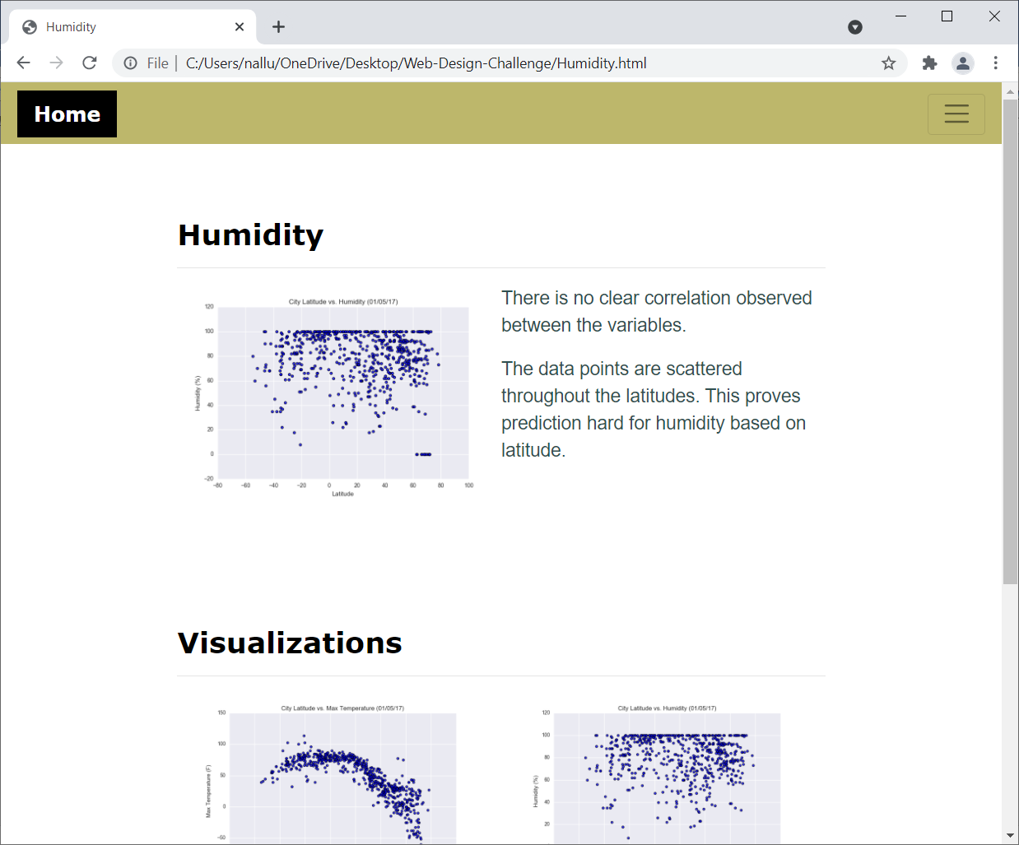

Cloudiness:

Large Screen:

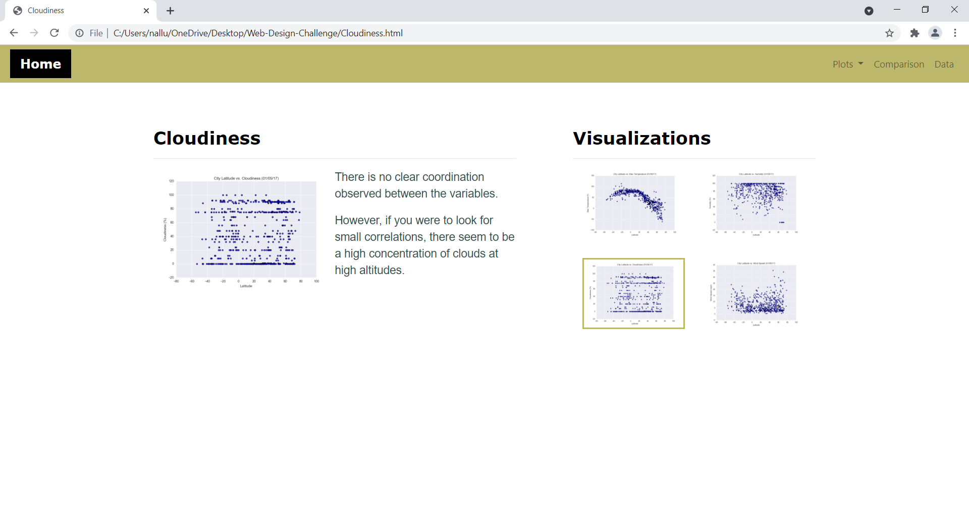

Small Screen:

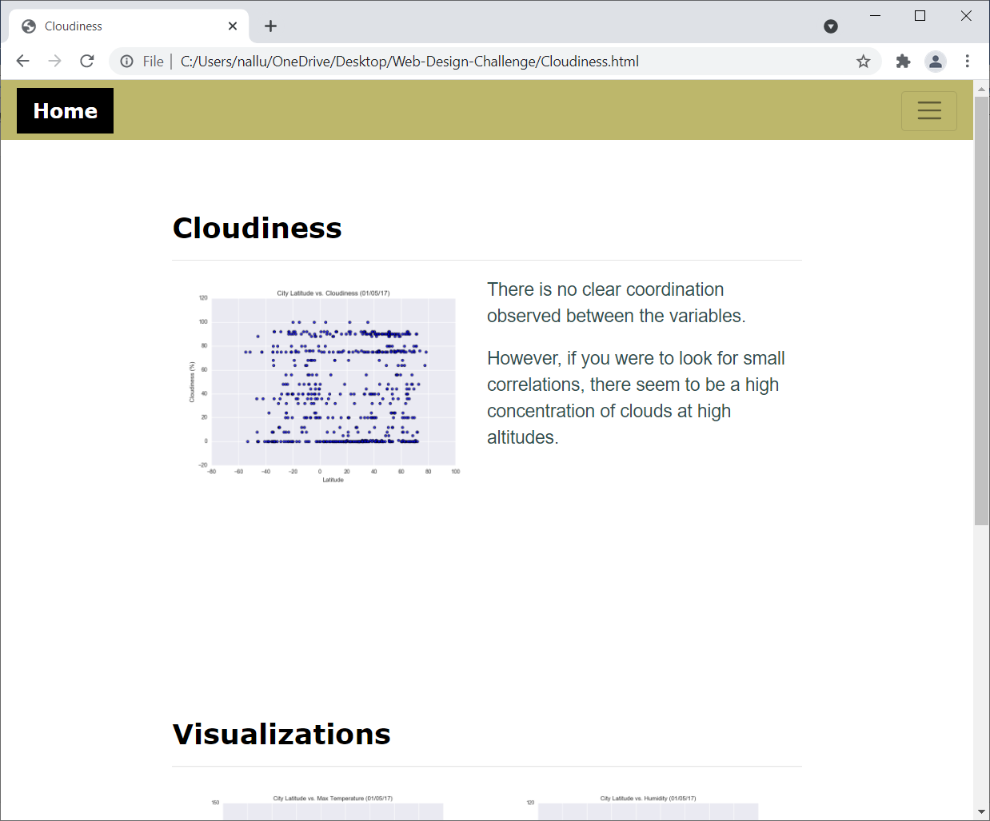

Wind Speed:

Large Screen:

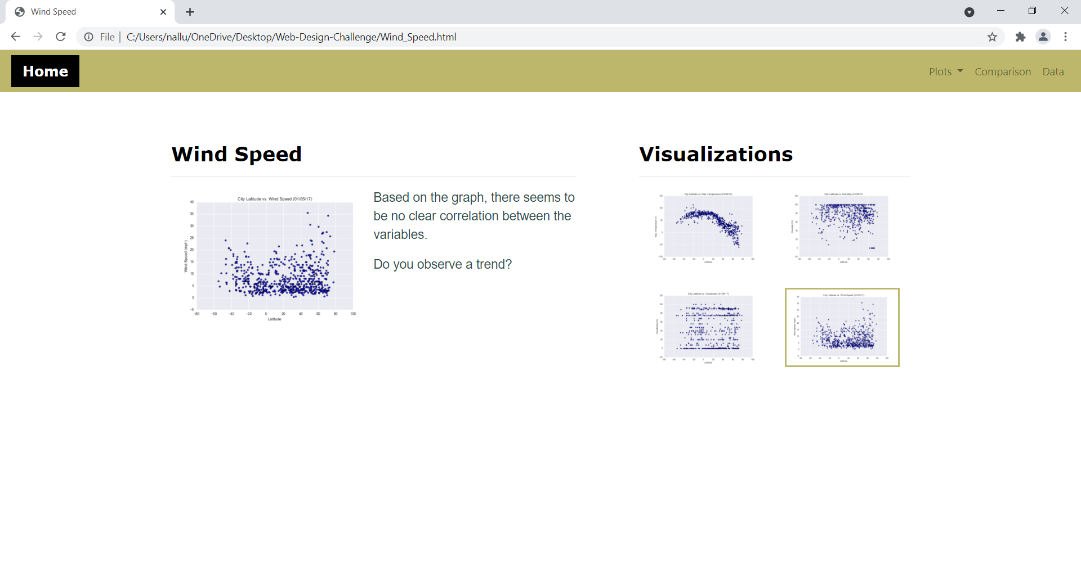

Small Screen:

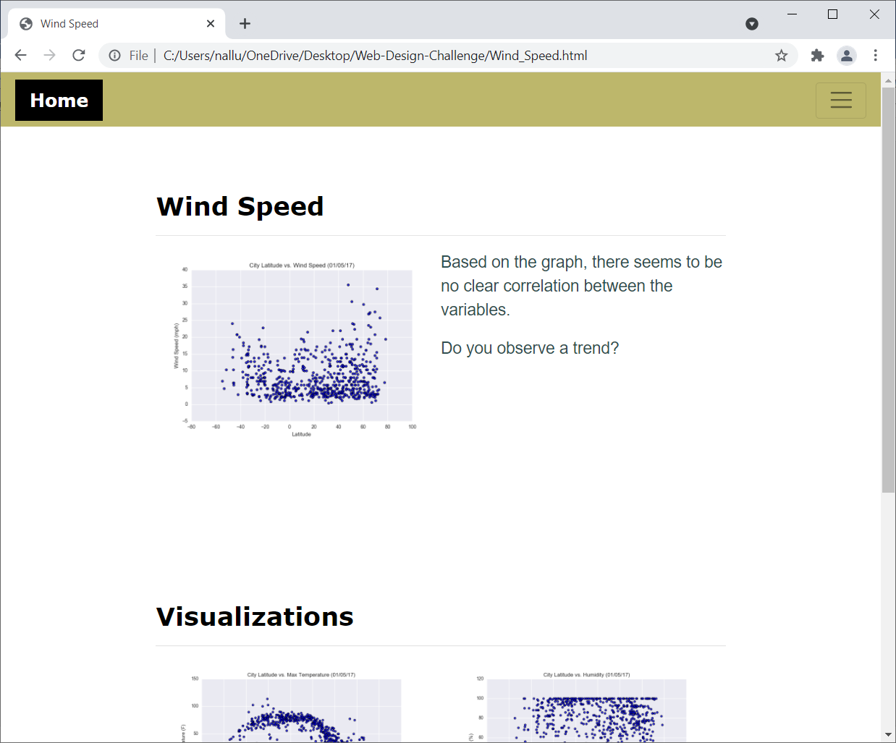

#### <a id="navigation-menu"></a>Navigation menu

Large screen:

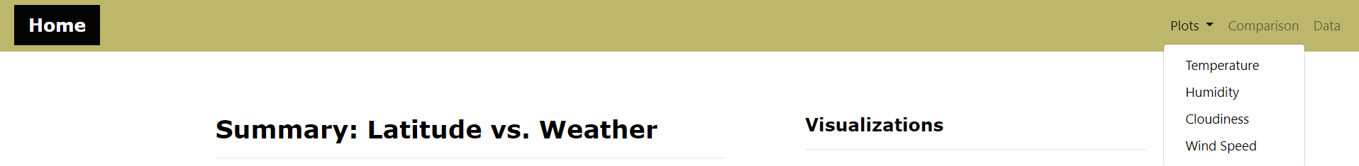

Small screen:

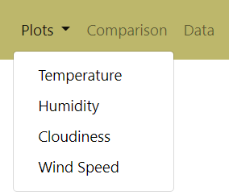

- - -

Â© 2021 Trilogy Education Services, LLC, a 2U, Inc. brand. Confidential and Proprietary. All Rights Reserved.