**AI ASSISTED CODING**

Prompt Engineering-Improving Prompts

H.no:2403a51182

Batch:06 Name: H.V.S.Vyshnavi

**TASK-1:**

PROMPT:



CODE:

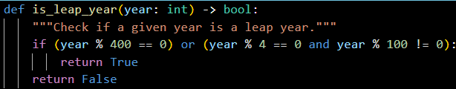

**TASK-2:**

CODE:

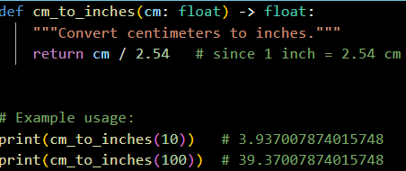

OUTPUT:



**TASK-3**:

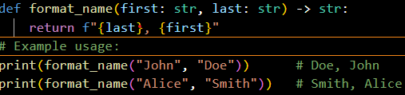



EXAMPLE:2

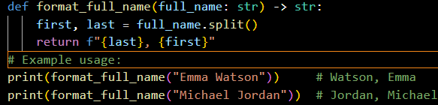



EXAMPLE:3

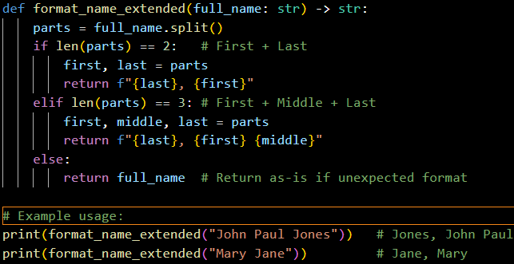



**TASK-4:**

PROMPTS:

ZERO SHOT:



FEW SHOT:



Outputs:

  
 



**TASK-5:**

PROMPT:

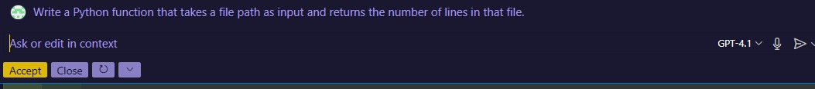

CODE:

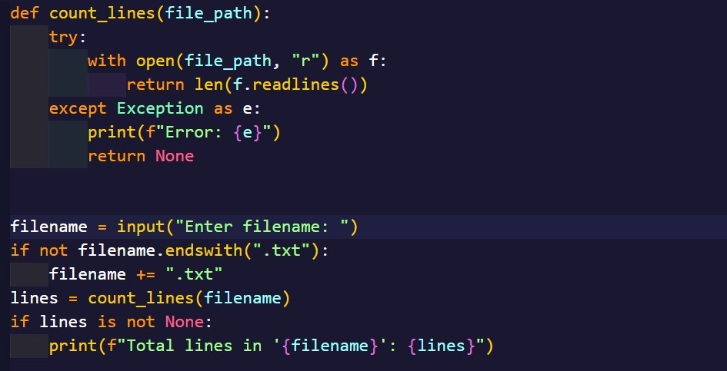

OUTPUT:

