HelloWorld_iFlow – External API Integration using SAP CPI
This project demonstrates a basic SAP Cloud Integration (CPI) flow that calls an external REST API and processes the response.
The integration flow represents a client request being processed through SAP CPI, where CPI communicates with an external API, receives a JSON response, and logs the payload using a Groovy script.

Architecture
Client Request → Content Modifier → Request Reply → HTTP Receiver → Groovy Script → End
Testing Note: During implementation in the SAP Trial environment, a Timer trigger was temporarily used to execute and validate the flow due to runtime authorization limitations affecting external HTTP testing.

Step-by-Step Working

1. Client Request
The integration flow begins when a request is sent to CPI.

2. Content Modifier
Prepares or modifies the message before calling the external API.

3. Request Reply
Sends the request and waits for the external API response.

4. HTTP Receiver
Calls the external REST API using HTTP GET.

5. External API Response
Receives JSON payload from JSONPlaceholder API.

6. Groovy Script
Logs the payload into CPI monitoring attachments.

7. Monitoring
Used Monitor → Message Processing to verify successful execution.

External API Used
https://jsonplaceholder.typicode.com/posts/1

Concepts Learned
- SAP CPI flow structure
- Client-to-API integration flow
- External API communication
- Request Reply processing
- HTTP Receiver adapter
- JSON payload handling
- Monitoring and logging
- Basic Groovy scripting

Screenshots

Integration Flow Design
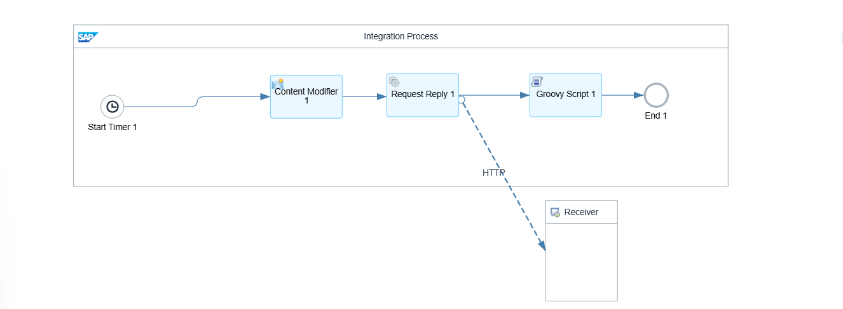

HTTP Receiver Configuration
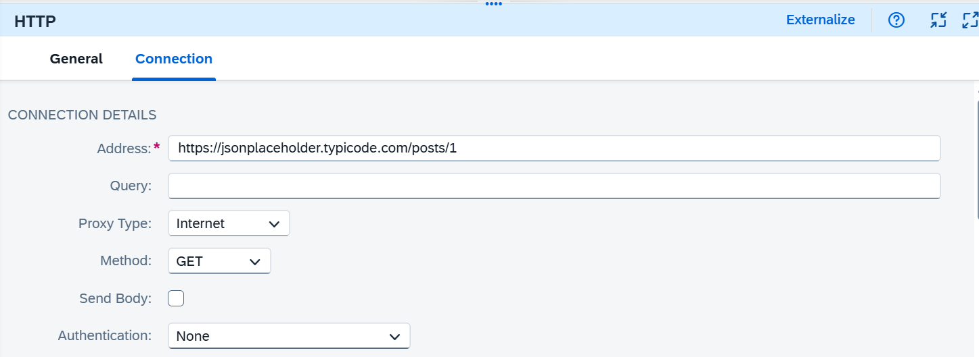

Successful Flow Execution
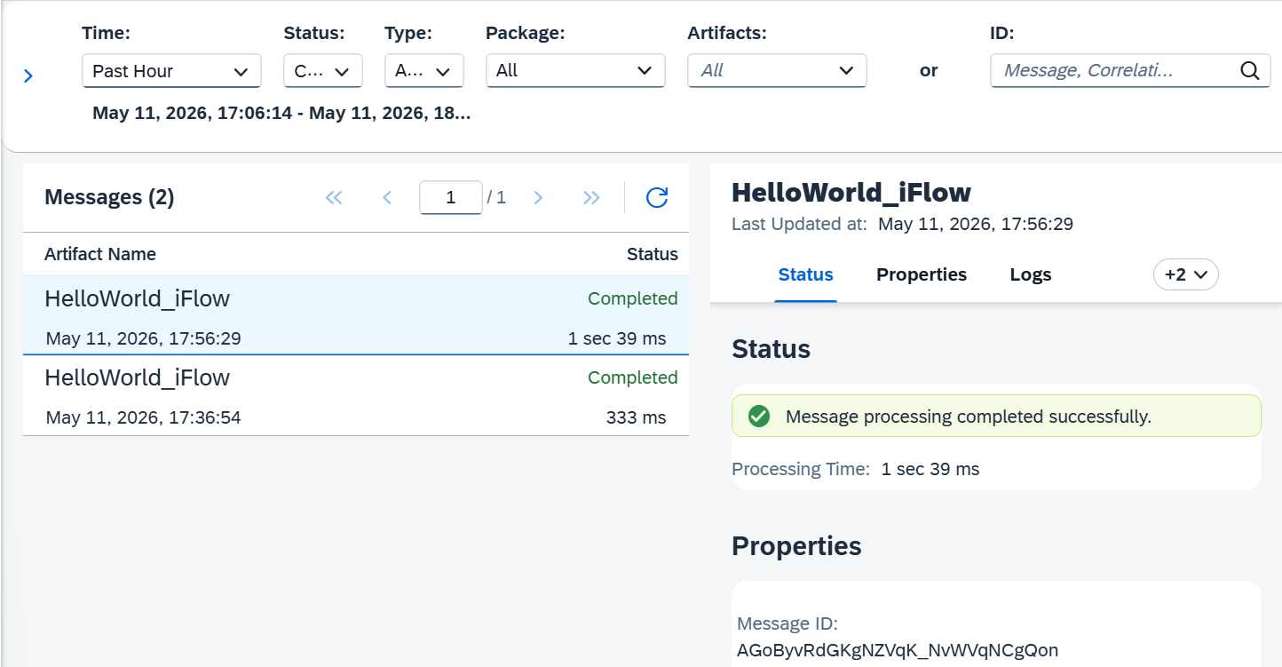

API Response Payload
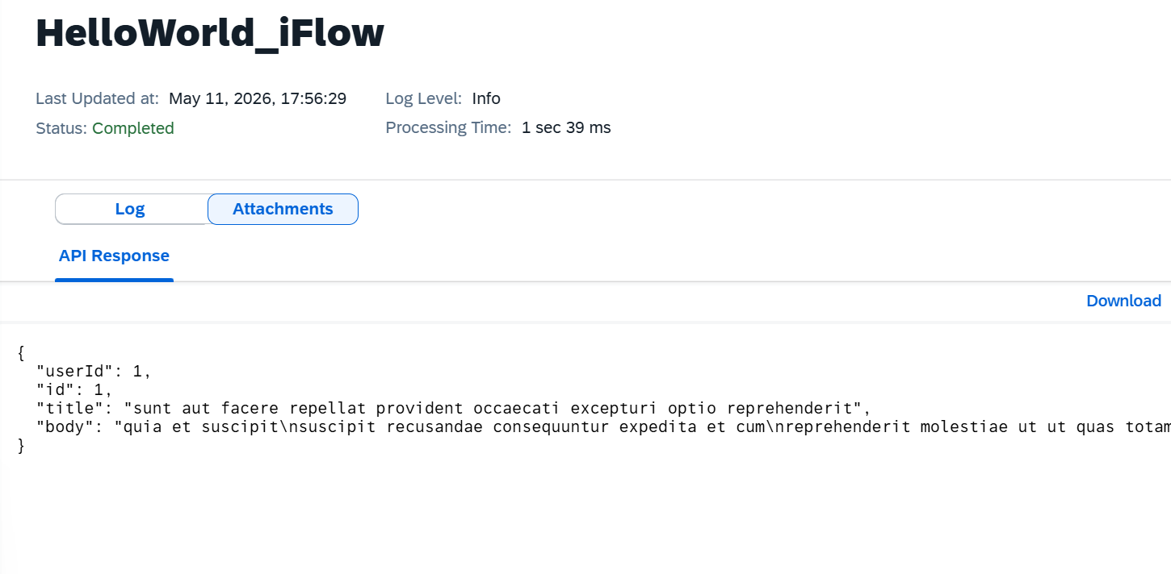

Project Summary
This project demonstrates how SAP CPI communicates with external REST APIs, processes responses, and logs payload data for monitoring and debugging. The same Request-Reply integration pattern is widely used in enterprise integrations involving SAP systems and third-party applications.

