TEMPERATURE-CONTROLLED DC MOTOR USING ARDUINO
Circuit Diagram
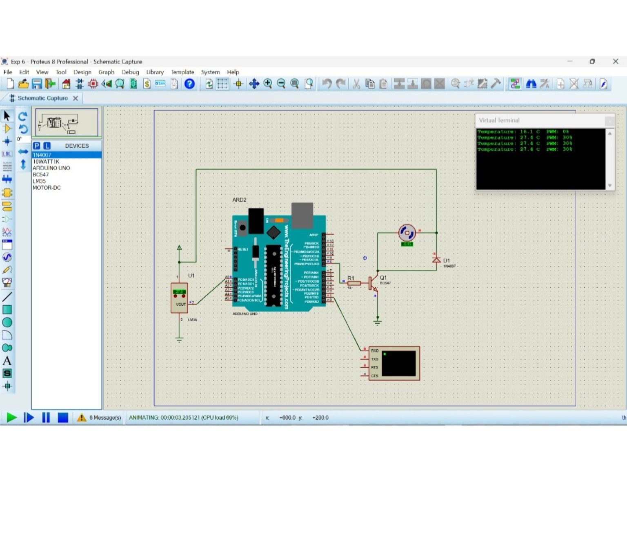
Coding
// Temperature-controlled DC motor using Arduino UNO and LM35
const int sensorPin = A0;
const int motorPin = 9; // PWM output to transistor driver
void setup() {
pinMode(motorPin, OUTPUT);
Serial.begin(9600);
}
void loop() {
int sensorValue = analogRead(sensorPin);
float voltage = sensorValue * (5.0 / 1023.0);
float temperature = voltage * 100.0; // LM35: 10 mV per degree C
int motorPWM;
if (temperature < 25.0) motorPWM = 0;
else if (temperature < 30.0) motorPWM = 77; // about 30%
else if (temperature < 35.0) motorPWM = 153; // about 60%
else motorPWM = 255; // 100%
analogWrite(motorPin, motorPWM);
Serial.print("Temperature: ");
Serial.print(temperature, 1);
Serial.print(" C PWM: ");
Serial.print((motorPWM * 100) / 255);
Serial.println("%");
delay(1000);
}
Observation
- The LM35 sensor senses the surrounding temperature and sends an analogue signal to the Arduino.
- The Arduino converts the sensor reading into temperature in degree Celsius.
- When the temperature is below 25°C, the motor remains OFF (PWM 0%).
- At about 27°C, the motor runs at approximately 30% speed, as shown in the virtual terminal.
- As the temperature increases, the Arduino increases the PWM output and the motor speed.
- Thus, the DC motor speed is automatically controlled according to the sensed temperature.

