EXPERIMENT 1
GAS AND INTRUSION ALERT SYSTEM
1. PROTEUS CIRCUIT DIAGRAM
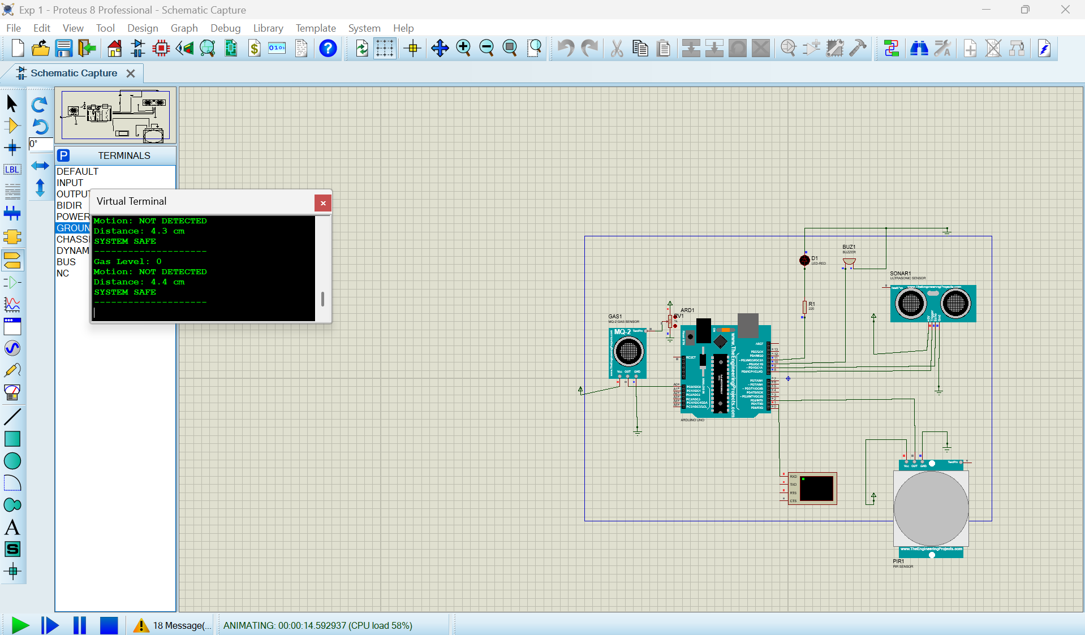
Figure 1: Proteus simulation of the gas and intrusion alert system.
2. ARDUINO PROGRAM
Pin mapping used in this program: MQ-2 OUT → A0; PIR OUT → D2; HC-SR04 TRIG → D9 and ECHO → D10; LED → D7; buzzer → D8.
// Gas and Intrusion Alert System
// Components: MQ-2 gas sensor, PIR sensor, HC-SR04 ultrasonic sensor,
// LED, buzzer and Arduino UNO.
const int gasPin = A0;
const int pirPin = 2;
const int trigPin = 9;
const int echoPin = 10;
const int ledPin = 7;
const int buzzerPin = 8;
const int gasThreshold = 400; // Adjust after testing the MQ-2 sensor
const float distanceThreshold = 10.0; // Distance in centimetres
void setup() {
pinMode(pirPin, INPUT);
pinMode(trigPin, OUTPUT);
pinMode(echoPin, INPUT);
pinMode(ledPin, OUTPUT);
pinMode(buzzerPin, OUTPUT);
Serial.begin(9600);
Serial.println("SYSTEM STARTED");
}
float readDistance() {
digitalWrite(trigPin, LOW);
delayMicroseconds(2);
digitalWrite(trigPin, HIGH);
delayMicroseconds(10);
digitalWrite(trigPin, LOW);
long duration = pulseIn(echoPin, HIGH, 30000);
if (duration == 0) {
return -1; // No valid echo received
}
return duration * 0.0343 / 2.0;
}
void loop() {
int gasLevel = analogRead(gasPin);
int motion = digitalRead(pirPin);
float distance = readDistance();
bool gasAlert = gasLevel > gasThreshold;
bool motionAlert = motion == HIGH;
bool distanceAlert = (distance >= 0 && distance < distanceThreshold);
Serial.print("Gas Level: ");
Serial.println(gasLevel);
Serial.print("Motion: ");
Serial.println(motionAlert ? "DETECTED" : "NOT DETECTED");
if (distance >= 0) {
Serial.print("Distance: ");
Serial.print(distance, 1);
Serial.println(" cm");
} else {
Serial.println("Distance: NO ECHO");
}
if (gasAlert || motionAlert || distanceAlert) {
digitalWrite(ledPin, HIGH);
tone(buzzerPin, 1000);
Serial.println("WARNING: CHECK AREA");
} else {
digitalWrite(ledPin, LOW);
noTone(buzzerPin);
Serial.println("SYSTEM SAFE");
}
Serial.println("--------------------");
delay(1000);
}
3. OBSERVATION NOTE
- The Proteus circuit was simulated successfully using the Arduino UNO.
- The MQ-2 sensor reads the gas level, while the PIR sensor checks for motion.
- The ultrasonic sensor measures the distance of an object in centimetres.
- When all readings are within the set limits, the system displays “SYSTEM SAFE”.
- If gas, motion, or a nearby object is detected, the LED and buzzer are activated.
- The Virtual Terminal displays the sensor readings and the system status.

