EXPERIMENT 3: PULSE RATE AND TEMPERATURE MONITOR

Circuit Diagram (Proteus)
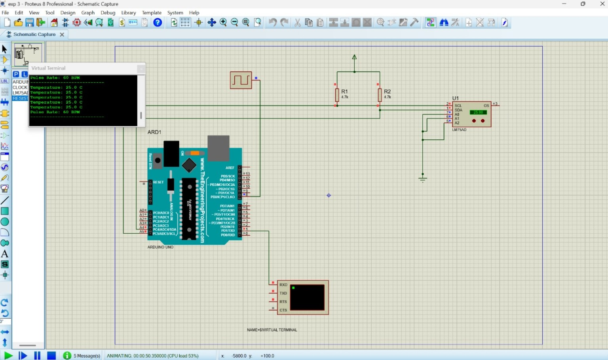

Introduction
This project monitors pulse rate and temperature using an Arduino Uno. A pulse signal is applied to the Arduino and counted over a fixed time interval to calculate beats per minute (BPM). An LM75A digital temperature sensor measures temperature through the I2C communication protocol. The readings are displayed on the Proteus Virtual Terminal.

Components Required
Arduino Uno, LM75A temperature sensor, pulse signal generator, two 4.7-kilohm pull-up resistors, Proteus Virtual Terminal and connecting wires.

Arduino Program / Coding
// Pulse Rate and Temperature Monitor
// Arduino Uno + LM75A temperature sensor (I2C)
// Simulated pulse signal is connected to digital pin 8.
#include <Wire.h>
const byte PULSE_PIN = 8;
const byte LM75_ADDRESS = 0x48; // A2, A1 and A0 connected LOW
float readLM75Temperature() {
Wire.beginTransmission(LM75_ADDRESS);
Wire.write(0x00); // Temperature register
Wire.endTransmission(false);
Wire.requestFrom(LM75_ADDRESS, (byte)2);
if (Wire.available() < 2) {
return -999.0; // Sensor read error
}
byte msb = Wire.read();
byte lsb = Wire.read();
int16_t raw = ((int16_t)msb << 8) | lsb;
// LM75A temperature is represented in 0.5 degree C steps.
raw >>= 7;
return raw * 0.5;
}
void setup() {
pinMode(PULSE_PIN, INPUT);
Serial.begin(9600);
Wire.begin();
// D8 is read by polling in loop(); it does not need an interrupt.
}
void loop() {
static int previousLevel = LOW;
static unsigned long lastReport = 0;
static unsigned long windowPulses = 0;
int currentLevel = digitalRead(PULSE_PIN);
if (currentLevel == HIGH && previousLevel == LOW) {
windowPulses++;
}
previousLevel = currentLevel;
if (millis() - lastReport >= 10000UL) {
float bpm = windowPulses * 6.0; // 10-second count to BPM
float temperature = readLM75Temperature();
Serial.print("Pulse Rate: ");
Serial.print(bpm, 0);
Serial.println(" BPM");
Serial.print("Temperature: ");
if (temperature == -999.0) {
Serial.println("Sensor read error");
} else {
Serial.print(temperature, 1);
Serial.println(" C");
}
windowPulses = 0;
lastReport = millis();
}
}

Observation
- The pulse signal generator provides digital pulses to the Arduino input.
- The Arduino counts the rising edges of the pulse signal during a 10-second interval.
- The pulse count is converted into beats per minute (BPM).
- The LM75A sensor measures the surrounding temperature and sends digital data through I2C.
- The Arduino reads the temperature value and displays it along with the pulse rate.
- The Virtual Terminal shows the pulse rate and temperature repeatedly during simulation.

Important Simulation Notes
This program assumes the pulse-generator output is connected to D8, the LM75A uses I2C address 0x48, and the sensor's A0-A2 address pins are LOW. On an Arduino Uno, connect SDA to A4 and SCL to A5. The screenshot's displayed 60 BPM corresponds to approximately one pulse per second. If your Proteus wiring uses a different pulse input pin or LM75A address, update the constants in the code.

