EXPERIMENT 2: TWO-WAY TRAFFIC LIGHT CONTROLLER

Circuit Diagram (Proteus)
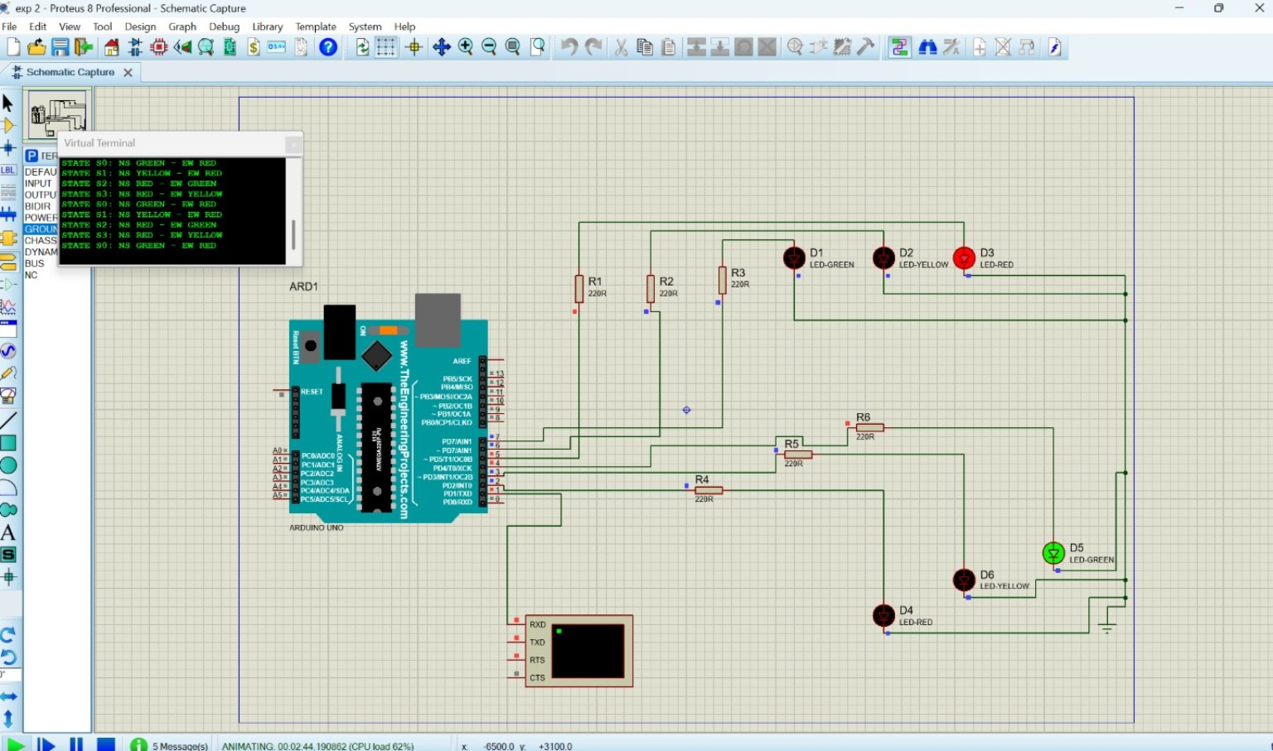

Introduction
The two-way traffic light controller is designed using an Arduino Uno. It controls the traffic signals for North-South and East-West directions in a fixed sequence. Green, yellow and red LEDs indicate go, caution and stop conditions. The program also displays each signal state on the Proteus Virtual Terminal.

Components Required
Arduino Uno, six LEDs (two red, two yellow and two green), six 220-ohm resistors, Proteus Virtual Terminal and connecting wires.

Arduino Program / Coding
// Two-Way Traffic Light Controller
// Arduino Uno - Proteus simulation
const int NS_GREEN = 7;
const int NS_YELLOW = 6;
const int NS_RED = 5;
const int EW_RED = 4;
const int EW_YELLOW = 3;
const int EW_GREEN = 2;
void allOff() {
digitalWrite(NS_GREEN, LOW);
digitalWrite(NS_YELLOW, LOW);
digitalWrite(NS_RED, LOW);
digitalWrite(EW_RED, LOW);
digitalWrite(EW_YELLOW, LOW);
digitalWrite(EW_GREEN, LOW);
}
void showState(const char *ns, const char *ew) {
Serial.print("STATE: NS ");
Serial.print(ns);
Serial.print(" - EW ");
Serial.println(ew);
}
void setup() {
pinMode(NS_GREEN, OUTPUT);
pinMode(NS_YELLOW, OUTPUT);
pinMode(NS_RED, OUTPUT);
pinMode(EW_RED, OUTPUT);
pinMode(EW_YELLOW, OUTPUT);
pinMode(EW_GREEN, OUTPUT);
Serial.begin(9600);
allOff();
}
void loop() {
// North-South traffic moves; East-West stops
allOff();
digitalWrite(NS_GREEN, HIGH);
digitalWrite(EW_RED, HIGH);
showState("GREEN", "RED");
delay(5000);
// North-South warning; East-West remains stopped
allOff();
digitalWrite(NS_YELLOW, HIGH);
digitalWrite(EW_RED, HIGH);
showState("YELLOW", "RED");
delay(2000);
// Both directions stop briefly
allOff();
digitalWrite(NS_RED, HIGH);
digitalWrite(EW_RED, HIGH);
showState("RED", "RED");
delay(1000);
// East-West traffic moves; North-South stops
allOff();
digitalWrite(NS_RED, HIGH);
digitalWrite(EW_GREEN, HIGH);
showState("RED", "GREEN");
delay(5000);
// East-West warning; North-South remains stopped
allOff();
digitalWrite(NS_RED, HIGH);
digitalWrite(EW_YELLOW, HIGH);
showState("RED", "YELLOW");
delay(2000);
// Both directions stop before the cycle repeats
allOff();
digitalWrite(NS_RED, HIGH);
digitalWrite(EW_RED, HIGH);
showState("RED", "RED");
delay(1000);
}

Observation
- The Arduino controls six LEDs representing the two traffic directions.
- When the North-South signal is green, the East-West signal remains red.
- The yellow LED turns ON before the signal changes to red.
- Both directions show red briefly to provide a safe transition.
- The East-West direction then receives green while North-South remains red.
- The sequence repeats continuously, and the current state is printed on the Virtual Terminal.

Important Simulation Notes
The code uses pins D7, D6 and D5 for North-South green, yellow and red, respectively. Pins D4, D3 and D2 are used for East-West red, yellow and green. The pin mapping should match the wiring in the Proteus circuit. The time delays can be adjusted according to the required signal timing.

