**TABLE SALESPEOPLE**

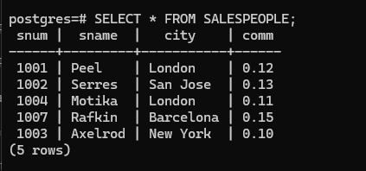

**TABLE CUST**

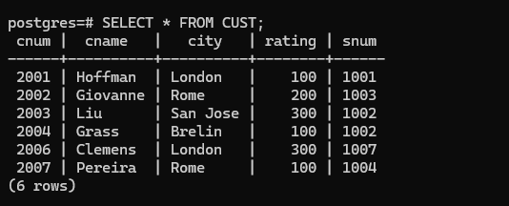

**ORDERS**

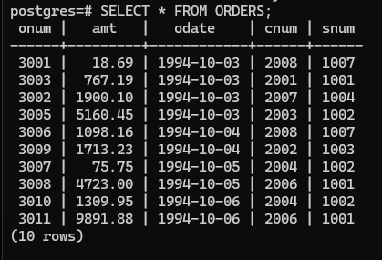

**QUERIES**

1. **Display snum,sname,city and comm of all salespeople.**

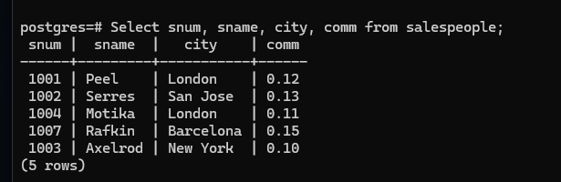

1. **Display all snum without duplicates from all orders**

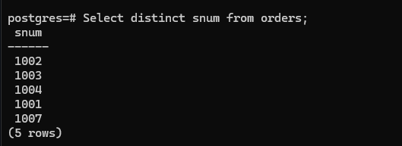

**3.Display names and commissions of all salespeople in london.** 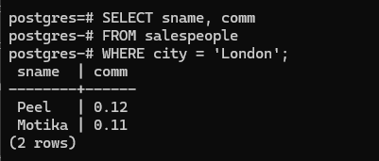

**4. All customers with rating of 100**

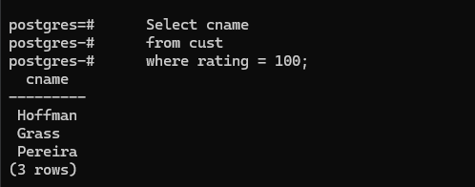

**5. Produce orderno, amount and date form all rows in the order table.**

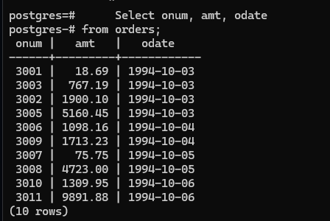

**6. All customers in San Jose, who have rating more than 200.**

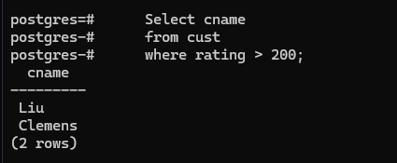

**7. All customers who were either located in San Jose or had a rating above 200.**

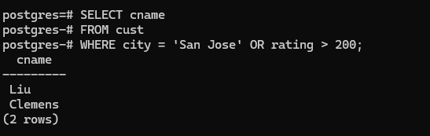

**8.All orders for more than $1000.**

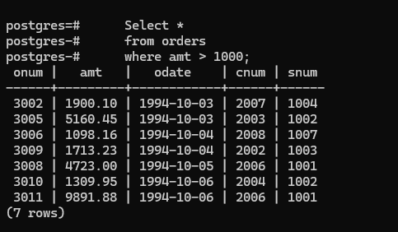

**9.Names and citires of all salespeople in london with commission above 0.10.**

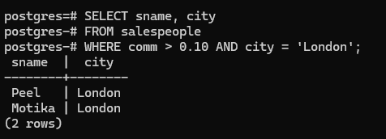

**10.All customers excluding those with rating <= 100 unless they are located in Rome.**

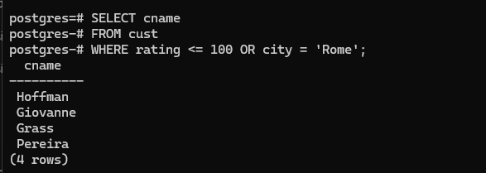

**11. All salespeople either in Barcelona or in london.**

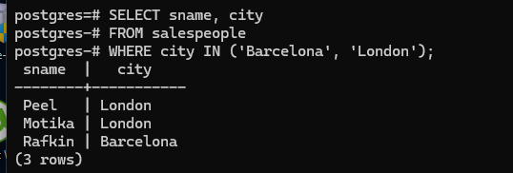

**12. All salespeople with commission between 0.10 and 0.12. (Boundary values should be excluded)**

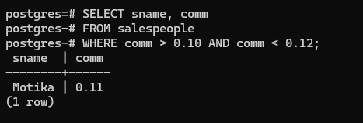

**13. All customers with NULL values in city column.**

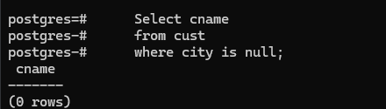

**14. All orders taken on Oct 3Rd and Oct 4th 1994.**

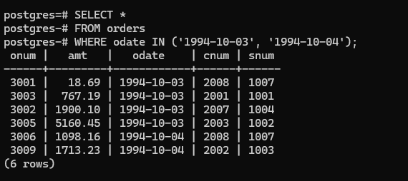

**15. All customers serviced by peel or Motika.**

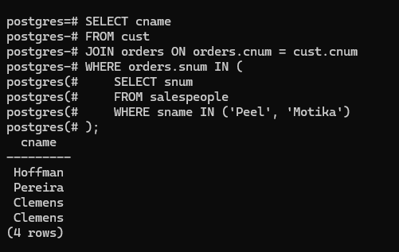

**16. All customers whose names begin with a letter from A to B.**

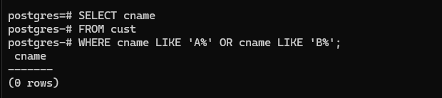

**17. All orders except those with 0 or NULL value in amt field.**

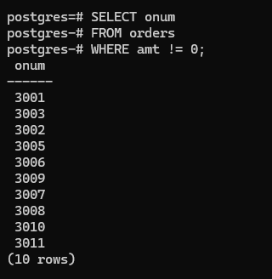

**18. Count the number of salespeople currently listing orders in the order table.**

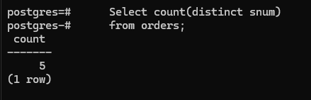

**19. Largest order taken by each salesperson, datewise.**

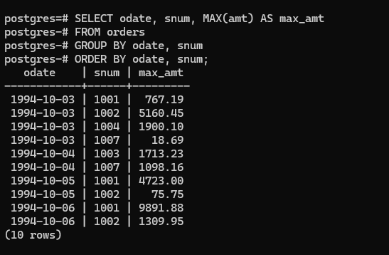

**20. Largest order taken by each salesperson with order value more than $3000.**

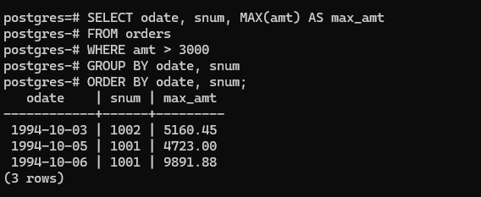

**21. Which day had the hightest total amount ordered.**

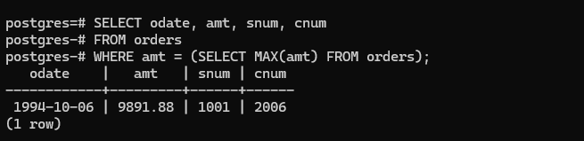

**22. Count all orders for Oct 3rd.**

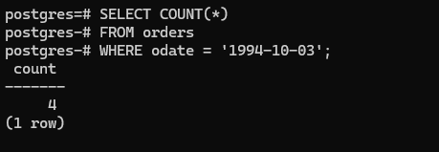

**23. Count the number of different non NULL city values in customers table.**

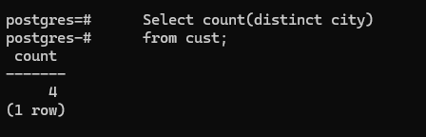

**24. Select each customer’s smallest order.**

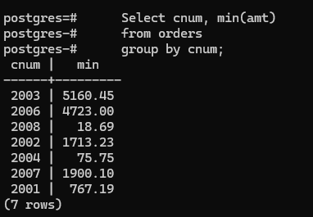

**25. First customer in alphabetical order whose name begins with G.**

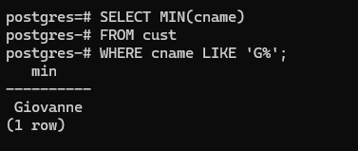

**26. Get the output like “ For dd/mm/yy there are ___ orders.**

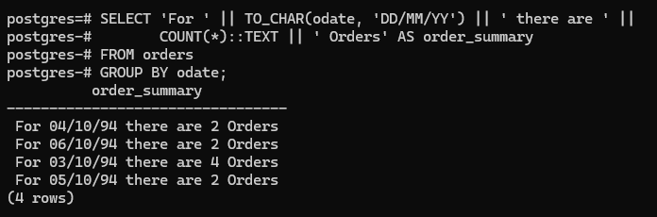

**27.Assume that each salesperson has a 12% commission. Produce order no., salesperson no., and amount of salesperson’s commission for that order.**

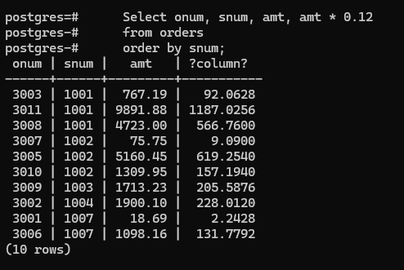

**28. Find highest rating in each city. Put the output in this form. For the city (city), the highest rating is : (rating).**

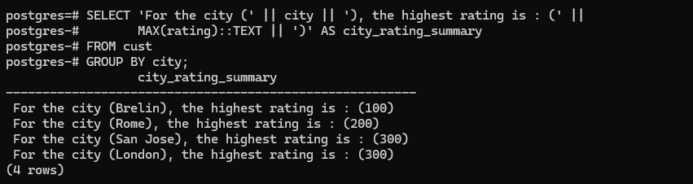

**29. Display the totals of orders for each day and place the results in descending order.**

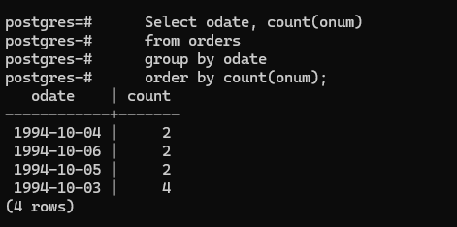

**30. All combinations of salespeople and customers who shared a city. (ie same city).**

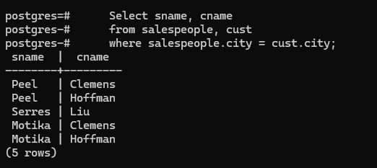

**31. Name of all customers matched with the salespeople serving them.**

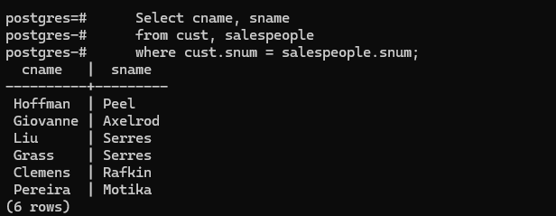

**32. List each order number followed by the name of the customer who made the order.**

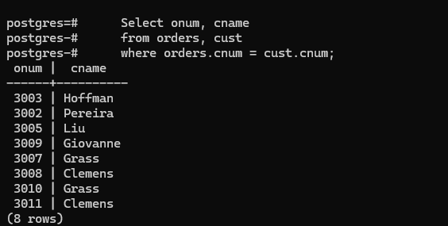

**33. Names of salesperson and customer for each order after the order number.**

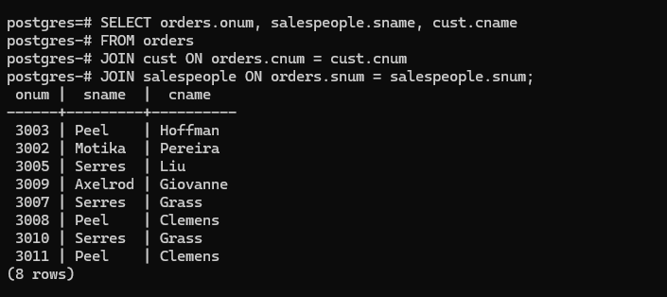

**34. Produce all customer serviced by salespeople with a commission above 12%.**

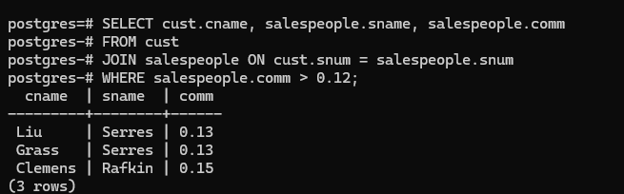

**35. Calculate the amount of the salesperson’s commission on each order with a rating above 100.**

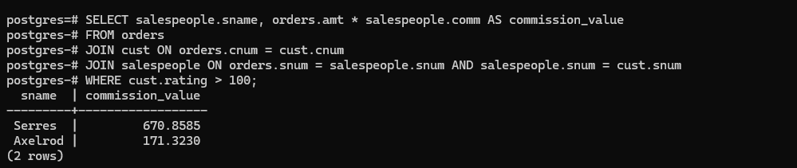

**36. Find all pairs of customers having the same rating.**

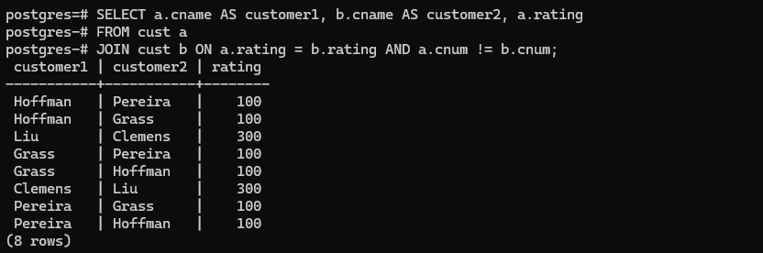

**37. Find all pairs of customers having the same rating, each pair coming once only.**

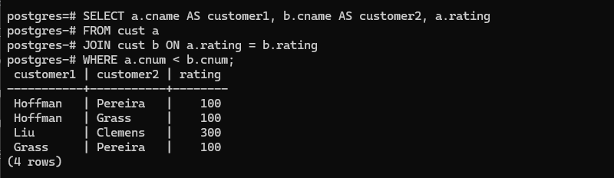

**38. Policy is to assign three salesperson to each customers. Display all such combinations.**

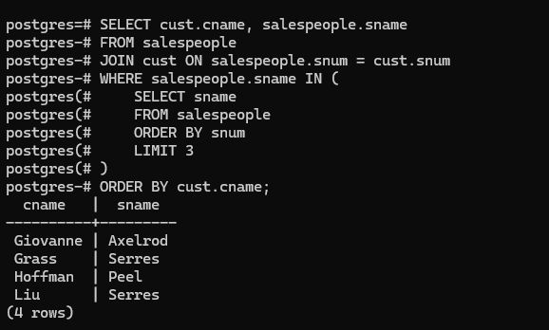

**39. Display all customers located in cities where salesman serres has customer.**

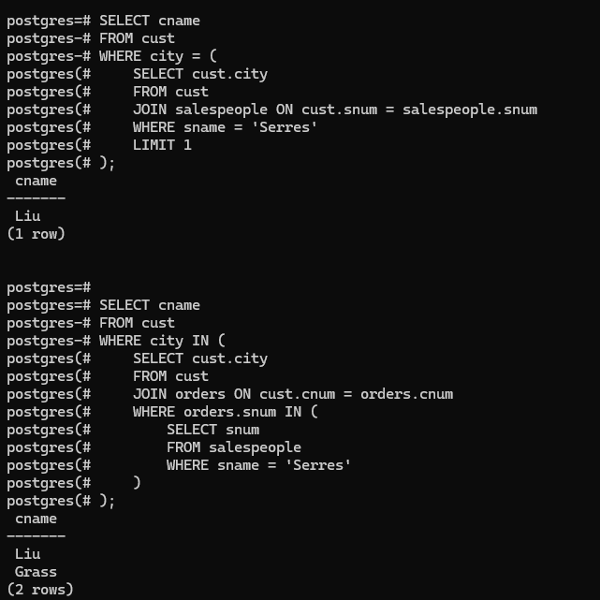

**40. Find all pairs of customers served by single salesperson.**

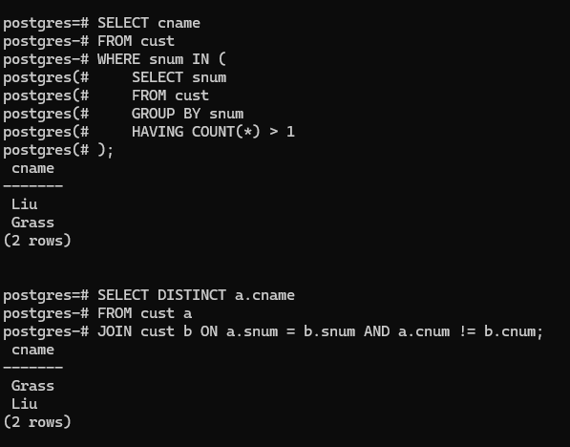

**41. Produce all pairs of salespeople which are living in the same city. Exclude combinations of salespeople with themselves as well as duplicates with the order reversed.**

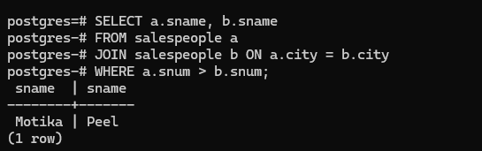

**42. Produce all pairs of orders by given customer, names that customers and eliminates duplicates.**

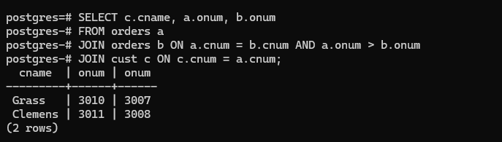

**43. Produce names and cities of all customers with the same rating as Hoffman.**

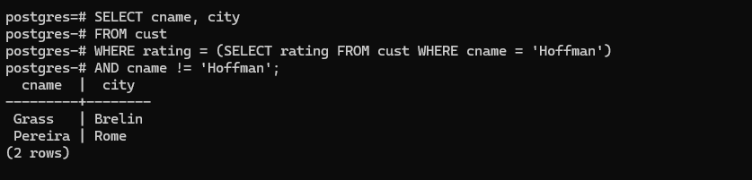

**44. Extract all the orders of Motika.**

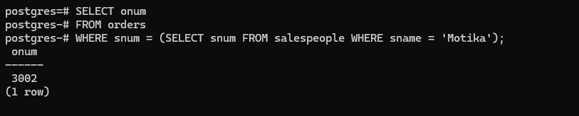

**45. All orders credited to the same salesperson who services Hoffman.**

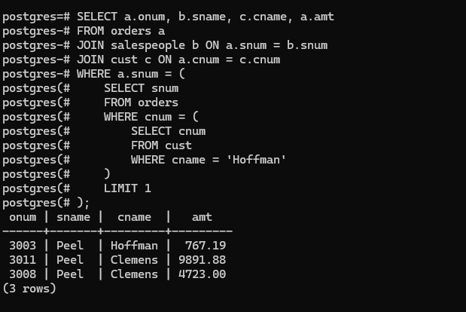

**46. All orders that are greater than the average for Oct 4.**

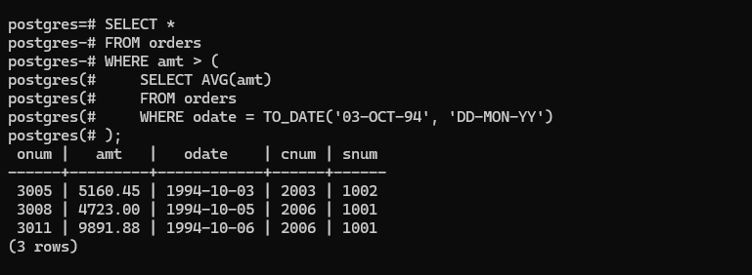

**47. Find average commission of salespeople in london.**

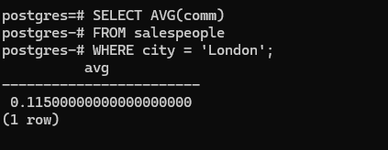

**48. Find all orders attributed to salespeople servicing customers in london.**

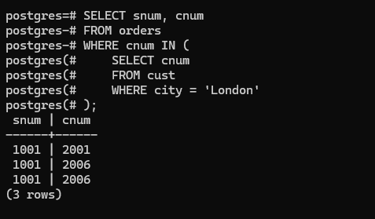

**49. Extract commissions of all salespeople servicing customers in London.**

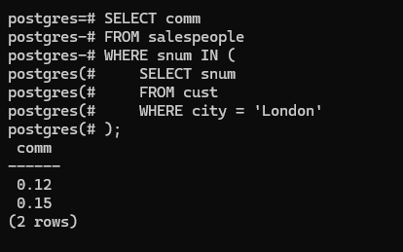

**50. Find all customers whose cnum is 1000 above the snum of serres.**

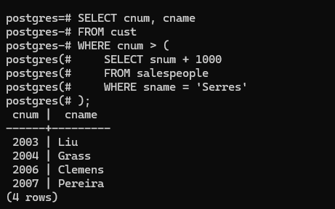

**51. Count the customers with rating above San Jose’s average.**

